1. Open JPA Perspective
2. In the Data Source Explorer create new Database Connection

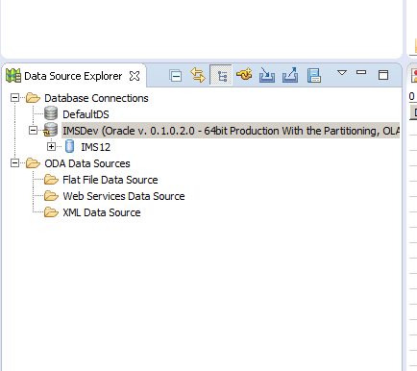

1. Create JAVA project. Configure 🡪 Convert to JPA Project (Select the above created connection in this step)
2. Right click on Project, JPA Tools 🡪 generate entities from table.