Determination of oxygen mass transfer coefficient IKLa) in batch reactor

Rafael Ventura

23 de junio de 2017

## Abstract

## Objectives

## Background

## Procedure

## Warning: package 'readxl' was built under R version 3.3.3

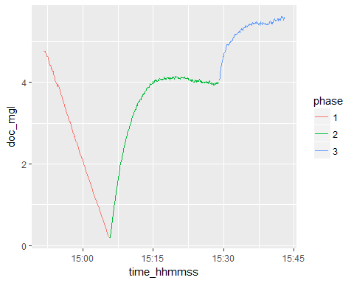 ## Discussion

## Conclussions