3B

K

**TASK 1:** List the IP addresses of both connected boards and include them in your report.

**TASK 5:** Run a ping and show the output.

**TASK 2 :** Run the ot router table command in the CLI app and copy or screenshot the output.

**TASK 3:** Run the ot child table command in the CLI app and copy or screenshot the output.

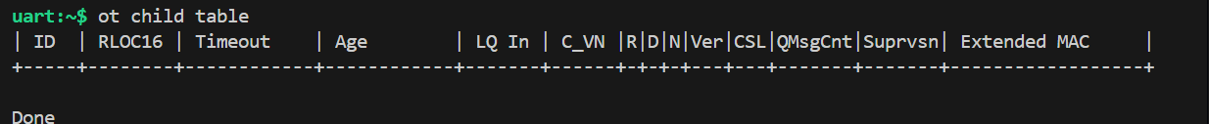

**TASK 4:** Run the ot neighbor table command in the CLI app and copy or screenshot the output.

L

**TASK 1:** Show evidence of sending UDP messages between your devices.

Sender :Com4

Receiver : Pita Bread

