MAS WES 268

Projet 4 : FFT

Rajan Verma

Initial :  
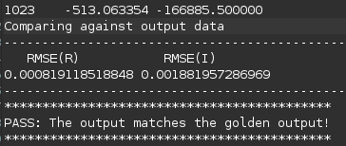

Hardware implementation – First :

Github Path : project4/FFT/HLS/2_Skeleton_Restructured

Report : project4/FFT/HLS/2_Skeleton_Restructured/fft_hardware_1/solution1/syn/report  
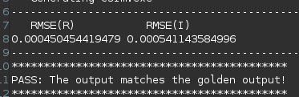

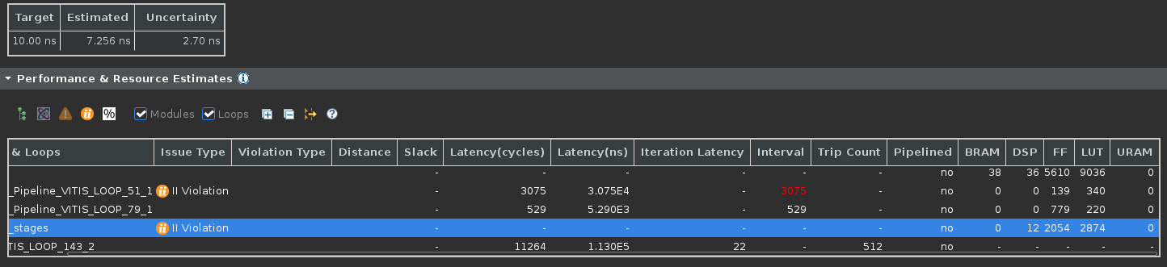

**Throughput : 45.9 Mega Samples/second**

**Architecture explanation :**

**Starting with Bit reversal , here both real and imaginary parts, so we go through all th indices and swap the elements. And this is required so that the data is in order for butterflies computations.   
for the first layer I use the unity twiddle factor (these come from give W* arrays). This stage performs pairwise computations also called butterlies for entire dataset. , we also calculate sum and differences of pairs.**

**For the middle stages , again butterflies are calculates. and this is for 2 to logN-1 (log base2).**

**The function calculates the number of points in each sub DFTs and iterates for maths.**

**For final stage processes entire dataset with twiddle factos and completed the transportion of time to**

**frequency domain.**

**Github : project4/FFT/HLS/2_Skeleton_Restructured_optimized**

**When I try to use Pragmas, loop unrolling and other techniques , testbench fails :  
