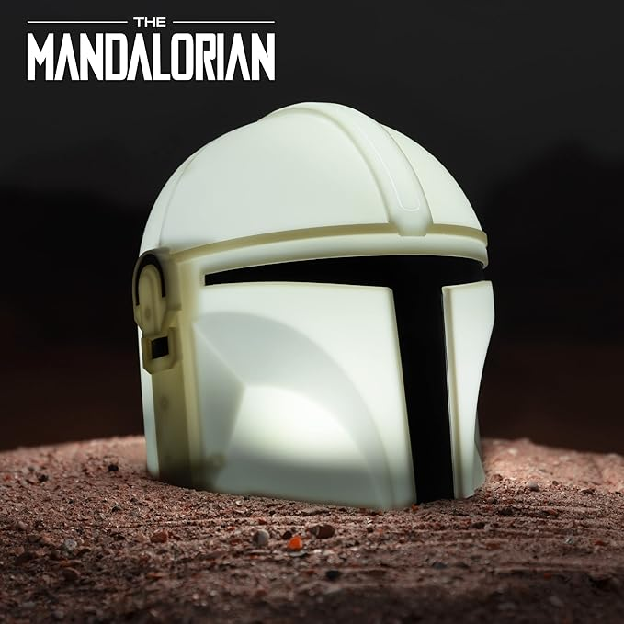

# **The Mandalorian Desktop Light**

With Official Sounds

# Connecting

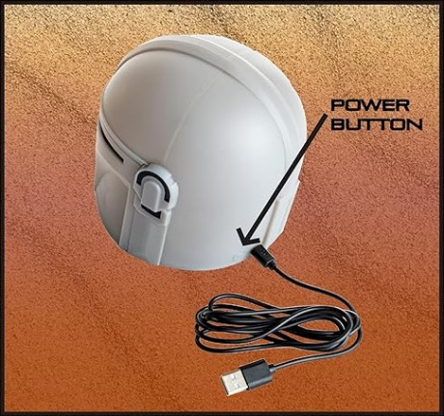

Micro USB port

5V DC 500mA

# Mando Helmet Interface

# Light Controls

# Sound Controls

