No-Kill is not what you think

Employees at animal welfare organizations are often faced with the question: Are you a no-kill shelter? If they answer the question with no, does that mean the organization is pro-kill? Definitely not. But that is how they are perceived by the public.

This question is not as easy to answer as you think.

A shelter is considered to be no-kill when **90%** of the animals taken in are placed in a home through adoption, transport, or reuniting lost animals with their owners. Best Friends Animal Sanctuary, a well-known self labeled no-kill organization states on their site:

*"A* [*90% save rate*](https://bestfriends.org/no-kill-faqs#benchmark) *for the animals entering a shelter is the common-sense benchmark for measuring lifesaving progress. Typically, the number of pets who are suffering from irreparable medical or behavioral issues that compromise their quality of life and prevent them from being rehomed is not more than 10% of all pets entering shelters." [1]*

When a member of the community inquires about a shelter's no-kill status, they typically ask a yes or no question: "Are you a no-kill shelter?" The person asking the question is usually not aware of the 90% benchmark mentioned above. Using data from a Louisiana shelter from 2015 through 2019, we will form a better answer to this question then yes or no.

The reality of a *non* no-kill shelter

In 2019, our shelter placed 84% of the animals that arrived through their life saving programs including adoption, transport to partner shelters and reuniting pets with their owners.While this is just shy of the 90% benchmark, it is still an impressive number of lives saved.

The benchmark for being considered a no-kill referenced above also mentioned that the 10% of animals euthanized should be those that "suffer from irreparable medical and behavioral issues that impact their quality of life". [1] Based on the figure below, a majority of the animals euthanized in 2019 were of the Unhealthy/Untreatable status with reasons such as severe medical conditions and aggressive behavior.

This shelter currently has seven different channels by which they place animals. The most popular channels are adoptions on the shelter's main campus, reuniting animals with their owners, the transport program, and their offsite adoption program. The variety in the top four indicates this shelter is not only getting people into their doors of the shelter but are also making an effort get animals out of the shelter and into their community. They are also willing to invest into expensive programs like transporting animals across the country to save lives.

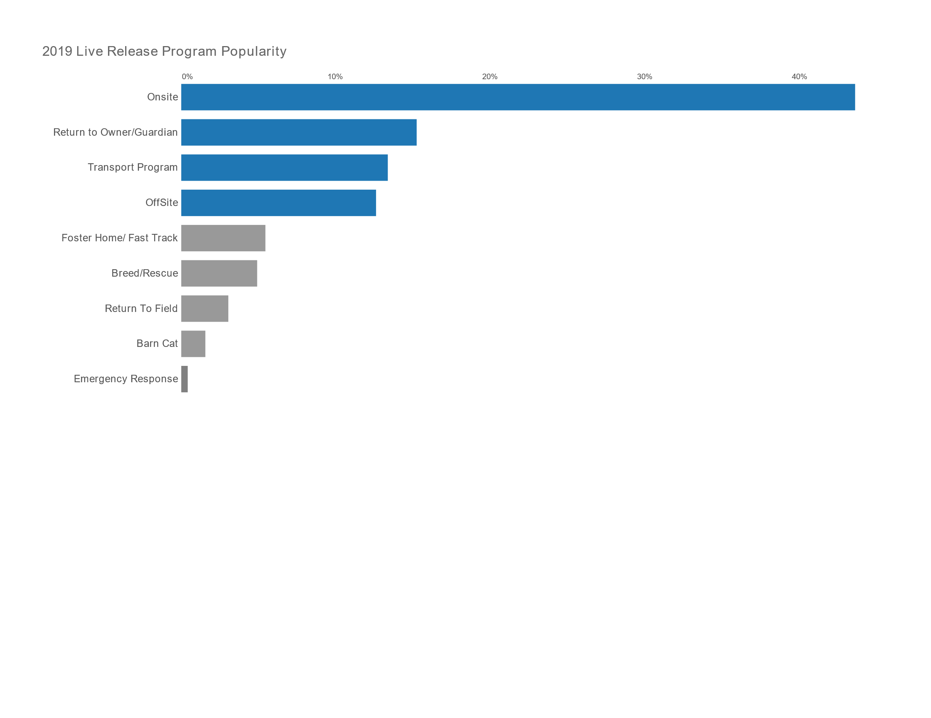

Trends and Potential Growth

The statistics from 2019 are not just the result of a lucky year. This shelter has been working towards this mission for quite some time.

In 2019, the number of animals taken into the shelter was 30% less than the number that arrived in 2015. This is an indication that their overpopulation reduction measures like low-cost spay/neuter and humane education programs are making an impact on the number of animals in the community that need help.

Looking at the live release and euthanasia rates over the last five years, we can see that live release has steadily increased while animals euthanized has decreased by an even sharper rate.

Despite the reduction in animals coming into the shelter seen above, the rate of animals released through live release channels has still increased.

If this Louisiana shelter continues on this trajectory, they will reach the no-kill benchmark in Quarter 1 of 2021.

The Answer to "Are you a no-kill shelter?"

So once an organization reaches the no-kill live release benchmark, do they stop trying to save lives? Of course not. Instead of answering the no-kill question with yes or no, I propose the following:

**"We currently save 84% of animals that come through our doors with our programs and services, just 6% shy of the no-kill benchmark of 90%. We have continued to increase our live-release rate each year while drastically reducing the number of animals euthanized. We expect to reach the no-kill goal in a few years, but we won't stop improving the lives of animals until we reach a goal of 0 unwanted and homeless animals in the community."**

References

[1] *What does no-kill mean?* (n.d.). Best Friends Animal Society. Retrieved October 24, 2020, from <https://bestfriends.org/no-kill-2025/what-does-no-kill-mean>

Go to link