# TP3 – About my data

GDPR :

-What is it?

The General Data Protection Regulation (GDPR) is a regulation in EU law on data protection and privacy for all individuals within the European Union (EU) and the European Economic Area (EEA). It also addresses the export of personal data outside the EU and EEA. The GDPR strengthens EU data protection laws by giving individuals more control over their personal data and how it is used. It aims to simplify the regulatory environment for international business by unifying the regulations within the EU. The GDPR came into effect on May 25, 2018, and replaces the 1995 EU Data Protection Directive.

- When has it been created and what was in place before?

The GDPR replaces the 1995 EU Data Protection Directive, which was in place before the GDPR. The GDPR is a significant update to EU data protection laws, as it replaces a directive, which required member states to implement its provisions through national legislation, with a regulation, which is directly applicable in all member states. This means that the GDPR has the same legal effect in all EU member states, without the need for national implementing legislation. The GDPR strengthens and updates EU data protection laws in several ways, including giving individuals more control over their personal data, establishing new rights for individuals, and imposing stronger fines for non-compliance.

- What has it changed and why?

The GDPR was adopted to strengthen and harmonize data protection for individuals within the EU and the EEA, in light of the increased use of personal data and the evolution of technology. The GDPR was designed to give individuals more control over their personal data and to provide a single set of data protection rules that would apply throughout the EU and EEA.

Github link : <https://github.com/rvie17/Datas-sources-rvie.git>

Website link : <https://0lhdlk.deta.dev/>

Timer log

5)

Using the sorting on deta we have thoses executions time.



Using the average and std on 100 iterations we have this for respectively the counter and then the dictionary.

It could be explained because using the dictionary we are using a non optimized way of parsing comparing to the Counter who is fully optimized.

Here we can look at the plot of the distribution of the 100 iterations of the classification method.

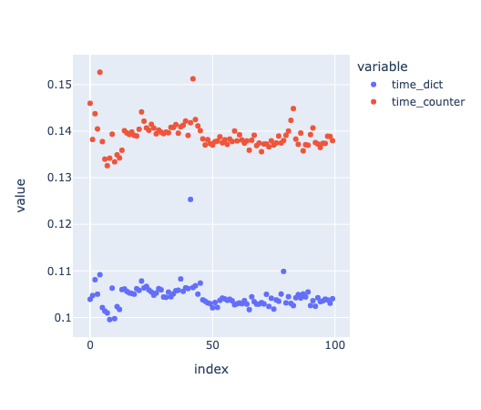

Personal data

Done.