Name:Vignesh.R

Reg.No:73152115085

Title : SQL TASK

TASK-1

Table - I ( CLIENT_MASTER ) 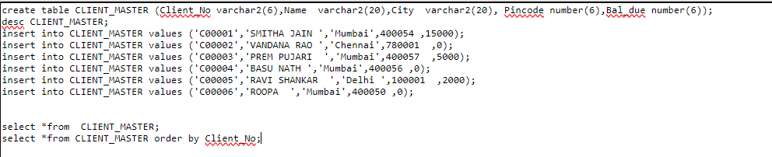

OUTPUT:

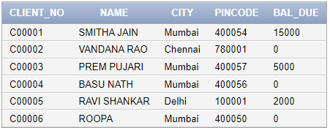

TASK-2

Table - II ( SALE_ORDER )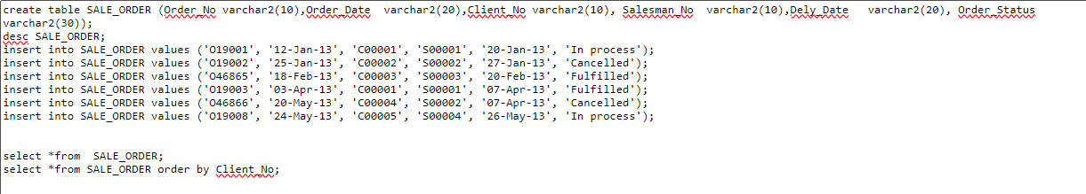

OUTPUT:

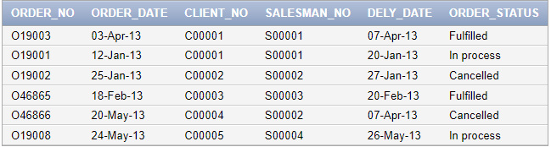

TASK:3

1.List all details from the client_master table for clients whose Bal_due = 0.

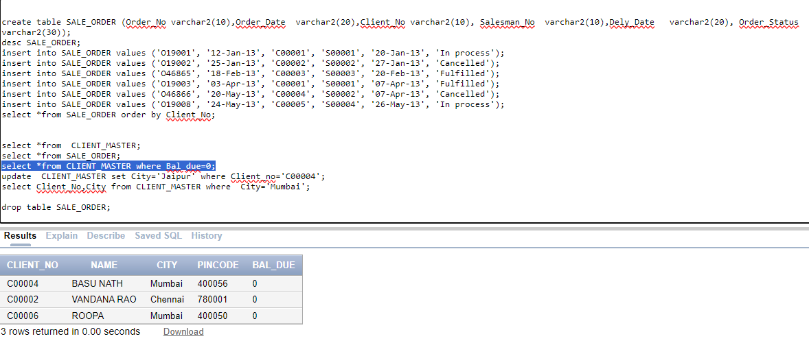

2. Update table client_master, Change city of Client_no C00004 to Jaipur.

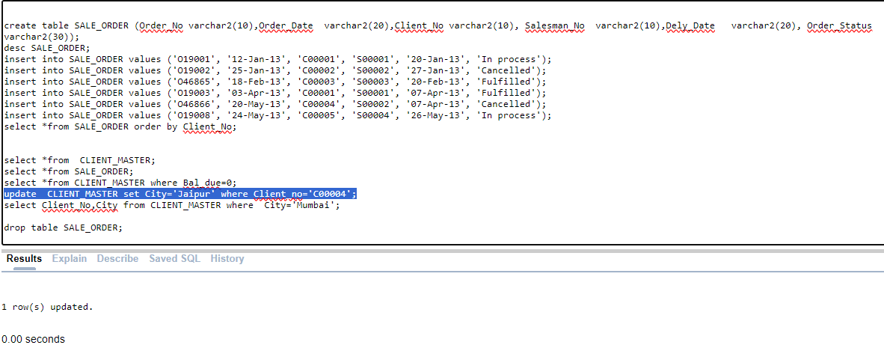

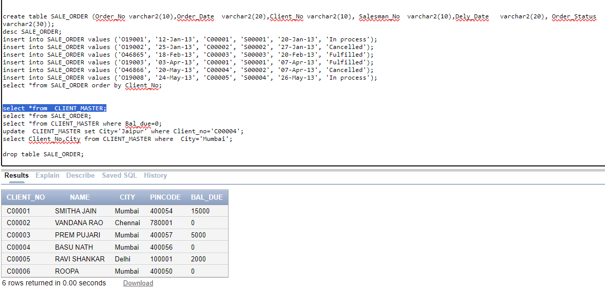

3. Retrieve records of clients residing in Mumbai.

