Name : VIGNESH.R

Reg no : 73152115085

Title : SQL

**Class-Day1**

1. **Create a table**

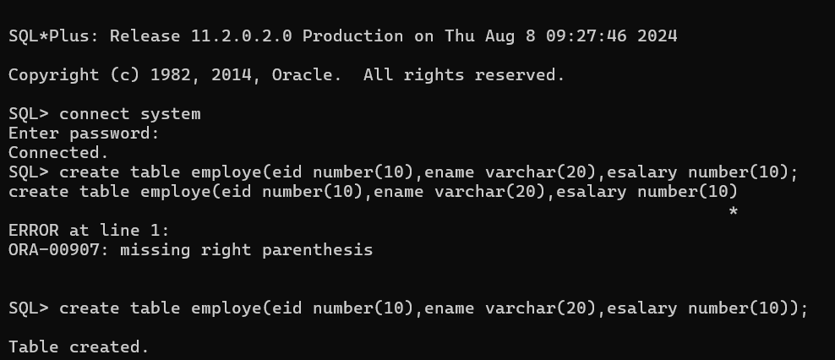

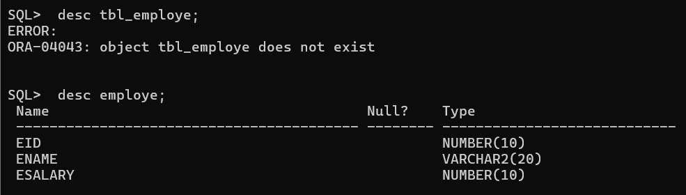

**2. Insert a data.**

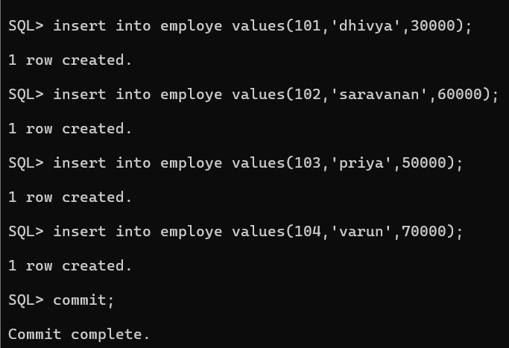

**3. Display a table**

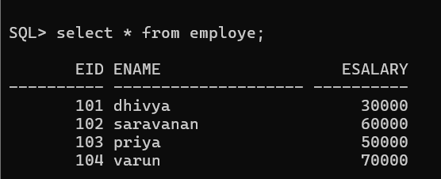

**4. Select id ,Salary.**

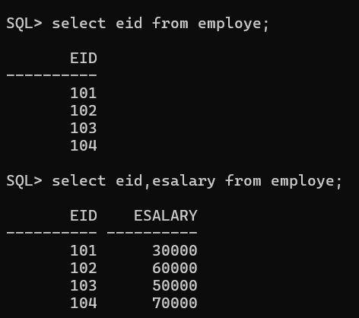

**5. Insert a row and display.**

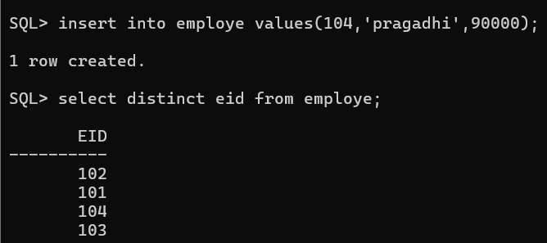

**6. Only select the id number is 104,name is saravanan and not equal 104. show the output.**

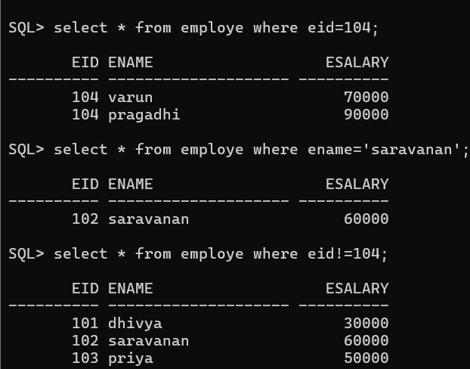

**7. Delete the id number is 104.**

