NAME:VIGNESH.R

REG.NO:73152115085

TITLE:SQL TASK

**TASK-1:**

1. **Retrieve all columns from the Sales table.**

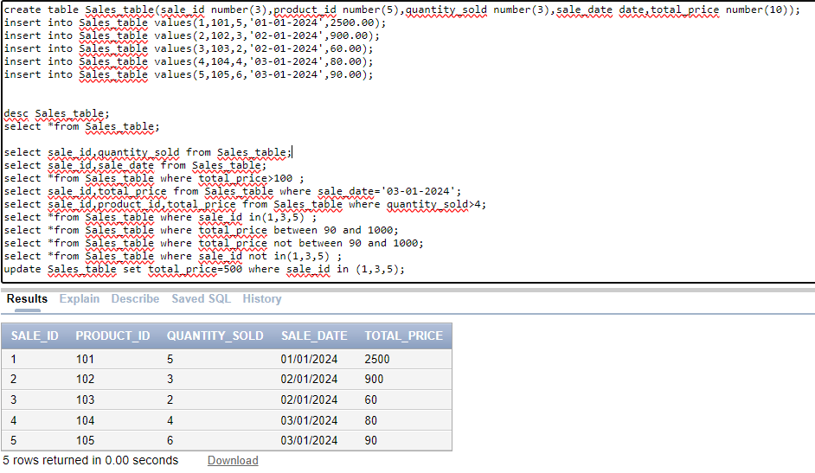

1. **Retrieve sale_id and quantity_sold from sales table.**

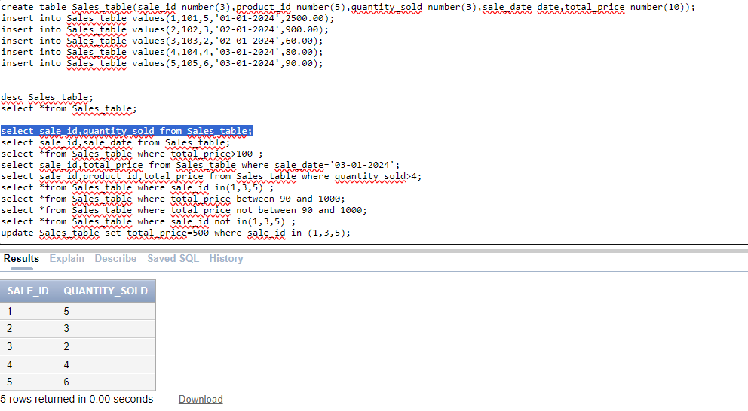

1. **Retrieve the sale_id and sale_date from the Sales table.**

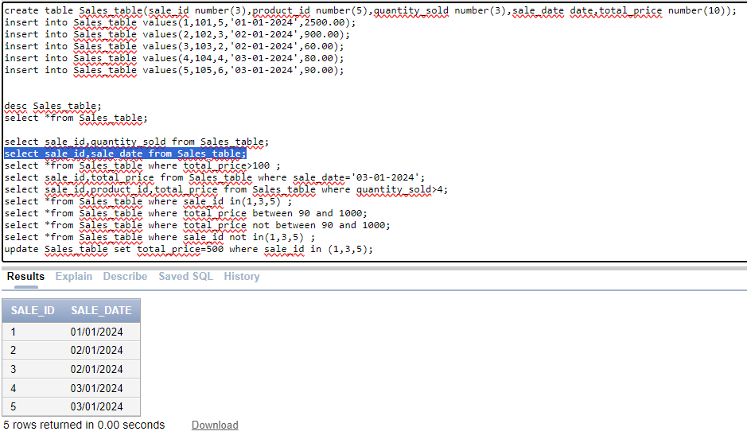

1. **Filter the Sales table to show only sales with a total_price greater than $100.**

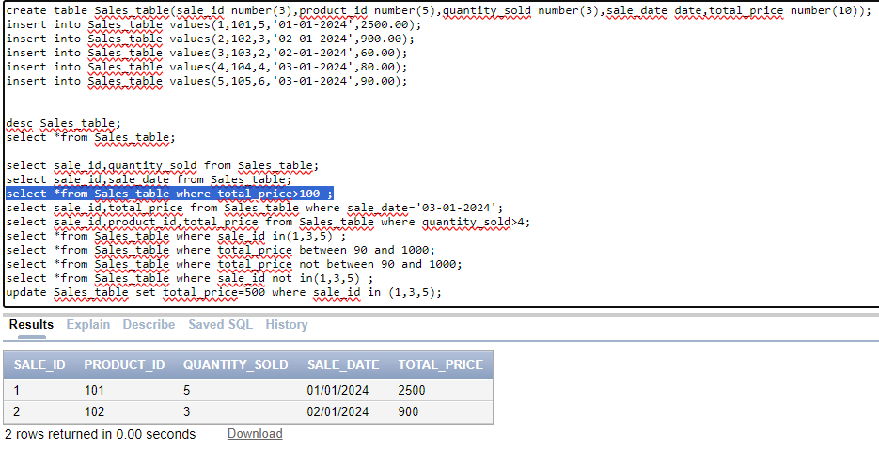

1. **Retrieve the sale_id and total_price from the Sales table for sales made on January 3, 2024.**

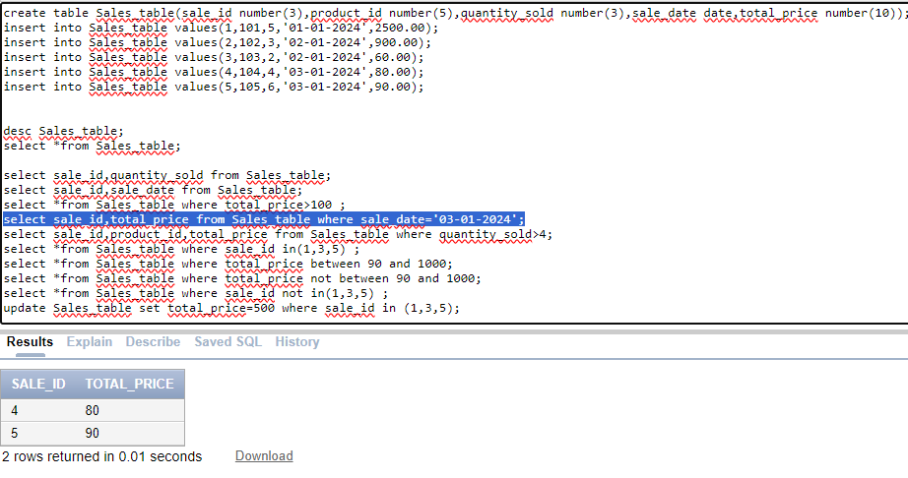

1. **Retrieve the sale_id, product_id, and total_price from the Sales table for sales with a quantity_sold greater than 4.**

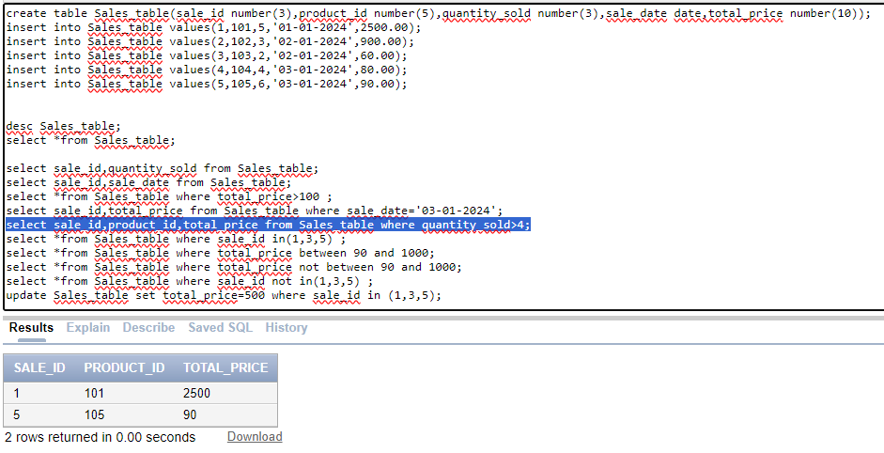

1. **Retrieve all columns from the Sales table those sale_id are 1, 3 & 5.**

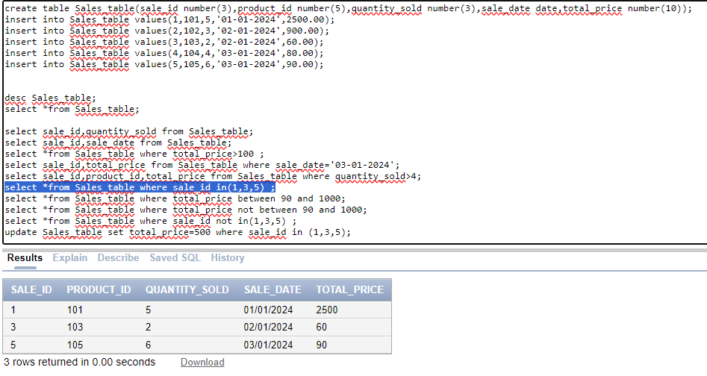

1. **Retrieve all columns from the Sales table those total_price between 90 and 1000.**

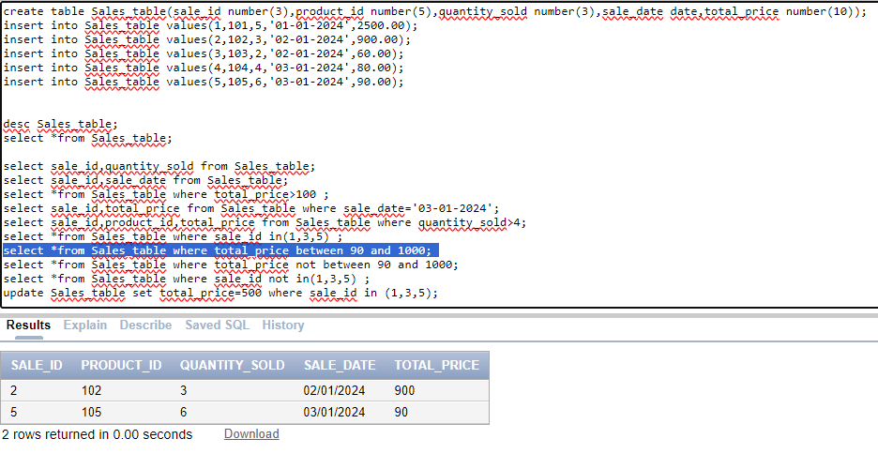

1. **Retrieve all columns from the Sales table those total_price not between 90 and 1000.**

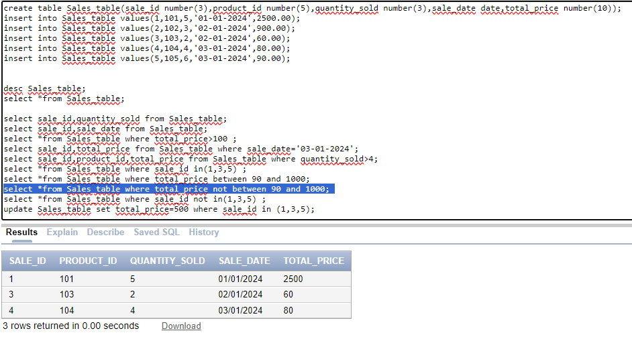

1. **Retrieve all columns from the Sales table those sale_id are not in 1, 3 & 5.**

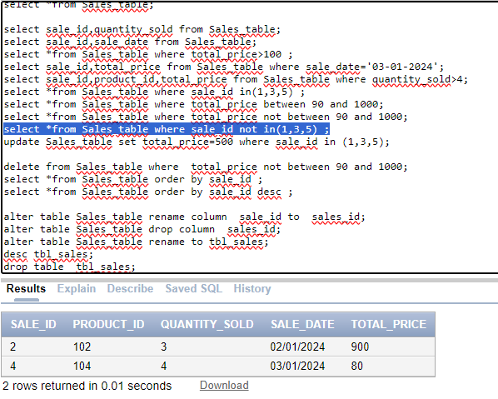

1. **Update total_price as 500 in the Sales table those sale_id are 1, 3 & 5.**

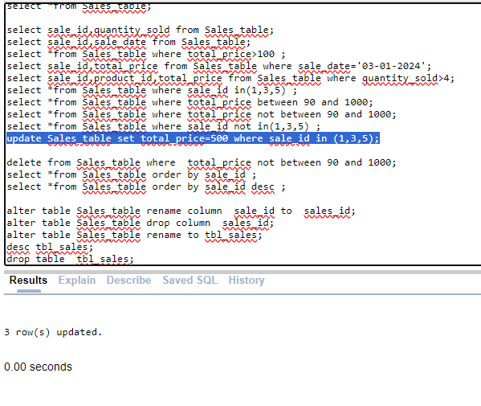

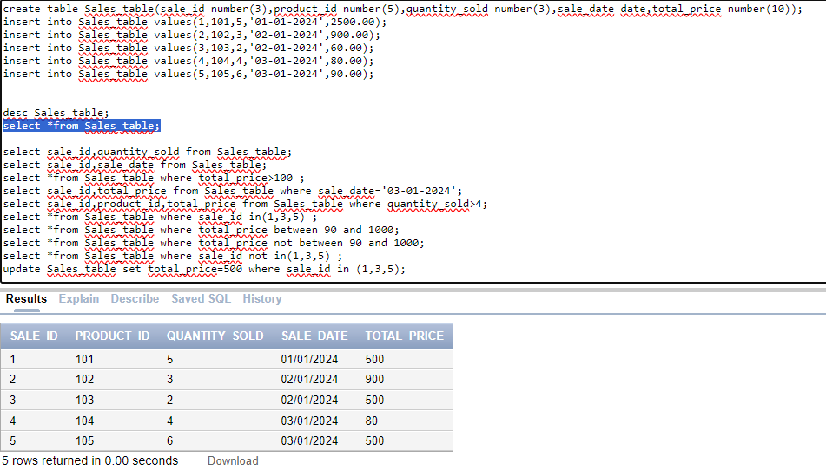

1. **delete from the Sales table those total_price not between 90 and 1000.**

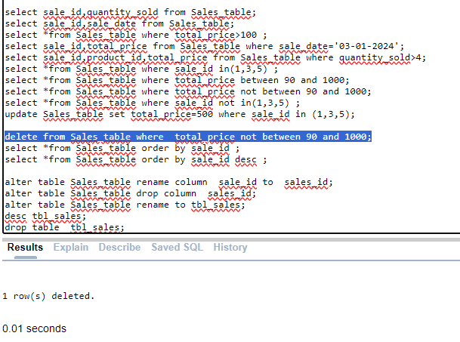

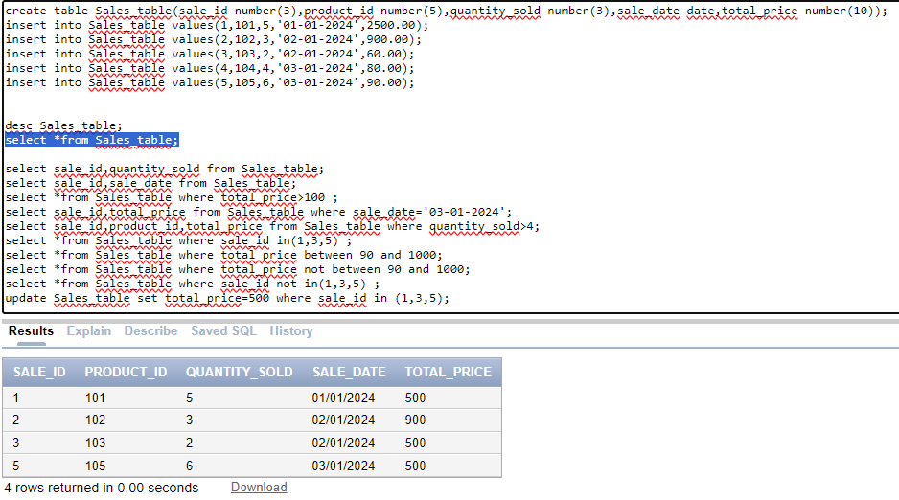

1. **Sort all the records using sale_id column in ascending order.**

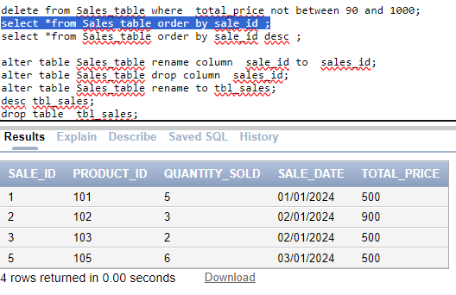

1. **Sort all the records using sale_id column in descending order.**

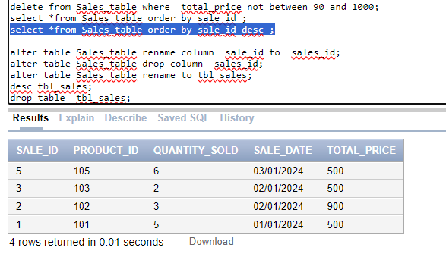

1. **Rename the sale_id column as sales_id;**

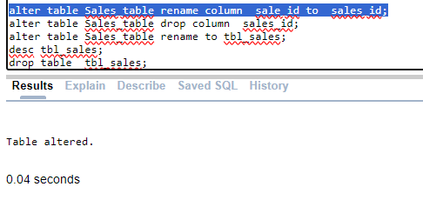

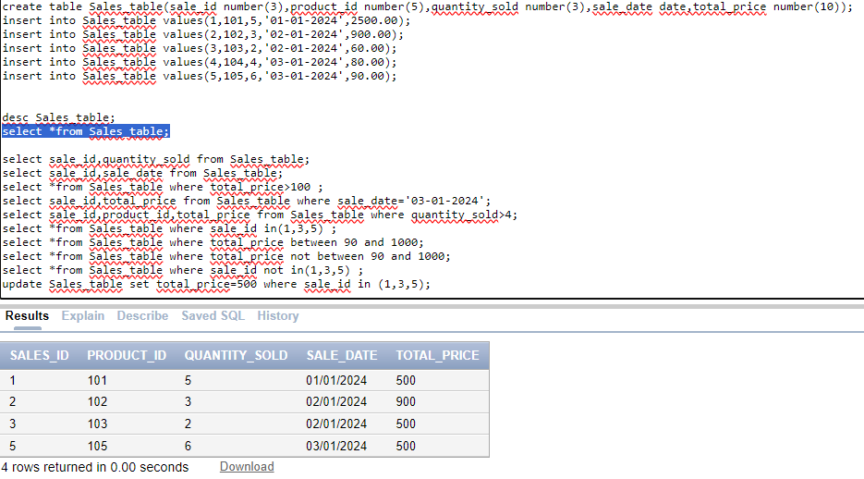

1. **Drop the column sales_id.**

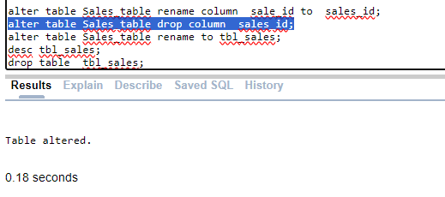

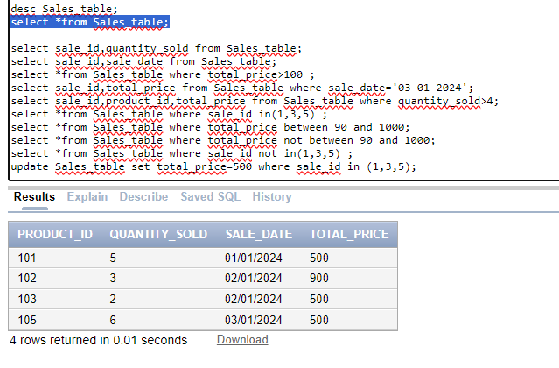

1. **Rename the table as tbl_sales.**

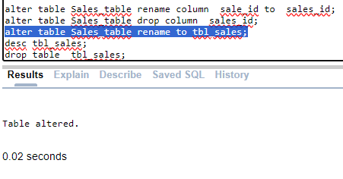

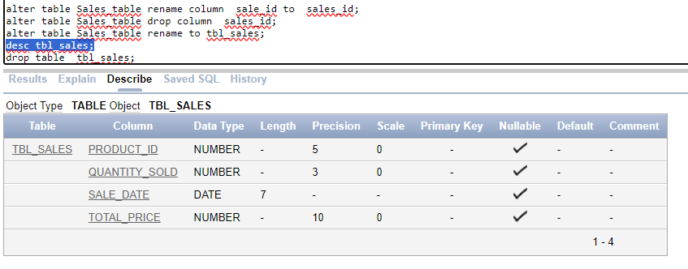

1. **Drop the table**

