Calculator Application using Android Studio
Team Name: Alpha Team - 9
Project Report
Generated on: 13-05-2026

1. Introduction
The Calculator Application is a simple Android application developed using Android Studio. The main purpose of this project is to perform basic arithmetic operations such as addition, subtraction, multiplication, and division. The application provides a user-friendly interface with responsive buttons and real-time calculations.

2. Objectives
- To develop a functional Android calculator application.
- To understand Android Studio project structure.
- To implement arithmetic operations using Kotlin.
- To design an attractive and easy-to-use user interface.

3. Software Requirements
- Android Studio
- Kotlin Programming Language
- Android SDK
- Emulator or Android Mobile Device

4. Features of the Application
- Addition, subtraction, multiplication, and division operations.
- Clear and delete functions.
- Simple and responsive user interface.
- Real-time display of inputs and results.
- Lightweight and easy-to-use application.

5. Project Structure
The project contains the following main components:
- MainActivity.kt : Handles calculator logic and operations.
- activity_main.xml : Designs the user interface.
- Drawable Resources : Custom button styles and icons.
- Values Folder : Stores themes, colors, and strings.

6. Working Principle
The user enters numbers using the calculator buttons. When an operator button is pressed, the application stores the first number and operator. After entering the second number and pressing the equal button, the application performs the selected arithmetic operation and displays the result on the screen.

7. Advantages
- Easy to use.
- Fast calculations.
- Attractive UI design.
- Helps beginners understand Android app development.

8. Conclusion
The Calculator Application was successfully developed using Android Studio and Kotlin. The project helped in understanding Android UI design, event handling, and arithmetic operation implementation. This application can be further improved by adding scientific calculator functions and dark/light themes.

9. Application Screenshot
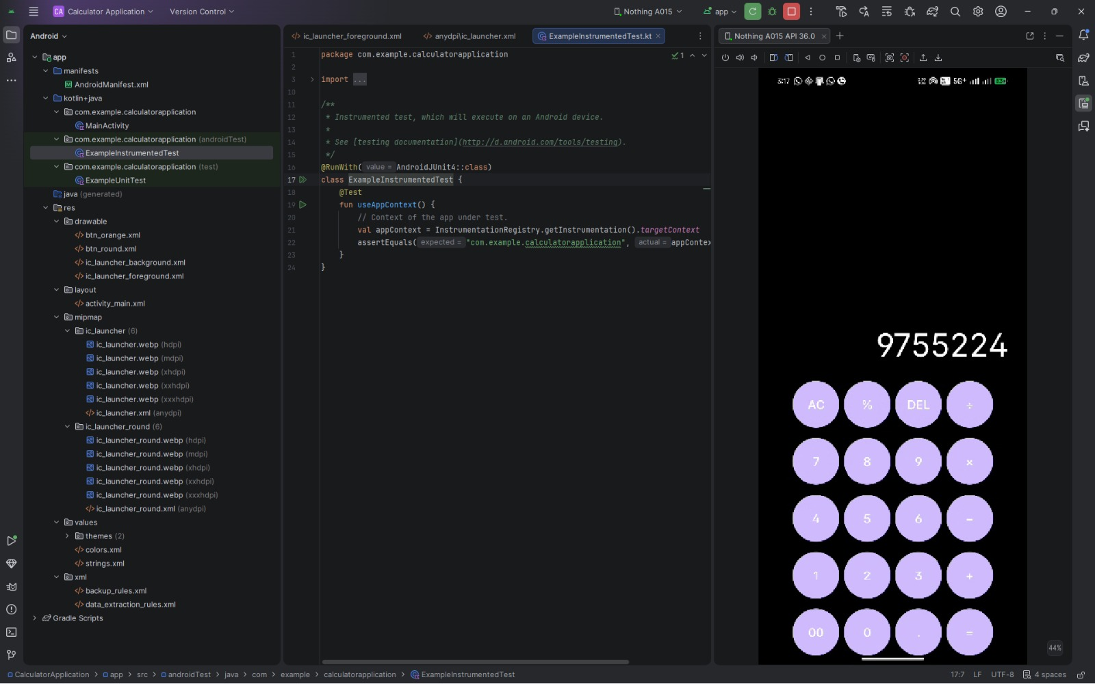
Figure: Calculator Application running in Android Studio Emulator.

