THERMOCHROMIC SENSOR
&
LINEAR ACTUATOR
Vijayaragavan R - 23BTT044
1. Introduction
Sensors and actuators are the two fundamental building blocks of any embedded or automated system. A sensor perceives changes in the physical environment and converts them into measurable signals, while an actuator converts electrical or mechanical energy into physical action or movement.
This document covers two specialized components: the Thermochromic Sensor, a smart material-based sensor that responds to temperature with a visible color change, and the Linear Actuator, a mechanical device that converts energy into precise straight-line motion.

2. Thermochromic Sensor
2.1 What is a Thermochromic Sensor?
A thermochromic sensor is a device or material that undergoes a reversible color change in response to temperature variations. The term 'thermochromic' is derived from the Greek words thermos (heat) and chroma (color). These sensors exploit the optical properties of thermochromic dyes, liquid crystals, or smart polymers to visually indicate temperature without requiring any electronic readout.
In electronic implementations, thermochromic materials are combined with photodetectors or cameras to convert the color change into a measurable electrical signal, enabling integration with microcontrollers and data acquisition systems.


Figure 1: Thermochromic effect – hand heat signature visible as color change on thermochromic surface
2.2 Types of Thermochromic Materials
- Liquid Crystal Thermochromics – Change color across a narrow, precise temperature range. Used in medical thermometers and mood rings.
- Leuco Dye Thermochromics – Transition between colored and colorless states at a set temperature. Used in packaging and labels.
- Thermochromic Inks – Printed coatings that change color; used in smart packaging and anti-counterfeit labels.
- IR Thermal Sensors (AMG8833 / MLX90640) – Electronic array sensors that capture thermal images by detecting infrared radiation emitted by objects.

2.3 Electronic Thermochromic Sensor – AMG8833
The AMG8833 (Panasonic Grid-EYE) is a popular electronic thermochromic-principle sensor that uses an 8x8 array of infrared sensors to create a thermal image. It communicates over I2C and is widely used with Arduino and Raspberry Pi for thermal imaging applications.

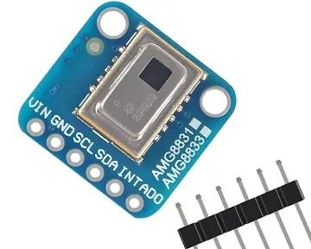
Figure 2: AMG8833 Thermal Camera Sensor Module – 8x8 IR array with I2C interface
2.4 Thermistor-Based Temperature Sensor Module
A thermistor is a temperature-sensitive resistor whose resistance changes significantly with temperature. NTC (Negative Temperature Coefficient) thermistors decrease in resistance as temperature rises. When paired with a comparator IC (LM393), they form a digital temperature detection module widely used with Arduino.

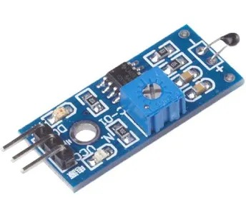
Figure 3: NTC Thermistor Sensor Module – with LM393 comparator and sensitivity potentiometer
2.5 Pin Configuration
Pin Description:
- VCC – Power supply (3.3V – 5V DC). Powers the comparator IC and thermistor circuit.
- GND – Ground reference pin. Common ground with the microcontroller.
- DO (Digital Out) – Goes LOW when temperature exceeds the set threshold (active-LOW).
- AO (Analog Out) – Outputs a variable voltage proportional to the actual temperature.

2.6 Working Principle
Thermochromic materials absorb or reflect different wavelengths of visible light depending on their temperature. In leuco dye systems, a three-component mixture (leuco dye, developer, solvent) transitions between a colored state (low temperature) and a colorless state (high temperature) based on the melting point of the solvent.
In electronic sensors, the thermistor's resistance change is fed into a voltage divider and comparator circuit. When the voltage crosses a set threshold (adjusted by the potentiometer), the digital output switches state, signaling the microcontroller.
2.7 Key Specifications (NTC Thermistor Module)
- Operating Voltage: 3.3V – 5V DC
- Output: Digital (DO) and Analog (AO)
- Temperature Range: -55°C to +125°C
- Sensitivity: Adjustable via onboard potentiometer
- Response Time: < 5 seconds
- Interface: Compatible with Arduino, ESP32, Raspberry Pi
2.8 Applications
- Food and beverage temperature monitoring (smart packaging)
- Medical skin temperature patches and thermometers
- Battery charge level and overheat indicators
- Thermal imaging and human presence detection (AMG8833)
- Anti-counterfeit labels and security printing
- Smart textiles and wearable temperature indicators

3. Linear Actuator
3.1 What is a Linear Actuator?
A linear actuator is a mechanical device that converts energy (electrical, hydraulic, or pneumatic) into straight-line (linear) motion, producing a push or pull force along a single axis. Unlike a rotary motor that produces circular motion, a linear actuator delivers controlled, precise movement in a straight line. It is a fundamental component in automation, robotics, and industrial machinery.

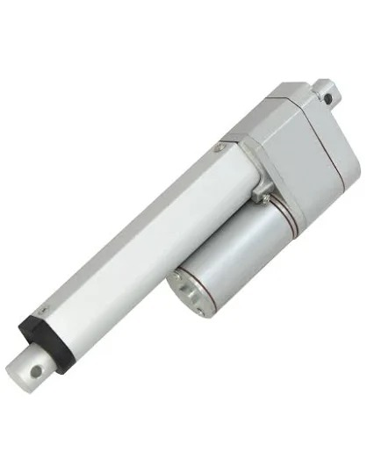
Figure 4: Electric Linear Actuator – Stroke rod extended, motor housing and mounting brackets visible
3.2 Types of Linear Actuators
- Electric Linear Actuator – Uses a DC/AC motor with a lead screw; most common, precise, and easy to control.
- Hydraulic Linear Actuator – Uses pressurized fluid (oil); delivers very high force; used in heavy machinery.
- Pneumatic Linear Actuator – Uses compressed air; fast response; used in industrial automation.
- Piezoelectric Actuator – Uses piezo crystals; nano-scale precision; used in optics and medical devices.
- Solenoid Actuator – Uses electromagnetic coil; short stroke; used in valves and locks.

3.3 Internal Parts & Structure
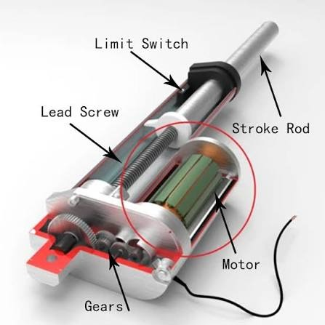
Figure 5: Linear Actuator Cutaway Diagram – Internal components labeled
Part Description:
- Motor – A DC motor that provides the rotational input power to drive the lead screw mechanism.
- Gears – A gear reduction assembly that reduces motor RPM and increases output torque for stronger push/pull force.
- Lead Screw – A threaded rod that converts the rotary motion of the motor into linear motion of the stroke rod.
- Stroke Rod – The extending/retracting rod that delivers the linear push or pull force to the load.
- Limit Switch – Micro-switches at each end of travel that automatically stop the motor at the fully extended or retracted position to prevent damage.

3.4 Working Principle
In an electric linear actuator, a DC motor spins a worm gear assembly, which in turn rotates a lead screw. A drive nut, threaded onto the lead screw, cannot rotate (it is constrained by the housing), so as the screw turns, the nut travels along it — pushing the stroke rod outward (extend) or pulling it inward (retract).
The direction of the motor determines the direction of stroke. Limit switches at each end of travel cut power automatically when the rod reaches its maximum extension or retraction, protecting the mechanism from over-travel damage.
3.5 Control Methods
- Simple ON/OFF Control – Relay or switch to extend/retract fully.
- PWM Speed Control – Varies motor speed for controlled movement using a motor driver (L298N, IBT-2).
- Feedback Control – Uses internal potentiometer or encoder for precise position control via Arduino/PLC.

3.6 Key Specifications (Typical Electric Linear Actuator)
- Operating Voltage: 12V – 24V DC
- Stroke Length: 50 mm – 500 mm (varies by model)
- Load Capacity: 100N – 8000N (push/pull force)
- Speed: 5 mm/s – 50 mm/s (no load)
- Duty Cycle: 20% – 25% (intermittent operation)
- Protection: IP54 to IP66 (dust and water resistant)
3.7 Applications
- Robotic arm joints and end-effector positioning
- Adjustable hospital beds, chairs, and medical equipment
- Solar panel tilt and tracking systems
- Automated gate, hatch, and door opening systems
- CNC machine Z-axis and tool positioning
- Agricultural machinery and tractor implement control

4. Comparison Table
The following table highlights the key differences between the Thermochromic Sensor and the Linear Actuator.

Parameter | Thermochromic Sensor | Linear Actuator
Category | Sensor (Input) | Actuator (Output)
Stimulus | Temperature Change | Electrical / Hydraulic
Response | Color Change | Linear (Push/Pull) Motion
Power | Passive (no power) | Requires Power Supply
Output | Visual / Optical | Mechanical Force
Use Case | Temp. Indication | Positioning / Movement

5. Conclusion
The thermochromic sensor and linear actuator represent two distinct but equally important categories in the world of smart systems. The thermochromic sensor leverages the optical properties of smart materials or electronic infrared detectors to provide non-contact, passive or active temperature sensing — making it ideal for safety monitoring, smart packaging, and thermal imaging.
The linear actuator, on the other hand, delivers reliable straight-line mechanical action with precise control, forming the backbone of automation systems ranging from industrial machinery to medical devices and robotics. Together, such sensors and actuators enable complete closed-loop systems where environmental conditions are sensed and physical responses are executed with precision.

