legend
<image>
+additional things that should be in the image but which are not there

Modular structure
the modular structure of the project requires each module being placed in its own directory along with documents on its purpose and structure, and a test directory. Each module may be implemented in different languages, for the purpose of getting both: high-speed (of C++) and the ease of modernising (of python).
The building script (high-level module) can be set to include particular implementations of modules for composing the final program.
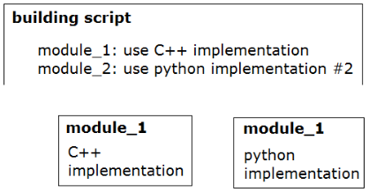
+grouping of modules
There should be different levels of modules (interface/back-end), and different grouping blocks (modules of modules etc).
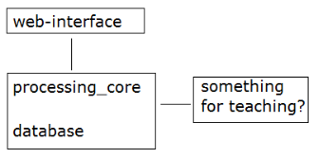
Input_receiver & History_line save raw input signals in a sequence.

Sequence_finder & Pattern_storage extract simple sequential figures (aka patterns) from raw data (History_line). saves the patterns in the Pattern_storage
input: a sequence of actions (a segment from the History_line)
output: repeated sequences of actions (a dictionary of patterns)

Figure_finder extracts figures out of raw data (History_line, Pattern_storage).
extracts figures not by using stencils, but by recurrence of their parts.
It spots recurring figures especially before a change of mood, which makes them more valuable.
input: a sequence of actions; a collection of patterns
output: a collection of figures (aka patterns without some connections)

Algorithm_finder finds algorithms that yield particular subfigures of a figure, given its other subfigures.
may use brute-force search.
input: a figure
output: sequences of operations over figure’s parts which return its other parts (algorithms of completion).

Figure_builder constructs a full figure given its part, either from memory or applying an algorithm.
input: sub-figure
output: full figure

Algorithm_executor executes commands of algorithms, which include moving, but also other control over execution.

Subfigure_mover moves sub-figures from stencils to other stencils.
Subfigure_extractor
input: figure, stencils
output: figure extracted from the input one
Figure_creator
input: figure-to, adding figure, stencils
output: figure constructed

