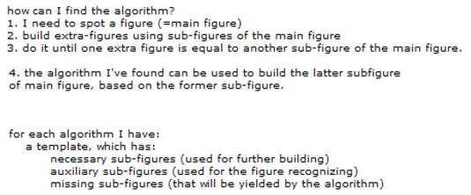
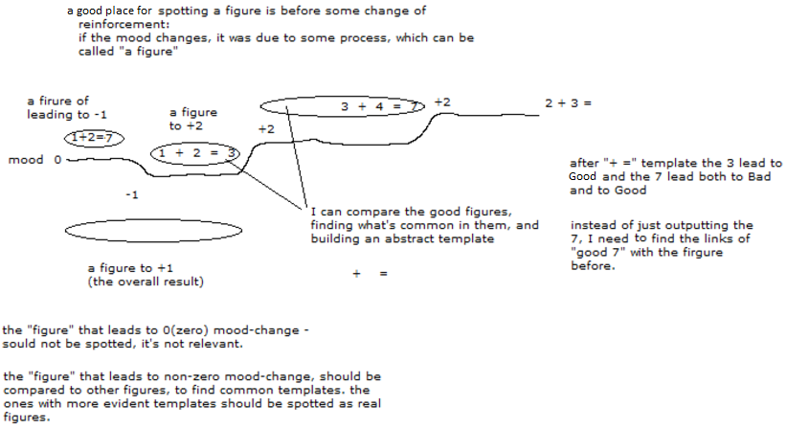
I can create a figure that ends at the end of each reinforcement and begins at any point before that.
the starting point can be another reinforcement or the start of a figure noticed earlier.

Step#1:
How can I spot my outputs?:
1. if I expect a figure
2. if that figure yields a good result
3. if that figure actually occurs
that means that the figure is probably under my control, on the motor output

is it needed to make the distinction between the inputs and my outputs before finding algorithms?
this distinction can speed up the finding of useful algorithms, because algorithms are used for answering to an input.
but it's still possible to connect any parts of a figure using algorithms to gather some clues about its structure.

resources applied to algorithm finding:
1) length: the amount of time taken into consideration
2) depth: the amount of layers of figures considered at one time
3) height: the amount of additional figures built during algorithm finding
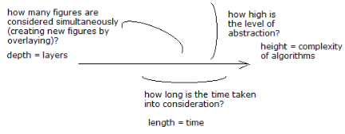
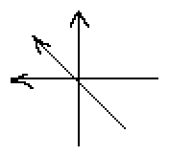
Finding a figure
1) what am I finding, which figure (out of infinite combinations of nodes)?
2) how am I finding it, what are the clues (instead of using brute force)?

