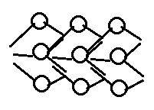
Signals_line

Signals_line get_subline(moment_t, moment_t)
moment_t begin_moment() const
moment_t end_moment() const

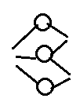
Simultaneous_signals

has:
activation_duration (start & end)
information(reference) about next and previous Simultaneous_signals
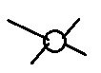
Signal

