Knowledge Based Life Cycle Management for Applications & Infrastructure
^{3/13/2019} Components in Scaled Hyperconverged

Software Defined Datacenters

Contents

Table of Content 1

Objective 1
What We are Solving 1
Problem Statement 1

Idea Overview 2
Invention Theory and Operation 3

Use Cases with Invention Theory 6

Table of Content

Objective

Proposing a Knowledge Based Life Cycle Management method for the Infrastructure Components and the Applications in the Scaled Hyperconverged Software Defined Datacenters.

What We are Solving

Problem Statement

Today Administrators who is handling modern software defined datacenters requires or should have a prior knowledge about the “Best Window time” or “best time” to perform Life Cycle Management. If Administrator performs LCM whenever upgrade or patch is available for any entity (Application or Infrastructure component) without knowing the best time to apply, then it might impact the current users of that particular entity and it is totally an inefficient mechanism in the present modern SDDC Era.

This is very important and critical information to know before Administrator going for any LCM operations in SDDC.

At present, the customers handling LCM in Software defined Datacenters which is deployed by using VMware Cloud Foundation (VCF) – During LCM operation – Any workload or Cluster level operations will be suspended or not allowed during the LCM process. Cluster level operations meaning Adding a Server to the Cluster, or Removing a server from Cluster, create a Cluster, expand a Cluster, Delete a Cluster).

So, it is obvious that during LCM window for any entity the Cluster level operations will not be allowed.

In this situation, if Administrator initiated LCM during peak hours usage of that entity, then it is very obvious customers may feel inconvenient and on top of its Administrator will not be able to do any dynamic workload or cluster level expansions based on dynamic customer demands at the peak usage of

that Entity by customers. So it is very important and obvious, to determine the “Best possible estimated time” prior to do any Entity LCM.

Now a days If any upgrade is available for any entity, it was just showing as “upgrade available”, but there is no mechanism exists today to propose a best time to trigger the available upgrade along with best proposal time to trigger the upgrade. It will be good and optimized mechanism if any entity shown with “available upgrade along with best time to apply the upgrade and Risk Analysis”. At present there is no sophisticated method or mechanism available to us in modern Software Defined Datacenters to handle this situation.

I am taking above issues or drawbacks as problem statement and coming up with a Method that will dynamically handle the situation in scaled environments and the proposing innovation that leveraging the capabilities of Machine Learning Techniques to predict the best window time or best possible time for any entity to go for LCM operation.

The innovation predominantly focusing on the following key points

- Based on Administrator/Customer request, Predict the best possible time to go for an LCM operation for any given Entity in SDDC.

- Dynamically identify the Entities that has “Available Upgrades” in SDDC and predict & propose a best possible time to trigger the Available Upgrades and also it will give the Risk Analysis with respect proposed time. Example – If Administrator triggers LCM with the ML proposed time, then how many users may feel performance impact or how many people may be users at the proposed time.

- Dynamic Time based LCM - Dynamically associate the Application that is triggered by Administrator to LCM when Administrator chosen the proposed or predicted time suggested by this invention.

- Adoptability of this innovation to VMware new architecture for VMware Cloud Foundation.

Idea Overview
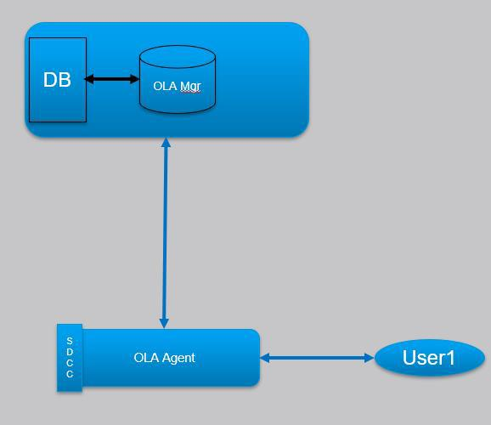

The above diagram represents a high-level summary of the invention. I request reviewers please have a look at the Invention Theory and Operations Section to get full essence of the Invention. Whenever User or Administrator requested for to find best optimal time for a particular Entity, the request will be proxied to the OLA Manager through OLA Agent. OLA Manager handover the request to the Analytics Engine which is part of the OLA Manager will run Machine Learning Technics on the Log Database to find the optimal time and return the results to Entity through OLA Manager and OLA Agent.

Invention Theory and Operation

Before Jump on to the Invention Theory and Operation, it is worth to focus on few terminologies that tied to this invention.

Entity – It can be an Application or an Infrastructure Component.

VMware Infrastructure Components - are PSC, vCenter,NSX,vRLI,vROPS,vRA.

Applications – A software application that runs on the Software Defined Datacenter Cluster - Example Email Server, Database or many more.

Optimal Window Time – Optimal Window time is the time interval or period in which Entity usage will be less in compared with the other intervals.

Optimal LCM Agent (OLA) – It is a software module sit in each Software Defined Datacenters Central Entity. As per VMware VCF is considered it will be placed in SDDC Manager. The main responsibility of this module is – to detect any upgrades available for any Entity in the Datacenter. The upgrade availability may be with manual or automatic.

For example – As soon as Administrator uploaded the image for Infrastructure Components like PSC, VC, NSX then these Entity statuses will show as “Upgrade Available”. For other entities like Outlook, Database will get automatic upgrade availability option as and when new image or patch available for those from internet. OLA can detect the “Upgrade Availability” status for each Entity and inform to the OLA Manager which is placed in the Pantheon (Will explain more about the Pantheon in the upcoming section) Monitoring and Logging Module. If administrator wants to scope out any particular Entity from this OLA vicinity, he can create Exclude Entity and provide the list to OLA Agent. Those Exclude List agent will not considered any more for Optimal LCM.

Apart from the above functionality, OLA Agent will generate unique Id for each entity in SDDC and will be maintained in separate table called “OLA Agent Table”.

OLA Agent Table
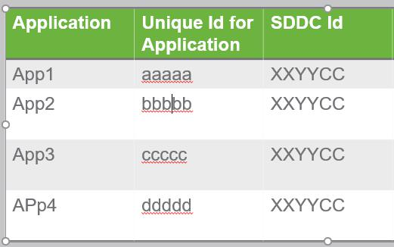

This module also responsible for to carry Administrator requests to find the optimal window time for entity to OLA Manager which is sitting at the Pantheon Monitor and Logging module. When the OLA Manager return the best possible time to an Entity, that will be mediated or facilitated or communicated by OLA Agent to the Entity.

OLA Manager – It is a software module, it will control and coordinates the functions of OLA Agents sitting in the various SDDC Managers at SDDCs.

It receives the requests from the OLA Agents and process the requests for to find the Best Optimal Time for LCM operation to an entity. OLA Manager Southbound connectivity is with Analytical Platform that will have connectivity intern to the Database in which all the logs for all the datacenters will be maintained. Machine Learning Techniques will be running in the OLA Manager Analytic engine. As soon as OLA Manager receives the request from OLA Agent, the request will he handover to Analytic Platform, there Machine Learning Algorithms will run on the Database based on the input query parameter given by OLA Manager. The result will be sent back to the OLA Manager and Manager intern proxy the request to respective OLA Agent. Detail work flow will be explained later.

Machine Learning Technic -

The Machine Learning Predictive Technic that we are using here is –

When ever upgrade is available for an Entity or Administrator manually trigger an event for an Entity to find an optimal time for LCM, then OLA Agent send the request with Application Name, Application Id and DataCenter Id to the OLA Manager. OLA Manager process the request and handover the request to Analytic Engine which runs Machine Learning Technics. Predictive Machine Learning Technics runs against the Log Database which contains the details of each application usage with respect to time and data. The predictive data samples will be taken for a year date or more. More Historical data will give more accurate predictive results.

One more important aspect is exporting the logs and maintaining that in log server DB. Log Server DB will maintain Each Entity logs for each SDDC.
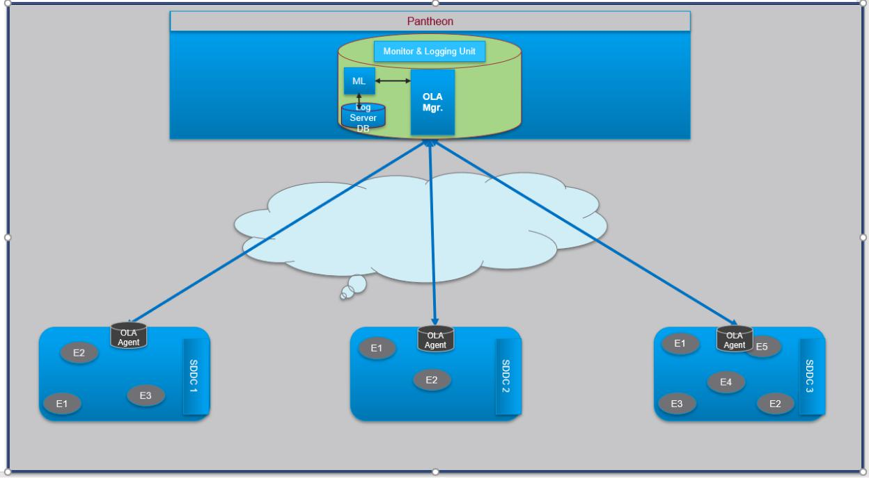

Detail WorkFlow:

- For each application in the SDDC , OLA Agent will generate unique Id and associate with the application. This data will be maintained in the table called “OLA Agent Table”.

- case 1 - Whenever any application gets “Upgrade Availability”, immediately OLA Agent form a request to the OLA Agent with Application Name, Application Id and SDDC Id.

- This request will be proxied to the OLA Manager.

- OLA Manager form a search sting with the details of Application Id and search Period [Max 1 year] and handover the request to Machine Learning Module [Analytic Module].

- With the inputs given by OLA Manager, ML Technic will run against the Logs Server data with search criteria. ML Technics will predict the best window time for the application to trigger LCM operation and also it will predict how may users may be users for that Application or Entity in that predicted Optimal Window time.

- The ML will return the Optimal proposed time along with the Estimated Risk in the proposed time to the OLA Manager.

- OLA Manager proxy the information to OLA agent and OLA agent will provide the details to the Administrator or user in the form of display text or this can be maintained in separate table called “Entity LCM Table” in the management node of SDDC.

- Entity LCM table is nothing but a simple table hold the information of Application Id, Name, Proposed LCM Time, Risk in the Proposed time, like wise it will maintain for all the applications.

- Case 2 – If there is no “Upgrade Available” for an entity but Administrator wish to findout the best time for an upgrade, then he can manually trigger an event that will set a Bit in the buffer, and Agent Proxy will read the bit and immediately follow the step 3 to 8.

Note : Implementor have an option to integrate the upgrade code based on the invention estimated time – meaning if user or administrator opted the invention or Agent Manager proposed time, then at the proposed time Upgrade will be automatically triggers without Administrator intervention. This can be achieved if Administrator intergrade LCM code to the “Entity LCM Table”. This Entity LCM Table has an option even to trigger the LCM based on Administrator choice.

Apart from this there is another important point associated with the invention that is ..At any point of time, Administrator Risk Associated information for his chosen time for LCM.

Example – If Administrator wants to trigger the Upgrade with his chosen time, then before triggering Upgrade for an application, he can generate a request to the OLA Agent and Manager to get the Risk Associated information with the Administrator chosen time.

Novelty Aspects:

- Based on Administrator/Customer request, Predict the best possible time to go for an LCM operation for any given Entity in SDDC.

- Dynamically identify the Entities that has “Available Upgrades” in SDDC and predict & propose a best possible time to trigger the Available Upgrades and also it will get the Risk Associated with respect proposed time. Example – If Administrator triggers LCM with the ML proposed time, then how many users may feel performance impact or how many people may be users at the proposed time.

- Dynamic Time-based LCM - Dynamically associate the Application that is triggered by Administrator to LCM when Administrator chosen the proposed or predicted time suggested by this invention.

- Administrator Dynamically can get Risk Associated with the any given time to LCM for an Entity.

Example – If Administrator wish to find the Risks Analysis for a specific time, then he can simply send a request to the OLA Manager. ML Algorithms will give the Risk Associated with that particular time that administrator chosen and send the details to Administrator.

Use Cases with Invention Theory

This Invention best suitable for VMware new upcoming architecture called Pantheon.

Pantheon:

Pantheon for VMware Cloud Foundation (VCF) provide multiple site / datacenter management (fleet) capabilities, with cloud connectivity in a SaaS model. The core functionality however is still delivered 'on-prem' but with cloud connectivity, to clearly better support us on-prem customers, with a nod towards future hybrid cloud workflows.

Specifically providing the following across multiple VMware Cloud Foundation deployments

Visibility into deployments

Monitoring / Alerts

Cloud based license/metering
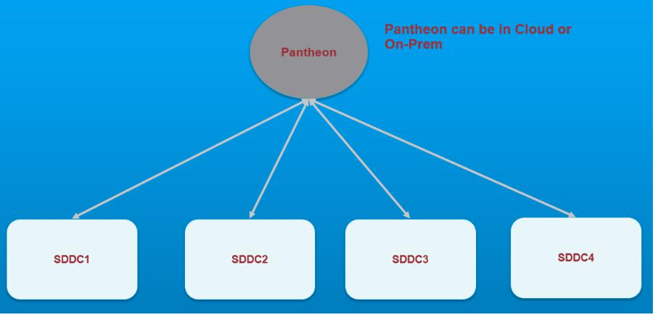

In the nutshell, a Centralized Control Management Architecture or Centralized Control station that has visibility to various VCF deployed SDDC (Software Defined Datacenters) on On-Prem and also provide capabilities for Monitoring, Alerts, Licensing and Metering. This Centralized Control Management Archtecture called Pantheon has capabilities to Monitor, Altering, Licensing and Metering for various Software Defined Datacenters.

This Pantheon Architecture can be in On-prem or from Cloud. For more information please refer the following architecture.

https://confluence.eng.vmware.com/display/ISBU/Project+Pantheon+Architecture

