Ultra-Low-Power High PSRR Sub-1 V Voltage using the 180 nm in LTSPICE

TASK REPORT
Submitted by
VISHAL R (2023105031)
ALAN REJI (2023105518)

in partial fulfilment for the award of the degree of
BACHELOR OF ENGINEERING
in
ELECTRONICS AND COMMUNICATION ENGINEERING



COLLEGE OF ENGINEERING GUINDY
ANNA UNIVERSITY
CHENNAI 600025
DECEMBER 2025 – MAY 2026

Introduction:
A traditional method of temperature-independent voltage reference is summing proportional-to-absolute-temperature (PTAT) voltage and complementary-to-absolute-temperature (CTAT) voltage circuits. Recently, CMOS sub-threshold-based voltage references have become popular due to their low supply voltage operation and, thus, very low power consumption. To reduce supply voltage, a switched capacitor network was used in a bandgap circuit. However, this induces switching noise into the system and requires a huge load capacitor to filter this noise, resulting in increased area consumption. Hybrid voltage references, a combination of both previous voltage reference types, including a resistor-less only MOS current reference circuit, BJT CTAT voltage, and CMOS PTAT voltage generators. To improve the accuracy of a temperature coefficient and line sensitivity, trimming circuits were added. However, it increases the complexity of the circuit and consumes chip area. In brief, the report is an analysis and study of an IEEE Research Paper (Ultra-Low-Power High PSRR Sub-1 V Voltage Reference Circuit in 22 nm FDSOI CMOS), which proposed a voltage reference circuit implemented in 22 nm FDSOI CMOS technology and comprises a nano-ampere current reference circuit, CTAT, and PTAT voltage generators, combination of which provides a temperature-independent output voltage.
Here, for our convenience, 180nm CMOS Technology is used instead of 22nm FDSOI CMOS Technology to replicate the work done in the research paper.

Simulation Software used:
LT Spice

Circuit Schematic (from IEEE Paper):
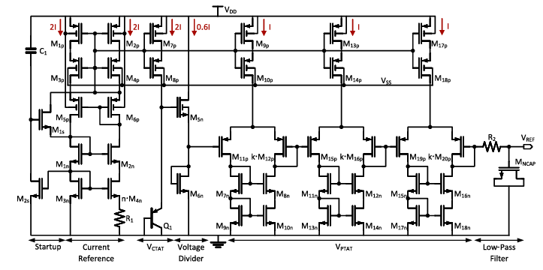

The various sections in the schematic:
- Startup circuit
- Current Reference circuit
- CTAT circuit
- Voltage divider circuit
- PTAT circuit
- Low-Pass Filter circuit

Circuit Schematic (LT Spice):

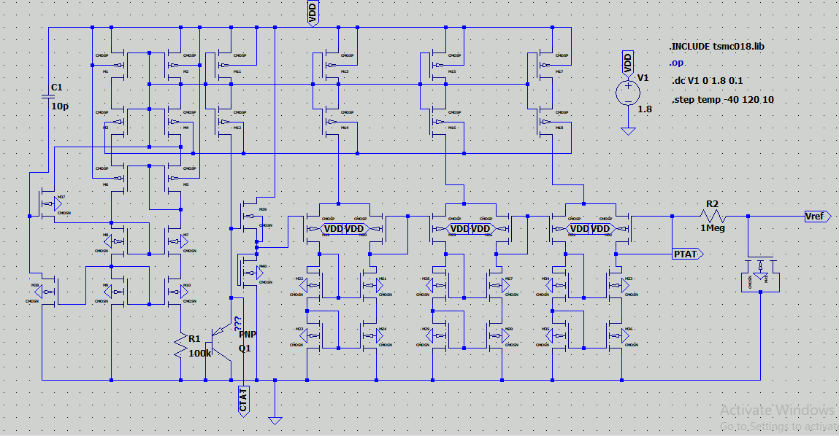

Outputs:

1) Supply Voltage(V1) Vs Output Voltage(Vref)
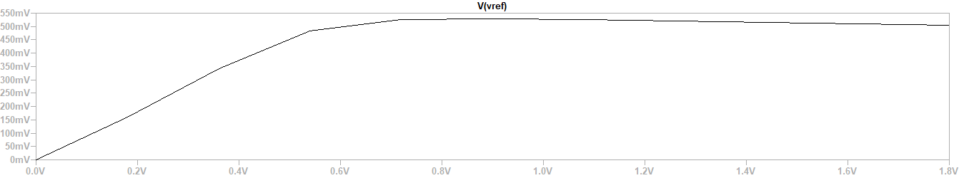
The reference voltage initially increases with supply voltage and then becomes nearly constant around 500 mV after approximately 0.7–0.8 V supply.
Once the supply voltage reaches the required operating region:
- The current reference circuit generates a stable nano-ampere bias current.
- The PTAT and CTAT voltages begin compensating each other.
- The self-cascode current mirror improves output resistance and isolates the circuit from supply variations.

VREF​≈constant

Our implementation produces approximately 504 mV, which is reasonable because:
- We used 180 nm CMOS instead of 22 nm FDSOI
- Threshold voltages differ
- Device matching differs
- Body-bias capability of FDSOI is unavailable in 180 nm CMOS

2) PTAT & CTAT
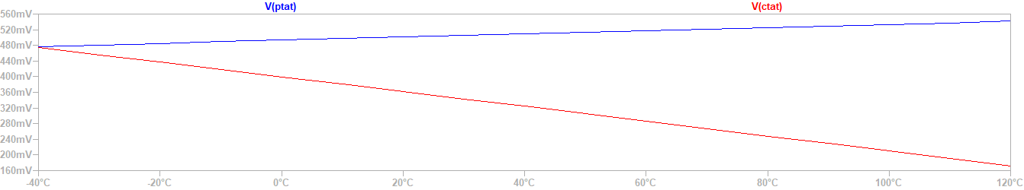

The second graph shows:
- PTAT voltage increasing with temperature
- CTAT voltage decreasing with temperature
The CTAT voltage is generated using the BJT base-emitter voltage:
VCTAT​=VBE​​/2
The PTAT generator uses a differential MOS pair.
VPTAT​=ηVT​ln(K2/​K1​​)
where:
- VT = thermal voltage
- K2/K1​ = transistor size ratio

3) Supply Voltage(V1) Vs Output Voltage(Vref) (17 Samples)

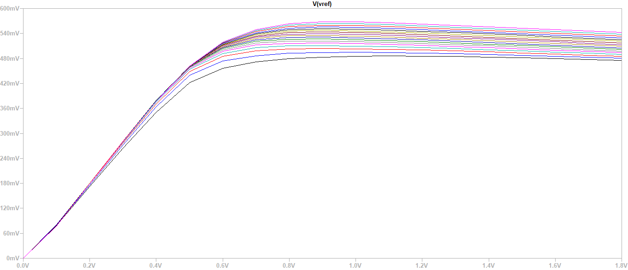

The third graph shows multiple VREF curves for different samples/process conditions.
This analysis represents:
- Process variation analysis
- Monte Carlo/sample variation behavior
- Device mismatch effects
Each curve corresponds to slight variations in:
- Threshold voltage
- Mobility
- Channel dimensions
- Leakage current
Because analog circuits are sensitive to fabrication variations, the reference voltage changes slightly between samples.
However, all curves remain close together, showing:
- Good robustness
- Stable reference generation
- Proper biasing operation

Design Description:

MOS Transistors | W/L Ratio
M1 to M6 (PMOS) | 8u/4u
M7 to M10 (NMOS) | 4u/4u
M11 to M18 (PMOS) | 20u/2u
M19,M23,M31 (PMOS) | 1u/2u
M20,M26,M32 (PMOS) | 40u/2u
M21 to M24 (NMOS) | 10u/2u
M27 to M30 (NMOS) | 4u/2u
M33 to M36 (NMOS) | 4u/2u
M37 , M38 (NMOS) | 4u/2u
M39 , M40 (NMOS) | 10u/2u
M41 (NMOS) | 4u/2u

Resistors | Value(Ohm)
R1 | 100 K
R2 | 1M

Inference:
- The VREF output voltage obtained is about 504mV, which is closer to the targeted output VREF voltage obtained in the research paper.
- Across the temperature variations, the circuit seemed to maintain almost constant reference voltage.

Reference:
[1] A. Dossanov, C. Ziegler, and V. Issakov, “Ultra-Low-Power High PSRR Sub-1 V Voltage Reference Circuit in 22 nm FDSOI CMOS,” IEEE Transactions on Circuits and Systems II: Express Briefs, vol. 71, no. 11, pp. 4643–4647, Nov. 2024, doi: 10.1109/TCSII.2024.3443459.

