Commands for running PG Vector locally using docker

docker run --name pgvector-container -e POSTGRES_USER=langchain -e POSTGRES_PASSWORD=langchain -e POSTGRES_DB=langchain -p 6024:5432 -d pgvector/pgvector:pg16
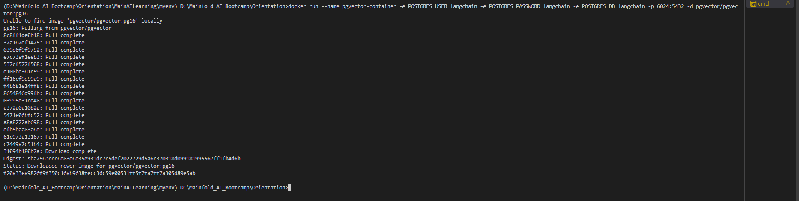
Docker ps
From docker desktop
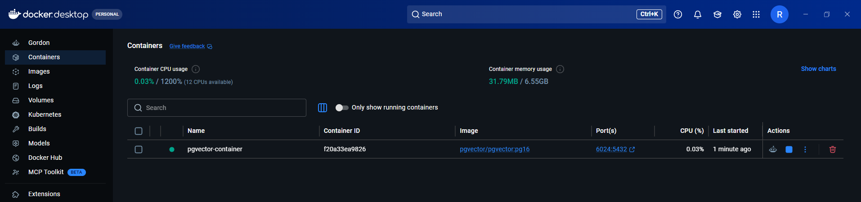
Run
# connect to postgres inside the container
docker exec -it pgvector-container psql -U langchain -d langchain
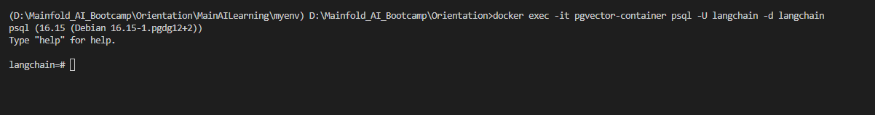
Run
CREATE EXTENSION IF NOT EXISTS vector;
CREATE EXTENSION IF NOT EXISTS pgcrypto; # to generate the UUID
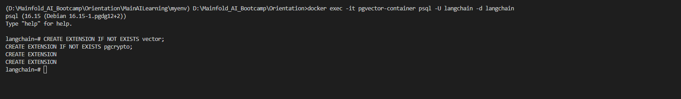
-- List extensions
\dx
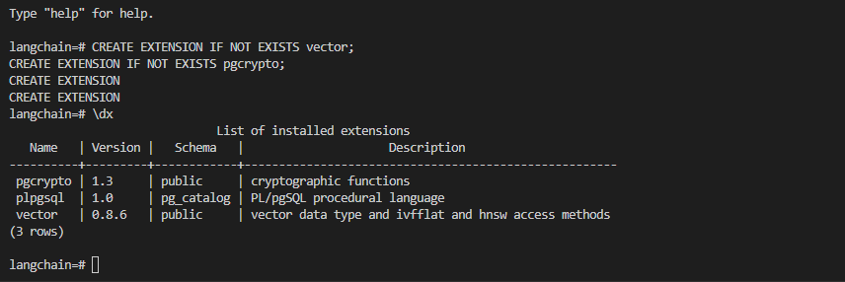
Run
DROP TABLE IF EXISTS documents;
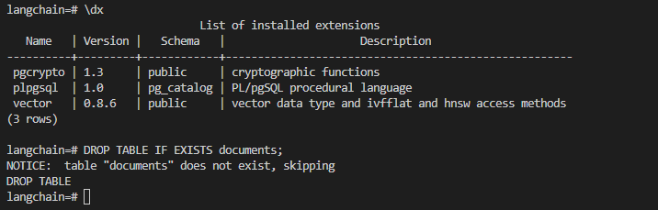
Run
CREATE TABLE documents (
id UUID PRIMARY KEY DEFAULT gen_random_uuid(),
content TEXT NOT NULL,
embedding vector(1024) NOT NULL,
source_file TEXT,
page_number INTEGER,
chunk_index INTEGER,
total_chunks INTEGER,
section_header TEXT,
doc_hash TEXT,
department TEXT,
access_level TEXT CHECK (access_level IN ('public', 'internal', 'confidential', 'secret')),
tenant_id UUID,
created_by TEXT,
doc_type TEXT CHECK (doc_type IN ('pdf', 'docx', 'html', 'code', 'email', 'text')),
chunk_type TEXT CHECK (chunk_type IN ('text', 'table', 'code', 'header')),
extraction_method TEXT,
extraction_confidence FLOAT CHECK (extraction_confidence BETWEEN 0 AND 1),
chunk_length INTEGER,
created_at TIMESTAMP DEFAULT NOW(),
updated_at TIMESTAMP DEFAULT NOW(),
metadata JSONB
);
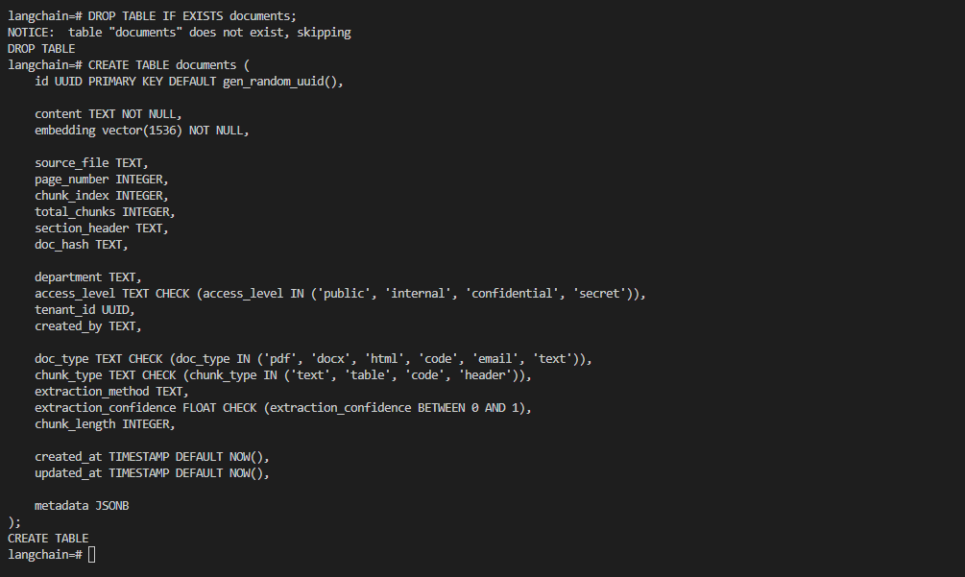
Run
CREATE INDEX IF NOT EXISTS documents_metadata_gin ON documents USING gin (metadata);
CREATE INDEX IF NOT EXISTS documents_department_idx ON documents (department);
CREATE INDEX IF NOT EXISTS documents_access_level_idx ON documents (access_level);
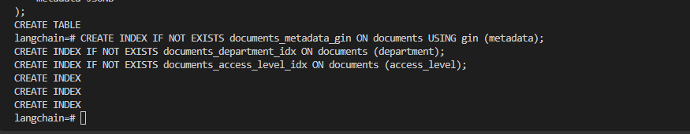

Load the indexex
\pset pager off
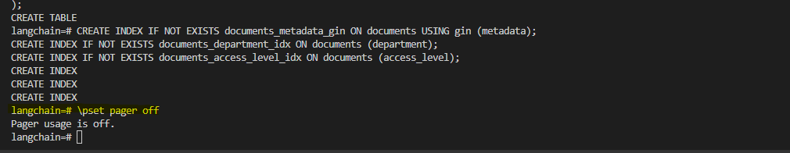

Make sure the embeddings are correct
Then run the below – previously getting error -> expected 1536 dimensions, not 1024
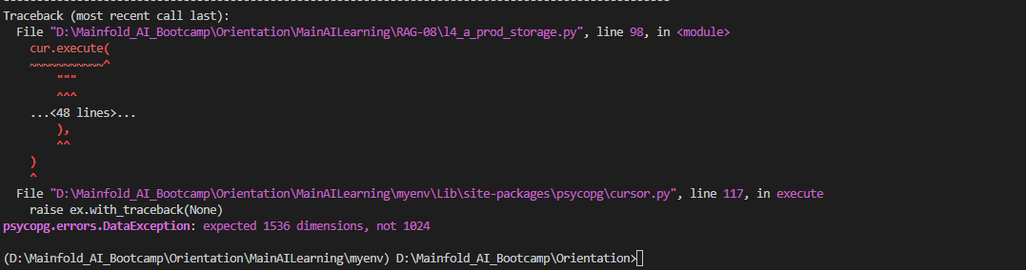

Then run
python D:\Mainfold_AI_Bootcamp\Orientation\MainAILearning\RAG-08\l4_a_prod_storage.py
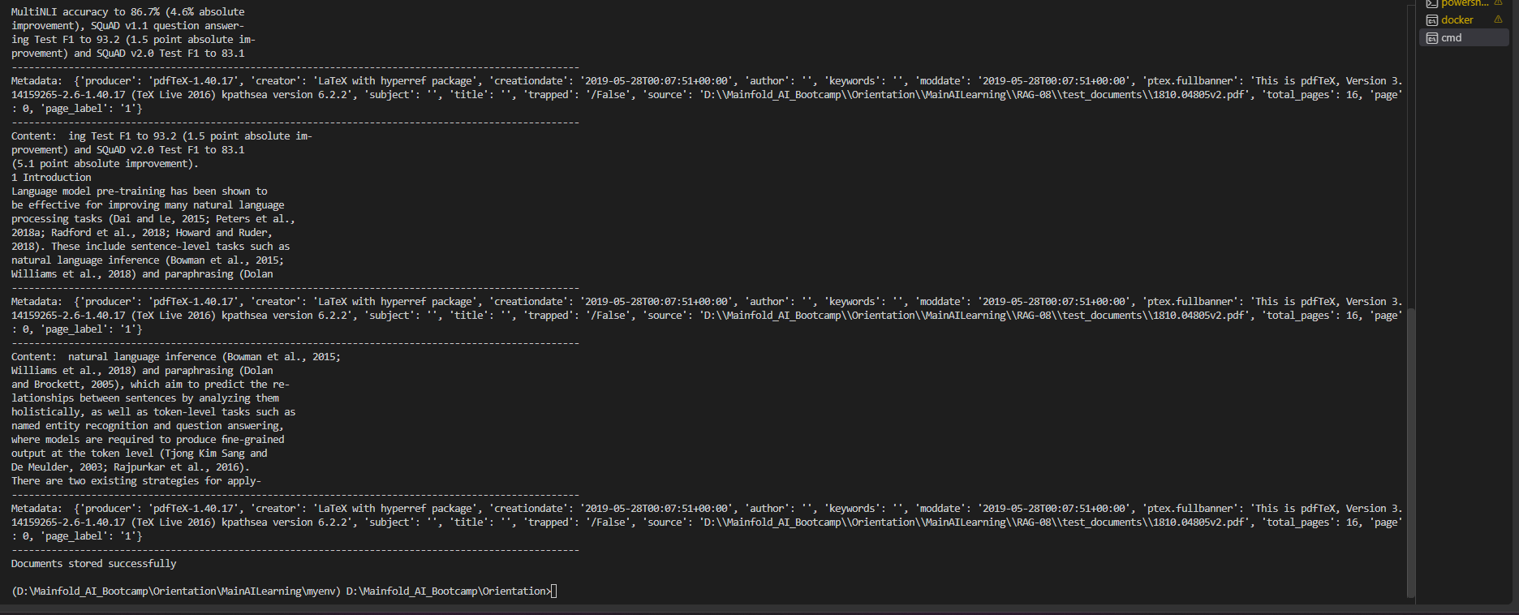
Now from the docker run the below to check if data is stored or not
Whenever these is issue on loading then run \pset pager off
SELECT COUNT(*) FROM documents;
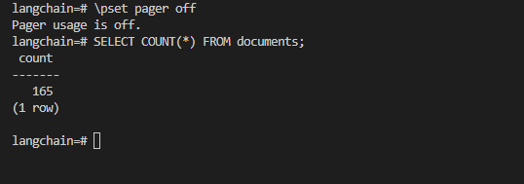
SELECT id, embedding
FROM documents
LIMIT 5;
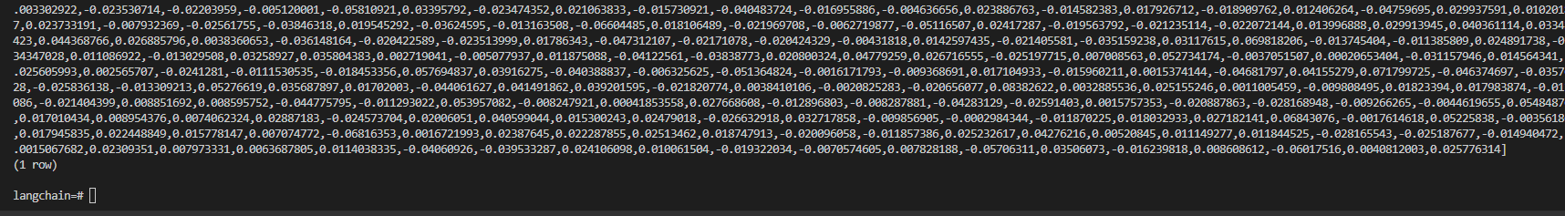
SELECT id, left(content, 120) AS doc_preview, department, total_chunks, access_level
FROM documents
LIMIT 5;
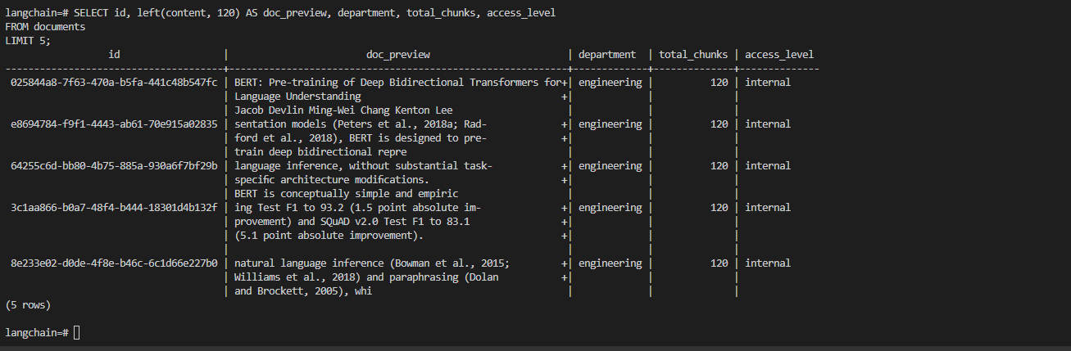
SELECT vector_dims(embedding)
FROM documents
LIMIT 5;
