Access control Metadata filerting and indexing

Run the previous docker container
Then run the file
python D:\Mainfold_AI_Bootcamp\Orientation\MainAILearning\RAG-08\l6_a_access_control_demo.py
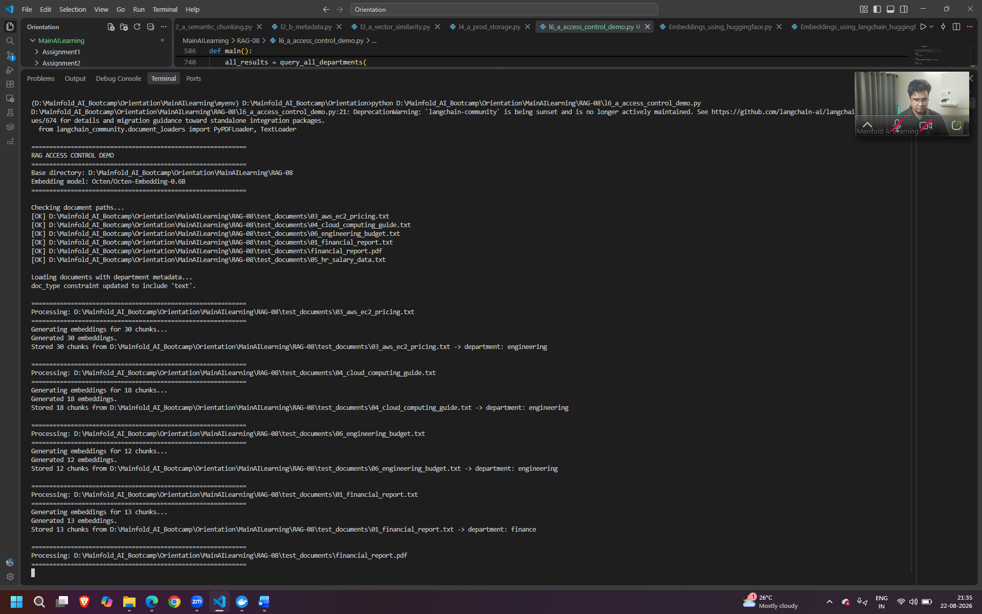

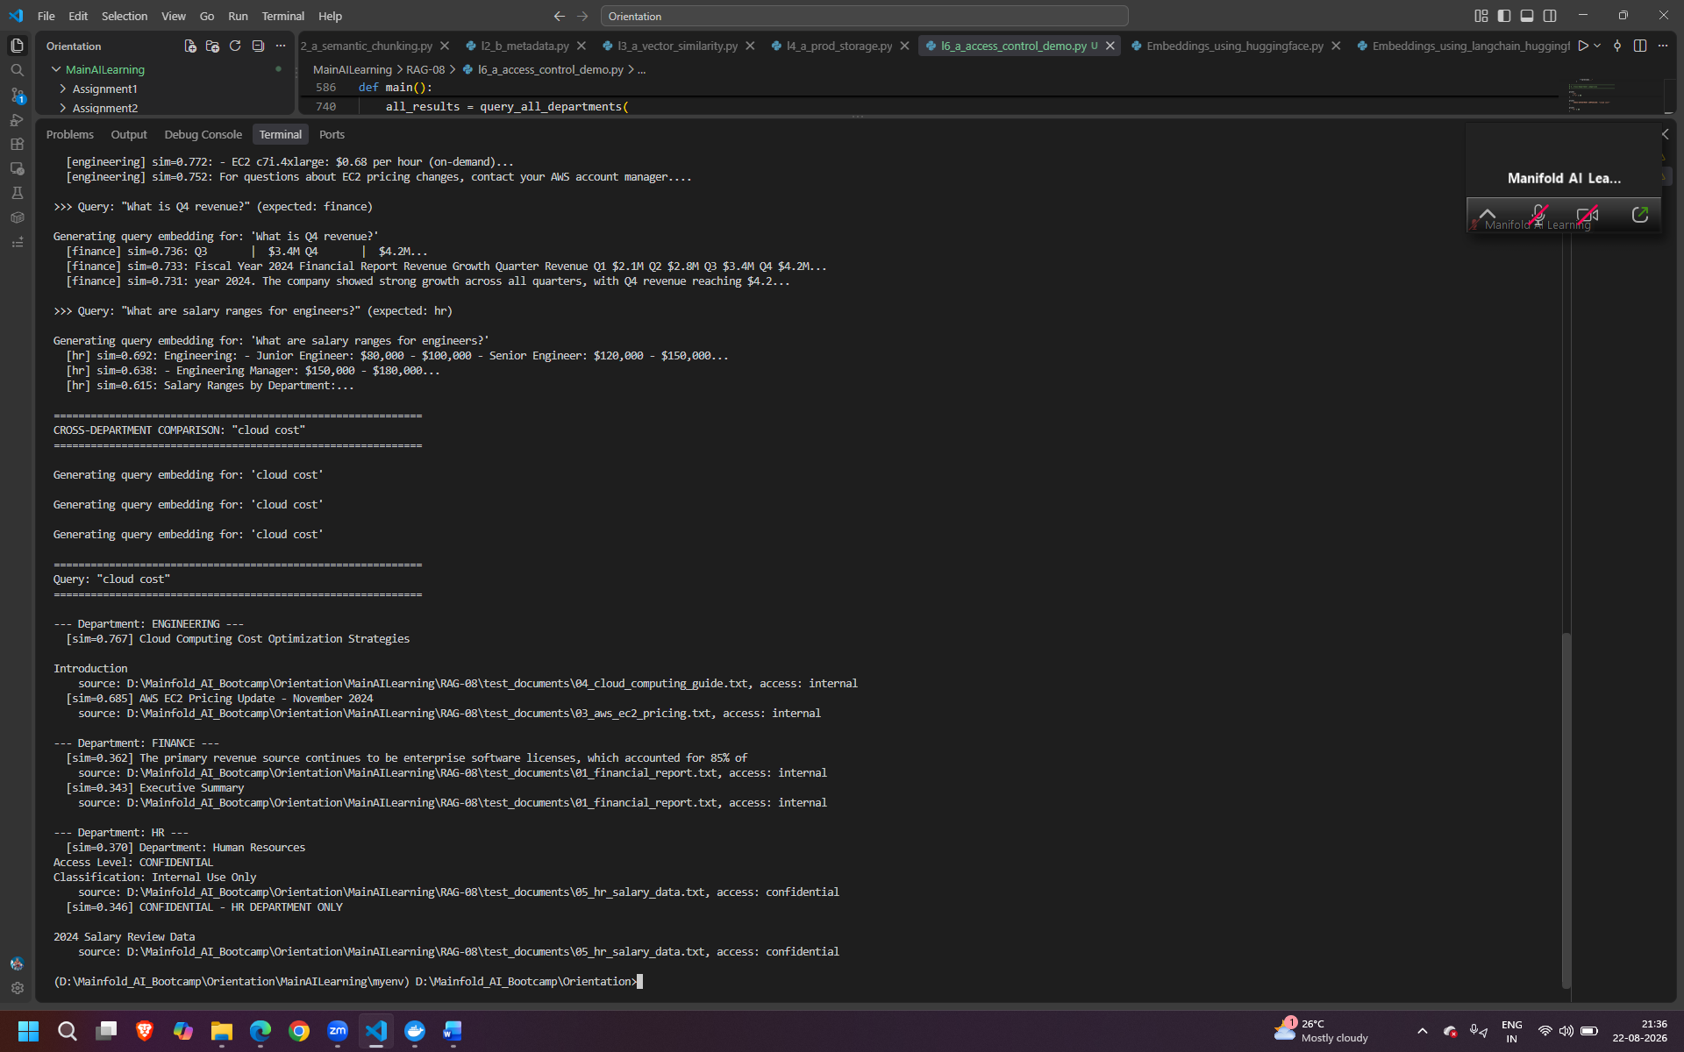

Quen 3 reranker – huggingface
LLM = ChatGroq(model="openai/gpt-oss-120b", temperature=0)

