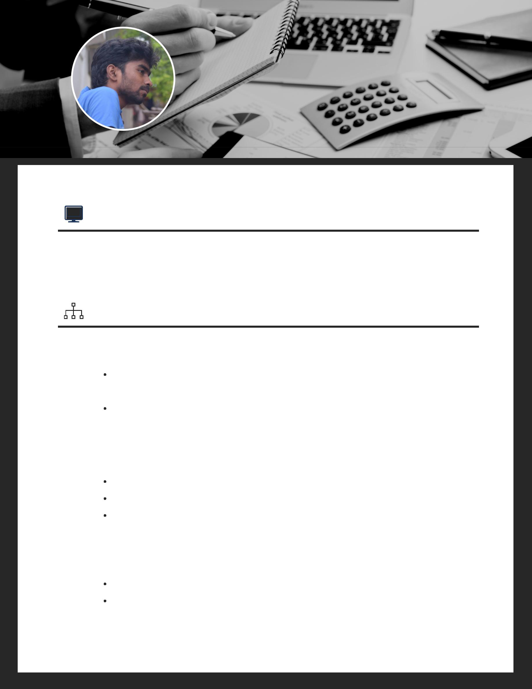Vijay Kumar

**JAVASCRIPT DEVELOPER**

**9944239288 | rvkumar2906@gmail.com | Chennai, India**

SUMMARY

Around 4.5 years of experience in IT. I love to program ideas that work in real world and useful for people in their business. Apart from career, love to drive cars, travel and passionate about cricket and I'm an avid gamer.

GITHUB

CozySews

Created a portfolio for a friend and its deployed in Heroku. Portfolio link -

https://cozysews.herokuapp.com/

The website is made responsive.

Sachin Tendulkar

Created a portfolio of Sachin Tendulkar career based on the given data.

Statistics shown are visualized into separate charts.

Portfolio developed using React & Flux with Bootstrap.

Resume

Created the first portfolio of my own and is deployed on Heroku. Developed using ReactJS. link - http://resume-rvkumar.herokuapp.com/.

Github - https://github.com/rvkumar92

EXPERIENCE

IT Analyst - TCS Chennai;

August 2013 - Present

Admin Tool Creation

Based on the JSON provided from the client request, a project structure is formed then concerned directories are scaffolded which are then compressed and returned to the client side as a downloadable zip file.

Project Creation Tool

Similar to admin tool creation but with minor changes, project creation scaffolds relevant HTML, CSS and typescript for a particular form sent as a JSON input. From the JSON using our team Angular Reusable Components, content will be generated with a template engine which is then compressed, zipped and downloaded in the client machine.

User Interface for a Team

Developed dashboard widgets in the front layer using AngularJS for the Quote process system which consumes spring-boot microservies.

Externalization of CSS using LESS

Worked on a project to externalize the whole CSS for a bespoke CRM application. Responsiveness, tidying the CSS, and creating a common header, footer & common design for modules are some of the key tasks involved in the project.

Angular Datagrid for CRUD Operations

Built an AngularJS application to project a list of Master data tables into a data grid. The goal of the project was to simplify the task of performing CRUD operations on a selected table. The project initially used Angular ng-grid and was later moved onto ag-grid.

 SKILLS

|  |  |  |
| --- | --- | --- |
| Html & Css | ExpressJS - NodeJS | Git |
| Javascript | Flask - Python | Ionic |
| ReactJS | Bootstrap | Angular |
| Flux & Redux | Less | Heroku |