{{ report_title }}
1. Client & Property Details

Client Name | {{ project.name }}  {{ project.description }}
Main Entrance | {{ property.entrance }}
Kitchen | {{ property.kitchen }}
Master Bedroom | {{ property.master_bedroom }}
Concern Area | {{ property.concern }}

2. Rating Breakdown
Room | Direction | Rating
{%tr for item in ratings %}
{{ item.name }} | {{ item.direction }} | {{ item.rating }}/10
{%tr endfor %}

{{ score.overall }}
Overall Vastu Rating After Remedies

3. Room Ratings Analysis
{{ bar_chart }}

4. Floor Plan
16 Direction Compass
{{ chart16 }}
32 Direction Compass
{{ chart32 }}

5. Detailed Vastu Analysis
(Python prep: rating_pairs = [ratings[i:i+2] for i in range(0, len(ratings), 2)])
{%tr for pair in rating_pairs %}
{{ pair[0].name }} — {{ pair[0].direction }}
{{ pair[0].analysis }}
{%tr endfor %}

6. Room Wise Analysis
Room | Direction | Status | Color | Remedy / Therapy
{%tr for room in ratings %}
{{ room.name }} | {{ room.direction }} | {{ room.status }} | {{ room.color }} | {{ room.remedy }}
{%tr endfor %}

7. Suggested Remedies (Pyramids/Ratna/Yantra/Crystals)
Room | Remedy
{%tr for item in ratings %}
{{ item.name }} | {{ item.sug_remedy }}
{%tr endfor %}

Personalised Notes
Space for the consultant / astrologer to add personalised notes.

8. Additional Vastu Remedies & Energy Balancing Guidelines
Vastu Remedies for Entrance
Convex Mirror
- Install a convex mirror outside the main door facing outward.
- Prevents negative energy from entering the house.
- Reflects harmful vibrations away from the entrance.
Black Salt Remedy
- Keep a bowl of black salt near the main entrance.
- Replace the salt every Saturday.
- Absorbs negative vibrations and stagnant energy.
Camphor Lamp
- Light a camphor lamp near the main entrance every evening.
- Purifies the atmosphere and removes negativity.
- Promotes peace, harmony, and prosperity.

Common Vastu Remedies
Space Cleansing
- Burn camphor, guggul, or loban daily.
- Helps remove negative energy and purify the environment.
- Tuesday, Thursday, and Saturday are especially effective.
Salt Remedy
- Keep rock salt in a glass bowl in a corner of the house.
- Absorbs negative energy and unwanted vibrations.
- Replace every Saturday or Sunday.
Mantra Chanting
- Chant “Om Namah Shivaya” or “Om Vastu Devaya Namah”.
- Hanuman Chalisa and Vishnu Sahasranama are beneficial.
- Creates positive vibrations and spiritual protection.
Flowers & Aroma
- Offer fresh flowers daily in the prayer area.
- Use incense sticks, dhoop, or essential oils.
- Recommended fragrances: Sandalwood, Lavender, Rose.
Light and Fire Element
- Light a ghee lamp every evening in prayer or entrance area.
- Activates the Fire Element (Agni Tattva).
- Encourages positivity, prosperity, and spiritual growth.
Clean Corners
- Keep corners clean, dry, and well-lit.
- Dark and cluttered corners attract stagnant energy.
- Improves energy circulation in the home.
Clocks & Calendars
- Place clocks and calendars on North or East walls.
- Supports growth, progress, and opportunities.
- Avoid placing clocks on the South wall.

Power of Positive Mindset
“No structure is inherently inauspicious; energy depends on the people living in it.”
- Positive thoughts create positive vibrations.
- Faith and gratitude strengthen energy of space.
- Love, peace, and respect transform a house into a temple.
- Vastu tools support energy — but mindset is the foundation.

Final Message: Give your home the feeling of a temple. A house filled with Love, Respect, Gratitude, Peace and Positive Thoughts becomes naturally balanced and prosperous. True Vastu begins from within and reflects in your surroundings.

🙏 Thank You!

Thank you for choosing Spiritual Hut Academy of Occult Science for your Vastu Analysis.

We hope this report helps you create a space filled with positivity, harmony, health, happiness, and prosperity.

For any clarification or personalized guidance regarding this report, feel free to contact us. We are always happy to assist you on your journey towards a balanced and successful life.

Wishing you abundant success, peace, and positive energy! ✨

Team Spiritual Hut Academy of Occult Science

16 Directions According to Vastu – Ideal House Directions
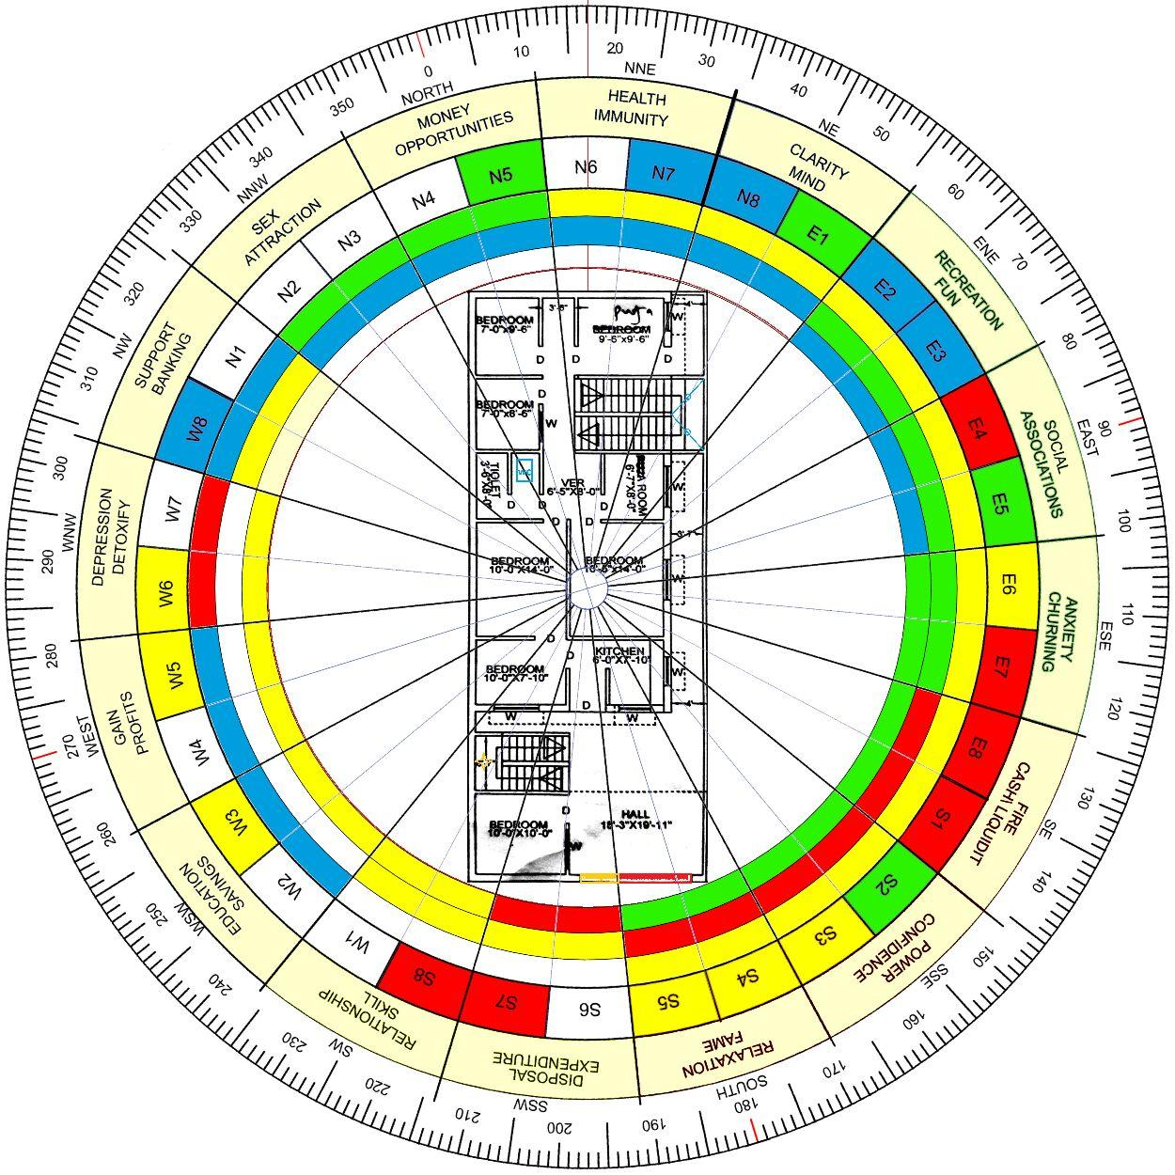
If you want to understand what should ideally be placed in each direction of a house according to the 16-Direction Vastu Model, the following chart is useful. This approach is based on the Vastu Purusha Mandala and the 16-Zone Vastu System.

Complete Chart of 16 Directions
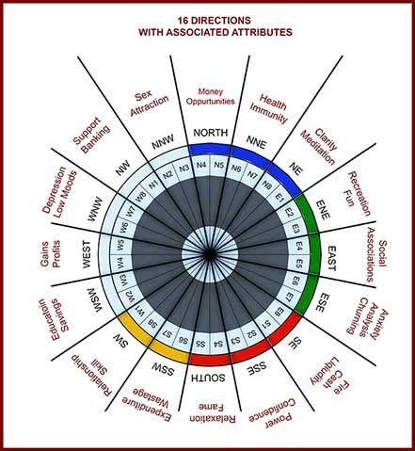
Direction | Ideal Use
N (North) | Wealth, office, cash locker, career opportunities
NNE | Health, meditation, water-related arrangements
NE (North-East) | Temple, पूजा/meditation, water, open space
ENE | Study, children's study area, learning activities
E (East) | Main entrance, especially E3/E4, living area
ESE | Electronics, inverter, electrical equipment
SE (South-East) | Kitchen, cooking and fire-related activities
SSE | Gym, fitness, electrical equipment and physical activities
S (South) | Storage, work-related activities, heavy items
SSW | Children's bedroom, support and stability
SW (South-West) | Master bedroom, stability, authority and control
WSW | Grain storage, stability, cash locker, study and children's study
W (West) | Dining area, food-related activities
WNW | Guest room, temporary stay and movement
NW (North-West) | Guest bedroom, air circulation and movement
NNW | Toilet, utility area and activities involving movement/disposal

Ideal House Layout
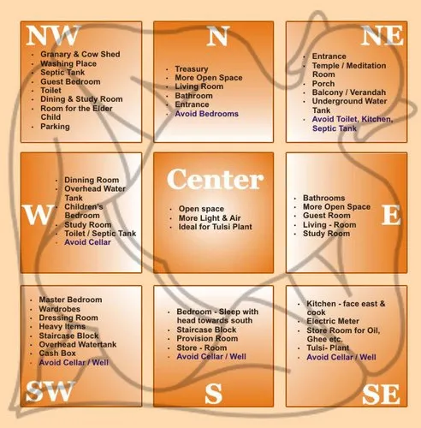
An ideal Vastu house should maintain a proper balance between the five elements — Earth, Water, Fire, Air and Space.

Most Auspicious Locations
- NE (North-East): Temple, water element and open space
- SE (South-East): Kitchen and fire-related activities
- SW (South-West): Master bedroom and heavy/stable areas
- N (North): Wealth, career and financial activities
- E (East): Main entrance, particularly E3/E4

Things to Avoid
- Avoid a toilet in the NE (North-East).
- Avoid a kitchen in the SW (South-West).
- Avoid placing heavy objects or unnecessary structures in the Brahmasthan.
- Avoid an underground water tank in the SW (South-West).
- Avoid a staircase in the NE (North-East).
- Avoid excessive clutter and heavy storage in the NE.
- Keep the Brahmasthan as light, clean and open as possible.
