

Big Data Analytics

LAB PROJECT

Rameesa Nadeem

Fa21-Bds-024

Instructor: Sir Rashid Mukhtar

January 17, 25

**Data Ingestion**

Ingested the scrapped textual data from hubspot data relevant to marketing articles in csv form

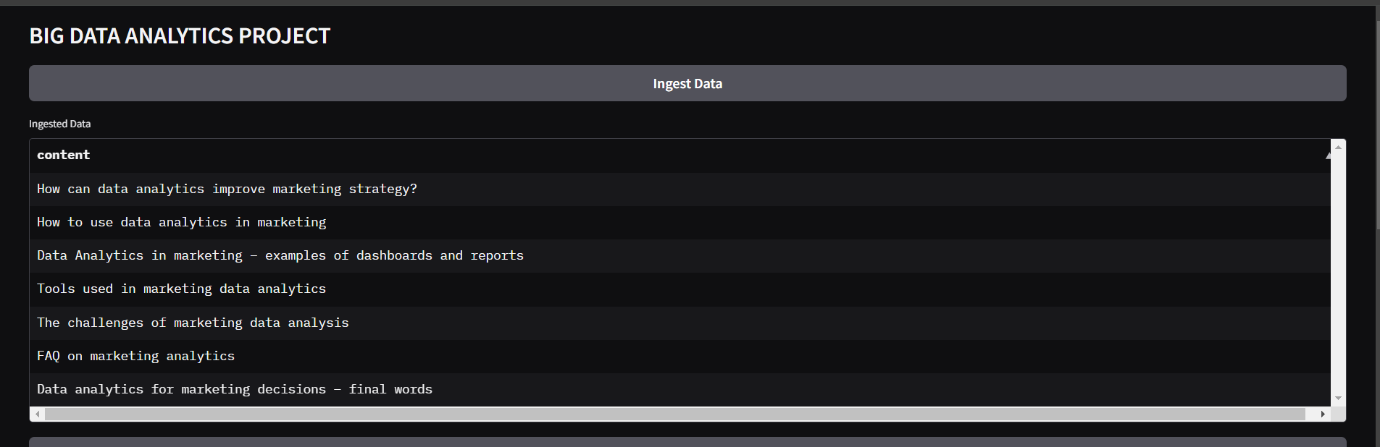

**Data Preprocessing**

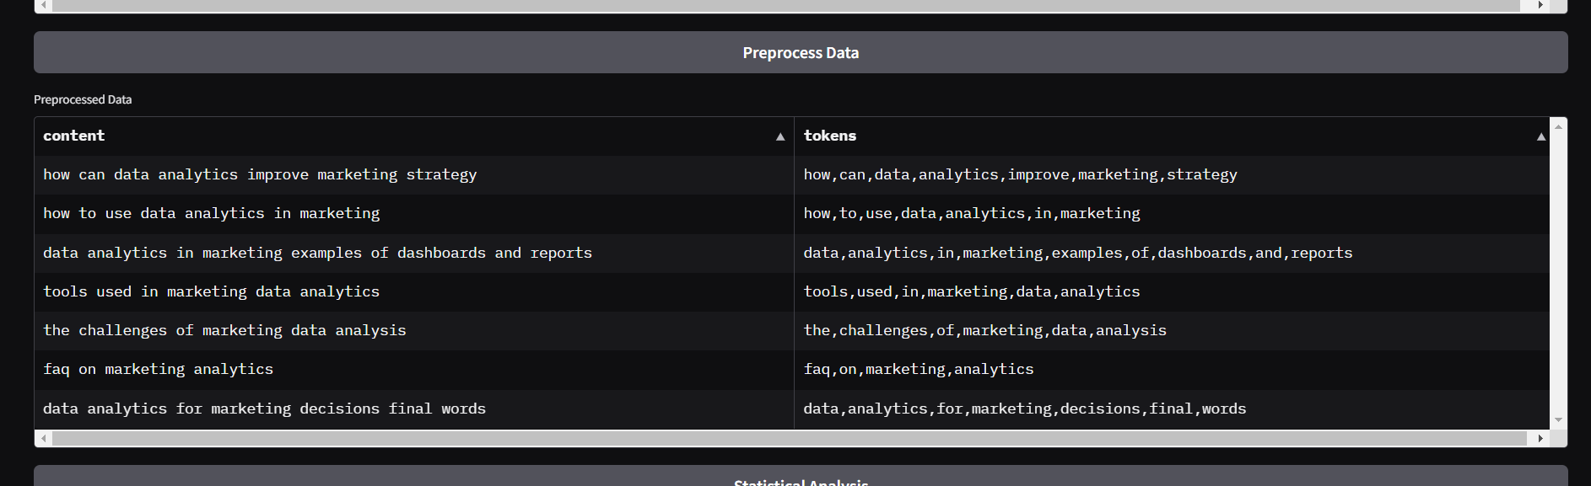

**Statistical Analysis**

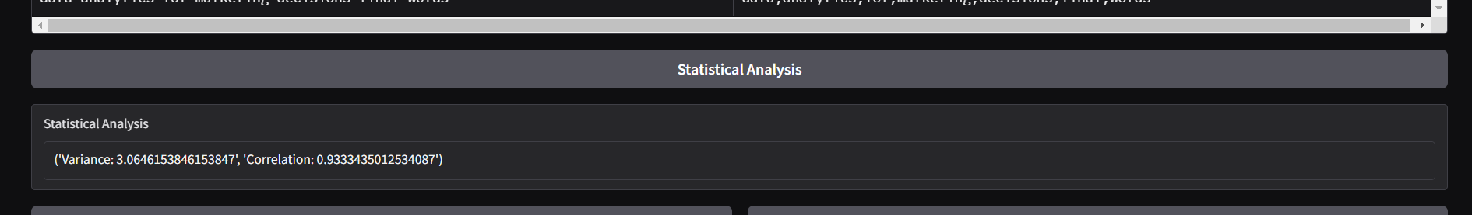

**Machine Learning Models**

**K means and Linear regression**

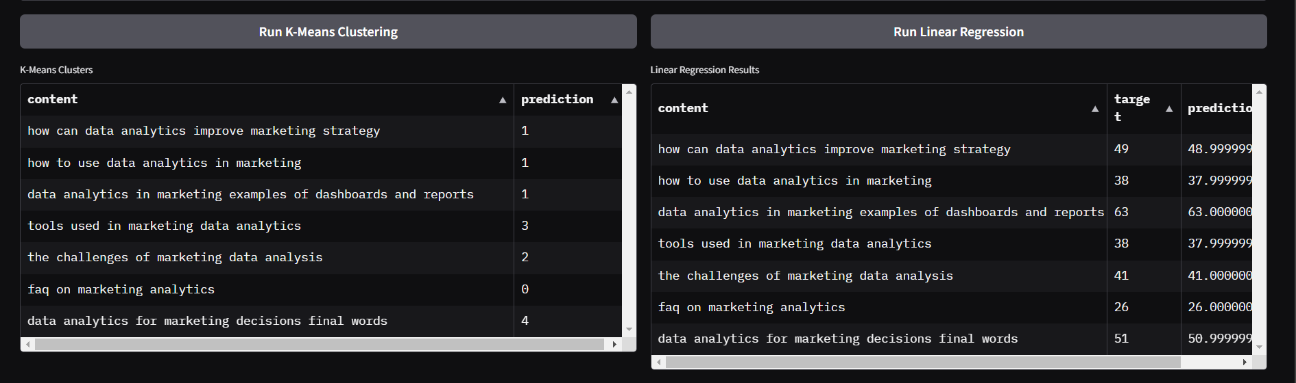

**Svm and Dbscan Model**

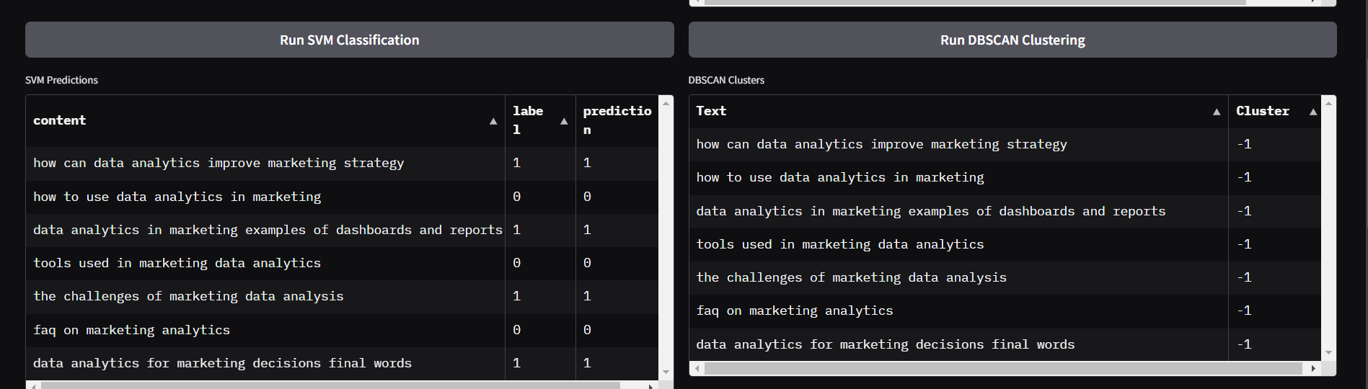

**Classification Model**

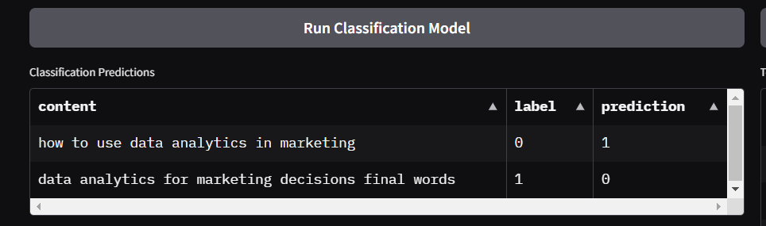

Topic Modelling

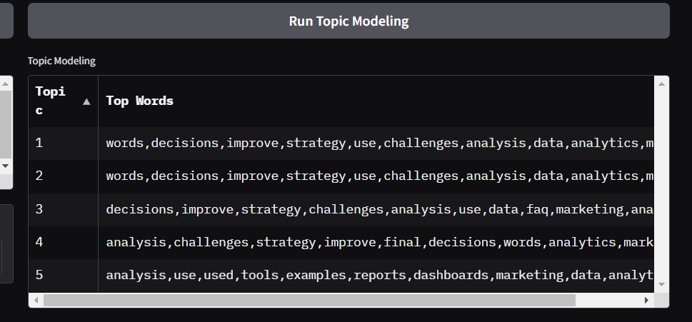

**Deep Learning Model**

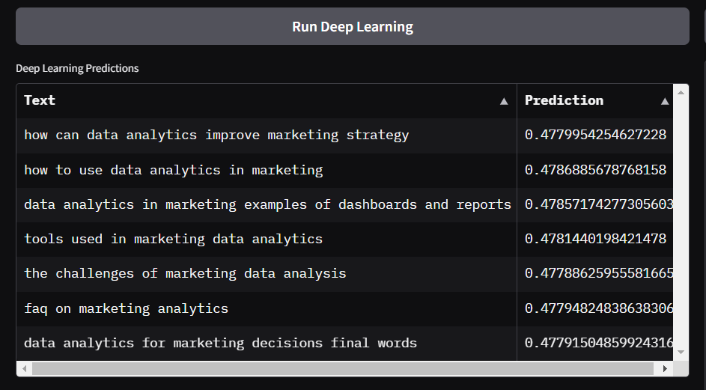

**Reinforcement Learning**

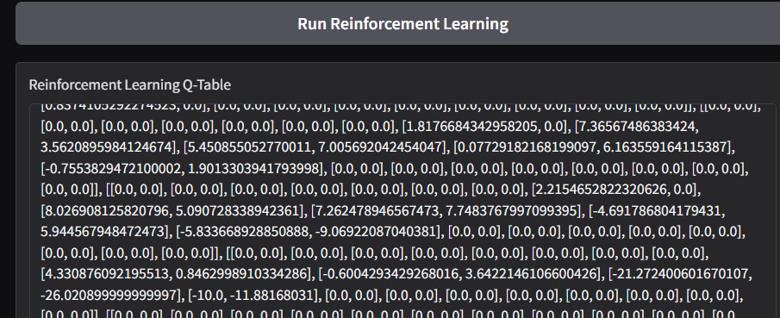

**Visualizations**

