

Site User Manual

revision 0

e-commerce site team

2018

TABLE OF CONTENTS

**LOGIN & REGISTRATION PAGE** ……….………………………………………………………………………………………………. 1

**NAVIGATION BAR** ……………………………………………………………………………………………………………………….…… 2

**HOME PAGE** ………………….………………………………………………………………………………………………………..…..….. 4

**MY CART PAGE** …………..…………………………………………………………………………………………………………………… 6

**PRODUCTS PAGE** …………………………………………….………………………………………………………………………………. 7

**PRODUCT DETAILS PAGE** ………………………………………………………………………………………………………………… 9

**CHECKOUT PAGE** …………………………………………………………………………………………………………………………….10

**ORDER TRACKING PAGE** ………………………………………………………………………………………………………………...11

**PURCHASE CONFIRMATION PAGE** …………………………………………………………………………………………………12

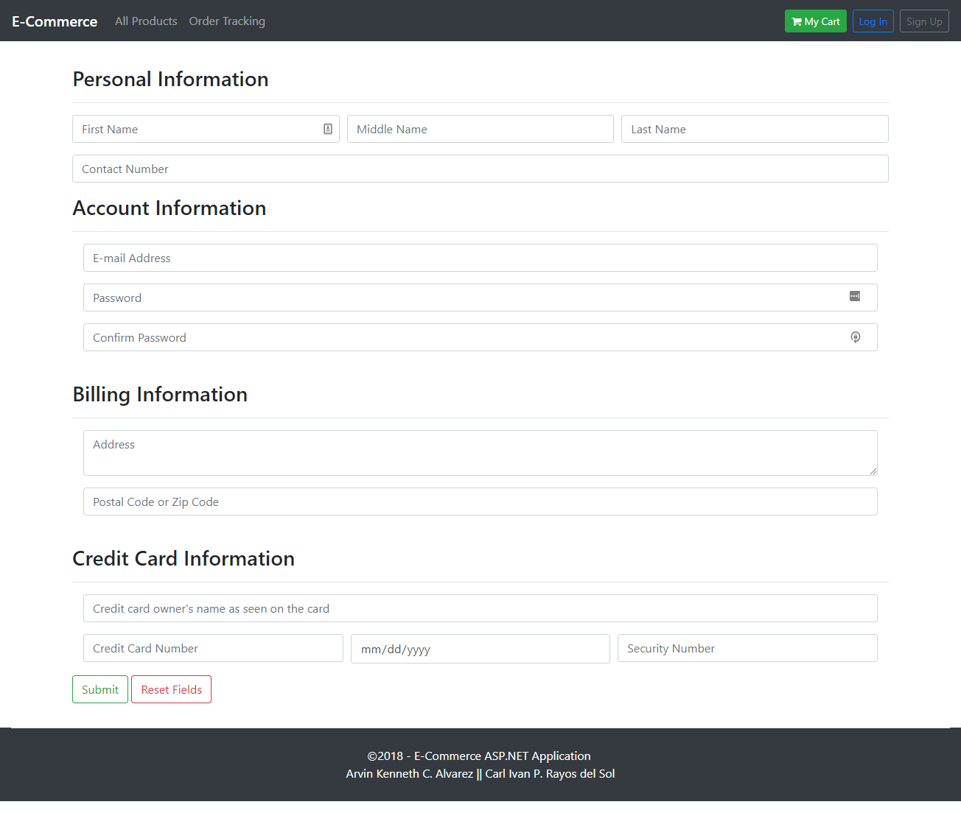The *Account Registration page* will allow you to sign up for an account. Take note that all the fields are required and must be filled in to successfully complete your registration.

ACCOUNT REGISTRATION PAGE

LOGIN PAGE

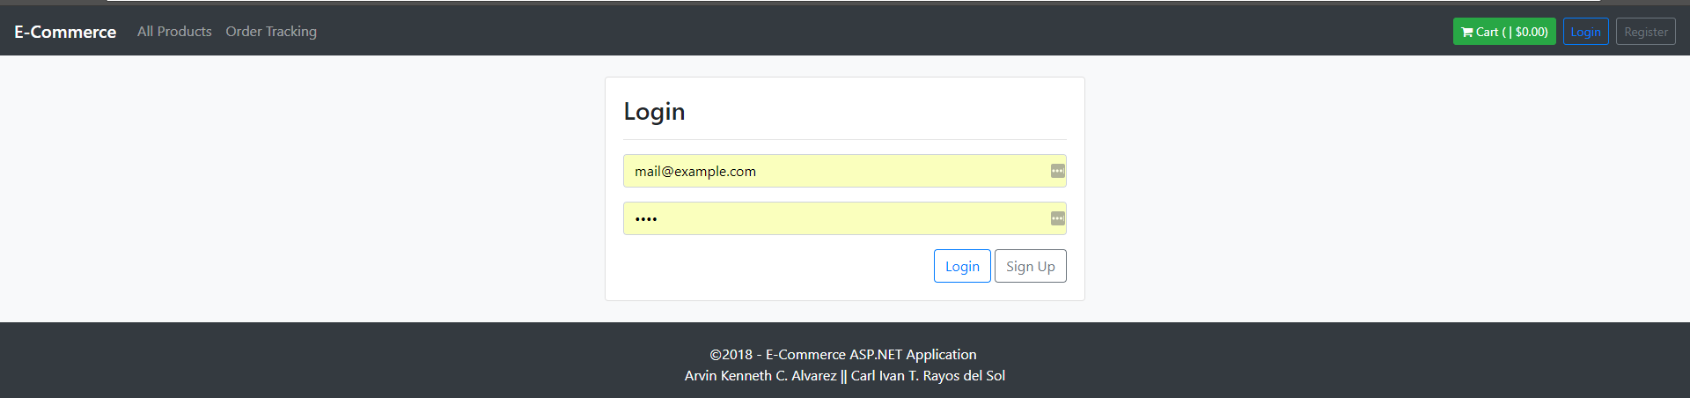

The *Login page* will allow you to log in to the account you registered. All that is needed is the **e-mail address** you used during registration and your **password.**

NAVIGATION BAR



All pages have a *navigation bar* that allow quick and easy access to the following pages:

* **Order Tracking** which will redirect you to a page in where you can view previous transactions, given that you have the *reference number* that was given to you after you checked out.
* **My Cart** which redirects you to your cart. This page shows you all the items you have added to it by clicking the *add to cart* button in any of the item cards. This also shows you the total number of items in your cart as well as the total price of all the items in it.
* **Register** which redirects you to a page in where you can have an account registered. Having an account registered will automatically fill up your *payment details form* every time you check out.
* **Log In** which will allow you to login to your account, given that you have one already registered.
* A user who is logged in will have access to a **Sign Out** button which logs him out of his account.

HOME PAGE

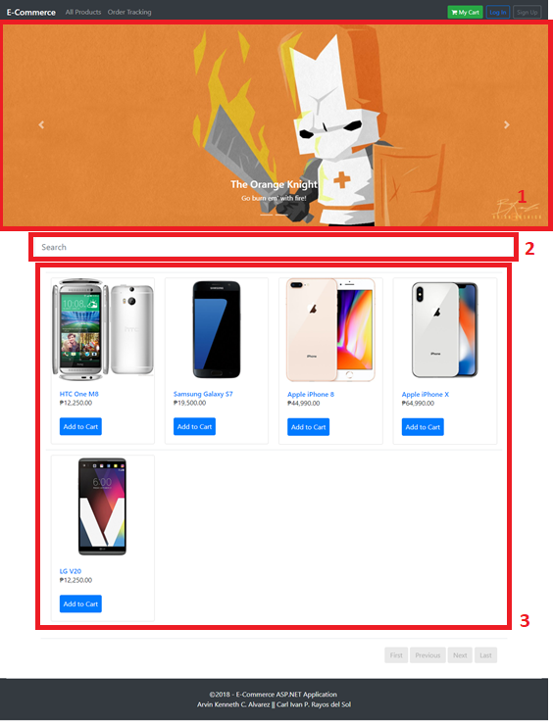

In the *Home Page* you are shown the following items:

1

* **Image Carousel** as indicated by which provides you with a quick way to add any of the trending products found in the site.

2

* **Search bar** as indicated by which will allow you to search for any product under any category. Just type in the product’s name followed by a press of the *enter key* or the *return key*.

3

* **Trending category product list** as indicated by which allows you to add any of the products in the current category to your cart.

MY CART PAGE

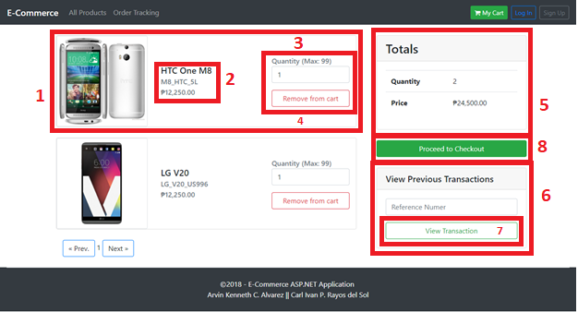

In the *My Cart* page, you have a list of all the details regarding your current transaction. This page contains the following:

1

* **Item card** as indicated by which contains details about each item in your cart. This card contains the following elements:

2

* + **Item name, SKU and price**as indicated by which is every detail you need to know about that specific item in your cart.

3

* + **Quantity Selector** as indicated by which will allow you to easily specify the quantity of the said product you want to purchase. This control also comes with arrows that removes the need for you to type in the number manually. Although, you could do so if you wish.

4

* + **Remove button** as indicated by which instantly removes the item from your cart

5

* **Transaction Details Table** as indicated by which shows all the totals (price and number of items) regarding your transaction.

6

* **View Previous Transaction form** as indicated by which will allow you to view previous transactions after you type in the provided reference number and press the button as indicated by

7

8

* **Proceed to Checkout Button** as indicated by which is the button you click once you have all the items you want to buy in your cart and you are ready to have them checked out.

PRODUCTS PAGE

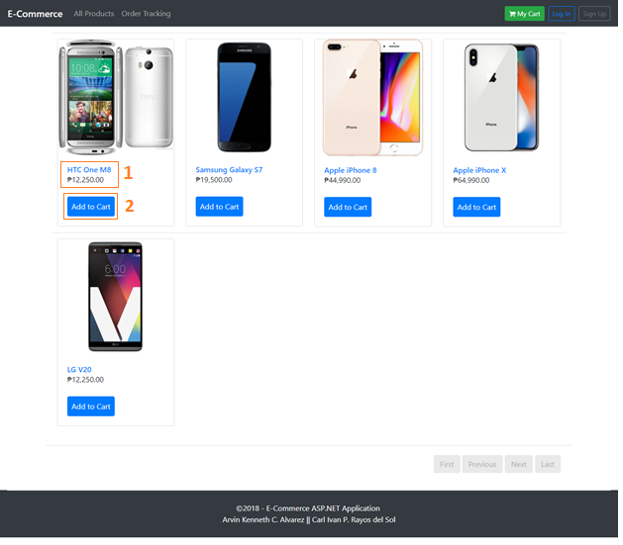

The *Products* page will allow you to browse categories and add items to your cart. This page contains *item cards* which contains the following elements:

1

* **Item name and price**as indicated by which is every detail you need to know about that specific item in your cart. Clicking on the item’s *name* will also redirect you to a page that outlines all the details regarding it.

2

* **Add to Cart Button** as indicated by which will allow you to add the selected item to your cart. Take note that only *one* of the selected item will be added.

PRODUCT DETAILS PAGE

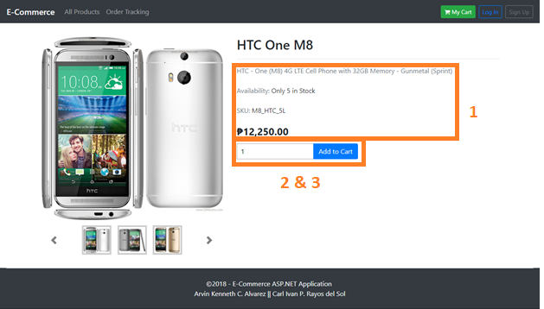

The *Product Details* page contains information about the selected item. This page contains the following elements:

1

* **Item name, SKU and price**as indicated by which is every detail you need to know about that specific item.

2

* **Quantity Selector** as indicated by which will allow you to easily specify the quantity of the said product you want to purchase. This control also comes with arrows that removes the need for you to type in the number manually. Although, you could do so if you wish.

3

* **Add to Cart button** as indicated by which adds the item from your cart with the specified quantity

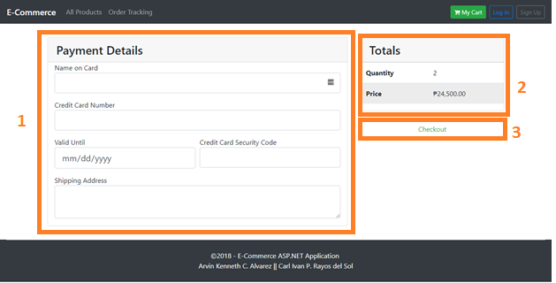

CHECKOUT PAGE

The *Checkout Page* will allow you to input payment details and place the order. This page contains the following controls:

1

* **Payment Details form**as indicated by which will allow you to input your payment details and shipping address manually if you are ***not*** a registered user. Otherwise, they are automatically filled in for you if you are. Do take note that **all** fields will have to be filled in if you must fill them in.

2

* **Transaction Details Table** as indicated by which shows all the totals regarding your transaction.

3

* **Proceed to Checkout Button** as indicated by which is the button that you press once every required detail is filled in to have your order placed.

ORDER TRACKING PAGE

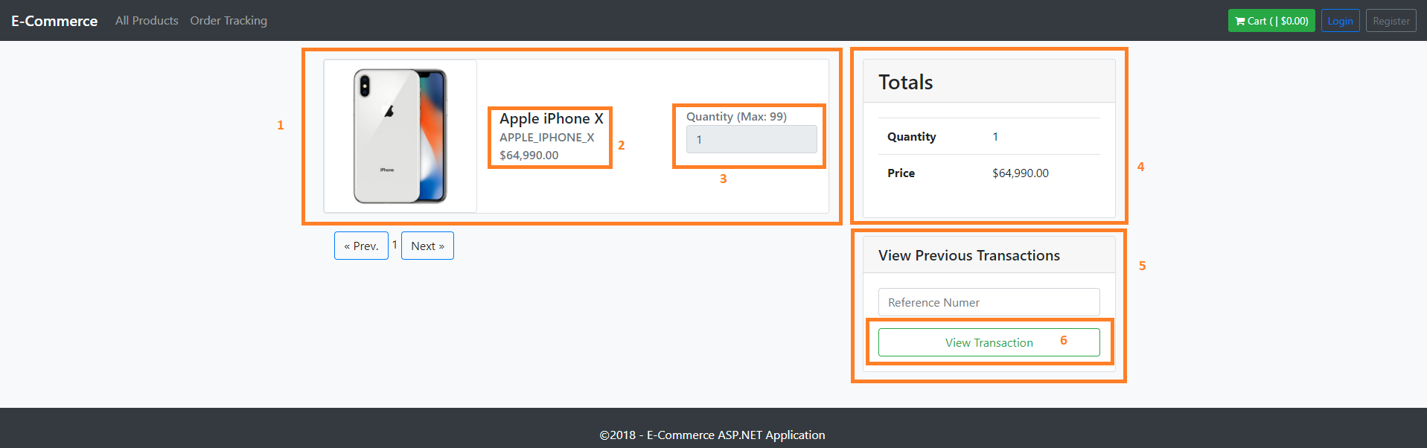

In the *Order Tracking* page, you have a list of all the details regarding your previous transaction. This page contains the following:

1

* **Item card** as indicated by which contains details about each item in your cart. This card contains the following elements:

2

* + **Item name, SKU and price**as indicated by which is every detail you need to know about that specific item in your cart.

3

* + **Quantity Selector** as indicated by which will show you how many of that specific item you purchased

4

* **Transaction Details Table** as indicated by which shows all the totals (price and number of items) regarding your transaction.

5

* **View Previous Transaction form** as indicated by which will allow you to view previous transactions after you type in the provided reference number and press the button as indicated by

6

PURCHASE CONFIRMATION PAGE

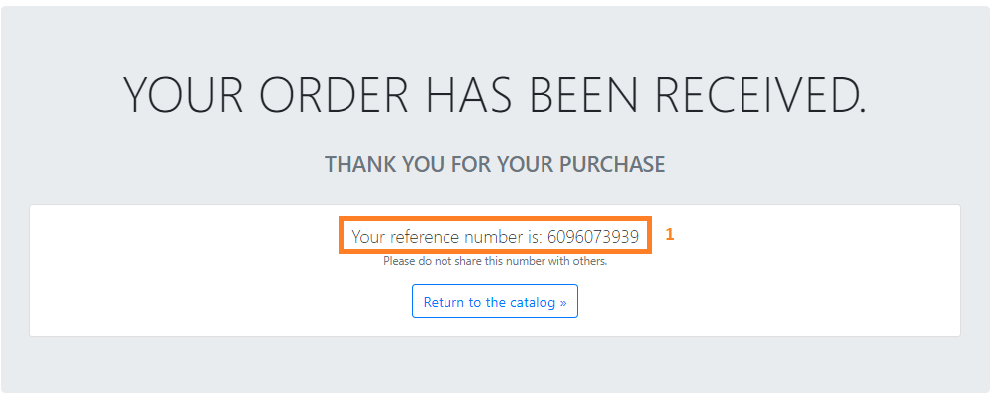

The *Purchase Confirmation page* shows a **thank you message** and your **reference number** as indicated

1

by which will allow you to retrieve previous transaction details.