ASSIGNMENT MW20 — ETHICS COMPETITION · HRM  Available within 24 hours  Case: a retail chain with 60 branches | COMPLEXITY  MESO ★★☆
Phase in the model: WEIGHING Time: 75 min Group: 2 teams of 3–5 + jury
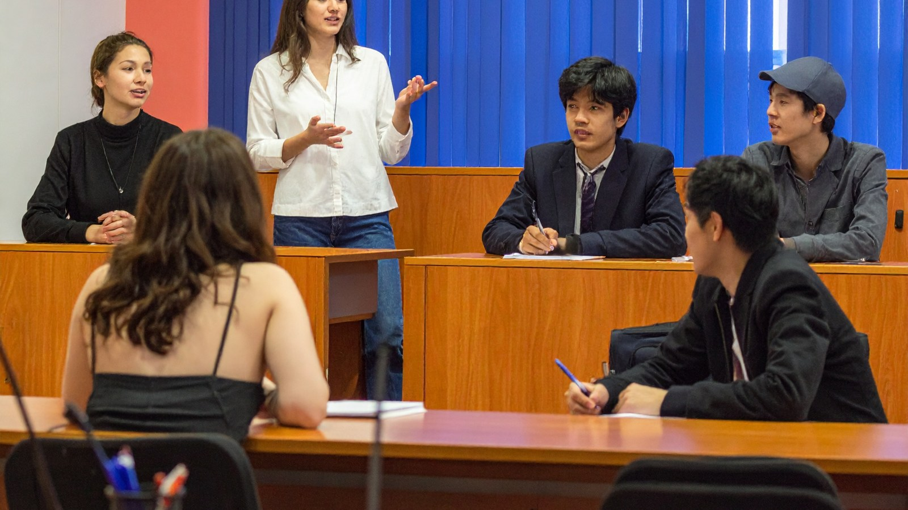
THE SITUATION
A retail chain with sixty branches is introducing a new scheduling policy. Employees receive their schedule two weeks in advance, but the store may change it up to twenty-four hours beforehand. Anyone who cannot make it is called in for a talk with the branch manager. The company says: “This is how we stay competitive.”
HR adviser Priya hears from both sides. Branch managers say that otherwise they have no staff on busy days. A part-timer says: “I can’t arrange my childcare in six hours.” And a student employee asks: “Will I still be able to go to lectures?”
Priya has to advise management. She puts the question to two teams of colleagues: is it reasonable for an employer to expect employees to accept a schedule change within 24 hours?
Fictional case. Any resemblance to real persons or organisations is coincidental.

HOW TO WORK
- Read the case. Choose whether your team answers the first or the second question. (5 min)
- Team A prepares its answer: position, three reasons, strongest objection. Team B prepares questions. (15 min)
- Team A presents (5 min). Team B responds as a critical friend (5 min): what is strong, what is missing, which question do you ask? (15 min)
- Team A responds to the questions (5 min). The jury asks both teams a question. (10 min)
- Swap roles with a second case or with the same question from the other side. Fill in the reflection. (30 min)
PREPARATION TEAM A
Our position in one sentence:

Our reasons (and the principle behind them)
Reason 1
Reason 2
Reason 3
The strongest objection to our position, and our answer to it:

PREPARATION TEAM B — THE CRITICAL FRIEND
What is strong? What is missing? Which two questions do we ask?

REFLECTION
WEIGHING What did you take on board from the other team’s criticism? Support your answer with at least two perspectives, for example justice and consequences.

