ASSIGNMENT MW01 — SOCRATIC DIALOGUE · HRM  What is loyalty?  Case: an HR trainee and his friend | COMPLEXITY  MICRO ★☆☆
Phase in the model: SEEING WEIGHING Time: 90 min Group: 5–12 students
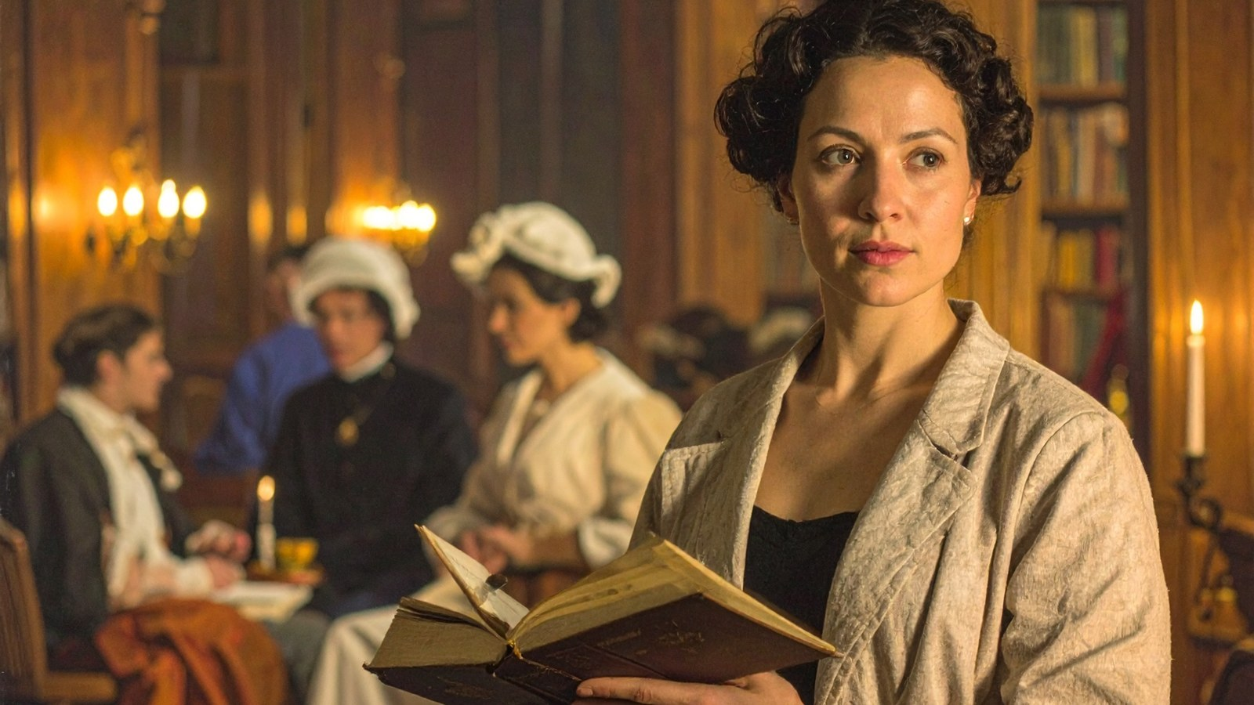
THE SITUATION
Milan (23) is an HR trainee. In a Socratic dialogue he describes something he experienced himself. His colleague and friend Ravi arrived three days late. He asked Milan to tell the team leader that he was “with a client”. Milan did.
“I felt loyal to Ravi,” Milan says. “But afterwards I don’t feel good about it. I don’t know whether I was loyal to Ravi or to myself.” The group falls silent. The facilitator says: “Let’s explore together what loyalty is, using this example.”
The core question: what is loyalty? It is not about who is right. It is about the group reaching a shared, well-founded insight together.
Fictional case. Any resemblance to real persons or organisations is coincidental.

HOW TO WORK
- Choose roles: a facilitator, a note-taker and the others. Milan tells his example once more. (10 min)
- Ask Milan questions to understand the example: what happened, what did he think and feel? No judgements yet. (15 min)
- Together, formulate one core statement about loyalty, in one sentence. (20 min)
- Test the core statement against counterexamples. Adjust it if necessary. (25 min)
- Look for the underlying principle. Why is that so? Formulate a shared insight. (20 min)
STEPS 1 AND 2 — THE EXAMPLE
What exactly happened? (facts only)

STEPS 3 AND 4 — THE CORE STATEMENT AND THE TEST
 | Core statement | Counterexample | Does it hold?
Version 1
Version 2
Version 3
STEP 5 — THE UNDERLYING PRINCIPLE
Loyalty is … because … Our shared insight:

REFLECTION
SEEING What did you see in Milan’s example that you had not seen at first?

WEIGHING Which counterexample changed your core statement the most? What does that say about loyalty?

