ASSIGNMENT MW08 — ETHICAL CYCLE · HRM  The performance screen  Case: Van Dijk Distribution | COMPLEXITY  MESO ★★☆
Phase in the model: SEEING WEIGHING ACTING Time: 90 min Group: Individual or 3–5
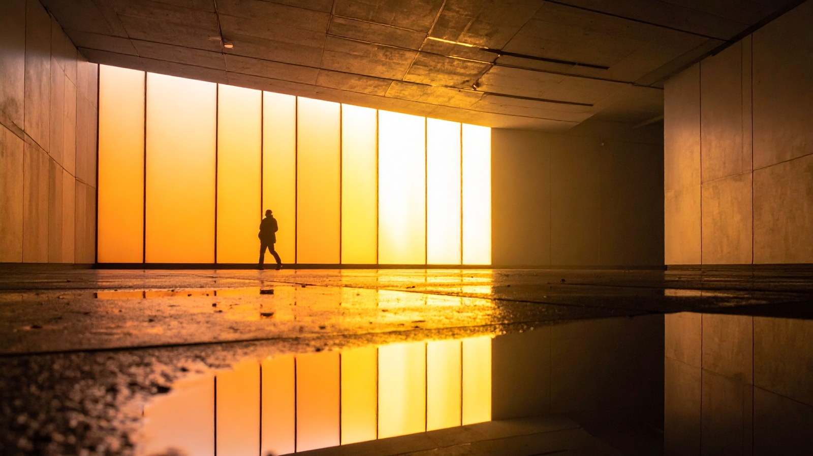
THE SITUATION
For the past three months a large screen has hung in the warehouse of Van Dijk Distribution. It shows live how many orders each order picker processes per hour, with the names of the fastest and slowest five. Productivity has risen by twelve per cent. Management is satisfied.
HR adviser Femke receives complaints. An older picker says he feels watched every day. A new colleague does not dare to take a break. Team leader Joris finds it motivating: “People just want to know where they stand.” The employee council has not heard anything yet.
The director asks Femke whether the screen can stay. She has to write an advice within two weeks and wants to substantiate it. She decides to work step by step.
Fictional case. Any resemblance to real persons or organisations is coincidental.

HOW TO WORK
- Formulate the problem. (10 min)
- Analyse: who, which values, which facts? (20 min)
- Come up with at least three options. (15 min)
- Assess the options from at least two perspectives. (25 min)
- Choose, explain and reflect. (20 min)
STEP 1 — THE PROBLEM
The problem in one sentence:

STEP 2 — THE ANALYSIS
Stakeholders  Who is affected? | Values  What do people consider important?
Facts I know | Facts I am still missing  What would I like to know?
STEP 3 — OPTIONS FOR ACTION
At least three options (A, B, C):

STEP 4 — ETHICAL ASSESSMENT
Option | Consequences | Duties and rights | Character and care
Option A
Option B
Option C
STEP 5 — DECISION
I advise … because …

REFLECTION
ACTING What exactly will Femke say or do tomorrow, and whom will she involve?

