ASSIGNMENT MW25 — FISHBOWL · HRM  Working without a permit  Case: a company and an asylum seeker | COMPLEXITY  MACRO ★★★
Phase in the model: WEIGHING Time: 45 min Group: 12–40 students
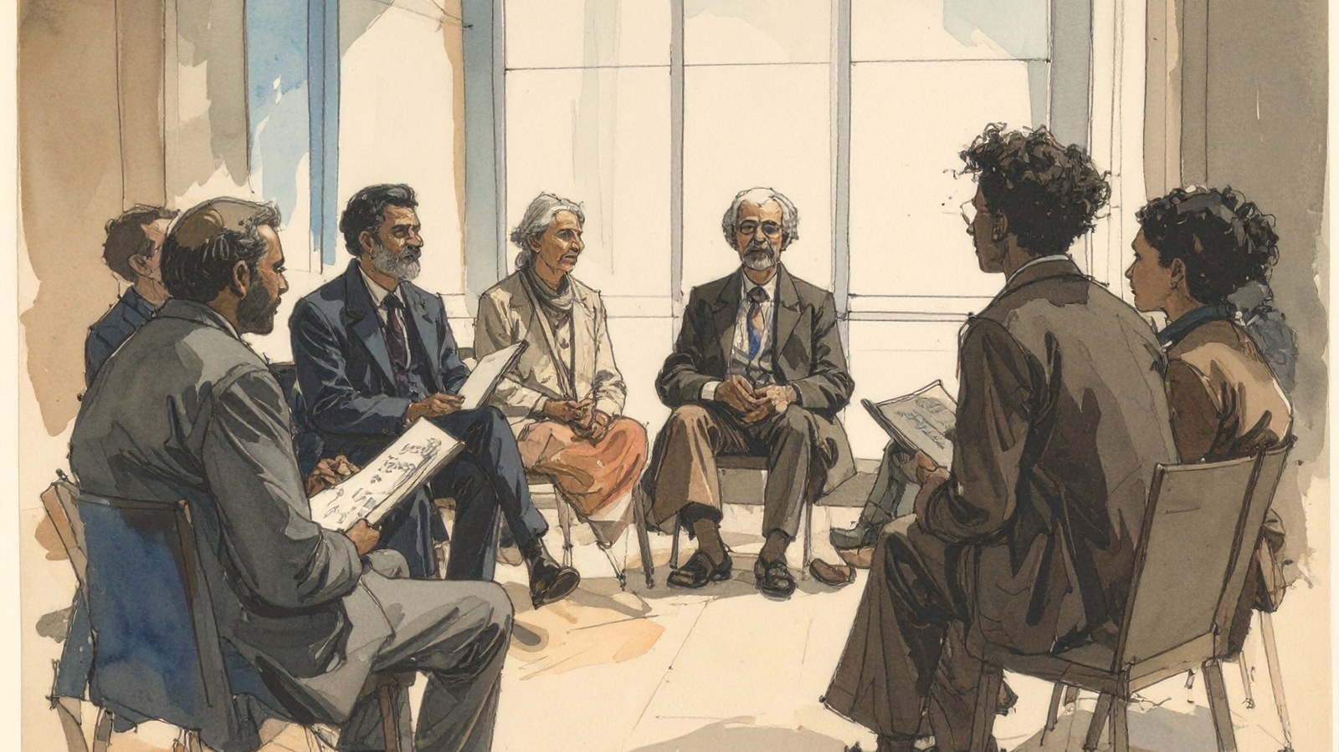
THE SITUATION
Vegetable processor Van Dijk has twelve vacancies for seasonal work. Nobody responds. HR adviser Mo receives an offer from Kadir (29), an asylum seeker who lives nearby and is keen to work. He is handy and already speaks the local language well.
Under the rules, Kadir may only work to a limited extent for now and the company needs a permit. That takes weeks. Kadir says: “I’ve been sitting at home for months. Just let me start.” The director says: “We can’t fix the whole system, but the harvest won’t wait.”
Mo sees the problem as bigger than this company: rules on work and asylum, shortages, and what is fair to those who are waiting. In the fishbowl, the inner circle holds the conversation and the outer circle observes.
Fictional case. Any resemblance to real persons or organisations is coincidental.

HOW TO WORK
- Read the case. Choose: inner circle (5–8 students) or outer circle. (5 min)
- Round 1: the inner circle discusses what Mo should do. The outer circle fills in the observation sheet. (15 min)
- Swap circles. Round 2 with a new inner circle. (15 min)
- Plenary: what did the outer circle see, and what stood out? (5 min)
- Fill in your reflection. (5 min)
OBSERVATION SHEET OUTER CIRCLE
Pay attention to… | Round 1 | Round 2
Who gets to speak? Who doesn’t?
Which values do you hear?
Which argument strikes you?
What is missing from the conversation?
MY OWN POSITION
If I were Mo, I would… because… (name at least two perspectives)

REFLECTION
WEIGHING Which value weighed most heavily for you, and what should the law or policy change?

