ASSIGNMENT MW38 — MORAL CASE DELIBERATION · HRM  Zero tolerance  Case: Van Houten Transport | COMPLEXITY  MESO ★★☆
Phase in the model: WEIGHING ACTING Time: 60 min Group: 4–5 students
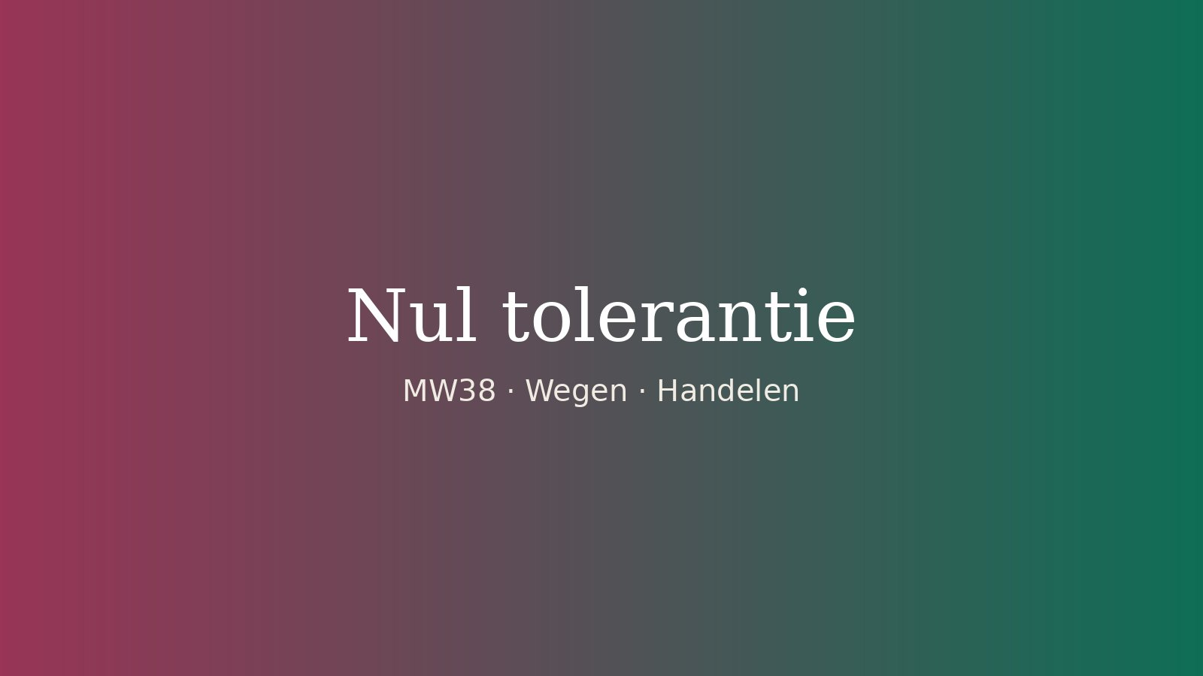
THE SITUATION
It is Monday morning at Van Houten Transport, a company with 400 employees. On Friday, forklift driver Jeroen (44, twelve years with the company) nearly hit a colleague in the warehouse. The mandatory test after the incident showed that he had been drinking. The policy is clear and everyone has signed it: alcohol at work means dismissal. “Zero tolerance”, it says in the staff handbook.
In his meeting with HR adviser Mirjam, Jeroen breaks down. Since his divorce he has been drinking too much, he says, and he wants help. “I’m so ashamed. Give me one chance.” His team leader backs him: “Twelve years and never a problem. He’s my best man.” But Esra, the colleague who was almost hit, says: “If he comes back, I won’t work on the floor next to him any more.”
The director wants a proposal tomorrow: “We have that policy for a reason.” Mirjam knows that two years ago an agency worker was dismissed on the spot for the same thing. She also knows that addiction is often regarded as an illness, and that an employer then has a duty of care. What will she put on the table tomorrow?
Fictional case. Any resemblance to real persons or organisations is coincidental.

HOW TO WORK
- Read the case on your own. Underline what Mirjam has to decide and who is involved. (5 min)
- Formulate the dilemma as a choice between two options: A or B. (5 min)
- For each option, fill in which values are at stake, which duties or rules apply and who faces which consequence. (15 min)
- Make your own choice before the discussion. Write it down using because – even though – therefore. (5 min)
- Discuss in your group. Listen first, then ask follow-up questions. Only respond to someone else’s choice once everyone has spoken. (20 min)
- Decide together what Mirjam will say to the director tomorrow and how she will inform Jeroen and Esra. (10 min)
STEP 2 — THE DILEMMA
Mirjam has to choose between A:

and B:

STEP 3 — THE ANALYSIS
 | Option A: … | Option B: …
Values
What matters here, and to whom?
Duties and rules
Which agreements, rules and duties apply?
Consequences
Who faces which consequence, now and later?
STEP 4 — MY DECISION (BEFORE THE DISCUSSION)
I choose ☐ A ☐ B, because … Even though … Therefore I will …

REFLECTION
WEIGHING Which value weighed most heavily for you, and which counterargument did you take most seriously? Support your answer with at least two ethical perspectives: duty, consequences, or virtue and care.

ACTING What exactly will Mirjam say tomorrow, to whom, and what will she do for Jeroen and for Esra?

