ASSIGNMENT MW60 — THEATRE FOR DEVELOPMENT · SUSTAINABILITY  Listen first, then play  Case: a sustainability adviser and a neighbourhood that does not feel heard | COMPLEXITY  MESO ★★☆
Phase in the model: SEEING ACTING Time: 90–120 min Group: 10–30 participants
Suitable for: Vocational · Applied · Academic
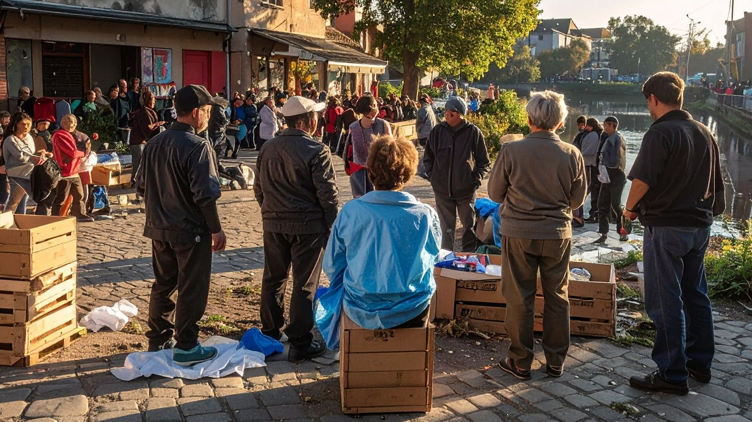
THE SITUATION
Fenna Verhoeven is a sustainability adviser at the municipality of Hoogeveld. The municipality wants to take the De Linde neighbourhood off natural gas within three years and connect it to a heat network. The plan is meant to make the neighbourhood more sustainable and lower energy costs in the long run. The council has approved the plan and the schedule is fixed.
Yet Fenna hears something different in the street and in the neighbourhood app. An older resident says the letter was incomprehensible. Young people in the neighbourhood say nobody asked them anything. The owner of a small shop fears the costs. At the first information evening few people came, and those who did were angry: “You decided this long ago.”
Fenna wants to find out first what is going on in the neighbourhood, through conversations and a short neighbourhood project, before the contractor starts. Her team leader points to the subsidy deadline. Some colleagues fear that extra research will delay the plan and that residents will only want more afterwards. Fenna knows trust is hard to win back once it has been lost.
How can Fenna let residents really take part without halting the plan, and what must change in the municipality for that?
Fictional case. Any resemblance to existing persons or organisations is coincidental.
HOW TO WORK
1. Read the case. Fill in the research sheet for the case: who is involved, what would they say, and what do we not know? (10 min)
2. In groups of 5–6, choose a small, non-sensitive issue from your own environment (programme, workplace, neighbourhood). Investigate it through short conversations or interviews with two or three people involved. Do not write down names and ask permission. (25 min)
3. Use the scene builder to make a short scene (five minutes at most) that shows what you heard. Use fictional names and give every voice involved a place. (25 min)
4. Perform the scene for the other groups and, if possible, for one or two people involved. Stop at the point of tension. (15 min)
5. Public conversation: the audience asks questions, makes suggestions and, where needed, takes the place of a character. Note which solutions are mentioned and who would have to carry them out. (20 min)
6. Make an action plan per group: what will we do, who does it, when, and which of the people involved will help decide? (15 min)
RESEARCH SHEET — WHAT IS GOING ON?
Question | What did I see or hear?
What is the problem, in one sentence?
Who is involved?
What does each person involved say?
What is not said or asked?

SCENE BUILDER
Part | My scene
Place and moment
Characters and their interests
What happens (beginning, middle, point of tension)?
Where do we stop for the audience?

ACTION PLAN
What will we do? | Who does it? | When?

REFLECTION
SEEING What did you see in the research or in the public conversation that you had not seen before?

ACTING Which first step can you take yourself, and whom do you need to involve?

WHERE DOES THIS METHOD COME FROM?
Theatre for Development has several forms that emerged in the second half of the twentieth century, among others in Botswana (Laedza Batanani), Kenya (Kamĩrĩĩthũ) and South Africa. Communities use theatre to investigate a problem from their own lives. Mda (1993) describes such practices. It is not a given that theatre gives everyone a voice: it can also be used from above. Therefore keep asking who poses the question and who decides about it.

