ASSIGNMENT MW64 — HARAMBEE ACTION PLAN · DIVERSITY AND INCLUSION  Pulling together, each their part  Case: a working group and a task that stays undone | COMPLEXITY  MESO ★★☆
Phase in the model: ACTING PERSEVERING Time: 45–60 min Group: 6–30 participants
Suitable for: Vocational · Applied
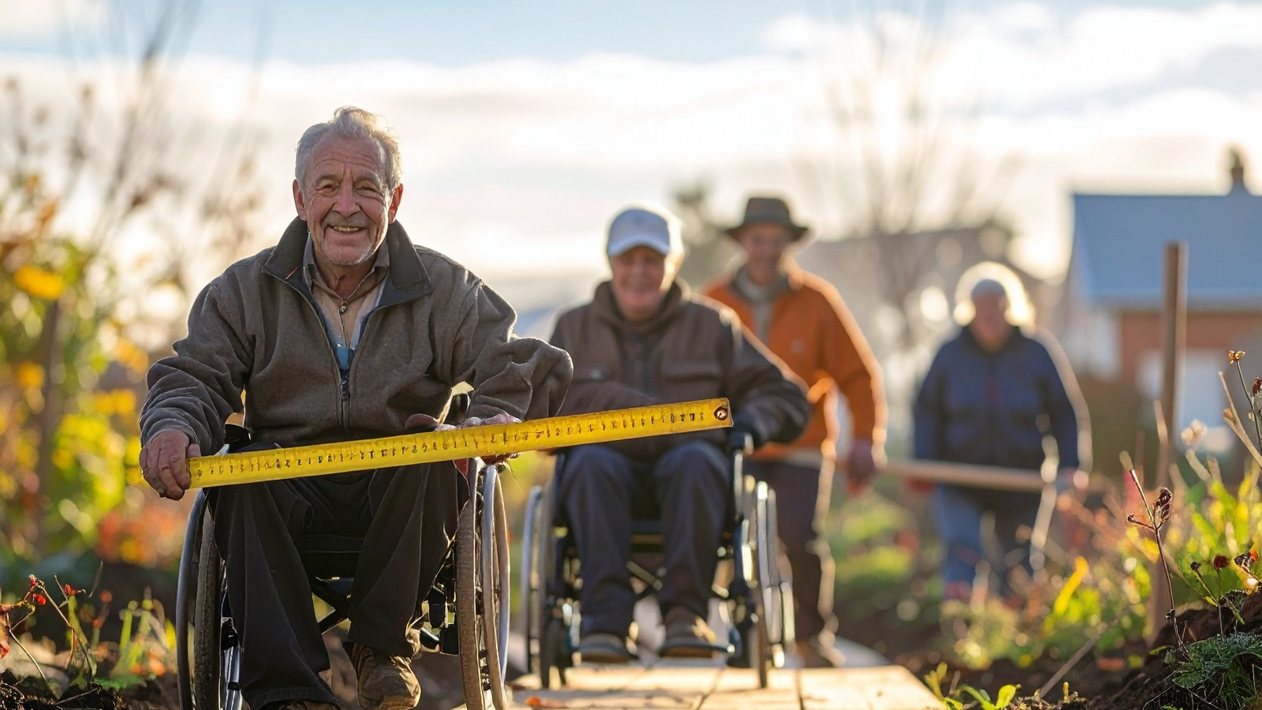
THE SITUATION
The diversity and inclusion working group of a mid-sized organisation wants to set up one concrete action this quarter: a mentoring programme for new colleagues. There are six members. Nora chairs the group and divides the tasks at the first meeting. Hamid writes the invitation, Joke arranges the room, Bas looks for mentors in his network and Femke makes the schedule.
After three weeks almost everything is ready, except Sven’s part. He was going to contact two departments but has not called anyone yet. At the meeting he says: “I’ll get to it, it’s busy.” Nobody responds. Afterwards Joke says quietly to Nora: “I’ll do it, otherwise it won’t get finished.”
Hamid prefers not to address Sven: the group started with the idea that everyone takes part voluntarily. Bas feels that free-riding undermines trust. Femke points out that Sven has only recently joined the organisation and may not dare to say that his task is unclear.
What should the working group do: take over Sven’s part, speak to him or change the agreements? And what does that say about how they carry collective responsibility?
Fictional case. Any resemblance to existing persons or organisations is coincidental.
HOW TO WORK
1. Read the case. Discuss briefly in pairs: what is going well and where does it get stuck? (10 min)
2. Choose with the group one moral issue in your own surroundings (school, internship, neighbourhood) that you can work on together. (10 min)
3. Fill in your contribution card individually: what do I bring in terms of time, knowledge and network? (10 min)
4. In groups of 4–6, make an action plan in which everyone has a part. Also agree how you will address each other when something stays undone. (15 min)
5. Share the plans. Discuss what makes collective responsibility strong and what makes it vulnerable. (10 min)
MY CONTRIBUTION CARD — WHAT DO I BRING IN?
I bring in | Concretely: what and when?
My time
My knowledge
My network
What I need from others

OUR ACTION PLAN
Step | Who | When

REFLECTION
ACTING What do you do when you see that someone in the group does not take up their part?

PERSEVERING What helps a group to persevere together without a few people carrying everything?

WHERE DOES THIS METHOD COME FROM?
Harambee is a Swahili word from Kenya and means “let us pull together”. In Kenya it is used for community self-help initiatives in which people bring together resources and effort. Research on this movement describes not only what it achieves, but also tensions (Ngau, 1987). We use the idea as a starting point for your own plan; this is not a description of how harambee works in Kenya.

