ASSIGNMENT MW36 — FOUR ETHICAL LENSES · HRM  One budget, two programmes  Case: a consultancy with 140 employees | COMPLEXITY  MESO ★★☆
Phase in the model: WEIGHING Time: 60 min Group: 2–4 students
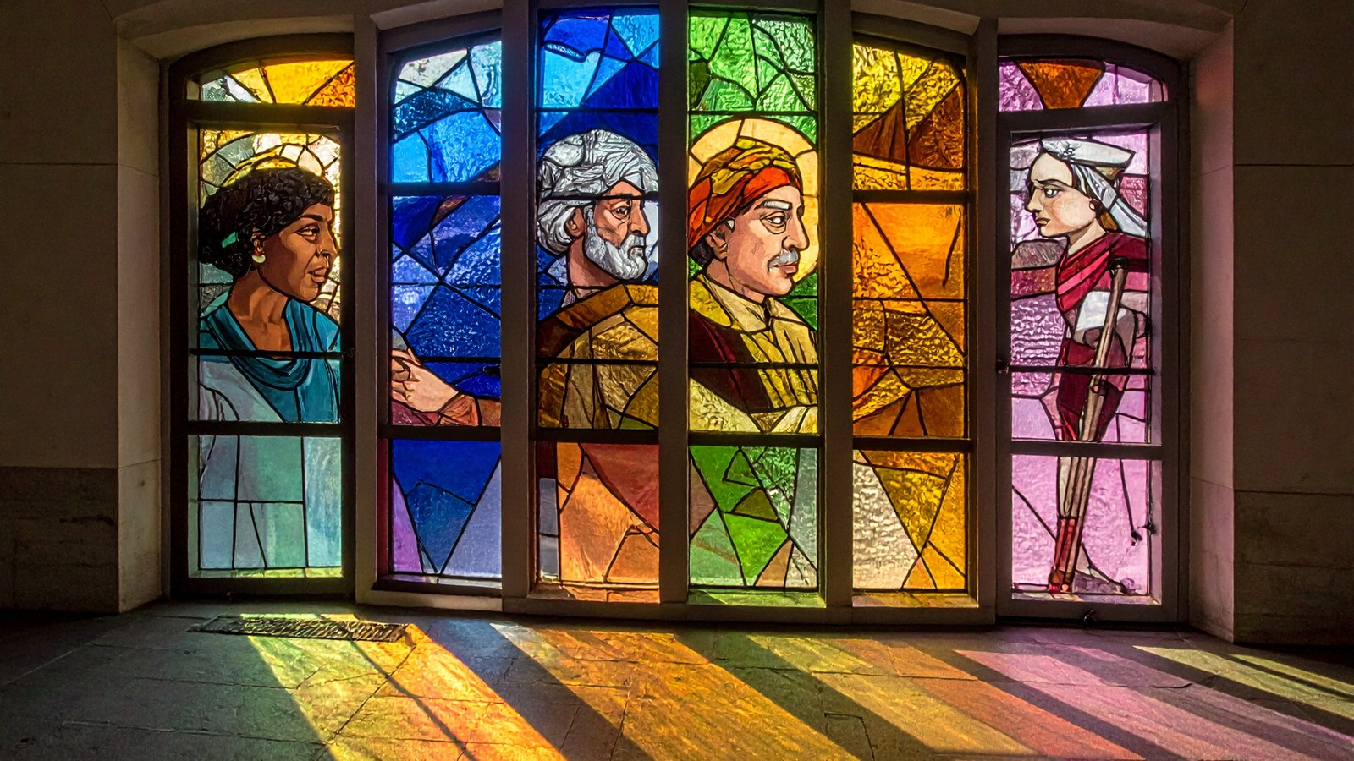
THE SITUATION
Femke is an HR adviser at a consultancy with 140 employees. She has one training budget of €40,000 and has to choose today. Option A: a leadership programme for eight high potentials whom management wants to retain. Option B: basic digital skills training for sixty employees, including many colleagues over fifty who feel insecure with the new systems.
Management says: “Invest in those who move the company forward.” A team leader says: “If we leave the rest behind, they’ll drop out.” One of the high potentials, Priya, says she is considering leaving without a programme. An older colleague, Hans, asks quietly: “Am I still of value?”
Femke does not want to decide on gut feeling alone. She looks at the choice through four lenses: what does it deliver, what do we owe each other, what kind of HR professional do I want to be, and who needs my care?
Fictional case. Any resemblance to real persons or organisations is coincidental.

HOW TO WORK
- Read the case. Note down in one sentence the choice Femke faces. (5 min)
- Look at the case through each lens. Fill in the table, first on your own, then with your group. (25 min)
- Choose an option or a third way. Write down which lens weighs most heavily for you and why. (15 min)
- Compare with another group. Does the difference lie in the lens or in the facts? (10 min)
- Fill in your reflection. (5 min)
THE CHOICE IN ONE SENTENCE
Femke has to choose between… and…

FOUR LENSES ON THE SAME CASE
Lens | What do you see in the case? | What weighs heavily here?
Consequences
What does each option deliver, for whom, and how much?
Duties and rights
What do we owe each other, even if it delivers nothing?
Virtues
What would a just, courageous or caring HR adviser do?
Care
Who is vulnerable and how does the relationship stay intact?
MY CHOICE
I choose… For me, the lens… weighs most heavily because…

REFLECTION
WEIGHING Which lens gave you the most new insight, and which lens made your choice harder? Support your answer with at least two perspectives.

