**Framework**

**A Framework is a set of conceptual structure and guidelines , used to buid something useful.**

**Example : Shape of Bricks Box / Frames**

Shape Box / Frame of Bricks

Bricks

Man

**Framework in terms of Programming :**

A Framework may include predefined classes and functions that can be used to process input , manage hardware devices, and interact with system software .

The purpose of the framework is to allow developers to focus on building a unique feature for their Projects rather than writing code scratch.

**Why use Framework :**

* Collection of tools
* No need to start from scratch
* Save Time
* Improve Productivity
* Clean Code
* Testing
* Debugging

**Web Framework**

A Web Framework ( WF ) or Web Application Framework ( WAF ) which helps to build Web Applications.

Web Frameworks provide tools and libraries to simplify common web development operations. This can include web services, API’s and other resources.

Web Frameworks help with a variety of tasks, from templating and database access to session management and code reuse.

**Some Web Frameworks**

* Laravel
* Codeigniter
* Zend
* Django
* Spring

**Model View Template (MVT) :**

The Model View Template ( MVT ) is an design pattern that seperates an application into three main logical components thts is : *Model , View* , and *Template .*

Each of these component has their own role in a Project.

**Model :**

The Model responsible to handle database. It is a data access layer which handles the data.

**View :**

The user can send request by interacting with template , the View handles three request and sends to Model then get appropriate response from the Model , sends response to template.

It may also have required logic.

It works as mediator between Template and Model.

**Template :**

It represents that how data should be presented to the application user. User can read or write the data from Template.

Basically it is responsible for showing end user content,we can say it is user interface.

It may consists of HTML,CSS,JS mixed with Django Template Language.

**How MVT Works ?**

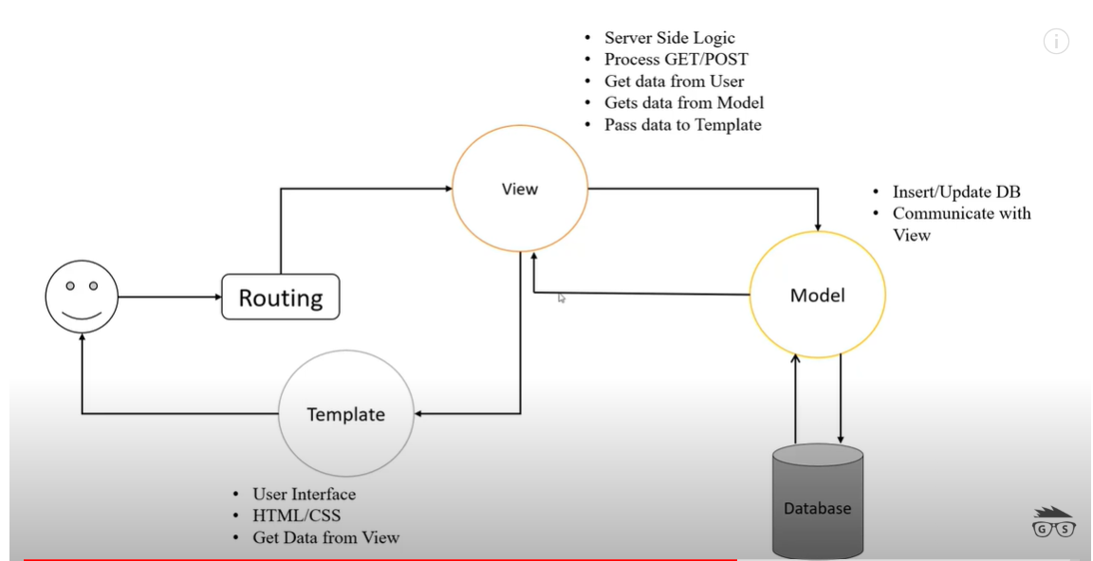

**Or we can represent by below Diagram…..**

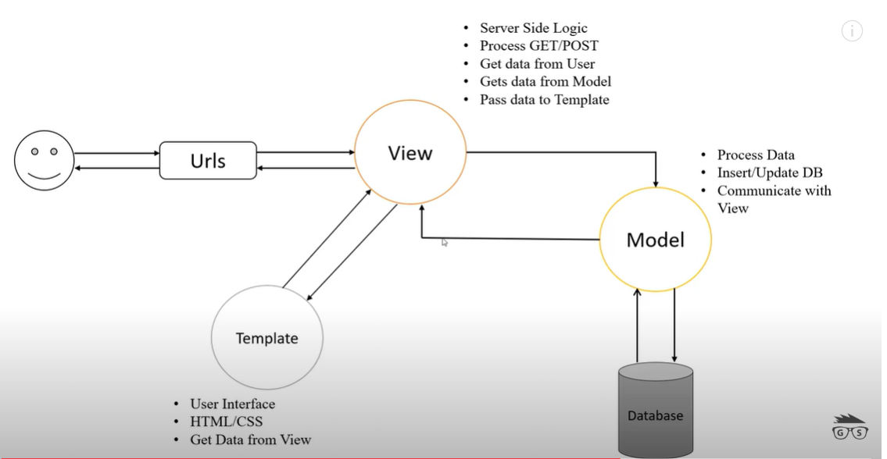

**Why use MVT :**

* Organized Code
* Independent Block
* Reduces the complexity of web applications
* Easy to maintain
* Easy to modify

**Chapter 1**

**Django**

* Django is a free open-source Python based High-Level **Web Framework.**
* It follows the *Model View Template* (MVT) arctitecture pattern.
* It was originally created by **Adrain Holovaty** and **Simon Willison.**
* It was created on 2003 at **Lawrence Journal World Newspaper.**
* It was released publicly under a **BSD** license in July 2005.
* In June 2008 , it was announced that **Django Software Foundation** (DFS) would maintain Django in the future.

**What we can build with Django** :

We can build High End Web Applications.

It encourages rapid development and clean , pragmatic design.

* Youtube
* Instagram
* Bitbucket
* NASA
* Spotify

**Advantages of Django :**

* Open Source
* Free and Fast
* Secure
* Scalable
* Authentication
* Versatile
* Provides Development Web Server by Default
* Provides SQLite Database by Default

**Chapter 2**

**Do You Know ?**

* HTML
* CSS
* JavaScript
* SQL
* Python
* MVT
* PIP
* Bootstrap

**Django Requirements**

* Python 3.0 or Higher
* PIP
* Text/Code Editor / IDE – Notepad++ , VS Code, ATOM ,Brackets , PyCharm.
* Web Browser : Google Chrome,Mozilla Firefox,Edge etc..

**Chapter -3**

**Django Requirements :**

* Python 3.0 or Higher

Python –version

* PIP

pip –version

* Text Editor / Code Editor : Notepad ++,VS Code, ATOM , Brackets , PyCharm
* Web Browser - Google Chrome,Mozilla Firefox,Edge etc..

**Check Django is Installed or Not ?**

**Open CMD :**

django-admin –version

'django-admin' is not recognized as an internal or external command,

operable program or batch file.

**How to Install Django ?**

There are two way to install Django

1. Virtual Env
2. Whole System

1. Using virtual env

**Install Virtual Environment Wrapper**

*pip install virtualenvwrapper-win* : This is used to install virtual environment wrapper.

**Create Virtual Environment (VE)**

*mkvirtualenv* envname : This is used to create virtual environment. It will automatically activate environment.

**Active VE**

*workon* envname : This is used to activate environment.

**Install Django in Created VE**

*pip install django* : First activate environment then run the command to install Django within active environment . You can also specify version

*pip install Django==2.0*

**Open CMD and just type---**

*django-admin --version*

'django-admin' is not recognized as an internal or external command,

operable program or batch file.

**Now type—**

*workon envname*

**Django Project**

A Django project may contain multiple Project Application , which means a group of Application and files is called as Django Project.

An Application is a part of Django Project.

A group of applications is can be called Project.

**SchoolProject**

* Registration application
* Fees application
* Exam application
* Attendance application
* Result application

**Create Django Project For VE**

Syntax :-

*django-admin startproject projectname*

Example :-

*django-admin startproject* *schoolproject*

SchoolProject **Outer Project Folder**

**SchoolProject Inner Project Folder**

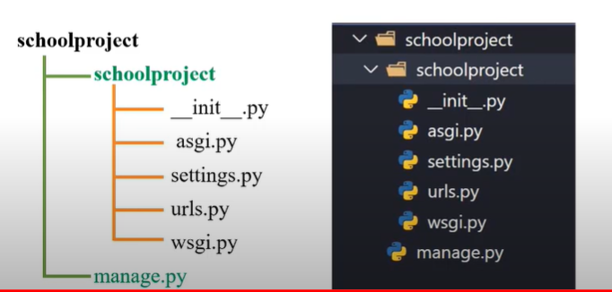

**Chapter – 5**

**How to Install Django ?**

2. For Whole System

**Django Requirements :**

* Python 3.0 or Higher

*python --version*

Python 3.11.0

* PIP

*pip --version*

pip23.3.1fromC:\Users\RAVIPRAKASH\AppData\Roaming\Python\Python311\site-packages\pip (python 3.11)

* Text / Code Editor
* Web Browser

**Check Django is installed or Not ?**

**For Check :** *python -m django --version*

'django-admin' is not recognized as an internal or external command,

operable program or batch file.

**How to Install Django:**

*pip install django* This is used to install Django Globally .

Successfully installed pip-24.0

**Now check that Django is installed or not**

*django-admin –version* This is older version command.

*python -m django --version*  This is new command.

**For Vesrion Specfic**

*pip install django==2.0*

**How to Uninstall :**

*pip uninstall django*

**Create Django Project For Globally Sysytem**

**d:**

Syntax :-

*python -m django startproject project_name*

Example :-

*django-admin startproject* *schoolproject* This is older version command.

*python -m django startproject ravipro* This is new version command.

SchoolProject **Outer Project Folder/ Root Directory**

**SchoolProject Inner Project Folder / Default Applic**



**How to run Python Project :**

*cd project_folder_name*

*python manage.py runserver*

now server will start and server link will be shown and be activated.

**Example:**

PS F:\Django\NHPC> python manage.py runserver

Watching for file changes with StatReloader

Performing system checks...

System check identified no issues (0 silenced).

February 09, 2024 - 13:40:55

Django version 5.0.2, using settings 'GymManagementSystem.settings'

Starting development server at http://127.0.0.1:8000/

Quit the server with CTRL-BREAK.

**How to stop server ?**

**ctrl+c**

**Chapter – 6**

**Django Project Directory Structure**