**A Neuro-Driven Mobile Robot Enhanced by LoRa and EEG Technology**

Aswin K1, Akash R2, Balaji M3, Barath K4, Kannan S5

1Assistant Professor, Department of Computer Science and Engineering, Dhanalakshmi Srinivasan Engineering College, Perambalur

2Student, Department of Computer Science and Engineering, Dhanalakshmi Srinivasan Engineering College, Perambalur

3Student, Department of Computer Science and Engineering, Dhanalakshmi Srinivasan Engineering College, Perambalur

4Student, Department of Computer Science and Engineering, Dhanalakshmi Srinivasan Engineering College, Perambalur

5Student, Department of Computer Science and Engineering, Dhanalakshmi Srinivasan Engineering College, Perambalur

**Abstract -** The Cognitive Rover project presents an imaginative way to deal with portable mechanical technology, coordinating high level neuro-innovations with long-range correspondence capacities to make a flexible and versatile mechanical stage. The essential target of the task is to foster a versatile robot fit for independent route and connection with its current circumstance, directed by brain signals got through electroencephalography (EEG) innovation. Utilizing the LoRa (Long Range) correspondence convention, the robot lays out strong network overstretched distances, empowering far off activity and information transmission in different situations, including search and salvage missions, perilous climate investigation, and far off review errands. The proposed framework design comprises of two fundamental parts: a neuro-driven control framework and a correspondence module. The neuro-driven control framework uses EEG signals gathered from a MindWave headset to decipher client orders and natural boosts. Through AI calculations and continuous sign handling strategies, the framework makes an interpretation of EEG signals into noteworthy orders for independent route, obstruction evasion, and undertaking execution. The correspondence module incorporates LoRa innovation to work with consistent information trade between the robot and far off administrators, empowering continuous observing, control, and video real time over significant distances. Key benefits of the Cognitive Rover incorporate its versatility to assorted conditions, instinctive client association through cerebrum PC interface innovation, and vigorous long-range correspondence abilities. Additionally, the task adds to progressions in mechanical technology, human-robot cooperation, and assistive advancements, with expected applications in misfortune reaction, ecological checking, and foundation review.

***Key Words*:** Electroencephalography (EEG), LoRa (Long Range), Cognitive Rover (CR), Brain Computer Interface (BCI), Bluetooth Low Energy (BLE), Transmitter (Tx)

**I. INTRODUCTION**

Lately, headways in mental science and advanced mechanics have combined to reclassify the conceivable outcomes of human-machine cooperation. The "Cognitive Rover" project arises at this convergence, meaning to spearhead an original way to deal with portable mechanical technology. By bridling the force of EEG signals and coordinating them with state-of-the-art correspondence innovation, the undertaking tries to foster a versatile robot fit for understanding and answering human mental orders. Customary techniques for robot control frequently depend on unequivocal orders or predefined calculations, restricting their versatility and responsiveness in unique conditions. Conversely, neuro-driven control offers an additional instinctive and regular method for collaboration, permitting clients to convey guidelines straightforwardly from their mental states. This venture's creative viewpoint lies in its mix of EEG-based Brain-Computer Interface (BCI) innovation with LoRa correspondence, empowering consistent communication between the client and the robot overstretched distances. Through this reconciliation, clients can remotely control the robot's developments and activities, cultivating additional opportunities for applications in investigation, reconnaissance, and help.

As indicated by researchers review; the Electroencephalogram (EEG) of individuals can mirror his various states all the more precisely. So, in the advanced Astute Transportation Frameworks which primarily characters organization and data, in the event that the driver's EEG data can be accumulated Progressively, we can drive the vehicle as per the directions from the mind. Electroencephalography (EEG) is an electrophysiological checking technique to record electrical action of the cerebrum. In the event that it tends to be utilized for controlling a meanderer we can roll out a wonderful improvement in the transportation field. These days cerebrum-controlled wheelchairs are accessible. With a stride in front of that we are uncovering the potential outcomes of EEG in the field of transportation. The wanderer was made to rouse all crippled individuals in the general public to have certainty to autonomously investigate. In the mind machine interface innovation, the electrical signs from the cerebrum are removed and handled to run different applications.

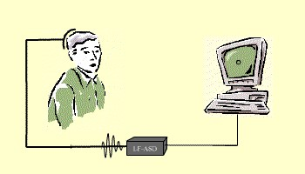

**Figure-1:** Brain-Computer Interface (BCI)

As examined before, this framework is shaped by utilizing remote innovation and we as of now have a modest bunch of remote conventions like BLE (Bluetooth Low Energy), Wi-Fi, and cell, and so on. Yet, these innovations are not great for IoT sensor hubs, since they expected to communicate data to a significant distance without utilizing a lot of force and with minimal expense. Aside from this LoRa innovation assumes an imperative part in the horticulture area.

That is the reason we are utilizing LoRa innovation, which can perform extremely lengthy reach transmission of information or data for minimal price and without a web association. The term LoRa represents Long Reach. It is a remote radio recurrence innovation presented by Sem tech. LoRa is accustomed to sending data in the two bearings to significant distance and commonly LoRa can accomplish a distance of 15 to 20 km and can deal with battery for a year. In remote innovation arrangement, BLE works with low power, yet can't send information to significant distance. While utilizing LoRa we can accomplish high distance correspondence without a web association, hence it defeats the downsides of Wi-Fi and BLE correspondence. The underneath diagram gives a distinction between WSN innovation.

**II. RELATED WORKS**

A BCI gives an interconnection stage that upholds the full duplex correspondence between the mind and an outside gadget. As indicated by the way that BCIs use to set up the cerebrum gadget interconnection, they are delegated harmless or obtrusive. Harmless BCIs use anodes put on the scalp. They are simple and protected to utilize, minimal expense, convenient, and offer a generally high transient goal. Obtrusive BCIs use terminals embedded in the inside of the scalp. Relatively to painless BCIs offer higher upsides of sufficiency, spatial goal, and protection from commotion. Notwithstanding, they require neurosurgery tasks and they are both perilous and costly. Besides, scar tissues decline the nature of signs got. For all intents and purposes, painless BCIs are utilized more regularly.

There are different harmless philosophies utilized in BCI innovation, like Positron Emission Tomography (PET), functional Magnetic Resonance Imaging (fMRI), and Near-Infrared Spectroscopy (NIRS), which study changes made in the blood stream, magnetoencephalography (MEG), which screens the attractive activity of the mind, and EEG, which records the electric movement of the cerebrum. Both NIRS and fMRI BCIs offer high spatial goal, however unfortunate worldly goal. Besides, MEG and PET BCIs offer high spatial and worldly goal. In any case, PET BCIs require the immunization of a radioactive constituent into the circulation system. Moreover, both fMRI and MEG techniques depend on the utilization of gear which isn't just exorbitant, yet in addition enormous. EEG BCIs are by a wide margin the most well known type, in light of the fact that, regardless of their generally poor spatial goal, they have high worldly goal, minimal expense, and simple establishment. [6].

In addition, BCIs are delegated either exogenous or endogenous, as per the idea of the information signals. Exogenous BCIs break down the cerebrum movement made because of outer improvements. They are not difficult to set up and offer high piece rates, yet they need the persistent reaction of the client to outward instigations which might be either tiring, or even impractical. Endogenous BCIs utilize self-guideline of brainwaves without outside improvements. They give lower information move rates however they can be worked by means of free poise even by clients with tangible organs impacted or experiencing engine neuron infections [10].

Also, BCI frameworks are characterized, as indicated by the technique utilized for input information handling, as simultaneous or offbeat. Coordinated BCIs break down the mind cues solely after a particular brief and during predefined time spans. Accordingly, the general cycle is better coordinated and the client is allowed to make any sort of developments, which would create ancient rarities, when mind cues are not noticed. They likewise require insignificant preparation and have stable execution and high exactness. Offbeat BCIs examine mind cues progressively, in this manner allowing the client to act at through and through freedom. Consequently, they offer more regular human-machine cooperation. Nonetheless, they are more perplexing in plan and assessment and require broad preparation. Also, their presentation might change among clients, and their exactness isn't extremely high [10].

2023 Rajeshwari Sissodia, This undertaking means to foster a robot vehicle controlled through voice orders and outfitted with hindrance identification highlights. By incorporating parts like the Arduino Uno microcontroller, HC-05 Bluetooth module, and ultrasonic sensor, the framework empowers clients to explore the robot utilizing verbal guidelines. The voice-controlled interface offers sans hands activity, upgrading client accommodation and wellbeing. Also, the consideration of snag discovery innovation permits the robot to independently stay away from impacts, guaranteeing productive and dependable route. Nonetheless, difficulties, for example, restricted jargon acknowledgment and potential sign obstruction might affect the framework's exactness and dependability.

**III. PROPOSED METHODOLOGY**

The proposed framework presents a change in outlook in versatile advanced mechanics by coordinating mental science, advanced mechanics, long-range correspondence innovation. It includes a rain-Computer Interface (BCI) that deciphers mental states from EEG signals got through a MindWave headset, empowering direct human-robot communication.

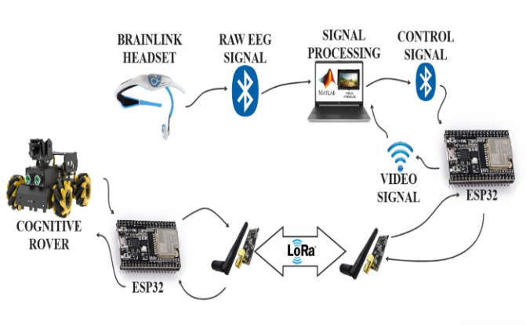

**Figure-2:** Proposed flow diagram

MATLAB works with the point of interaction between the BCI sensor and the PC, considering consistent information handling and investigation. Correspondence between the robot and a UI is worked with by LoRa innovation, guaranteeing productive information move overstretched distances.

Clients have some control over the robot's developments and activities through neuro-driven orders got from EEG signals handled in MATLAB. This exhaustive framework expects to upset human-robot connection capacities, preparing for applications in investigation, reconnaissance, and help.

The venture coordinates different modules to make an exhaustive mental meanderer framework. The Brain-Computer Interface (BCI) Execution module empowers direct correspondence between the client's mind cues and the robot's control framework, working with instinctive control. Mix of LoRa Correspondence lays out lengthy reach remote correspondence between the robot and the administrator, guaranteeing dependable information transmission overstretched distances. The Neuro-Driven Control Framework saddles progressed calculations to decipher mind cues and make an interpretation of them into exact orders for controlling the robot's developments and activities. Moreover, Continuous Video Web based uses the ESP32-CAM to communicate live video feed from the robot's camera, furnishing administrators with visual input for remote observing and reconnaissance. Together, these modules empower consistent communication and control of the mental wanderer framework, upgrading its usefulness and ease of use in different applications.

*Brain-Computer Interface (BCI)*

The Brain-Computer Interface (BCI) Execution module incorporates sensors equipped for catching brainwave flags straightforwardly from the client's cerebrum. These sensors, frequently EEG (Electroencephalography) gadgets, recognize electrical movement created by neurons in the cerebrum and convert it into computerized signals.

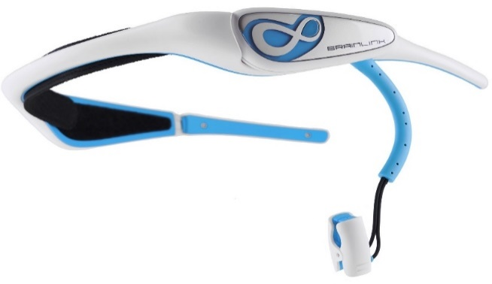

**Figure-3:** Brain-Link Headset

High level sign handling procedures, including sifting and element extraction calculations, are utilized to preprocess the crude brainwave information, upgrading its quality and dependability. AI calculations, for example, brain organizations or backing vector machines, are then used to decipher the handled signals and group them into particular mental states or orders. This empowers the framework to perceive explicit cerebrum designs related with client goals, for example, development orders or mental errands.

The BCI framework lays out an immediate correspondence pathway between the client's mind and the robot, considering consistent cooperation without the requirement for customary info gadgets. Clients have some control over the robot's activities just by balancing their cerebrum action, for example, envisioning explicit developments or zeroing in on specific undertakings. Constant criticism instruments guarantee that the framework consistently adjusts to the client's mental state, giving a responsive and natural control insight. Also, the BCI execution is intended to be easy to understand and open, obliging people with changing degrees of mental capacity or engine capability. This cultivates inclusivity and empowers a large number of clients to really draw in with the robot.

By tackling the force of brainwave flags, the BCI execution module opens additional opportunities for human-robot communication and control. It empowers natural and normal correspondence among clients and robots, upgrading the ease of use and openness of mechanical frameworks in assorted applications. Also, progressing innovative work endeavors in BCI innovation keep on further developing sign handling calculations, arrangement precision, and framework heartiness, further propelling the abilities and execution of BCI-empowered robots. Thus, the BCI execution module addresses a critical part in making keen and client driven mechanical frameworks that can flawlessly coordinate into different conditions and help clients in achieving undertakings all the more productively and really.

*Integration of LoRa Communication*

In the Coordination of LoRa Correspondence module, there are two unmistakable parts: the transmitter and the collector. The transmitter is liable for sending information from the robot to the UI, while the recipient gets information from the UI and transfers orders or criticism to the robot.

The transmitter part of the LoRa Correspondence module is coordinated into the robot's equipment design. It comprises of a LoRa handset module associated with the microcontroller installed the robot. This module is modified to encode information bundles containing data about the robot's status, sensor readings, or telemetry information. The LoRa handset utilizes regulation procedures to send these bundles remotely over significant distances, guaranteeing dependable correspondence with the collector.

**Figure-4:** Block Diagram of Processing Side

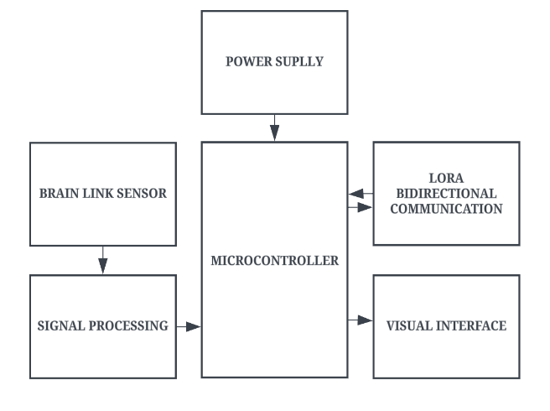

On the UI side, the beneficiary piece of the LoRa Correspondence module is coordinated into the equipment or programming connection point used to control or screen the robot. It comprises of one more LoRa handset module associated with a microcontroller or a PC. This module is designed to get the information bundles sent by the robot's transmitter. After getting the bundles, the collector translates the data and cycles it in like manner. For instance, in the event that the information parcel contains orders for the robot, the recipient advances these orders to the suitable parts of the robot's control framework.

Utilizing a site or android application, the ranchers can remotely control the engine. Here framework beneficiary work as a transmitter. Presently our transmitter is an assortment of ESP32, LoRa SX1278 with receiving wire, 5V power supply, and controlling page.

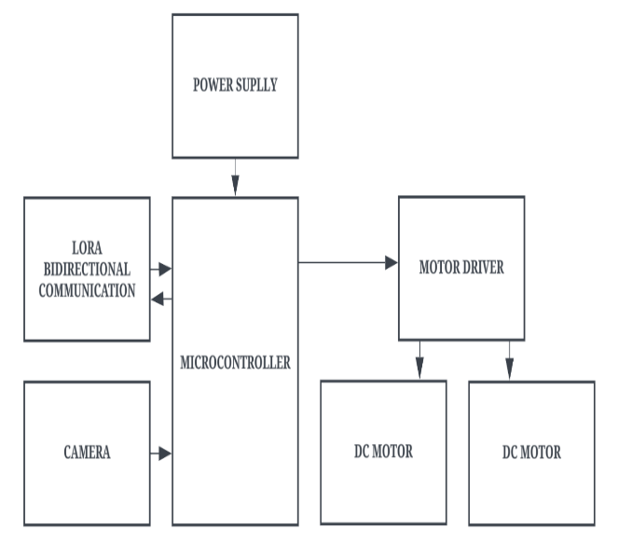

**Figure-5:** Block Diagram of Rover Side

The Neuro-Driven Control Framework module outfits the force of Cerebrum PC Point of interaction (BCI) innovation to empower direct control of the robot's developments and activities through brain signals. This imaginative framework interprets mind action caught by BCI sensors into significant orders for the robot, working with instinctive and responsive control.

The module starts with the obtaining of brain signals utilizing BCI sensors, for example, electroencephalography (EEG) terminals or other neuroimaging gadgets. These sensors identify electrical signs produced by the client's cerebrum action, catching examples related with explicit mental states or orders.

*Preprocessing and Feature Extraction*

To remove the ideal alpha brainwaves from the EEG signals, separating was applied. All the more explicitly, a second request IIR score channel, having a quality component Q equivalent to 35, was applied to eliminate mains recurrence (50 Hz).

Thus, the signs were additionally separated by utilizing a Butterworth IIR bandpass channel with cutoff frequencies of 5 and 15 Hz. The greatest misfortune in the passband was viewed as equivalent to 0.1 dB. Essentially, the base weakening in the stopband was estimated to be equivalent to 30 db. The SciPy Python library was utilized for the plan and use of the channels.

**IV. RESULT & DISCUSSION**

The ESP32-CAM catches video film utilizing its installed camera module and encodes the video transfer into a reasonable organization for transmission over the correspondence organization. Encoding designs like MJPEG or H.264 are commonly utilized to adjust video quality and transfer speed utilization.

When encoded, the module chooses a suitable transmission convention, like RTSP, RTP, or HTTP, in light of elements like dormancy necessities, network data transfer capacity, and similarity with the less than desirable end.

The encoded video transfer is then sent over the correspondence network progressively. The ESP32-CAM can use Wi-Fi for remote correspondence inside or match with outside modules like LoRa or GSM for long-range correspondence in open air or far off conditions.

At the less than desirable end, a remote checking connection point shows the live video feed, permitting administrators to remotely notice the robot's environmental factors and exercises. The EEG application Bluetooth and WiFi Used for short range communication and LoRa used for long range communication.

Using the ESP32-CAM for ongoing video real time offers a practical and minimized answer for incorporating visual input into mechanical applications. Be that as it may, difficulties, for example, overseeing inactivity, improving data transfer capacity use, and guaranteeing strong organization network should be tended to for solid execution.

**V. CONCLUSIONS**

All in all, the task addresses a huge progression in the mix of mental science, mechanical technology, and correspondence innovation. By outfitting EEG signals through a Cerebrum PC Point of interaction (BCI) and utilizing LoRa correspondence for long-range network, the framework empowers natural human-robot connection and controller. The fruitful execution of this task opens ways to different applications in fields like investigation, observation, and help, exhibiting the potential for groundbreaking headways in human-robot collaboration standards. In future, wanted to make this as an application which can be effectively utilized by everybody. Carrying out cutting edge AI calculations to empower the wanderer to persistently gain from its cooperations and work on its mental abilities over the long run.

**REFERENCES**

1. X. Gao, D. Xu, M. Cheng, and S. Gao, “A bci-based environmental controller for the motion-disabled,” IEEE Transactions on Neural Systems and Rehabilitation Engineering, vol. 11, pp. 137–140, June 2003.

2. Zickler, V. Di Donna, V. Kaiser, A. Al-Khodairy, S. Kleih, A. K¨ubler, M. Malavasi, D. Mattia, S. Mongardi, C. Neuper, et al., “Bci applications for people with disabilities: deﬁning user needs and user requirements,” Assistive technology from adapted equipment to environments, AAATE, vol. 25, pp. 185–189, 2009.

3. S. P. Levine, J. E. Huggins, S. L. BeMent, R. K. Kushwaha, L. A. Schuh, M. M. Rohde, E. A. Passaro, D. A. Ross, K. V. Elisevich, and B. J. Smith, “A direct brain interface based on event-related potentials,” IEEE Transactions on Rehabilitation Engineering, vol. 8, pp. 180–185, Jun 2000.

4. J. J. Vidal, “Real-time detection of brain events in eeg,” Proceedings of the IEEE, vol. 65, pp. 633–641, May 1977.

5. J. J. Daly and J. E. Huggins, “Brain-computer interface: current and emerging rehabilitation applications,” Archives of physical medicine and rehabilitation, vol. 96, no. 3, pp. S1–S7, 2015.

6. Hanggoro, M. A. Putra, R. Reynaldo, and R. F. Sari, “Green-house monitoring and controlling using Android mobile application,” in 2013 International Conference on QiR, Jun. 2013, pp. 79–85, doi: 10.1109/QiR.2013.6632541.

7. Luzheng Bi, Xin-An Fan, Yili Liu “EEG-Based Braincontrolled Mobile Robots: A survey”, Human-Machine Systems, IEEE Transactions on (Volume: 43, Issue: 2), pp. 161-176, Mar 2013.

8. K ale Swapnil T, Mahajan Sadanand P, Rakshe Balu G, Prof. N.K.Bhandari “Robot Navigation control through EEG Based Signals” International Journal Of Engineering And Computer Science ISSN:2319-7242 Issue 3 March-2014.

9. E. W. Sellers, P. Turner, W. A. Sarnacki, T. Mcmanus, T. M. Vaughan, and B. Matthews, “A novel dry electrode for brain–computer interface,” in Proc. 13th Int. Conf. Human–Computer Interac., San Diego, CA, 2009, pp. 623–631.

10. J.d.R.Millan, R.Rupp, G.R.Muller-Putz, R. MurraySmith, C.Giugliemma, M.angermann, C. Vidaurre, F.Cincotti, A.Kubler, R. Leeb, C.Neuper, K.-R. Muller, and D.Mattia, “Combining brain–computer interfaces and assistive technologies state-of-the-art and challenges,” Frontiers Neurosci., vol. 4, pp. 1–15, 2010.

11. Shubh Srivastava, Rajanish Singh. Voice Controlled Robot Car Using Arduino, International Research Journal of Engineering and Technology (IRJET), ISSN: 2395-0056, Volume: 07, Issue: 05, May 2020.

12. Off-line Classification of EEG from the "New York Brain-Computer Interface (BCI)" Flotzinger, D., Kalcher, J., Wolpaw, J.R., McFarland,J.J., and Pfurtscheller, G., Report #378, IIG-Report Series, IIG:Institutes for Information Processing,Graz University of Technology, Austria 1993.

13. "Man-Machine Communications through Brain-Wave Processing" Keirn, Z.A. and Aunon, J.I., IEEE Engineering in Medicine and Biology Magazine, March 1990.

14. "The brain response interface: communication through visually-induced electrical brain responses" Sutter, E.E., Journal of Microcomputer Applications, 1992, 15: 31-45.

15. Kennedy P.R., Bakay R.A., Moore M.M., Adams K. & Goldwaithe J, “Direct Control of a computer from the human central nervous system”, IEEE Trans Rehabil Eng. 2000 June 8 (2):198-202.

16. J.R. Wolpaw, N. Birbaumer, D.J. McFarland, G. Pfurtscheller, and T.M. Vaughan, “BCI for communication and control,” Clin. Neurophysiology, vol. 113, no. 6, pp. 767– 791, 2002.

17. Ms. Pranjali Deshmukh, Mr. S. B. Somani, Ms. Shivangi 2505 International Journal of Engineering Research & Technology (IJERT) Vol. 2 Issue 10, October – 2013 IJERT IJERT ISSN: 2278-0181 www.ijert.org IJERTV2IS100680.

18. Mishra and Mr. Daman Soni, “EEG based drowsiness estimation using mahalanobis distance,” ISSN vol.1 pp. 2500-2501,Aug.2012.

19. S. Y. Cho, A. P. Winod, K. W. E. Cheng and, "Towards a Brain Computer Interface Based Control for Next Generation Electric Wheelchairs ", 2009 3rd International Conference on Power Electronics Systems and Applications pp. 1-5.

20. D. Millett, “Hans Berger: From psychic energy to the EEG,” Perspectives in Biology and Medicine, vol. 44, no. 4. Johns Hopkins University Press, pp. 522–542, 2001. doi: 10.1353/pbm.2001.0070.