**1) Aim: Create user define date npm module by using node.js and access date npm package module to read the year is leap year or not.**

**Source code :**

**Second.js**

exports.date=function(){

return new Date().getFullYear();

}

**date.js**

const year=require('./second');

if(year.date()%400==0 || (year.date()%4==0&& year.date()%100!=0)){

console.log("Leap Year");

}

else{

console.log("Not leap Year");

}

**Output:**



**2) Aim: Create nested function component by using CDN’s (without react environment)**

**Source Code :**

<!DOCTYPE html>

<html>

<head>

<script src="https://unpkg.com/react@18/umd/react.development.js" crossorigin></script>

<script src="https://unpkg.com/react-dom@18/umd/react-dom.development.js" crossorigin></script>

<script src="https://unpkg.com/@babel/standalone/babel.min.js"></script>

</head>

<body>

<div id="root"></div>

<script type="text/babel">

function Greet() {

let date=new Date();

let hours=date.getHours();

let msg;

if(hours>5 && hours<12){

msg='Good Morning! Have a nice Day Ahead';

}

else if(hours>=12 && hours<16){

msg="Good Afternoon! It's Too Hot here,Don't Go Outside";

}

else if(hours>=16 && hours<21){

msg='Good Evening! Have Some Tea and Snacks';

}

else if(hours=>21){

msg='Good Night! Have a Sweet Dreams';

}

return <h1> Time is {hours} hours now and {msg} </h1>;

}

function Welcome() {

return <Greet/>;

}

const container = document.getElementById('root');

const root = ReactDOM.createRoot(container);

root.render(<Welcome/>)

</script>

</body>

</html>

**Output :**

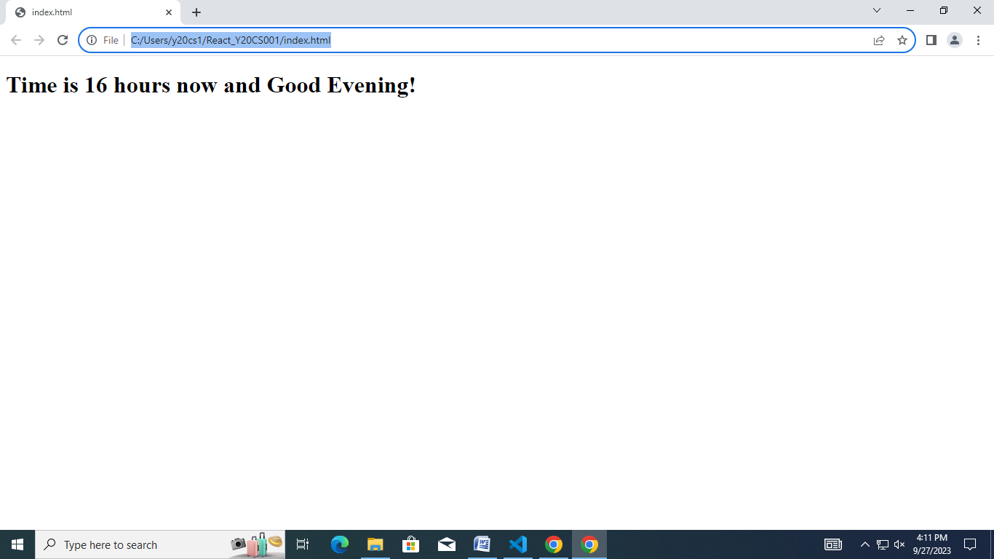

**3) Aim: Create and develop reactJS app folder structure using npx and npm utilities and display the welcome react app message**

**Source Code :**

**App.js**

import rvr from './rvr.jpg';

import './App.css';

function App() {

return (

<div className="App">

<header className="App-header">

<img src={rvr} className="App-logo" alt="rvr" />

<p>

Welcome to My First ReactJS Application

</p>

</header>

</div>

);

}

export default App;

**App.css**

.App {

text-align: center;

}

.App-logo {

height: 40vmin;

pointer-events: none;

}

.App-header {

background-color: #282c34;

min-height: 100vh;

display: flex;

flex-direction: column;

align-items: center;

justify-content: center;

font-size: calc(10px + 2vmin);

color: white;

}

**Index.js**

import React from 'react';

import ReactDOM from 'react-dom/client';

import './index.css';

import App from './App';

import reportWebVitals from './reportWebVitals';

const root = ReactDOM.createRoot(document.getElementById('root'));

root.render(

<React.StrictMode>

<App />

</React.StrictMode>

);

reportWebVitals();

**Output :**

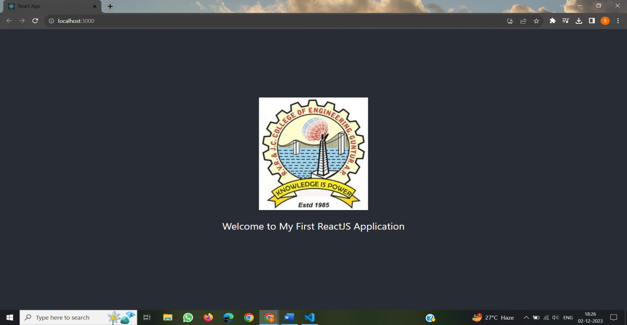

**4) Aim: Create React 2 types of Components ( Class Component and Functional Component ) and demonstrate each Component**

**Source Code :**

**ClassComp.js**

import React from 'react';

class Class1 extends React.Component{

render(){

return (<h1 style={{textAlign:"center",backgroundColor:"yellow",color:"green"}}>My First Class Component</h1>);

}

}

export default Class1;

**FunctionalComp.js**

function Func1(){

return (

<h1

style={{

color:"red",

backgroundColor:"yellow",

textAlign:"center"

}}

>My first Function Component</h1>

);

}

export default Func1;

**Index.js**

import React from 'react';

import ReactDOM from 'react-dom/client';

import './index.css';

import reportWebVitals from './reportWebVitals';

import Func1 from './FunctionalComp.js';

import Class1 from './ClassComp.js'

const root = ReactDOM.createRoot(document.getElementById('root'));

root.render(

<React.StrictMode>

<Func1/>

<Class1/>

</React.StrictMode>

);

reportWebVitals();

**Output :**

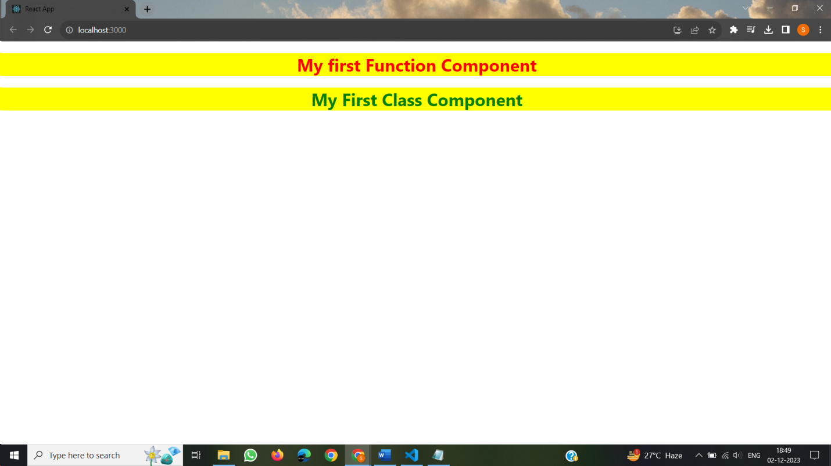

**5) Aim: Create React application by using different style components in React**

**Source Code :**

**Style.js**

import React from 'react';

import './style1.css';

const style2={

fontSize:'50px',

textAlign: 'center',

backgroundColor:"yellow",

color: 'red'

};

class Class2 extends React.Component{

render(){

return (

<div>

<p className='style1'>This is the example of external CSS</p>

<p style={style2}>This is the example of Inline CSS</p>

</div>

);

}

}

export default Class2;

**Style1.css**

.style1

{

font-size: 60px;

text-align: center;

background-color: aqua;

color: rgb(71, 21, 187);

}

**Index.js**

import React from 'react';

import ReactDOM from 'react-dom/client';

import reportWebVitals from './reportWebVitals';

import Class2 from './Class2';

const root = ReactDOM.createRoot(document.getElementById('root'));

root.render(

<React.StrictMode>

<Class2/>

</React.StrictMode>

);

reportWebVitals();

**Output :**

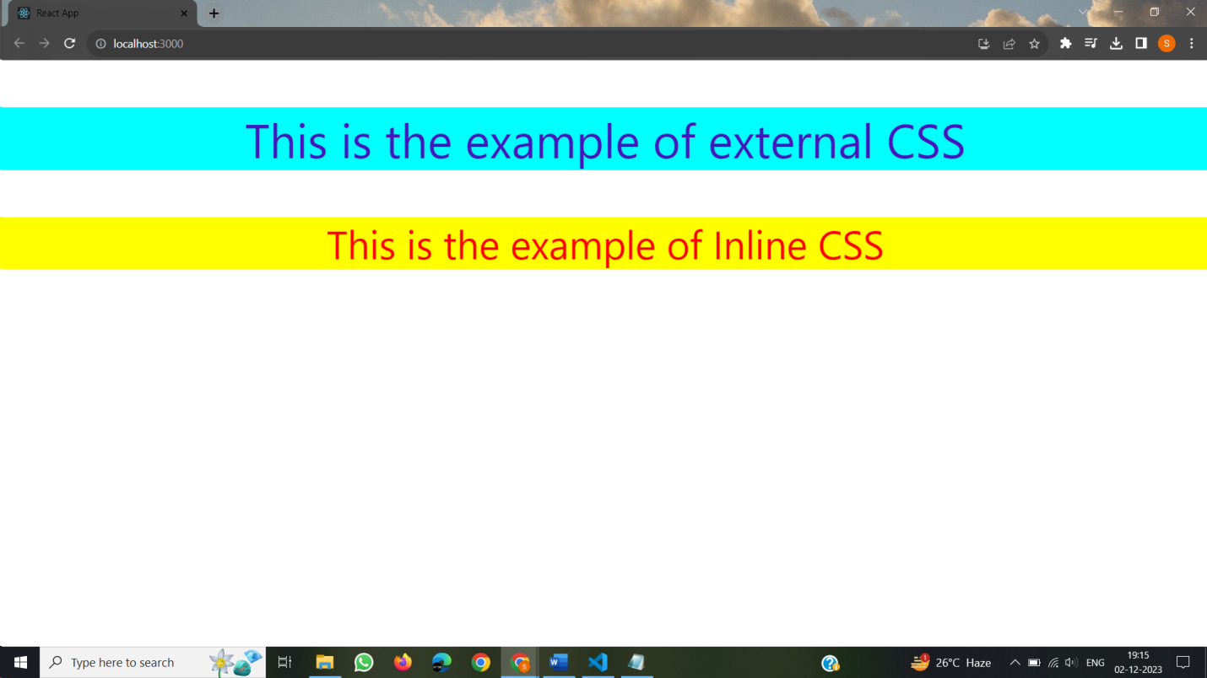

**6) Aim: Create a simple Counter application using ReactJS which increments and decrements count dynamically on screen as user clicks on the button by using props and states concept**

**Source Code :**

**Counter.js**

import React from "react";

import "./Counter.css";

class Counter1 extends React.Component{

constructor(){

super();

this.state={

counter:0

};

}

Incr=()=>{

this.setState({

counter:this.state.counter+1

});

};

Decr=()=>{

this.setState({

counter:this.state.counter-1

});

}

render(){

const mystyle={

textAlign:"center"

}

return(

<center>

<div className="main" >

<h1 style={mystyle}>Counter Application : ReactJS</h1>

<h2 style={mystyle}>Counter = {this.state.counter}</h2>

<div style={mystyle}><button className="button" onClick={this.Incr} >Increment</button>

<button className="button" onClick={this.Decr}>Decrement</button>

</div>

</div>

</center>

)

}

}

export default Counter1;

**Counter.css**

.main{

border-radius: 8px;

font-size: 18px;

background-color: rgba(197, 242, 244, 0.979);

width: 700px;

height: 230px;

border-radius: 10px;

color: rgb(21, 20, 22);

margin: 140px;

padding: 20px;

}

.button{

color: rgb(238, 247, 247);

background-color: blue;

text-align: center;

margin-right: 10px;

font-weight: bold;

width: 100px;

height: 30px;

border-radius: 6px;

border: 2px solid blue;}

**Index.js**

import React from 'react';

import ReactDOM from 'react-dom/client';

import reportWebVitals from './reportWebVitals';

import Counter from './ Counter ';

const root = ReactDOM.createRoot(document.getElementById('root'));

root.render(

<React.StrictMode>

<Counter/>

</React.StrictMode>

);

reportWebVitals();

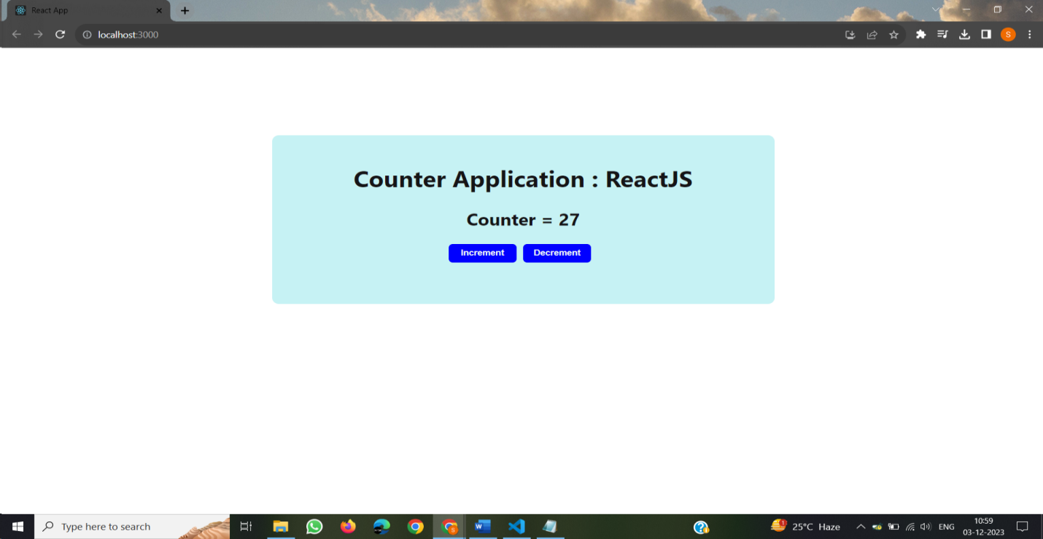**Output :**

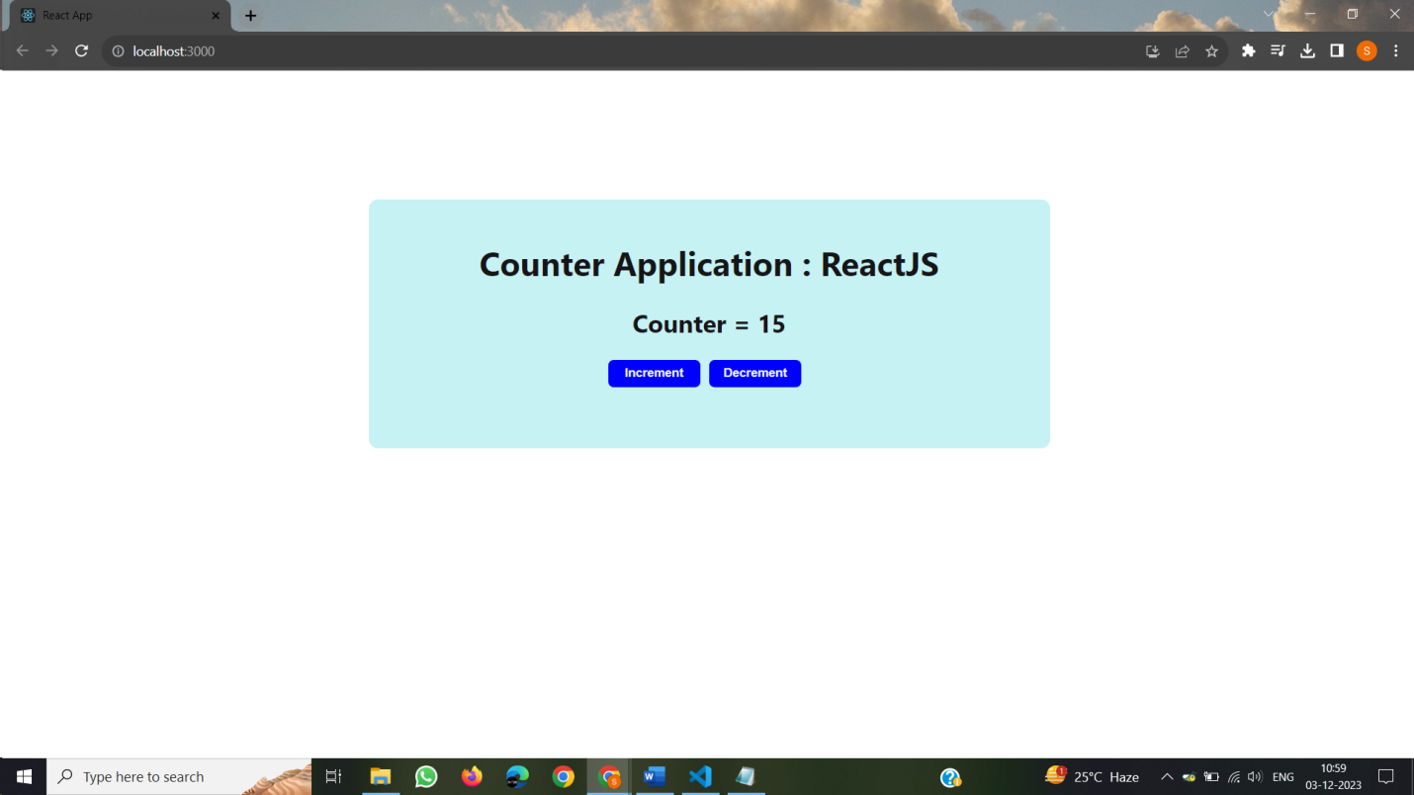

**7) Aim: Create a simple Login Form single page application using ReactJS**

**Source Code :**

**Login.js**

import React, { useState } from "react";

import "./Login.css";

function App6() {

const [errorMessages, setErrorMessages] = useState({});

const [isSubmitted, setIsSubmitted] = useState(false);

const data = [

{

username: "chrb",

password: "abc"

},

{

username: "rishi",

password: "def"

},

{

username: "RVR",

password: "def"

}

];

const errors = {

uname: "Invalid Username",

pass: "Invalid Password"

};

const handleSubmit = (event) => {

event.preventDefault();

var { uname, pass } = document.forms[0];

const userData = data.find((user) => user.username === uname.value);

if (userData) {

if (userData.password !== pass.value) {

setErrorMessages({ name: "pass", message: errors.pass });

} else {

setIsSubmitted(true);

}

} else {

setErrorMessages({ name: "uname", message: errors.uname });

}

};

const renderErrorMessage = (name) =>

name === errorMessages.name && (

<div className="error">{errorMessages.message}</div>

);

const WebForm = (

<div className="form">

<form onSubmit={handleSubmit}>

<div className="input-container">

<label>Username </label>

<input type="text" name="uname" required />

{renderErrorMessage("uname")}

</div>

<div className="input-container">

<label>Password </label>

<input type="password" name="pass" required />

{renderErrorMessage("pass")}

</div>

<div className="button-container">

<input type="submit" value="LOGIN"/>

</div>

</form>

</div>

);

return (

<div className="main1">

<div className="login-form">

<div className="title">Sign In</div>

{isSubmitted ? <div>User is successfully logged in</div> : WebForm}

</div>

</div>

);

}

export default Login;

**Login.css**

.main1{

font-family: sans-serif;

display: flex;

align-items: center;

justify-content: center;

flex-direction: column;

height: 100vh;

font-family: Georgia, Times, "Times New Roman", serif;

background-color: lightcoral;

}

input[type="text"],

input[type="password"] {

height: 30px;

width: 150px;

border: 1px solid rgba(0, 0, 0, 0.2);

}

input[type="submit"] {

margin-top: 10px;

width: 100px;

font-size: 15px;

background: #01d28e;

border: 2px solid #01d28e;

color: #fff;

padding: 10px 20px;

}

input[type="submit"]:hover {

background: #6cf0c2;

}

.button-container {

display: flex;

justify-content: center;

}

.login-form {

background-color: rgb(71, 117, 12);

padding: 3rem;

box-shadow: 0 4px 8px 0 rgba(0, 0, 0, 0.2), 0 6px 20px 0 rgba(0, 0, 0, 0.19);

}

.list-container {

display: flex;

}

.error {

color: red;

font-size: 20px;

}

.title {

font-size: 25px;

margin-bottom: 20px;

color:maroon;

font-weight: bold;

}

.input-container {

display: flex;

flex-direction: column;

gap: 8px;

margin: 10px;

}

**Index.js**

import React from 'react';

import ReactDOM from 'react-dom/client';

import reportWebVitals from './reportWebVitals';

import Login from './Login';

const root = ReactDOM.createRoot(document.getElementById('root'));

root.render(

<React.StrictMode>

<Login/>

</React.StrictMode>

);

reportWebVitals();

**Output :**

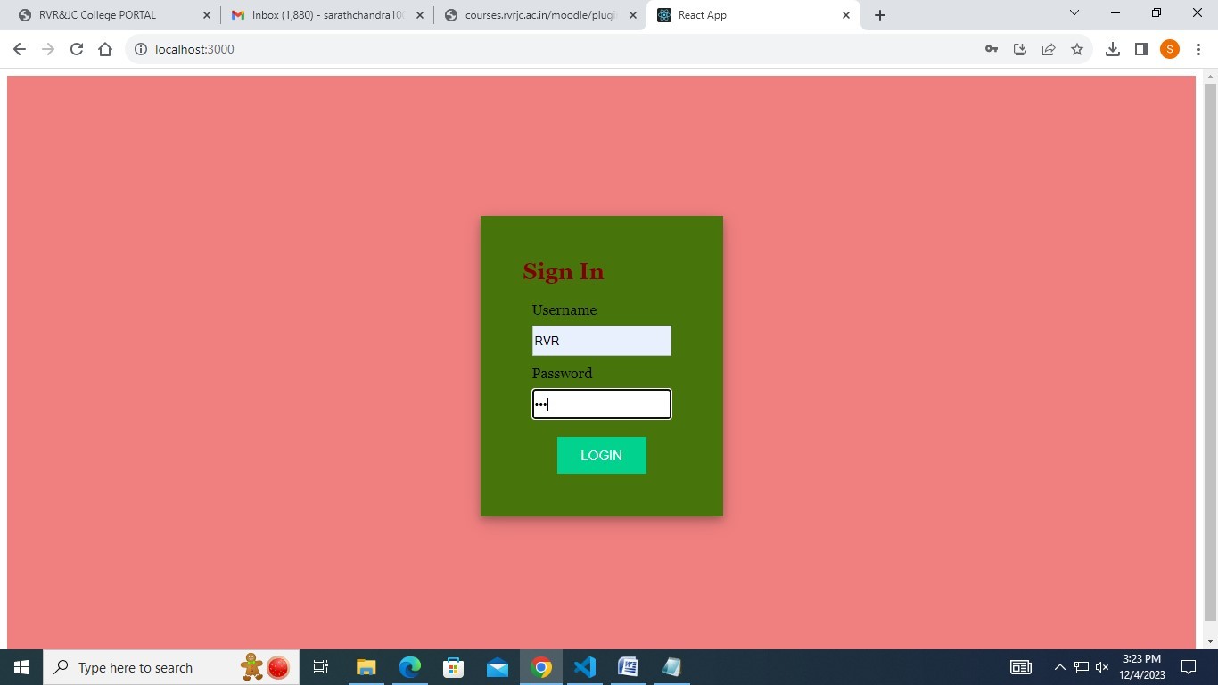

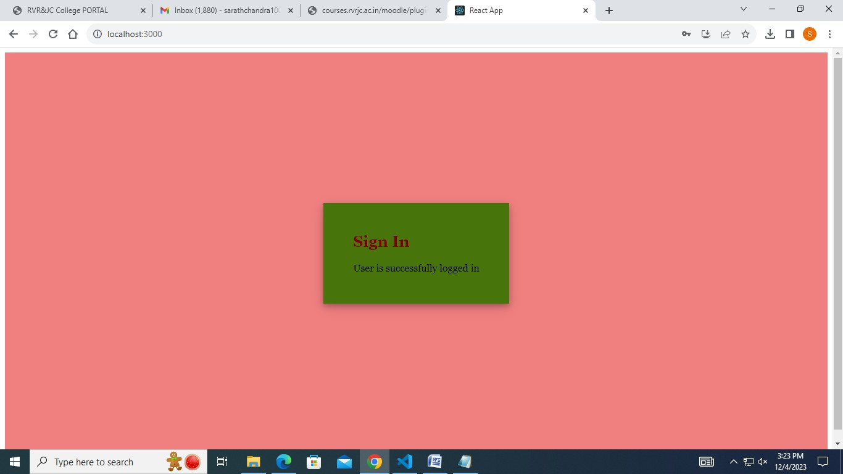

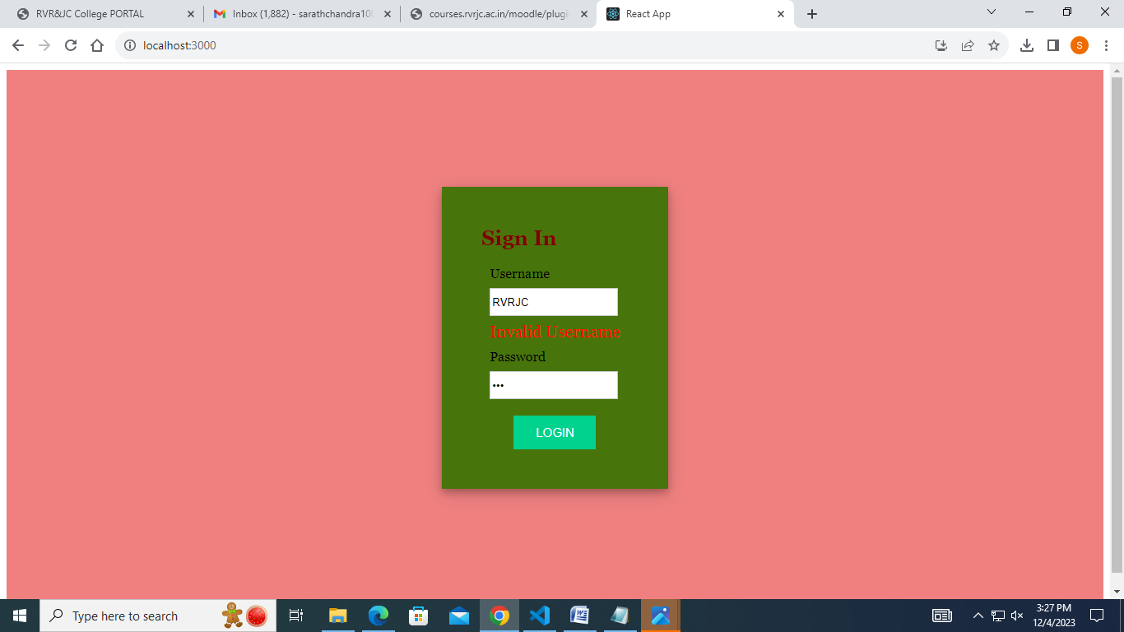

**8) Aim: Create a simple Registration form with different input elements using event handling**

**Source Code :**

**Registration.js**

import rvr from './rvr.jpg'

import './Registration.css'

import {useState} from 'react'

function Registration(){

const [Name,setName]=useState("")

const [Mobile,setMobile]=useState("")

const [Age,setAge]=useState("")

const [Email,setEmail]=useState("")

const [Password,setPassword]=useState("")

return (

<center>

<h1>R.V.R & J.C College of Engineering</h1>

<div className='main1'>

<div className='App'>

<header className='App-header'>

<img src={rvr} className='App-logo' alt='rvr'/>

</header>

</div>

<div className='main'>

<h2>STUDENT REGISTRATION FORM</h2>

<form>

<pre>

<b>Name : </b><input className='input' placeholder='Name' onChange={(e)=> setName(e.target.value)}/><br/>

<b>Mobile : </b><input className='input' placeholder='Mobile' onChange={(e)=> setMobile(e.target.value)}/><br/>

<b>Age : </b><input className='input' placeholder='Age' onChange={(e)=> setAge(e.target.value)}/><br/>

<b>Email : </b><input className='input' placeholder='Email' onChange={(e)=> setEmail(e.target.value)}/><br/>

<b>Password : </b><input className='input' type='password' placeholder='Password' onChange={(e)=> setPassword(e.target.value)}/><br/><br/>

<b>Confirm Password : </b><input className='input' type='password' placeholder='Confirm Password' onChange={(e)=> setPassword(e.target.value)}/><br/><br/>

<b>Address : </b>

<textarea rows="4" cols="31" className='input' placeholder='Address' onChange={(e)=> setPassword(e.target.value)}/><br/><br/>

<div className='gender'>

<b>Gender : </b>

<input type='radio' className='input1' name='gender'/>Male

<input type='radio' className='input1' name='gender'/>Female

<input type='radio' className='input1' name='gender'/>Transgender <br/>

</div>

</pre>

<button type='submit' className='button'>Login</button>

<button type='submit' className='button'>SignUp</button>

</form>

</div>

</div>

</center>

)

}

export default Registration;

**Registration.css**

.button{

color: rgb(238, 247, 247);

background-color: blue;

text-align: center;

margin-right: 10px;

font-weight: bold;

width: 100px;

height: 30px;

border-radius: 6px;

border: 2px solid blue;

}

.App-header {

min-height: 8vh;

display: flex;

flex-direction: column;

align-items: center;

justify-content: center;

font-size: calc(10px + 2vmin);

color: white;

}

.App{

float: left;

padding-left: 200px;

padding-top: 200px;

}

.input{

width: 200px;

height: 30px;

margin: 1% 2%;

border-radius: 8px;

}

.main{

background-color: rgb(203, 181, 181);

width: 550px;

height: 540px;

border-radius: 10px;

margin: 60px;

float: right;

}

.input1{

margin:1% 1%;

}

.main1{

padding-right: 250px;

}

**Index.js**

import React from 'react';

import ReactDOM from 'react-dom/client';

import reportWebVitals from './reportWebVitals';

import Registration from './ Registration ';

const root = ReactDOM.createRoot(document.getElementById('root'));

root.render(

<React.StrictMode>

< Registration />

</React.StrictMode>

);

reportWebVitals();

**Output :**

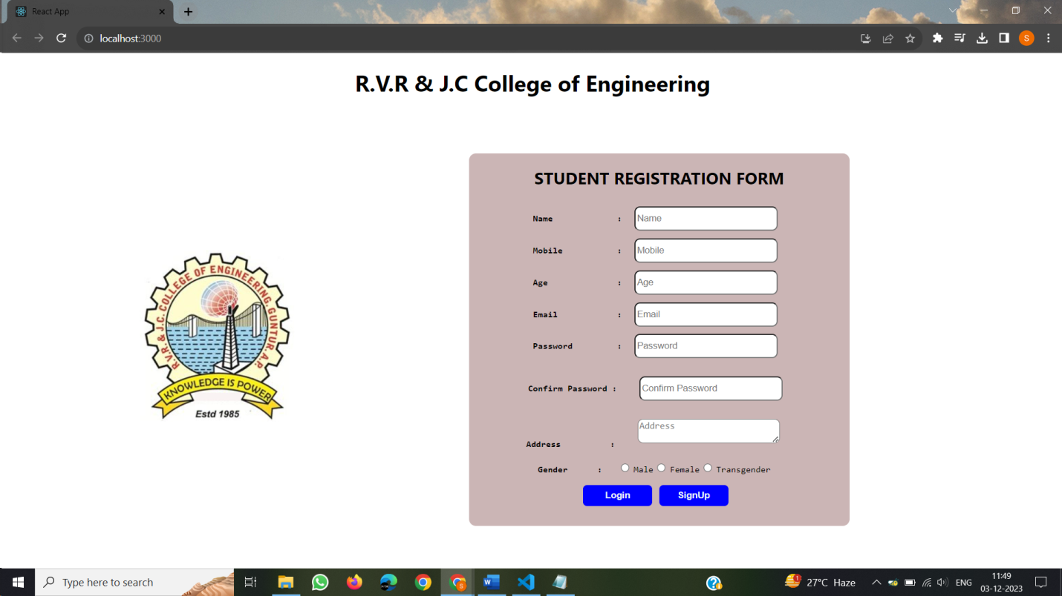

**9) Aim: Build basic arithmatic calculator by using ReactJS.Use Statehook with button events.**

**Source Code :**

**Calculator.js**

import React, { useState } from 'react';

import './Calculator.css';

function Calculator() {

const [value, setValue] = useState('');

return (

<div className="container">

<div className="calculator">

<form action="">

<div className='display'>

<input type= "text" value={value}/>

</div>

<div>

<input type="button" value="AC" onClick={e => setValue('')}/>

<input type="button" value="DE" onClick={e => setValue(value.slice(0, -1))}/>

<input type="button" value="." onClick={e => setValue(value + e.target.value)}/>

<input type="button" value="/" onClick={e => setValue(value + e.target.value)}/>

</div>

<div>

<input type="button" value="7" onClick={e => setValue(value + e.target.value)}/>

<input type="button" value="8" onClick={e => setValue(value + e.target.value)}/>

<input type="button" value="9" onClick={e => setValue(value + e.target.value)}/>

<input type="button" value="*" onClick={e => setValue(value + e.target.value)}/>

</div>

<div>

<input type="button" value="4" onClick={e => setValue(value + e.target.value)}/>

<input type="button" value="5" onClick={e => setValue(value + e.target.value)}/>

<input type="button" value="6" onClick={e => setValue(value + e.target.value)}/>

<input type="button" value="+" onClick={e => setValue(value + e.target.value)}/>

</div>

<div>

<input type="button" value="1" onClick={e => setValue(value + e.target.value)}/>

<input type="button" value="2" onClick={e => setValue(value + e.target.value)}/>

<input type="button" value="3" onClick={e => setValue(value + e.target.value)}/>

<input type="button" value="-" onClick={e => setValue(value + e.target.value)}/>

</div>

<div>

<input type="button" value="00" onClick={e => setValue(value + e.target.value)}/>

<input type="button" value="0" onClick={e => setValue(value + e.target.value)}/>

<input type="button" value="=" className='equal' onClick={e => setValue(eval(value))}/>

</div>

</form>

</div>

</div>

);

}

export default Calculator;

**Calculator.css**

.container {

width: 100%;

height: 100vh;

display: flex;

align-items: center;

justify-content: center;

background: linear-gradient(140deg, rgb(255, 255, 255), rgb(255, 255, 255));

}

.calculator {

padding: 20px;

border-radius: 10px;

background-color: rgb(211, 211, 211);

}

form input {

outline: 0;

width: 60px;

height: 60px;

font-size: 16px;

background-color: rgb(216, 130, 0);

margin: 2px;

border-radius: 10px;

color: white;

font-weight: bolder;

cursor: pointer;

}

form input[type="button"]:hover {

background-color: rgb(255, 94, 0);

}

form .display {

display: flex;

justify-content: flex-end;

margin: 5px 0px 15px 0px;

}

form .display input {

text-align: right;

font-size: 40px;

padding: 5px 10px;

background-color: rgb(64, 64, 64);

}

form input.equal{

width: 123px;

}

**Index.js**

import React from 'react';

import ReactDOM from 'react-dom/client';

import reportWebVitals from './reportWebVitals';

import Calculator from './Calculator.js';

const root = ReactDOM.createRoot(document.getElementById('root'));

root.render(

<React.StrictMode>

<Calculator/>

</React.StrictMode>

);

reportWebVitals();

**Output :**

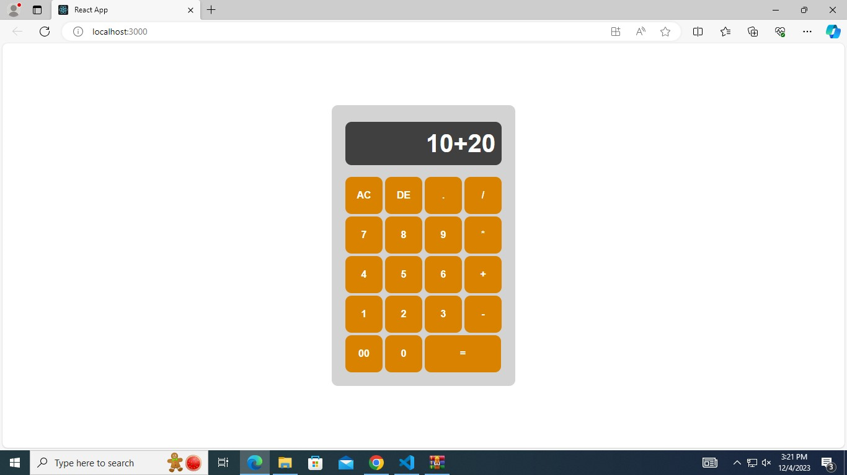

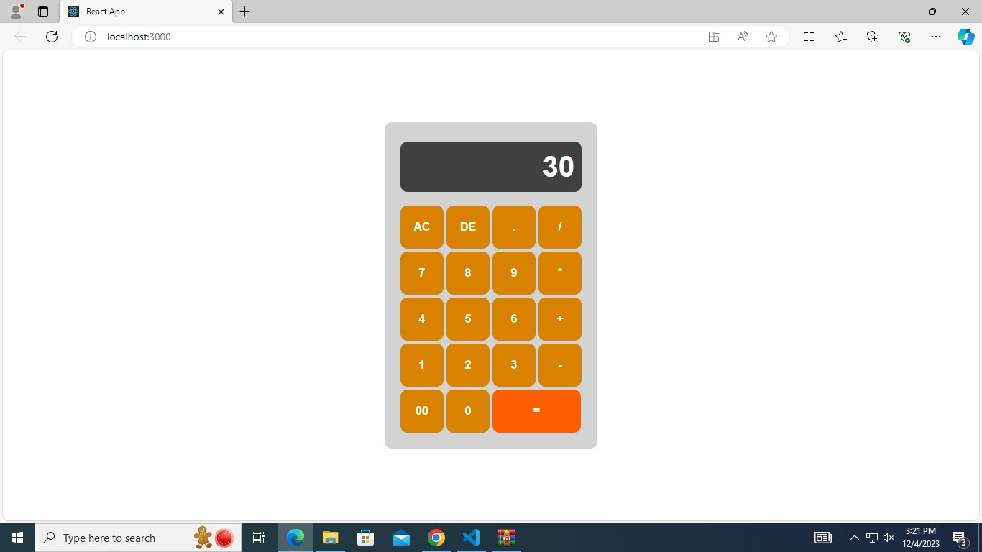

**10) Aim: Build student name search form filter with basic search functionalities by using array.filter method and filter utilities.**

**Source Code :**

**Search.js**

import React, { useState } from "react";

import logo from './logo.svg';

import "./Search.css";

function Search() {

const list = [

"Y20CS021",

"Y20CS091",

"Y20CS171",

"Y20CE021",

"Y20CE091",

"Y20CE171",

"Y20ECE021",

"Y20ECE091",

"Y20ECE171",

"Y20IT021",

"Y20IT091",

"Y20IT171",

"Ratna Babu",

"Rishi Babu",

"Deepak",

"Jyothi",

"Rama Raju",

"Sunil",

"Sitha",

"Ramana",

"Ratna Raju"

];

const [filterList, setFilterList] = useState(list);

const handleSearch = (event) => {

if (event.target.value === "") {

setFilterList(list);

return;

}

const filteredValues = list.filter(

(item) =>

item.toLowerCase().indexOf(event.target.value.toLowerCase()) !== -1

);

setFilterList(filteredValues);

};

return (

<div className="app11">

<div className="App">

<header className="App-header">

<img src={logo} className="App-logo" alt="logo" />

</header>

<p >STUDENT INFORMATION SEARCH!</p> </div>

<div>

<b>Search: <input name="query" type="text" onChange={handleSearch} />

</b></div>

{filterList &&

filterList.map((item, index) => (

<div key={index}>{item}</div> //Display each item

))}

</div>

);

}

export default Search;

**Search.css**

.app11 {

font-family: sans-serif;

display: flex;

align-items: center;

justify-content: center;

flex-direction: column;

gap: 20px;

height: 100vh;

font-family: Cambria, Cochin, Georgia, Times, "Times New Roman", serif;

}

b{

color:red;

font-size:2pc;

}

p{

color:yellowgreen;

}

input {

padding: 1%;

width: 100%;

margin: 1% 2%;

}

**Index.js**

import React from 'react';

import ReactDOM from 'react-dom/client';

import reportWebVitals from './reportWebVitals';

import Search from './Search';

const root = ReactDOM.createRoot(document.getElementById('root'));

root.render(

<React.StrictMode>

<Search/>

</React.StrictMode>

);

reportWebVitals();

**Output** :

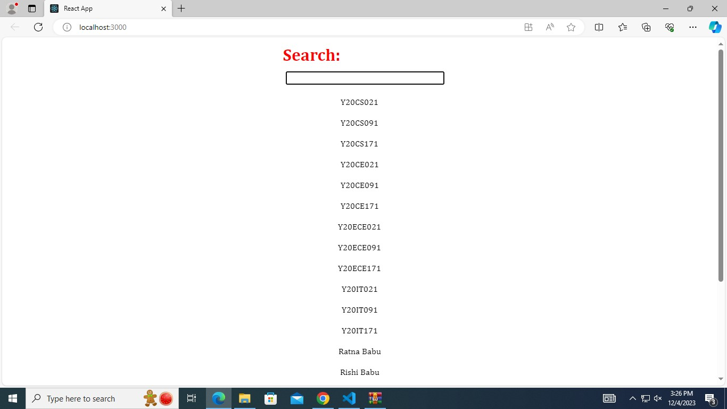

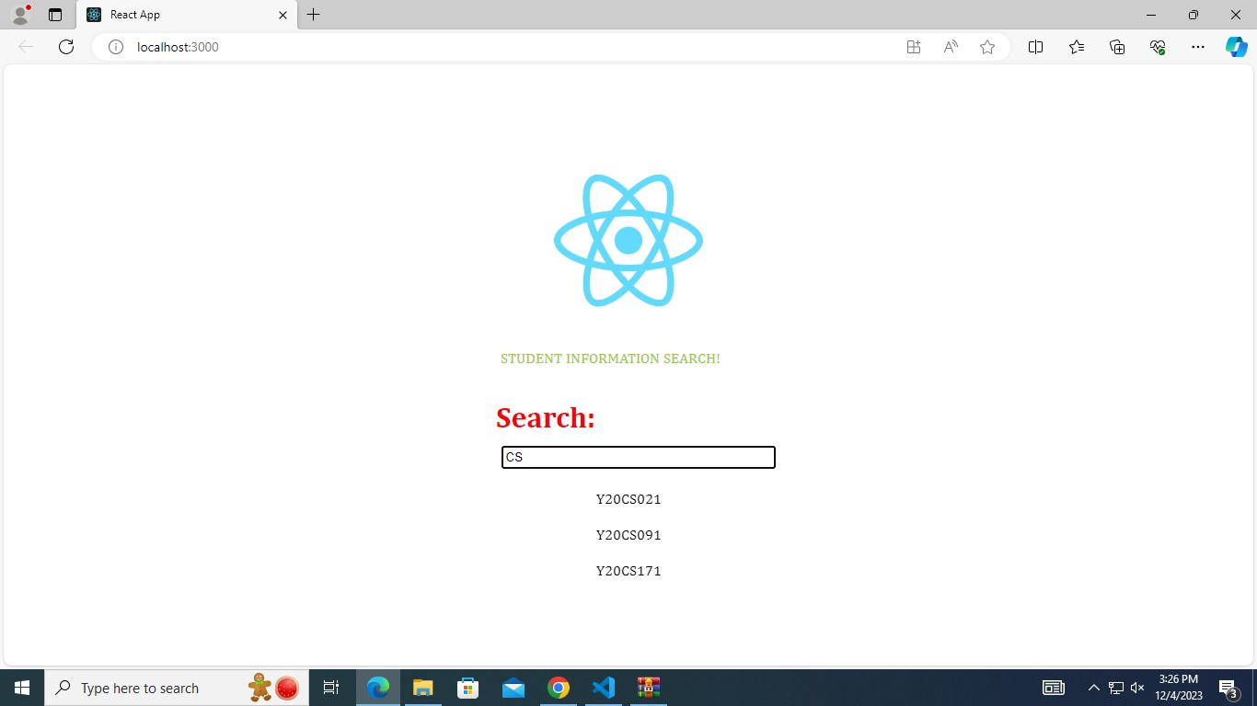

**11) Aim: Create a React JS calendar along with events that are triggered based on user actions**.

**Source Code** :

**Calendar.js**

import React, { useState } from "react";

import Calendar from "react-calendar";

import "react-calendar/dist/Calendar.css";

import "./Calendar.css";

function Calendar () {

const allMonthValues = [

"January",

"February",

"March",

"April",

"May",

"June",

"July",

"August",

"September",

"October",

"November",

"December"

];

const [selectedDate, setSelectedDate] = useState();

const [calendarText, setCalendarText] = useState(`No Date is selected`);

const handleDateChange = (value) => {

setSelectedDate(value);

setCalendarText(`The selected Date is ${value.toDateString()}`);

};

const handleYearChange = (value) => {

const yearValue = value.getFullYear();

setCalendarText(`${yearValue} Year is selected`);

};

const handleMonthChange = (value) => {

const monthValue = allMonthValues[value.getMonth()];

setCalendarText(`${monthValue} Month is selected`);

};

return (

<div className="app1">

<h2 className="calander-details">{calendarText}</h2>

<Calendar

onClickMonth={handleMonthChange}

onClickYear={handleYearChange}

onChange={handleDateChange}

value={selectedDate}

/>

</div>

);

}

export default Calendar;

**Calendar.css**

.app1 {

display: flex;

align-items: center;

justify-content: center;

flex-direction: column;

gap: 20px;

height: 100vh;

color:black;

font-family:Georgia, Times, "Times New Roman", serif;

}

**Index.js**

import React from 'react';

import ReactDOM from 'react-dom/client';

import './index.css';

import reportWebVitals from './reportWebVitals';

import Calendar from './Calender/App7';

const root = ReactDOM.createRoot(document.getElementById('root'));

root.render(

<React.StrictMode>

<Calendar/>

</React.StrictMode>

);

reportWebVitals();

**Output** :

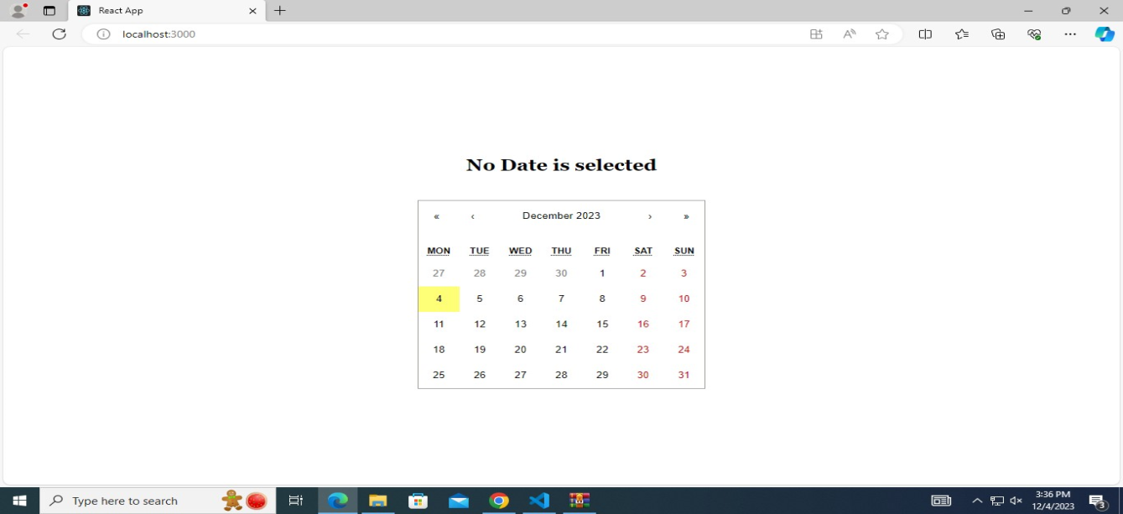

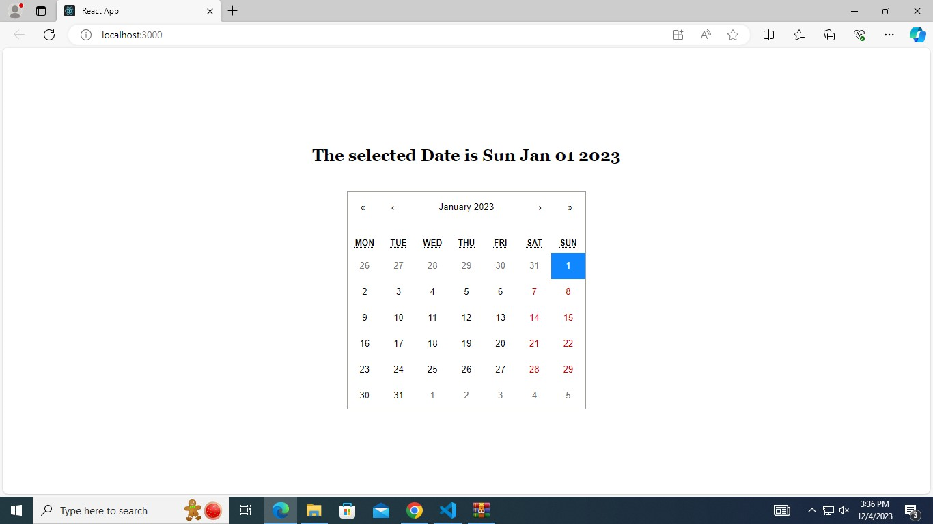

**12) Aim: Create a react router application by using React Router utilities**

**Source Code :**

**Router1.js**

import "./Router1.css";

import {

BrowserRouter as Router,

Routes,

Route,

Navigate,

} from "react-router-dom";

import Home from "./Comp/Home";

import About from "./Comp/About";

import ContactUs from "./Comp/ContactUs";

function Router1() {

return (

<>

<Router>

<Routes>

<Route

exact

path="/"

element={<Home />}

/>

<Route

path="/about"

element={<About />}

/>

<Route

path="/contactus"

element={<ContactUs />}

/>

<Route

path="*"

element={<Navigate to="/" />}

/>

</Routes>

</Router>

</>

);

}

export default Router1;

**Router1.css**

.App {

text-align: center;

}

.App-logo {

height: 40vmin;

pointer-events: none;

}

@media (prefers-reduced-motion: no-preference) {

.App-logo {

animation: App-logo infinite 20s linear;

}

}

.App-header {

background-color: #060c01;

display: flex;

flex-direction: column;

align-items: center;

justify-content: center;

font-size: calc(10px + 2vmin);

color: white;

}

.App-link {

color: #61dafb;

}

@keyframes App-logo-spin {

from {

transform: rotate(0deg);

}

to {

transform: rotate(360deg);

}

}

**Index.js**

import React from 'react';

import ReactDOM from 'react-dom/client';

import reportWebVitals from './reportWebVitals';

import Router1 from './Router1';

const root = ReactDOM.createRoot(document.getElementById('root'));

root.render(

<React.StrictMode>

<Router/>

</React.StrictMode>

); reportWebVitals();

**Output** :

