LAB EVALUATION – 2
Roll No: CB.SC.U4CSE23644
Name: R.Vishnu Sathwick

Title
Galaxy Math Academy: Visual Learning Adventure
1. About the Use Case
The Galaxy Math Academy is an inclusive, gamified educational system designed to make mastering mathematics an interstellar adventure for children, particularly those with autism and different learning needs. The application transforms abstract math concepts—such as counting, arithmetic (addition, subtraction, multiplication), patterns, and memory—into interactive "planetary missions." It utilizes high-contrast visuals, text-to-speech audio support, and a structured reward system (coins, avatars, and streaks) to reduce cognitive load and anxiety. By replacing traditional drills with engaging visual gameplay, it fosters focus, confidence, and independent learning in a safe, stress-free digital environment.

2. Product Details
GitHub Repository: https://github.com/rvsr26/galaxy-math-visual-learning
Deployed Link: https://galaxy-math-visual-learning.vercel.app/

3. Purpose
The purpose of this application is to make mathematics accessible, engaging, and less intimidating for children, especially those with diverse learning needs. It aims to transform traditional learning into a rewarding visual adventure, providing a stress-free environment where users can build confidence in their analytical and arithmetic skills at their own pace.
4. How This Application Improves Comfort for Autism Kids
- Uses a Predictable "Galaxy Map" to provide a clear, structured learning path, reducing anxiety about "what comes next."
- Visual-First Learning: Relies on emojis, stars, and planets to represent numbers, making abstract math concepts concrete and easier to process.
- Sensory-Friendly Design: Features a calming space theme (dark mode) with gentle, non-startling sound effects to prevent sensory overload.
- Positive Reinforcement: Focuses on celebrating success with "milestones" and encouraging voice feedback, ensuring a frustration-free experience.
- Stress-Free Logic: Adapts problems to avoid confusion (e.g., subtraction always results in positive numbers), building confidence through consistent success.
- Audio-Visual Support: Combines text, icons, and spoken voice cues to accommodate different processing styles and support non-verbal learning.

5. List of Similar Applications
- Khan Academy Kids: Excellent general education content but can be visually overwhelming with complex animations.
- Prodigy Math: Highly gamified RPG style, but the fast-paced battles and competitive elements can cause anxiety.
- Traditional Flashcard Apps: Effective for drilling facts but lack the engaging, connective "journey" or sensory-friendly feedback loops.
Difference: This application focuses on accessibility + autism-friendly design + stress-free progression, making math learning approachable and devoid of failure anxiety. Unlike standard educational games, it prioritized clarity and comfort over speed and competition.

6. Technology Stack
- Frontend: React.js
- Styling: CSS (custom components) & Tailwind CSS (utility classes)
- Animations: Framer Motion
- Backend: Node.js & Express.js
- Database: MongoDB (via Mongoose)
- Authentication: JSON Web Tokens (JWT) & bcryptjs
- Voice Assistance: Web Speech API (window.speechSynthesis)
- State Management: React Hooks (useState, useEffect, useContext)
- Routing: React Router DOM

7. Output
i)Home Page
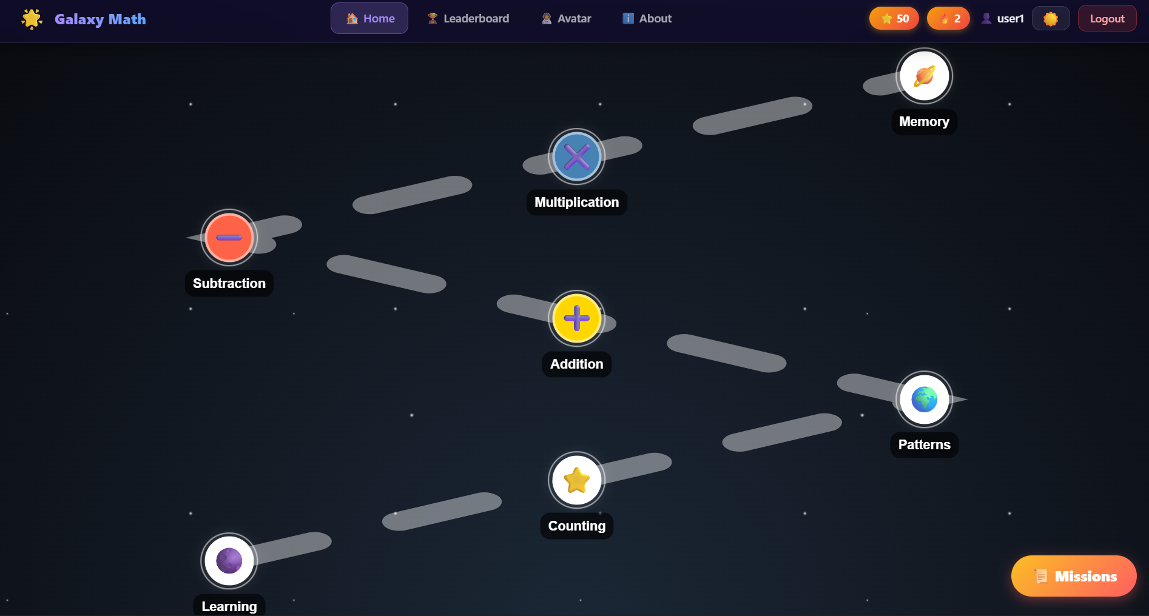
ii)Counting
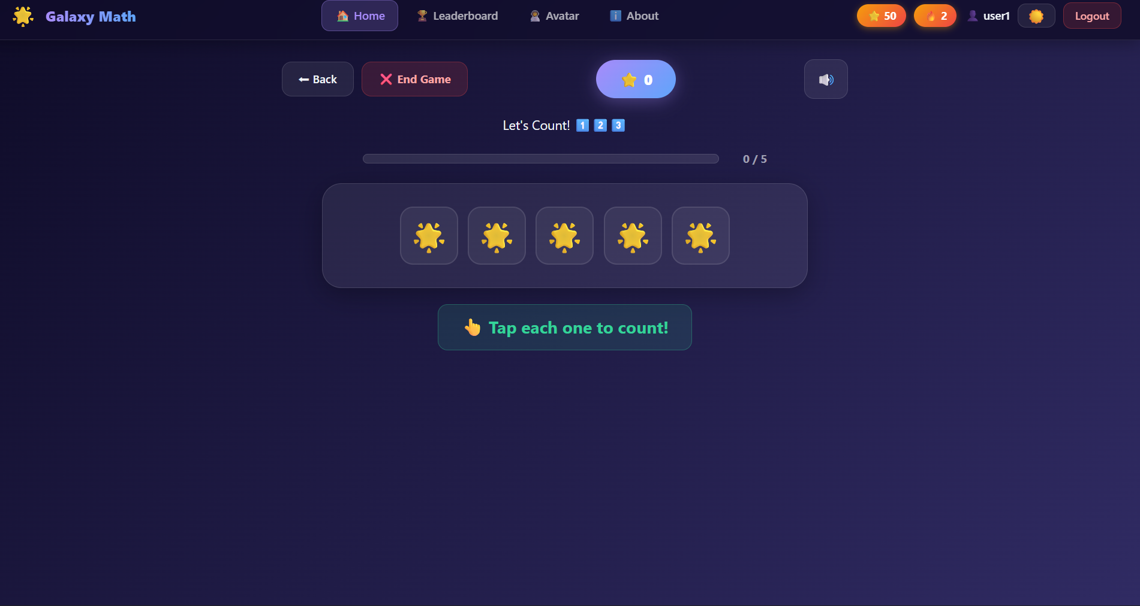
iii)Addition
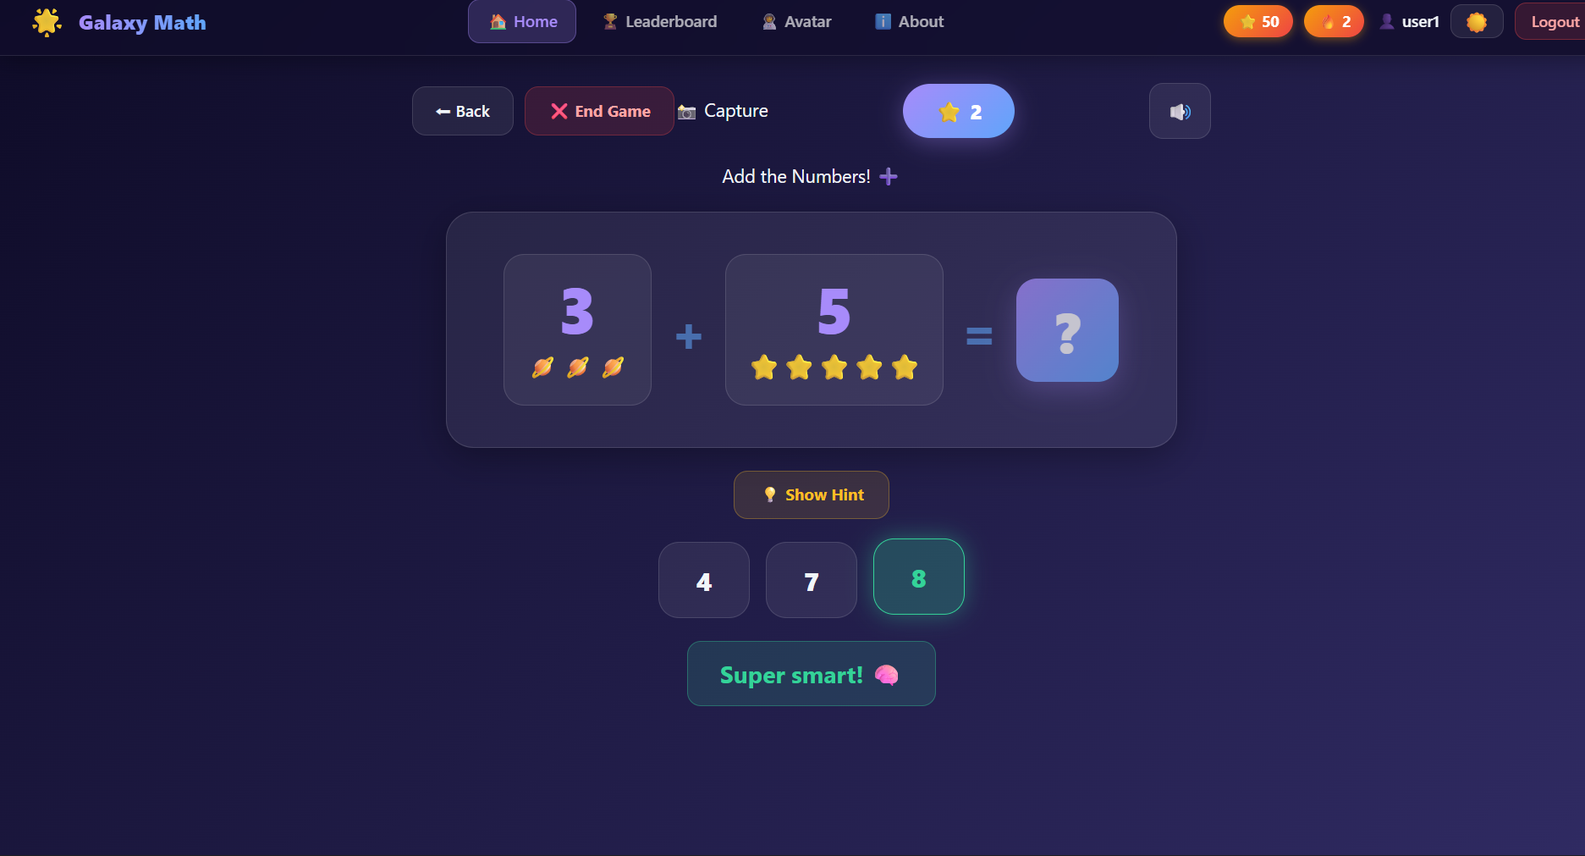
iv)Subtraction
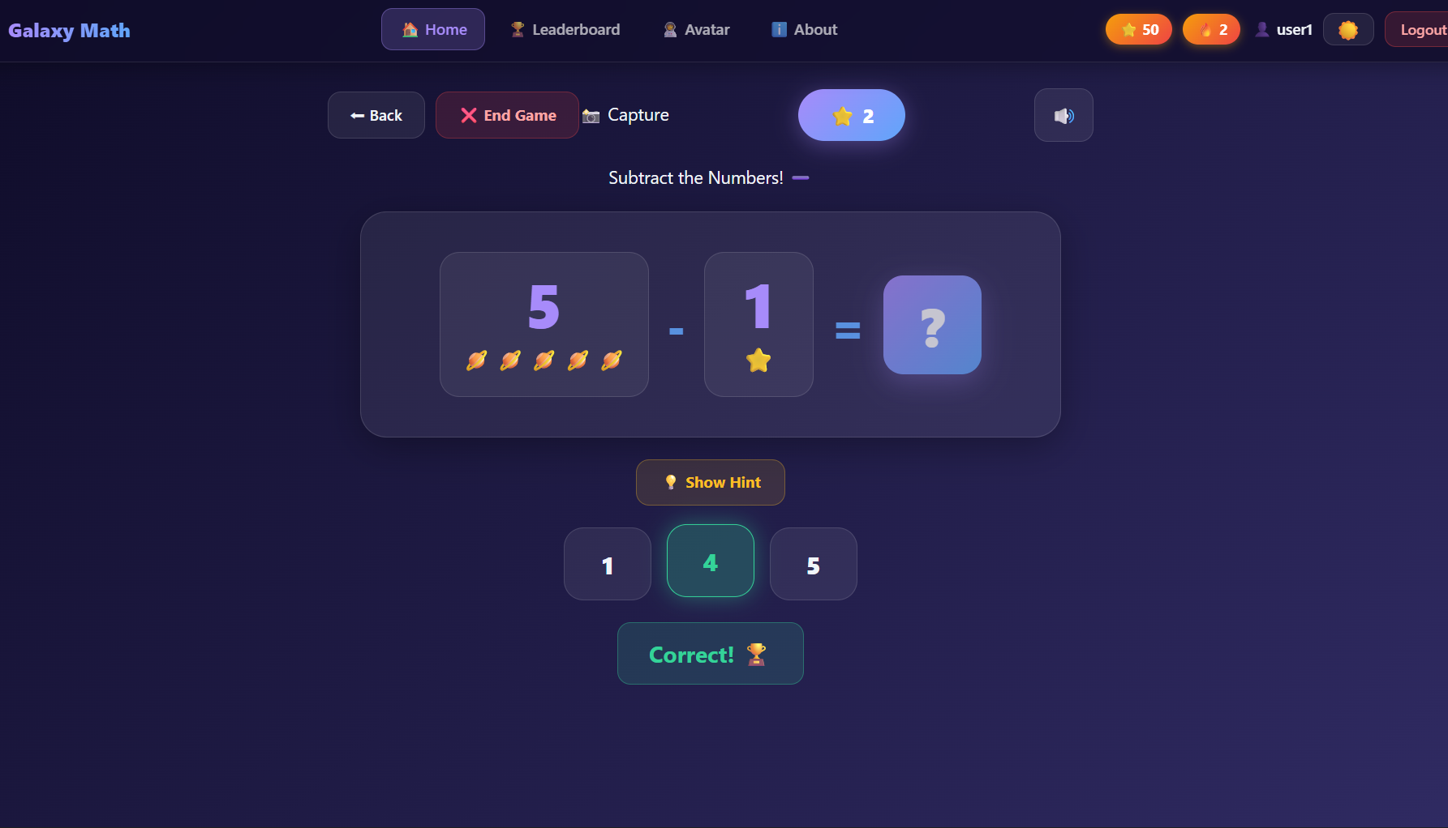
v) Pairing(Memory)
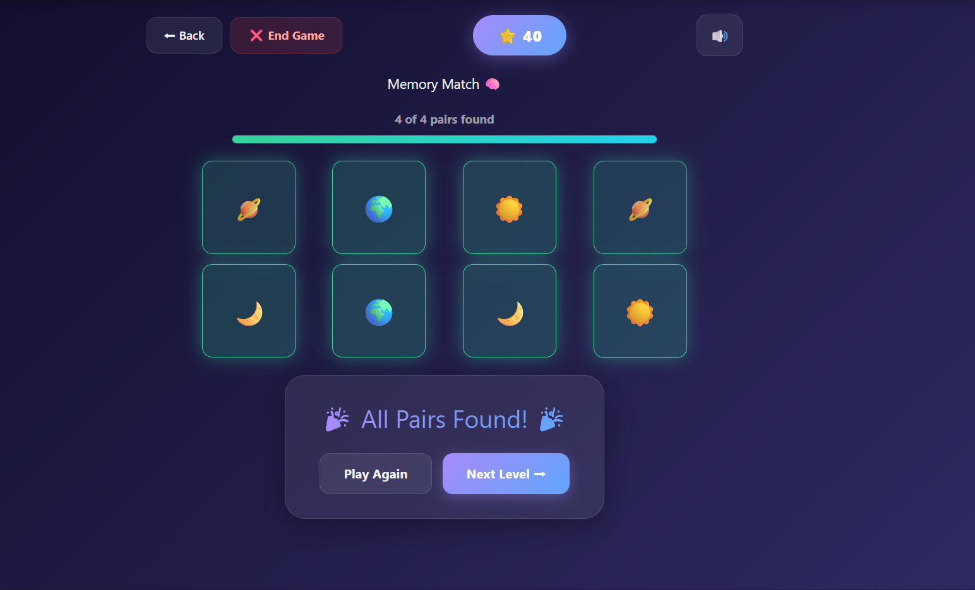
vi)Multiplication
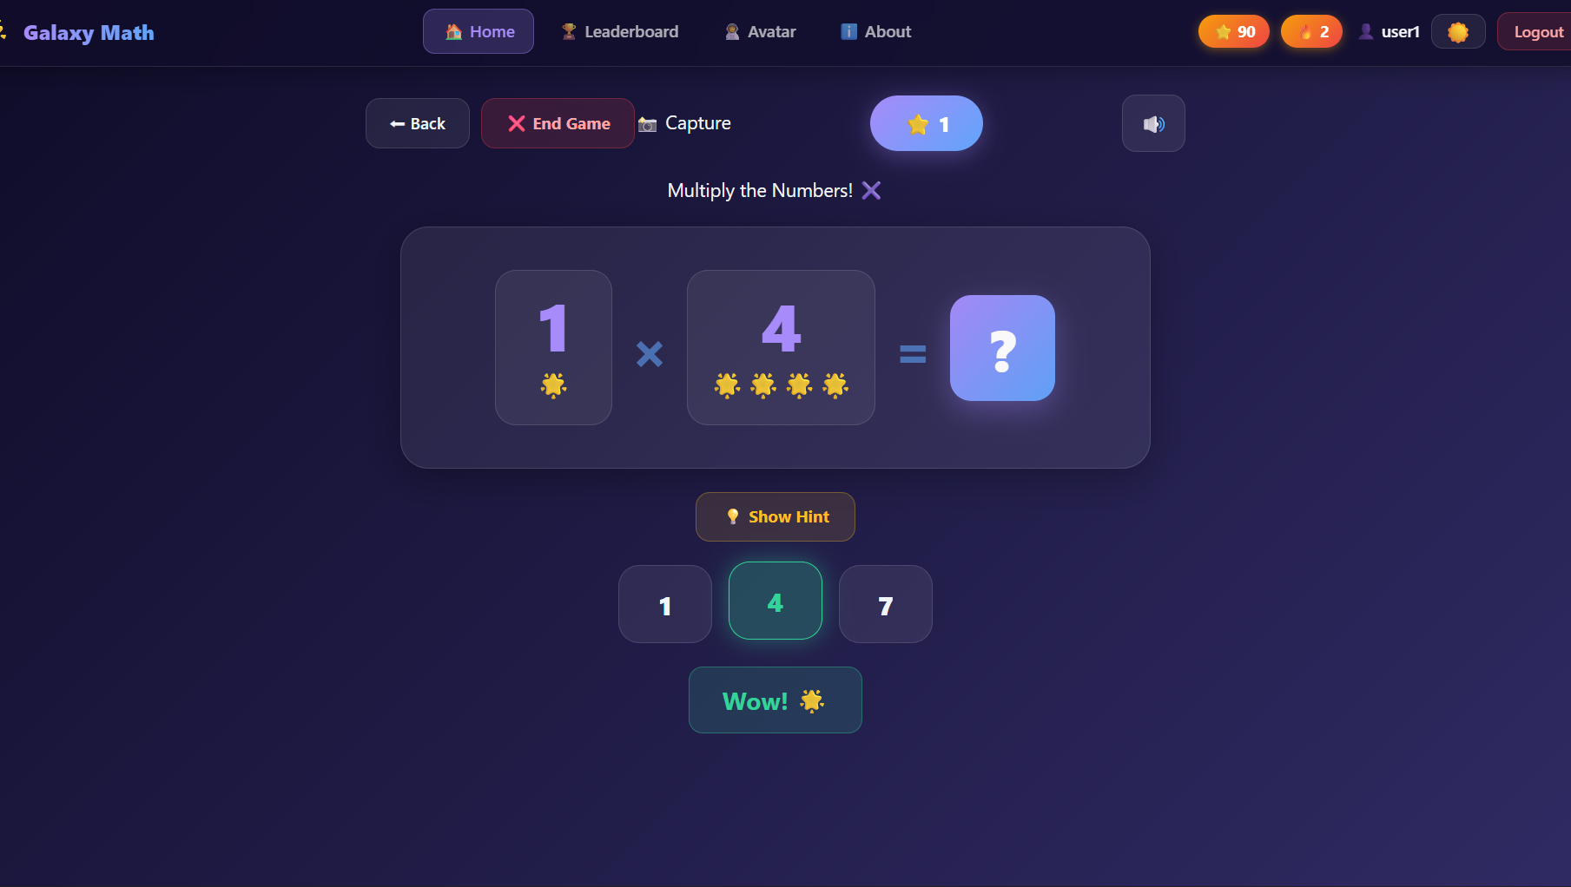

8. Operations in the Portal

Operation Name | Expected Output | ReactJS Concepts Used | How concept improved application
Counting Game | User selects correct count of objects. Success message on match. | Usestate,props | useState  manages the live count score and tapped items without requiring page reloads, ensuring instant feedback.
Math Game | User solves arithmetic problems (Add/Sub/Mul). | Use effect, Conditional Rendering | useEffect  triggers new problem generation when difficulty changes or a correct answer is given.
Pattern Game | User identifies the next item in a sequence. | Map(), Component Reusability | map()  efficiently renders dynamic pattern sequences from arrays, making the game scalable.
Memory Game | User flips cards to find matching pairs. | useState  , Grid Layout (CSS) | useState  tracks flipped card IDs and match status, enabling the game loop logic.
Sequence Game | User repeats a sequence of lights/sounds. | setTimeout , useEffect | setTimeout  precisely controls the playback speed of the light sequence for the user to memorize.
Learning Mode | Visual representation of numbers 1-10. | Static Components, Routing | React Router allows seamless navigation between differing learning m

9. Advantages of the Application
- Easy to Understand: Uses intuitive icons and minimal text, making it accessible even for children with limited reading skills.
- Autism-Friendly Design: Features a calming interface, structured routines, and sensory-friendly audio to create a comfortable learning environment.
- Improves Math Proficiency: Builds core skills in counting, arithmetic, and pattern recognition through engaging gamification.
- Reduces Learning Anxiety: Replaces pressure-filled testing with positive reinforcement and a "no-fail" approach to encouragement.
- Encourages Independent Learning: Safe, guided navigation allows children to explore and learn without constant adult supervision.

10. Conclusion
The Galaxy Math Academy successfully demonstrates how technology can be harnessed to make mathematics accessible and enjoyable for autistic children and early learners. By combining high-contrast visuals, calming auditory feedback, and a structured "galaxy" of learning, the application provides a practical, impactful, and stress-free educational experience that fosters both academic skills and personal confidence

