**Project Milestone 1 - Summer 2020**

**Business Case for Dr Rip Van Winkle**

**2205 MSA 6600 6E1 502W LEC 43109**

**EHR implementation of a web portal with a database at**

**Catskill Family Practice**

**Project Manager (BSTC)**

**Venkata Sai Suneeth Ravilla**

**Summer 2020**

**Bowling Green State University, Ohio**

1. **Introduction/ Background**

Catskill Family Practice (CFP) is a well-known medical health center established by Dr Rip Van Winkle in 1990 which is located at southeastern New York State. CFP is dedicated to providing quality health care to the residents of the community. Few of their top health care services include respiratory problems, fever and infections, women’s health, immunizations and well-childcare, sports medicine including physicals and heart-related problems and they also offer nutrition counselling.

CFP is one of the major hospitals in the neighbouring communities which has a patient base of 15000. It employs five physicians specializing in family/ internal medicine, ten registered nurses, and six administrative staff.

1. **Business Objective**

CFP is one of the top successful health centers providing a various services for the community needs in terms of health care and had taken care of any emergency issues. The goal of CFP is to provide treatment for patients in a better way using the latest technology. They have equipment which can be used to cure the problem for the patients however the process followed by CFP has been outdated. CFP can improve their incoming patient rate by introducing latest technology called an EHR software which has more advantages in terms of tracking patient needs to a systematic database. With the use of latest technology implementation, CFP will be able to retain incoming patients and provide better service to the patients. This will be the perfect time for CFP to implement EHR as the community has recently inaugurated a community college which would bring in close to 20,000 new students in the next five years. This will help CFP in increasing their patient base and to create impactful opinion with their latest technology.

1. **Current Situation and Problem/Opportunity Statement**

CFP has relied on paper-based records and the most they have used is spreadsheets but the newer healthcare facilities in their region have utilized latest technologies such as state-of-the-art technologies, including electronic health records (EHRs) to manage patient care. This might be the main reason that the enrolment of the new patient has reduced, and the existing patients are approaching newer healthcare facilities. The physicians including nurses at CPF had indicated that their medical health care is in lacking technology compared with their competitors and pointed out that they were missing valuable tools that can help their professional career.

Along with implementing HER, CPF also requires a development of web portal and back-end database which helps CFP personnel to access patient information and it is equally beneficial for patients as well such as to track what type of specialities available at CPF.

1. **Critical Assumptions and Constraints**

Partitioning assumptions into different parts as the project contains different aspects of development. The contract of this project is handed over to Black Swamp Technology Consultants (BSTC) and below assumptions are taken care of by them to implement EHR in CPF.

**4.1 Technology-based assumption**

The key assumption of this project is to implement EHR software with addition to a web portal and back end database. To meet the goal of this assumption the technologies required are SQL developer for database management, Front end java developer for web portal development and mainly a resource with enough knowledge about managing the project.

**4.2 Resource-based assumption**

Allocating required resources to the project will help in shaping the project in the right way along with completing the project in time. The current resources in BSTC have no experience in implementing EHR and the only knowledge about it was based on a conversation with other healthcare facilities.

**Potential Constraints**

The quality of the output is very important for BSTC as this will later give lucrative opportunities for the company as it is their initial entry into the booming Health Information Technology (HIT) sector.

1. **Analysis of Option and Recommendation**

**5.1 Do Nothing**

Currently, medical health care runs perfectly fine without the usage of technology and updating their records in spreadsheets. Using this process helped CPF to update the patient records and information in the past and this can be continued for the future. But this process is indirectly affecting the physicians and nurses that they are behind the technology curve and for small mistakes, it takes more time to rectify them.

**5.2 Using Base EHR**

Implementing the base EHR in CPF will help in advancing their technology needs and might help them in reducing the cost for the implementation but it will not meet the specific requirements which are focused for attracting patients to their medical center. This solution is simple and likely to be effective but with a lot of investment and time in this project, the output will not satisfy the required implementation.

**5.3 Using Custom EHR**

Using the existing EHR software by adding additional features to the model will have better benefits like web portal and database which play a crucial role in the terms of technology. This custom implementation will help in introducing all the required software for CPF in one go.

**Recommendation**

Based on the above financial analysis and the provided description, option 3 is the best considering the development required for the specifications that meet their needs.

1. **Preliminary Project Requirements**

To complete this project successfully we need to maintain close communication with Dr Winkle. Upon survey, based on the Health Level Seven (HL7) International standards we have identified multiple requirements for the project and consulted with CFP personnel. The data about the patients needs to be updated to the database, these records should be identified from the old records and spreadsheets. Just by including patient name and address will not benefit so managing patient demographics are the key role in the patient’s data. Having an intensive look at the previous records, we need to build a database with all the effective tables that represent the data well. We need to include tables such as patient’s problems, what type of medication does one problem is required, how many times a patient has visited the hospital, updating the clinical documents and notes provided to the patient for future reference which helps in tracking the patient better who needs to be checked on timely period, capturing external clinical notes if the patient has visited another doctor for consultation, what plans do the health care currently possess along with the details, guidelines and protocols of the plan, managing the guidelines, protocols and patient-specific care plans and finally generating and recording the patient-specific instructions if any provided by the physician.

1. **Budget Estimate and Financial Analysis**

The expected preliminary cost of the entire project is $3,500,000, this cost is divided among different categories such as $500,000 for hardware equipment, $500,000 for training, $2,000,000 for software development (EHR) and $500,000 for reserve in case of any requirement needed in the process of development. Once the project is completed there are additional costs included, maintaining the developed software and equipment for each following year up to 5 years such as $150,000 for hardware maintenance in case if there is any trouble occurred in the newly equipped hardware, $100,000 for software updates as not all the time we expect the initial output as perfect there might be some bug issues or slight improvement in the model will shape the software well, $150,000 for operational labor. These costs are added to each subsequent years after the implementation.

Calculating the benefits/returns after the implementation in the preliminary analysis it is observed that through improved patient retention, attracting new patients and improved operational efficiencies will benefit the CPF with the amount $1,450,000.00. The EHR implementation is expected to run successfully for 5 years and the benefit keeps on increasing by 10% compared to the previous year which subjects to $2,122,945.00 in 5th year.

The costs and benefits described above are discounted at a rate of 8% each year, based on this discounted rate we expected return on investment, net present value and payback analysis of this project. The return on investment is expected to be 37% by which we can say that for every $100 spent on this project we would expect $137 in return with benefit/ profit of $37. The net present value calculation is $1,878,020, this total amount is the profit by implementing this project. From payback analysis, we can see the project is expected to turn profits. We do not obtain any returns in the implemented year, but after around less than 3.5 years we will reach the breakeven point. So, it takes less than 3.5 years to gain the money invested and we have more 1.5 years to gain the profit from the implementation.

1. **Schedule Estimate**

Dr Winkle would like to see the project to be completed by one year. The EHR will be available post the year for usability. If any bugs or improvement needed in the software, there is a scheduled budget for implementation of the key items.

1. **Potential Risks**

Without prior work experience on EHR is the major risk as the implementation will go as expected or not. Updating the manual records into database might have risk if any details are entered wrongly or false information is updated. There are a lot of tables included in the database, the potential risk would be misclassifying the relationships of the tables. When developing new software with additional features than original there are always chances to mislead from the actual output. The return of this project is estimated to be 3.5 years which is more as incase if new technology or software is into the market this implementation might not make better benefit from the investment.

1. **Exhibits**

Financial analysis of the project is shown below along with the payback analysis.

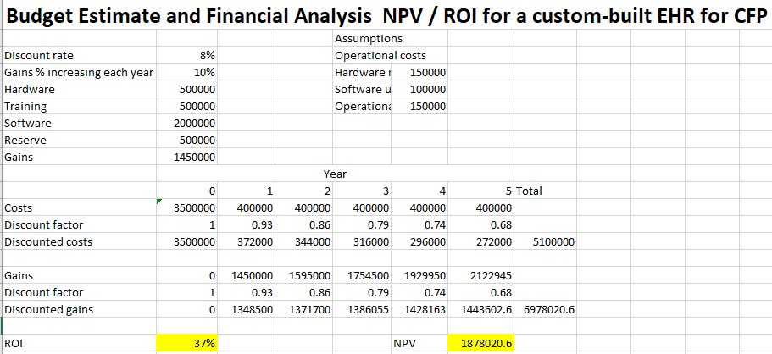

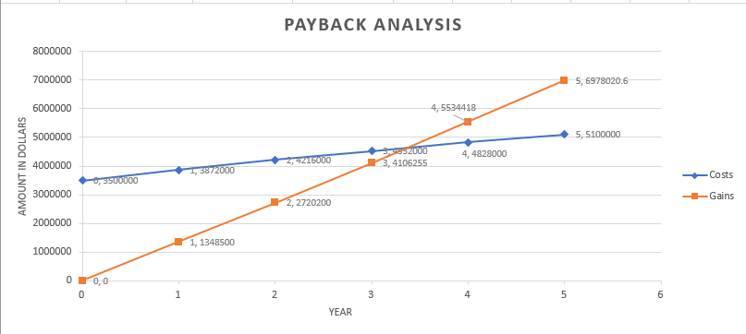

**Financial Analysis of the TTC project**

The preliminary costs of complete TTC project are $4,000,000 and it has subsequent costs after 1 year for its maintenance. The costs per year are $300,000 which is added to each year after implementation i.e. for 5 years. Calculating the benefits of TTC project, the returns of the project after implementation in year one is estimated to be $1,200,000 with different percentage of increase and it is expected to receive until 5 years which gains subjects to $3,100,000. These costs and benefits are discounted at a rate of 8% each year and based on this rate the return on investment, net present value and payback analysis of the project is calculated. The Return on investment for TTC project is expected to be 39% which states that that for every $100 spent on this project we would expect $139 in return with a profit of $39. The net present value is $2,041,000 which is the profit obtained in the 5 years after implementation. Payback analysis shows that the project is expected to reach a breakeven point in 4 years.

**Comparing the BSTC project with the TTC project**

Comparing both the projects, the return on investment and net present values are high for TTC but in payback analysis, we can see BSTC project has a better return in terms of the recovery period. Assuming if both the projects are started at the same time and if any new technology has introduced and boomed in the 3rd year of this implementation, BSTC project will recover most of the amount from the investment but TTC project will fail to get their investment back. By looking at the return of investment and net present values there is very less difference, but the time difference is high which is nearly 1 year. So, I would recommend BSTC project will be beneficial in terms of payback period where there are minimal risk factors involved when compared with the TTC project.

**Stakeholder analysis grid for CFP**

High interest/ Low power

**Keep Informed**

High interest/ High power

**Manage Closely**

* 6
* 1

Low interest/ Low power

**Monitor**

**Interest**

**Power**

Low

Low

High

High

* 3

Low interest/ High power

**Keep Satisfied**

* 4
* 2
* 5
* 7
* 8

1. Dr Winkle
2. Dr Ackerman
3. Dr King
4. Dr Koehler
5. Dr Jones
6. Dr Moore
7. Nursing staff
8. Administrative staff