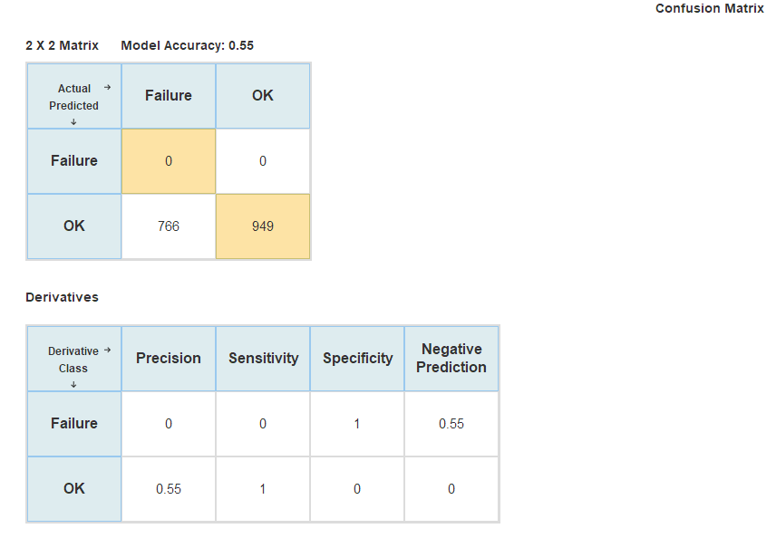

Question 1: Do you think that this classification model is a good predictor of equipment failure? Why or why not?

No, actual failures are 766 but predicted failures is 0