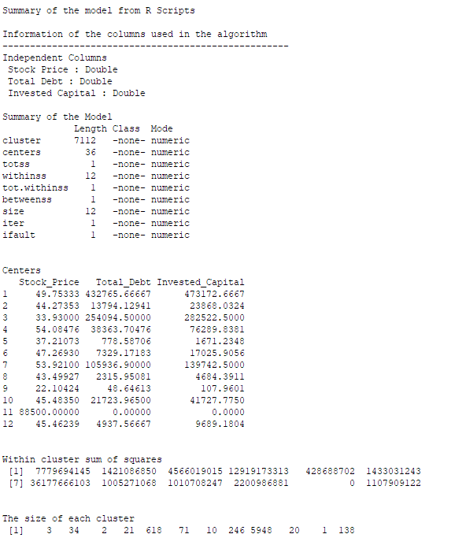

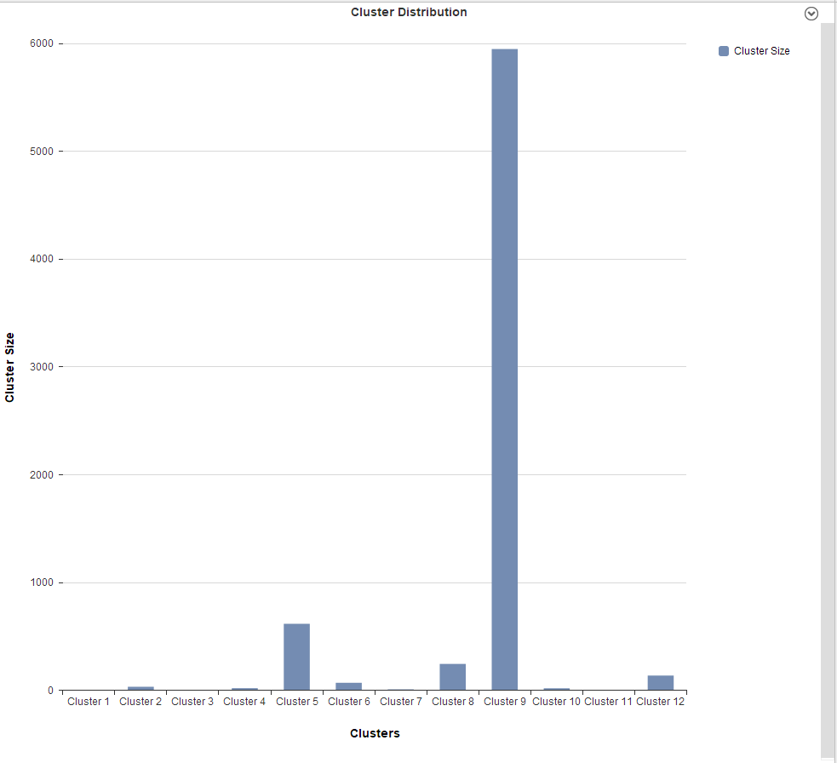

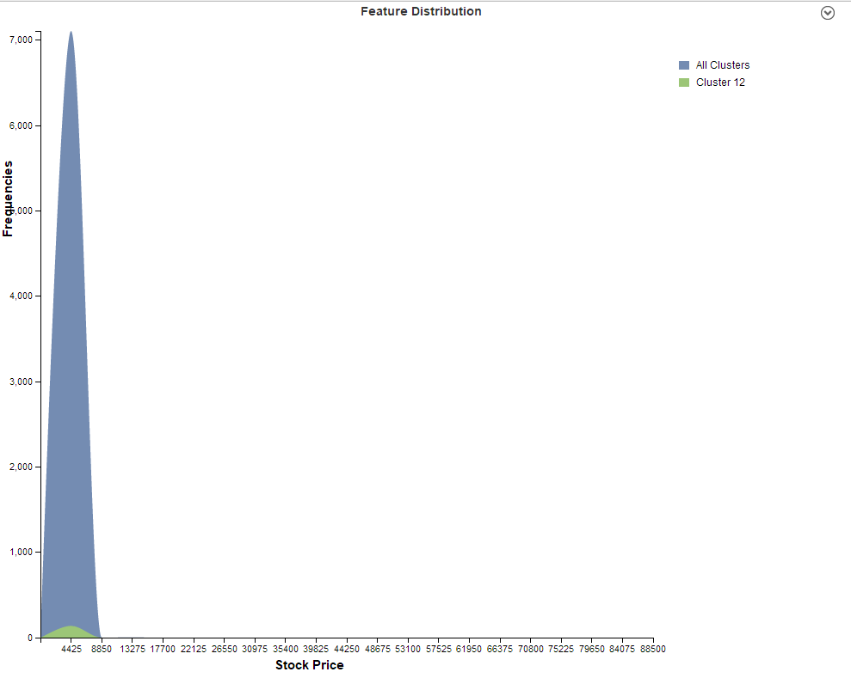

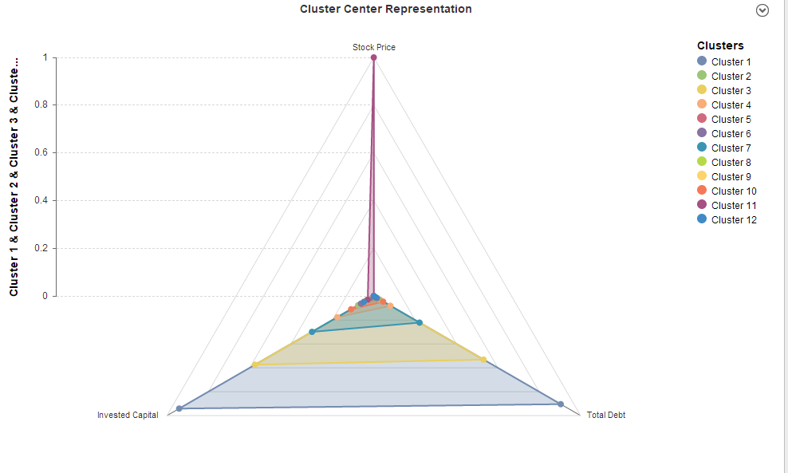

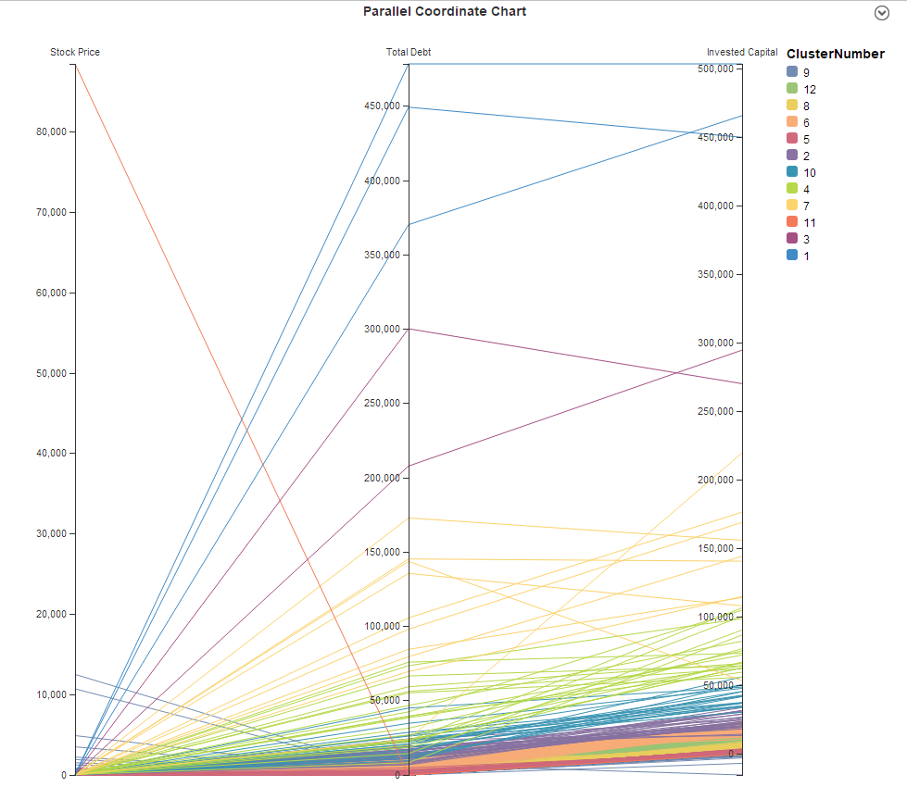

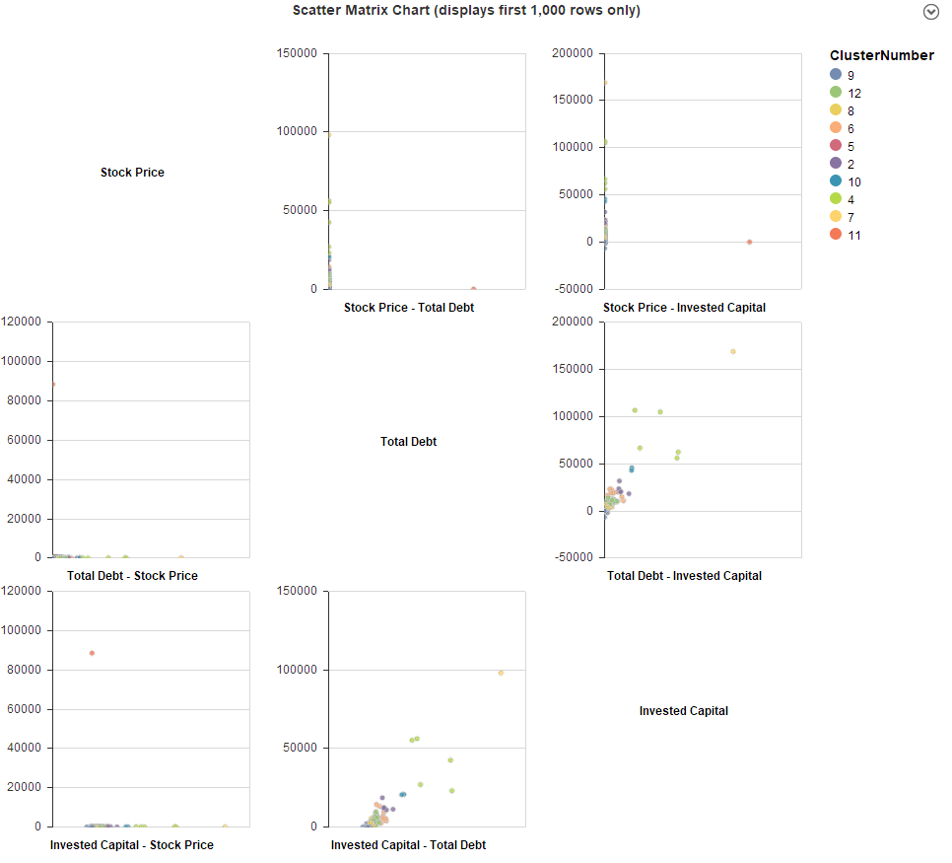

Question 1: Which cluster contains those stocks with the lowest average stock price? What is the average stock price in this cluster?

Lowest cluster – 9

Avg stock price 22.10

Question 2: Excluding the two removed clusters, which is the cluster with the highest average stock price? Of that cluster, what company has the highest average stock price and what is that price? What company has the lowest?

Cluster 4 has highest average of 54.08

Highest average company of cluster 4 is Lehman Bros with 128.15 stock price

Time Warner has lowest stock price with average of 17.43

Question 3: Continue to examine the cluster from question 2. What do your observations tell you regarding total debt and invested capital for the companies in this cluster?

Almost most of the companies in this cluster gained profit except 2 companies.

Question 4: What other observations can you make about the clusters in this analysis?

SLM corporation and Country wide financial has debt

Question 1: Which cluster has the most number of stores?

Cluster 1

Question 2: List the name of one store in each cluster.

1 – Garland

2 – Jackson

3 – San Jose

Question 3: What can the manager do with these segmentation results?

He can visualize the profit margin and sales turn over based on staff size and store size