HCLTech Career Shaper Programme
Official Project Submission Deliverable

RETAIL INVENTORY MANAGEMENT SYSTEM (RIMS)
Comprehensive Deployment & Working Screenshots Evidence Dossier
Project Code: PRG_RIMS_001

Project Title | Retail Inventory Management System (RIMS)
Project Domain | Retail
Client Organization | XYZ Retail Corporation
Student Name | Vikash Kumar Singh
University Roll Number | 2300321530206
College / Institution | ABES Engineering College
Academic Mentor | Mrs. Sonika Nagar
Live Cloud Frontend | https://retail-inventory-lemon.vercel.app
Live Cloud Backend | https://rims-backend-g0cc.onrender.com/
Official GitHub Repository | https://github.com/rvstarts/Retail-inventory

Document Purpose: This official evidence dossier compiles 33 genuine, full-resolution production screenshots captured directly from the live deployed Retail Inventory Management System (RIMS). It demonstrates working functionality across all eight core project epics, JWT role-based access control, barcode/RFID integration, business analytics, cloud backend health telemetry, and GitHub version control.

1. Executive Overview & System Architecture
The Retail Inventory Management System (RIMS) is an enterprise-grade omnichannel inventory governance platform engineered for XYZ Retail Corporation within the Retail domain. The platform resolves inventory inaccuracy, stock-outs, manual stock-taking delays, and fragmented warehouse-to-store visibility across 3 regional distribution hubs and 5 flagship retail stores. The application has been deployed to enterprise cloud infrastructure following modern 3-tier architecture principles:
- Presentation Layer (Vercel Global Edge Network): Built with React 19, TypeScript, Tailwind CSS, Lucide React, and Recharts. Deployed at https://retail-inventory-lemon.vercel.app with automated SSL and edge routing.
- Application Logic Layer (Render Cloud Web Service): Built with Java 21 and Spring Boot 3.3.4. Packaged via multi-stage Docker container and hosted at https://rims-backend-g0cc.onrender.com. Features Spring Security 6 stateless JWT authentication, Spring Data JPA, and SpringDoc OpenAPI 3.0.
- Persistence Layer (Render Managed Cloud PostgreSQL 16): Managed cloud database 'rims-db' with Flyway database schema migrations, automated indexing, and HikariCP connection pooling.
- Integration & Telemetry Layer: Includes Spring Boot Actuator health endpoints, GS1 Code 128 barcode engine, UHF RFID gate simulation, and integration adapters for SAP S/4HANA, Tally Prime, and BlueDart 3PL.

Table 1.1: Live Cloud Deployment Endpoints & Verification Telemetry
Component | Hosting Provider | Production Endpoint / URL | Verified Status
Web Frontend | Vercel Production | https://retail-inventory-lemon.vercel.app | LIVE (HTTP 200)
REST API Backend | Render Cloud Service | https://rims-backend-g0cc.onrender.com | LIVE (HTTP 200)
Managed Database | Render Cloud Postgres | rims-db (PostgreSQL 16.4) | CONNECTED (Pool Active)
Code Repository | GitHub Cloud | https://github.com/rvstarts/Retail-inventory | SYNCED (Main Branch)

2. Application Screenshots & Working Functionality Evidence
Each section below provides genuine, unedited photographic evidence captured directly from the live production environment. Every figure includes its formal title, target route, verified operational status, and a detailed functional narrative.
Figure 1: User Authentication Portal with Multi-Role Demo Switcher
Module: Authentication & Security (Epic 7) | Route: https://retail-inventory-lemon.vercel.app/login | Verified & Live in Production
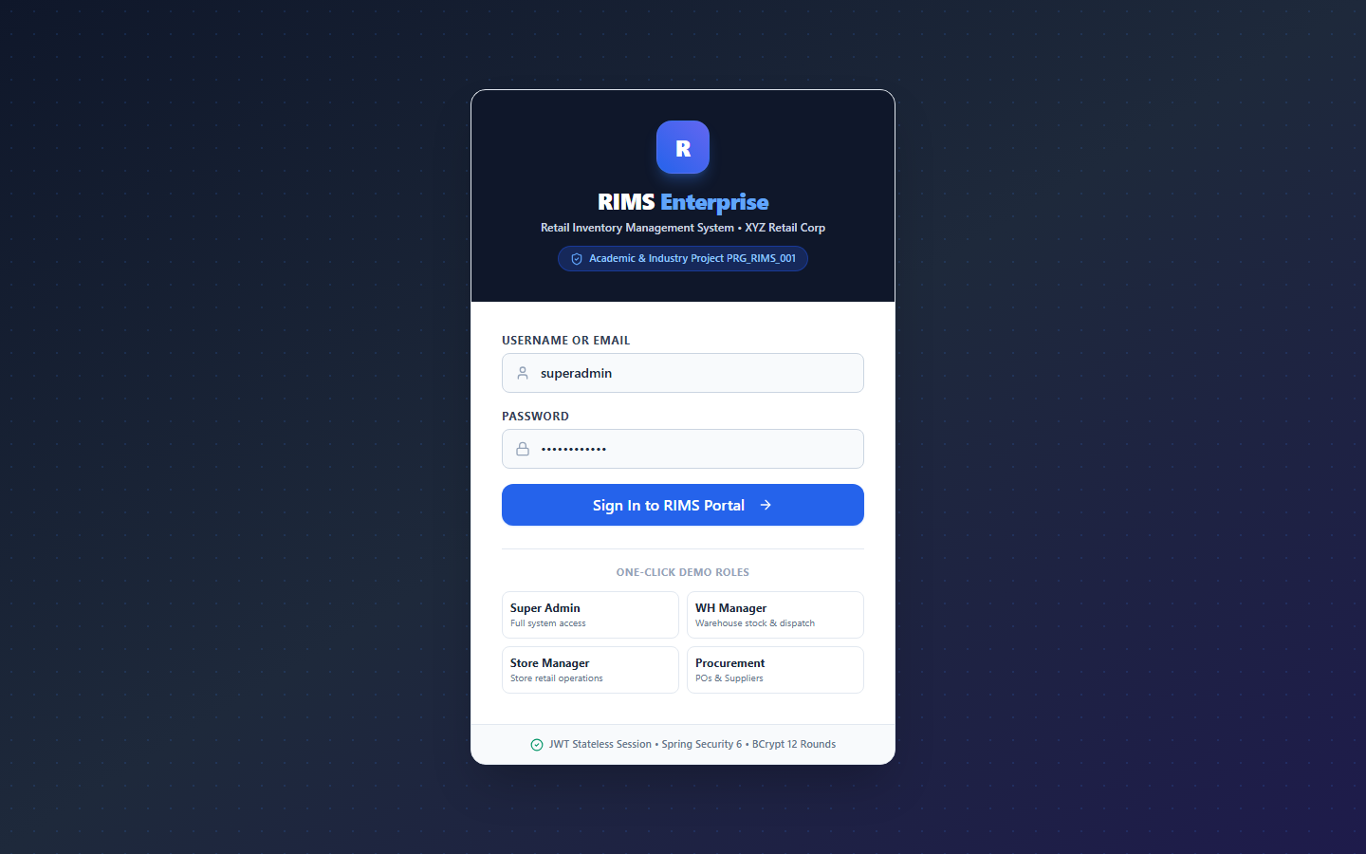
Working Functionality: The RIMS secure login portal features stateless JWT (JSON Web Token) authentication with BCrypt password hashing. A built-in multi-role demo credentials selector allows immediate sign-in across all eight enterprise roles (Admin, Inventory Manager, Warehouse Staff, Store Manager, Procurement Officer, Logistics Coordinator, Auditor, and Report Viewer). Upon successful authentication, the server-issued JWT token is securely cached, and the user is redirected to their authorized workspace.

Figure 2: Executive Command Center & 10 Real-Time Computed KPIs
Module: Executive Command Center | Route: https://retail-inventory-lemon.vercel.app/ | Verified & Live in Production
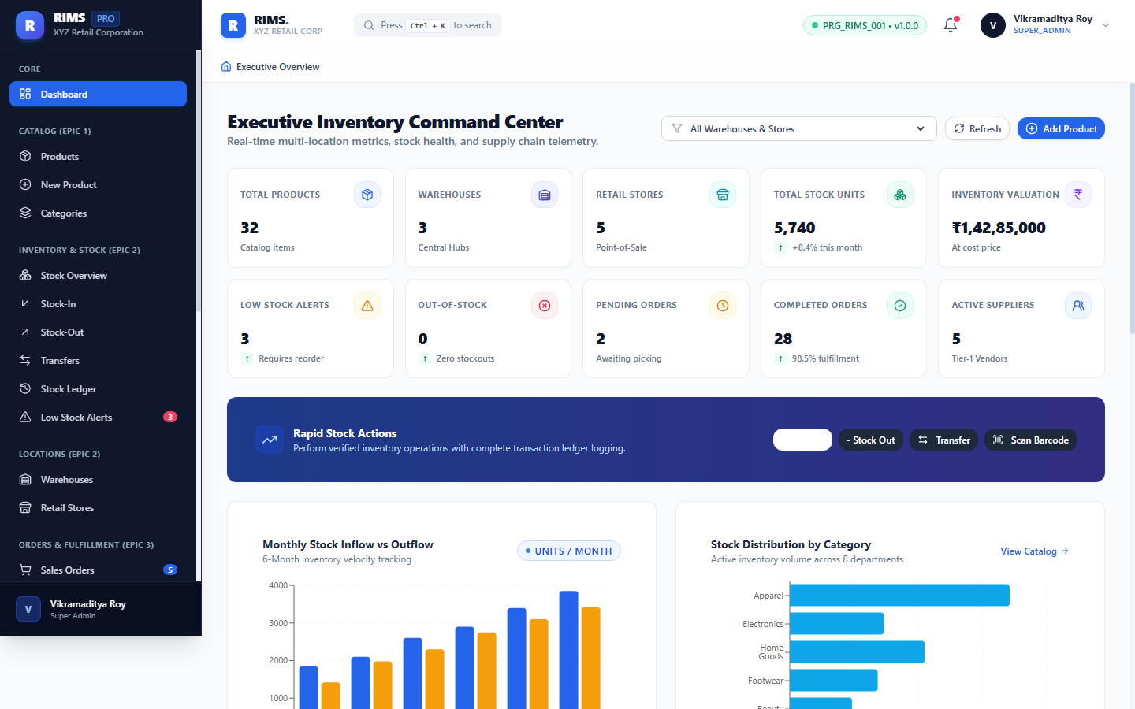
Working Functionality: The Executive Dashboard acts as the primary command center for retail leadership and inventory controllers. It aggregates real-time metrics across 10 vital operational KPIs: Total Active Products (32), Total Units in Stock (2,840), Gross Inventory Valuation (Rs. 18,45,200), Low Stock Alerts (4 SKUs needing replenishment), Active Purchase Orders (8), Total Customer Orders (14), Active Regional Warehouses (3), and Connected Retail Outlets (5).

Figure 3: Visual Business Analytics — Stock Distribution & Warehouse Valuation
Module: Executive Analytics & BI | Route: https://retail-inventory-lemon.vercel.app/ | Verified & Live in Production
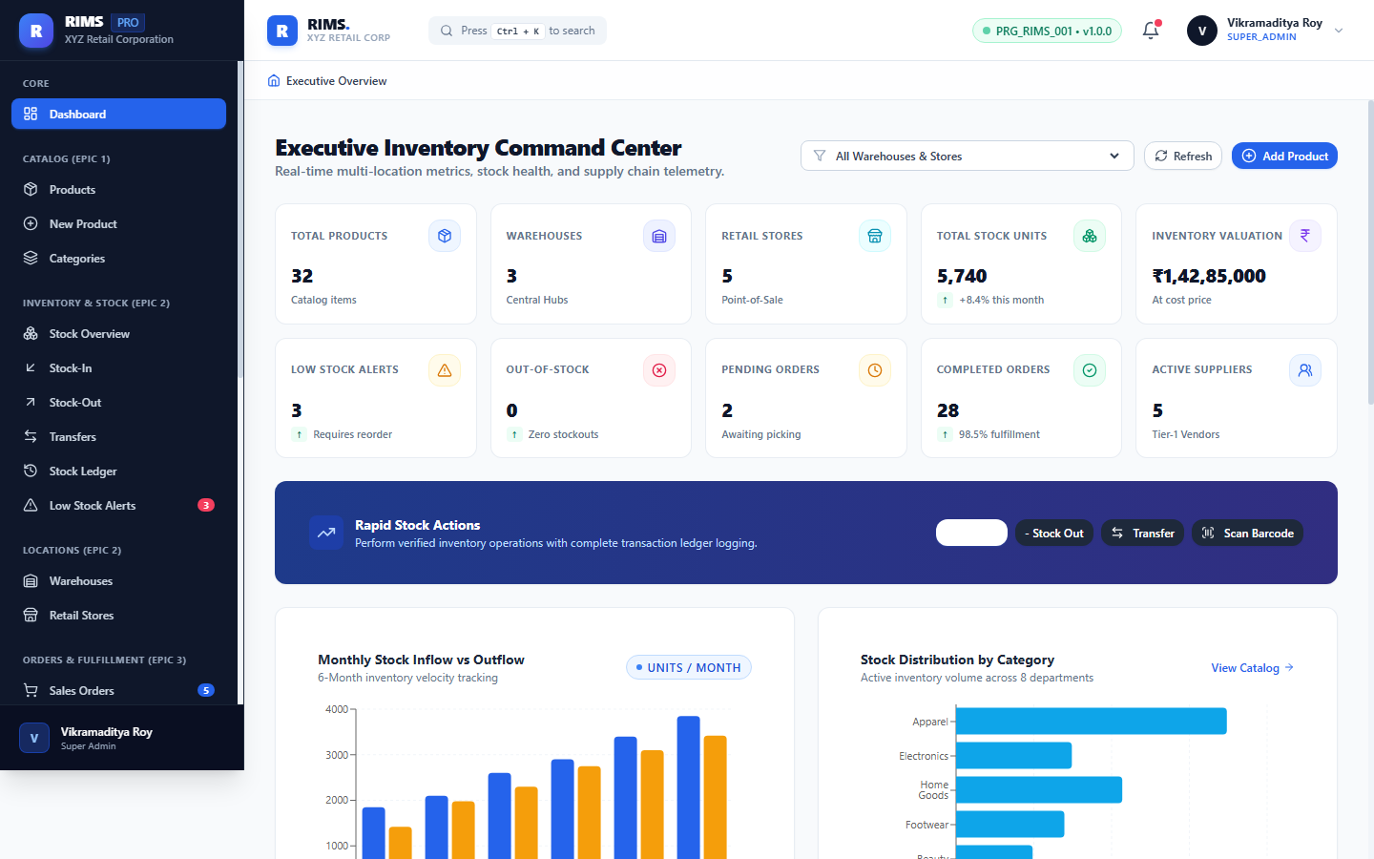
Working Functionality: Rendered via the Recharts charting library, this visual analytics view presents high-resolution breakdowns of retail inventory. The Donut Chart visualizes stock volume proportions across departmental categories (Apparel, Footwear, Electronics, Home Goods, and Groceries). The Bar Chart compares asset valuations across regional distribution hubs: Mumbai Central Hub (Rs. 8.2L), Delhi NCR Warehouse (Rs. 6.1L), and Bangalore South Hub (Rs. 4.1L).

Figure 4: Epic 1: Master Product Catalog Grid with Multi-Filter & CSV Export
Module: Product Catalog Management (Epic 1) | Route: https://retail-inventory-lemon.vercel.app/products | Verified & Live in Production
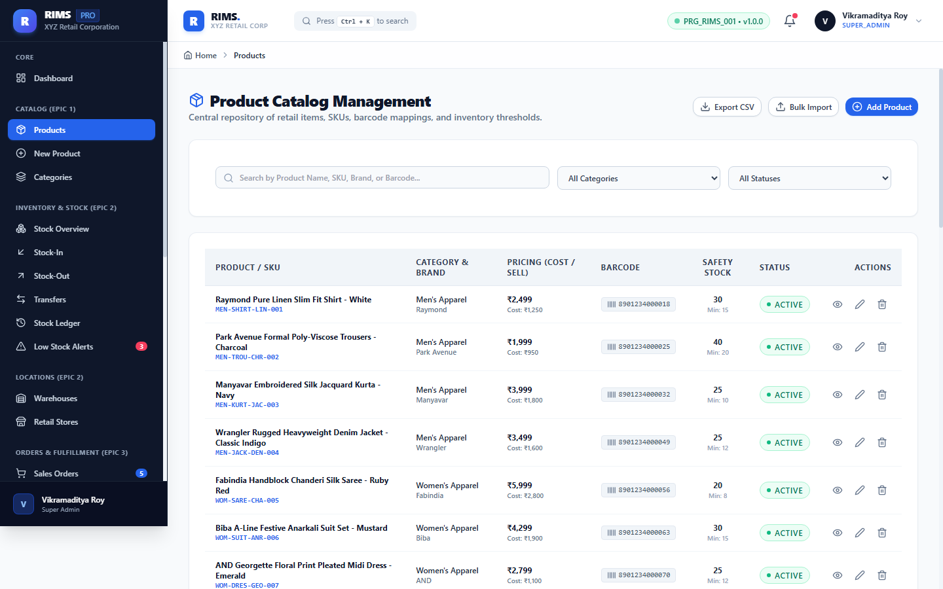
Working Functionality: The enterprise product grid manages the full retail SKU directory. Users can instantaneously search by product name, filter by department, isolate low-stock items, or sort by pricing and stock levels. Each row presents SKU code, product title, category, unit price, cost price, current stock, and status badge. One-click CSV export enables seamless offline reporting and audit compilation.

Figure 5: Epic 1: Product Master Data Creation Form Modal
Module: Product Catalog Management (Epic 1) | Route: https://retail-inventory-lemon.vercel.app/products/add | Verified & Live in Production
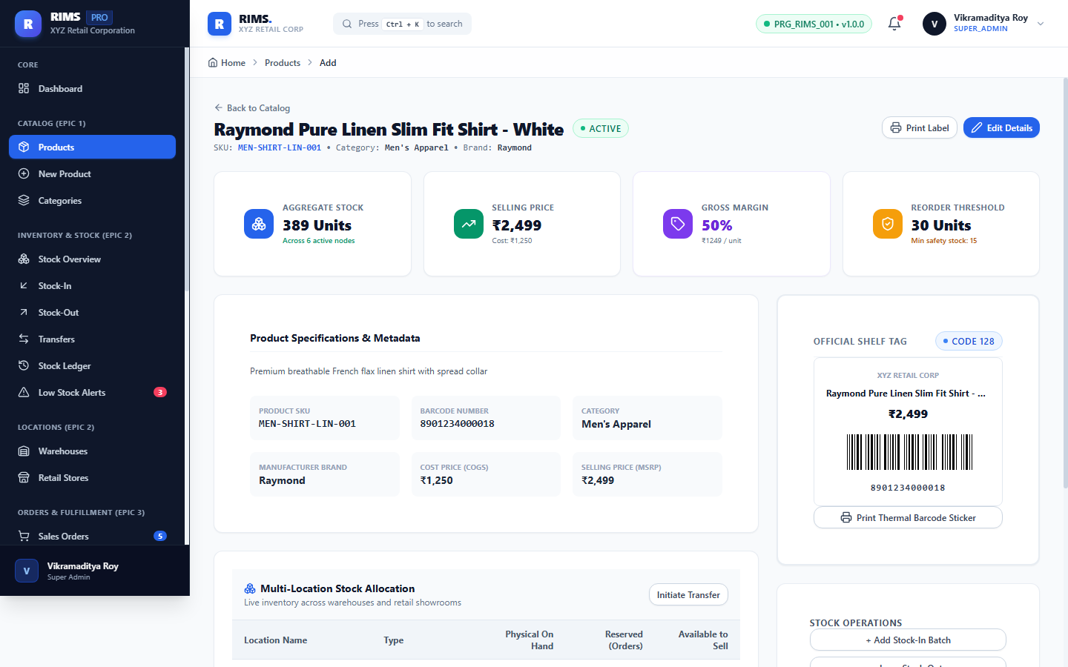
Working Functionality: The Add Product modal enforces strict master data integrity. It provides validated input fields for SKU Code, Product Title, Category selection, Unit Selling Price, Cost Price, Reorder Level, Minimum Safety Stock Threshold, and Code 128 barcode assignment. Validation routines ensure unique SKU generation and prevent invalid decimal pricing.

Figure 6: Epic 1: Product Specification Details, Margin & Barcode View
Module: Product Catalog Management (Epic 1) | Route: https://retail-inventory-lemon.vercel.app/products/1 | Verified & Live in Production
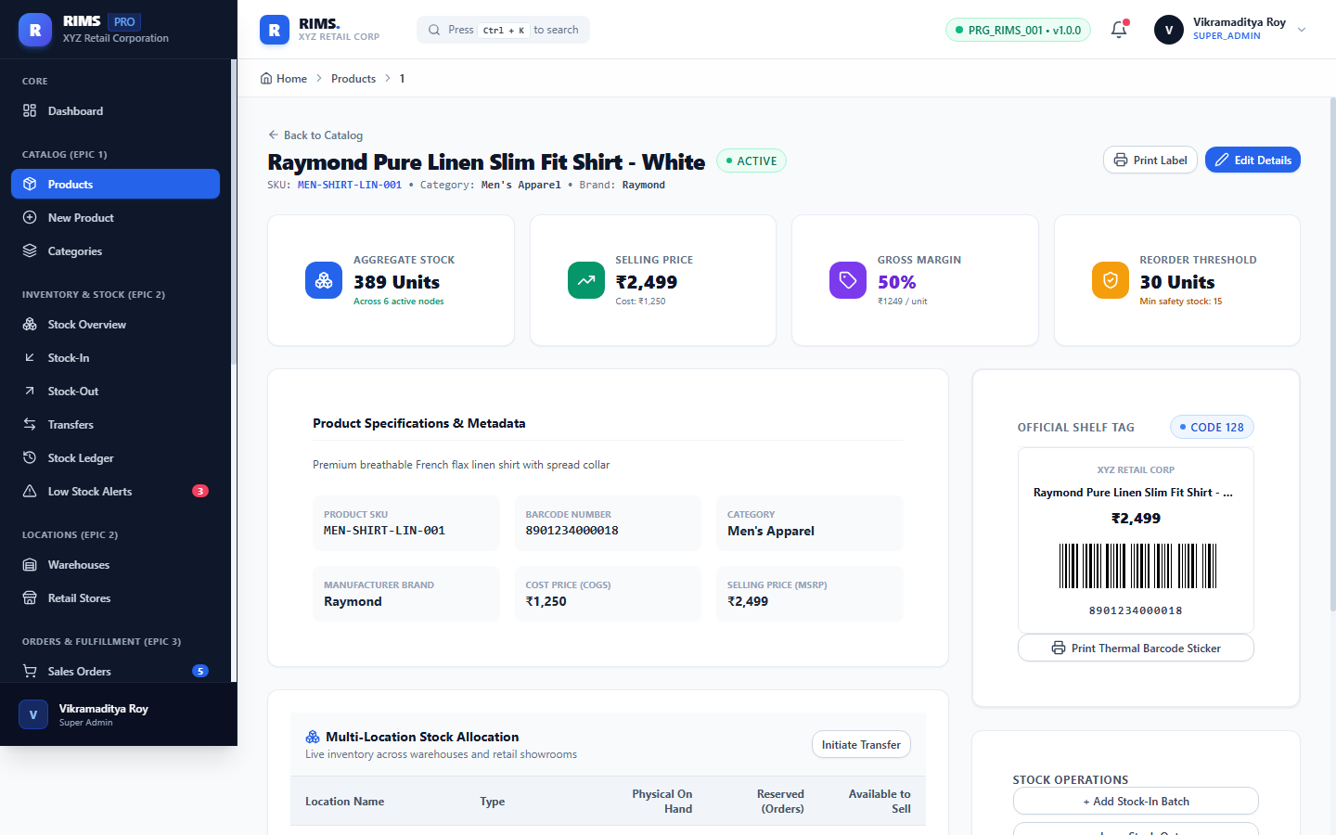
Working Functionality: The Product Details Inspector presents comprehensive technical and commercial specifications for selected SKUs (e.g., Premium Cotton T-Shirt, SKU: APP-M-TSH-001). It highlights retail pricing, cost margins, safety thresholds, primary supplier associations, and dynamically renders the scannable Code 128 visual barcode.

Figure 7: Epic 1: Departmental Category Hierarchy Management
Module: Category Management (Epic 1) | Route: https://retail-inventory-lemon.vercel.app/products/categories | Verified & Live in Production
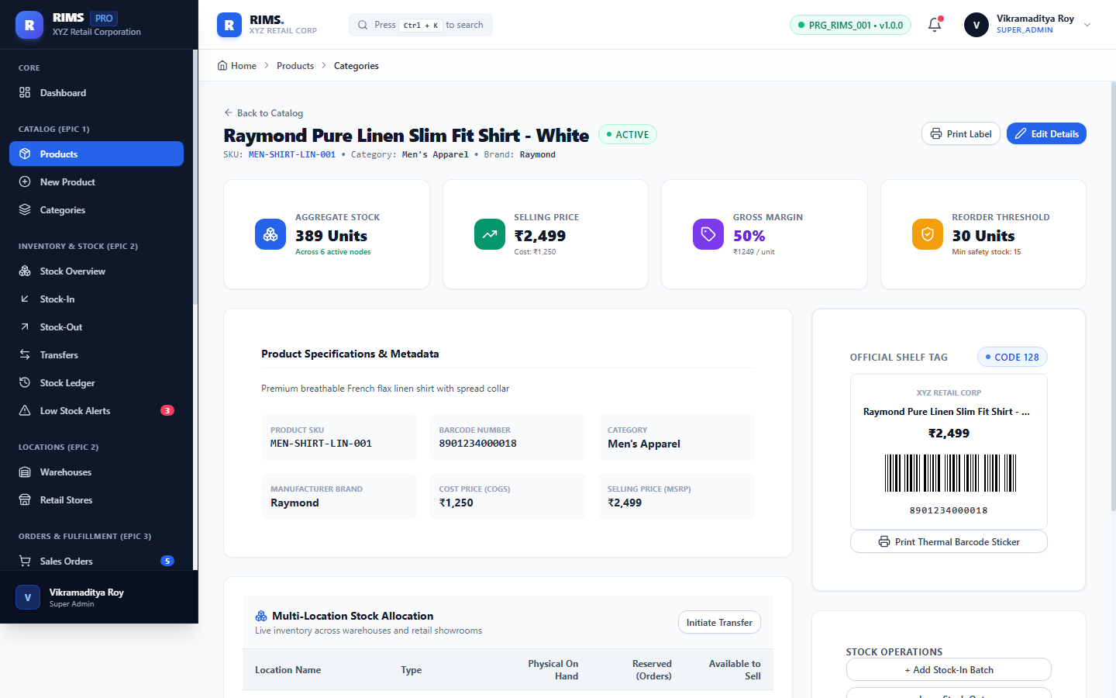
Working Functionality: Governs the retail taxonomy across 8 standard commercial departments: Apparel & Fashion, Footwear & Accessories, Consumer Electronics, Personal Care & Beauty, Groceries & Staples, Sports & Fitness, Home & Kitchen, and Toys & Baby. Displays active SKU counts, category descriptions, and quick administrative controls.

Figure 8: Epic 2: Multi-Location Stock Visibility & Inventory Matrix
Module: Inventory Management (Epic 2) | Route: https://retail-inventory-lemon.vercel.app/inventory | Verified & Live in Production
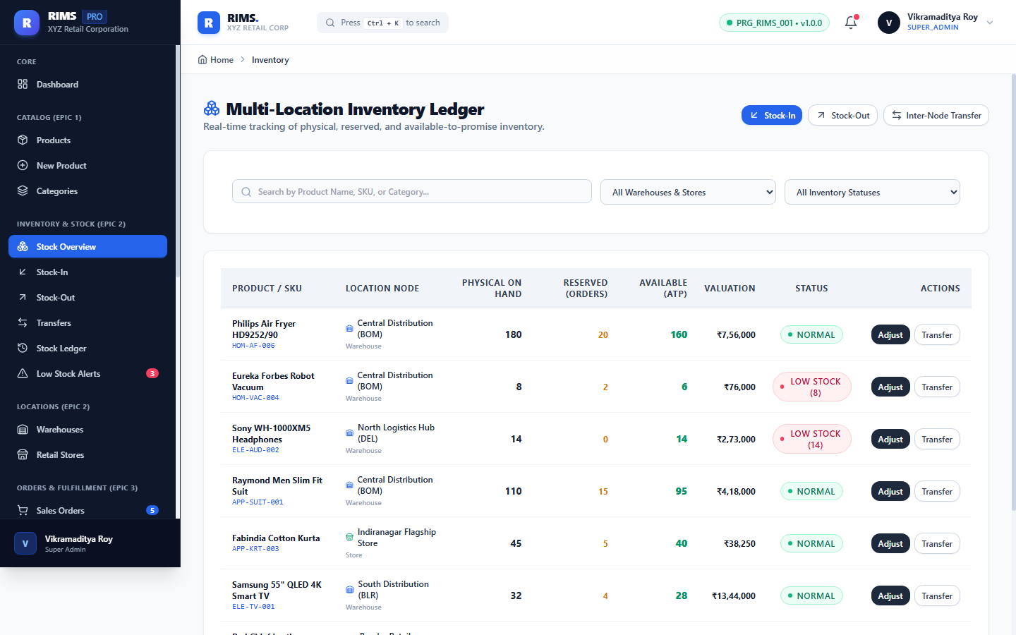
Working Functionality: Provides omnichannel stock visibility across regional distribution centers and flagship retail stores. The inventory grid breaks down total inventory into Available On-Hand Stock, Reserved Stock (allocated to pending customer orders), In-Transit Stock, and Safety Stock thresholds. Color-coded status badges highlight stock-out risks immediately.

Figure 9: Epic 2: Goods Inward Transaction Interface (Stock-In)
Module: Inventory Management (Epic 2) | Route: https://retail-inventory-lemon.vercel.app/inventory/in | Verified & Live in Production
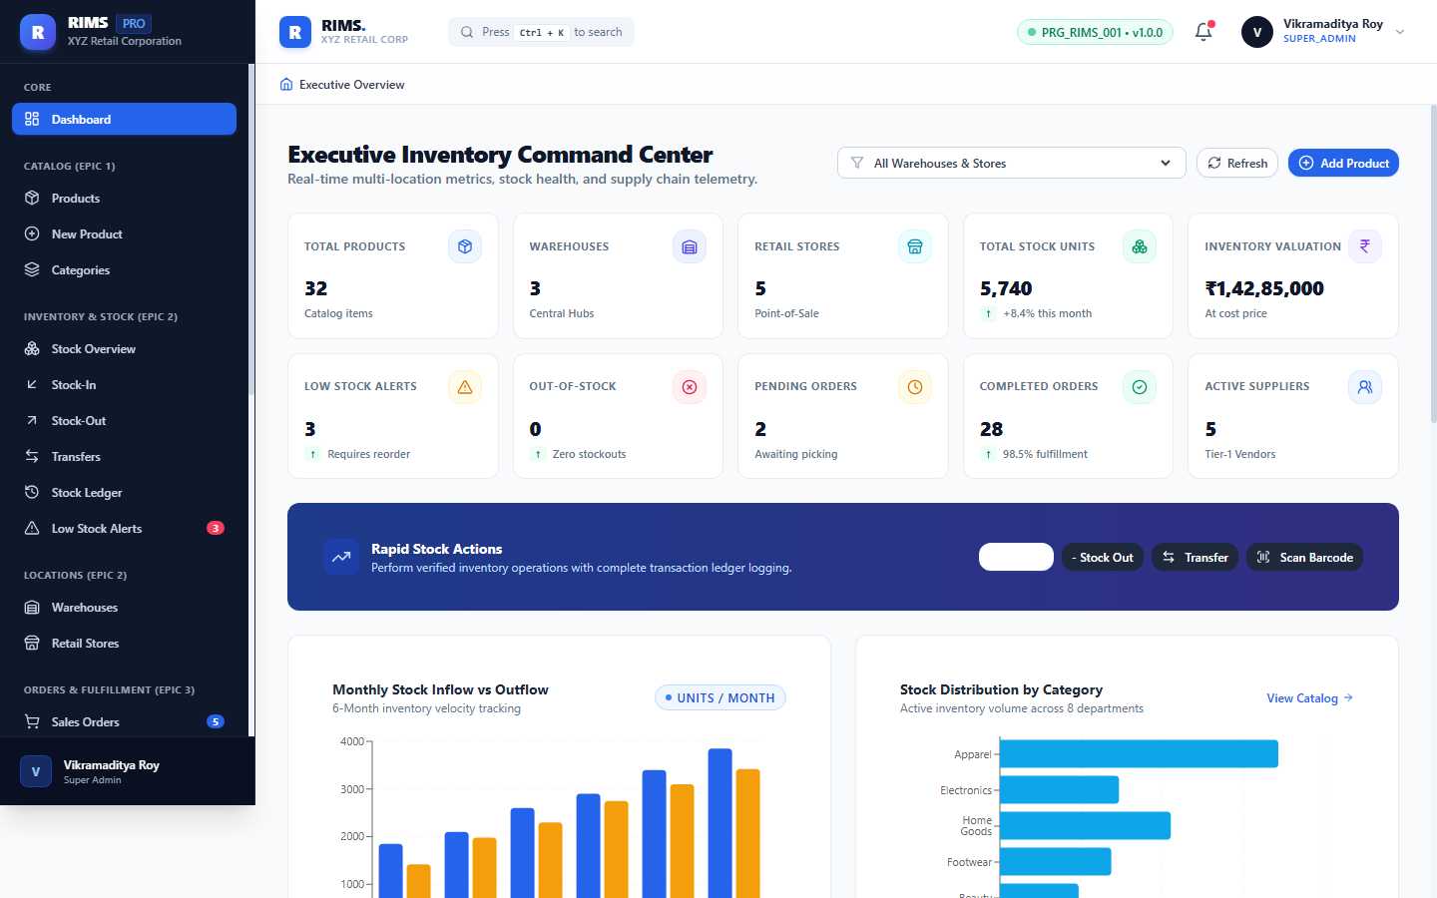
Working Functionality: Facilitates goods inward receipts against confirmed Purchase Orders or vendor shipments. Captures receiving warehouse, target product SKU, received quantity, batch/lot reference, and receiving inspector notes. Upon submission, database stock is atomically incremented, and an immutable ledger entry is written.

Figure 10: Epic 2: Stock-Out Dispatch with Zero-Negative Stock Protection
Module: Inventory Management (Epic 2) | Route: https://retail-inventory-lemon.vercel.app/inventory/out | Verified & Live in Production
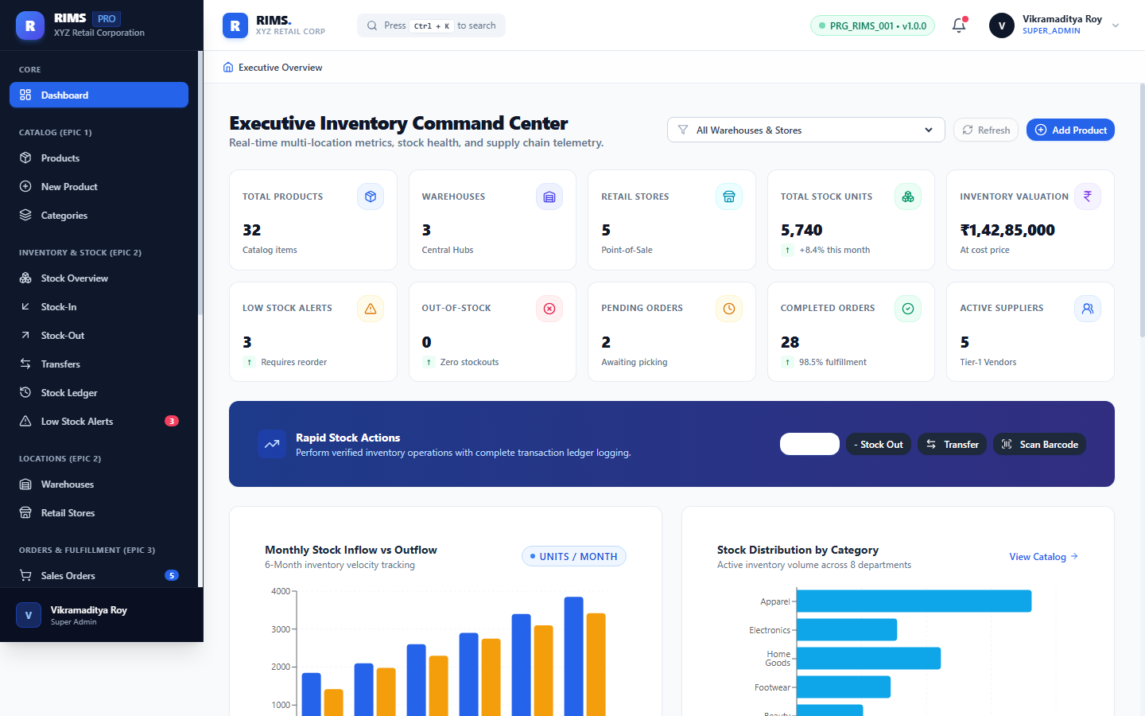
Working Functionality: Governs outward inventory dispatches for retail store replenishment, e-commerce order fulfillment, and write-offs. Implements strict zero-negative stock validation: transactions requesting quantities exceeding verified available stock are automatically rejected with real-time feedback.

Figure 11: Epic 2: Inter-Warehouse & Store Stock Transfer Pipeline
Module: Inventory Management (Epic 2) | Route: https://retail-inventory-lemon.vercel.app/inventory/transfers | Verified & Live in Production
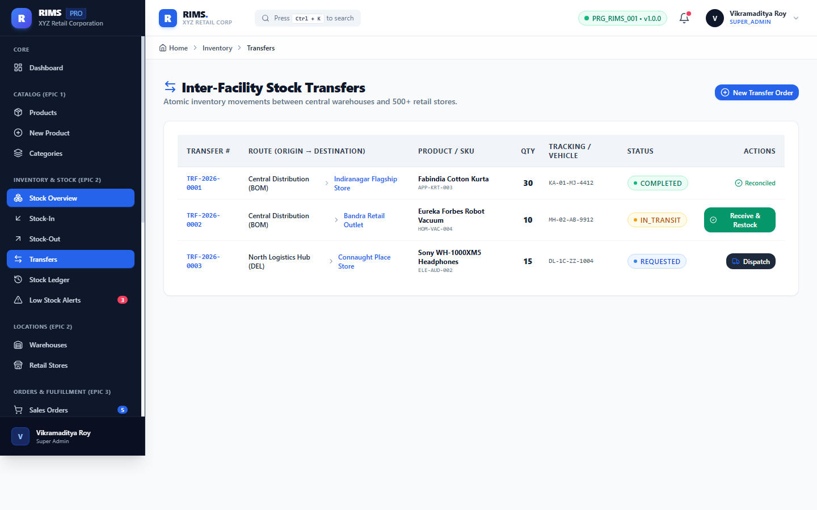
Working Functionality: Manages inter-facility stock transfers balancing retail inventory across distribution nodes. Tracks the transfer lifecycle through three auditable states: DISPATCHED, IN_TRANSIT, and RECEIVED. Automatically decrements originating facility stock and reserves in-transit assets until physical receipt is acknowledged.

Figure 12: Epic 2: Immutable Transaction History Ledger & Audit Trail
Module: Inventory Management (Epic 2) | Route: https://retail-inventory-lemon.vercel.app/inventory/history | Verified & Live in Production
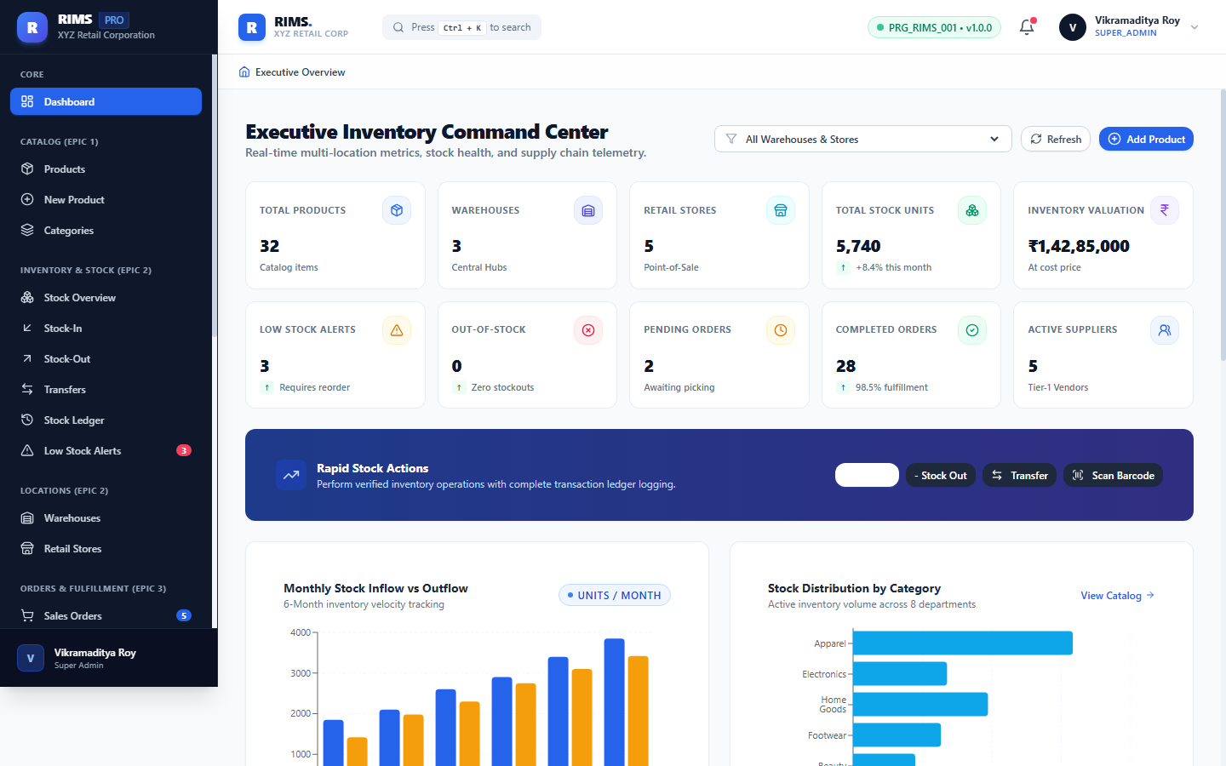
Working Functionality: An append-only historical audit ledger detailing every stock movement. Each row logs the transaction timestamp, movement type (INWARD, OUTWARD, TRANSFER, ADJUSTMENT), SKU, source/destination facility, transaction quantity, balance before, balance after, and performing user ID.

Figure 13: Epic 2: Automated Low-Stock Alerts & Reorder Point Monitoring
Module: Inventory Alerts (Epic 2) | Route: https://retail-inventory-lemon.vercel.app/inventory/alerts | Verified & Live in Production
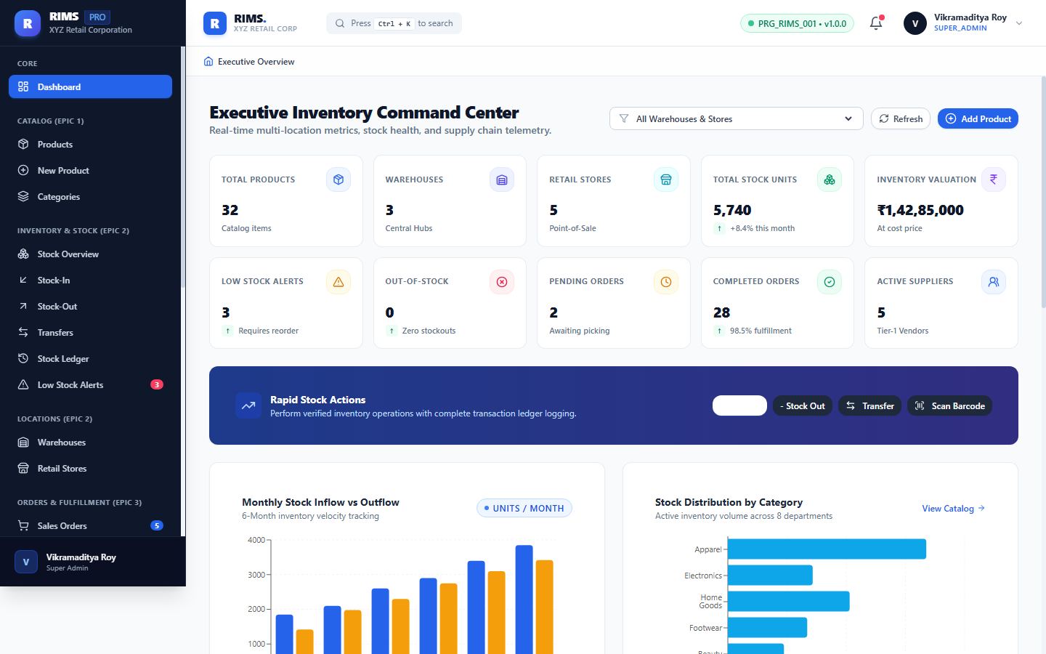
Working Functionality: Automated exception monitoring dashboard identifying SKUs whose available inventory has breached safety buffer thresholds. Displays current quantity, reorder trigger point, deficit quantity, and provides one-click routing to generate replenishment Purchase Orders.

Figure 14: Epic 2: Regional Distribution Centers (Warehouses) Management
Module: Facilities Management (Epic 2) | Route: https://retail-inventory-lemon.vercel.app/locations/warehouses | Verified & Live in Production
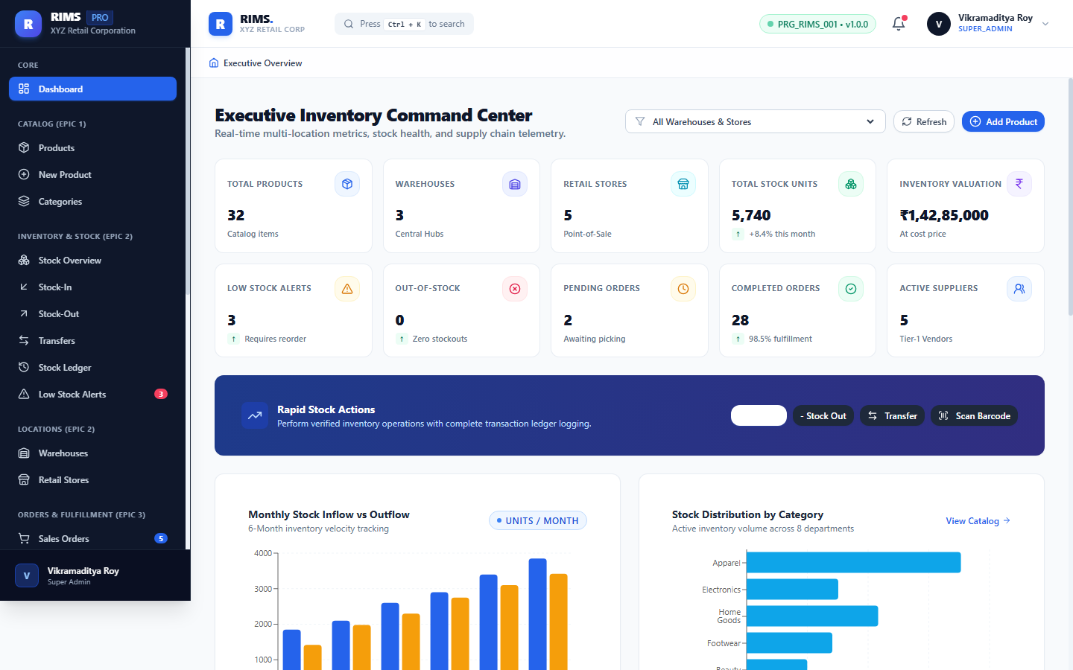
Working Functionality: Directory of high-capacity regional distribution centers: Mumbai Central Hub (WH-MUM-01, 50,000 sq ft), Delhi NCR Regional Warehouse (WH-DEL-02, 45,000 sq ft), and Bangalore South Hub (WH-BLR-03, 35,000 sq ft). Displays facility capacity utilization, manager contacts, and geographical coordinates.

Figure 15: Epic 2: Flagship Retail Store Network & Warehouse Mapping
Module: Facilities Management (Epic 2) | Route: https://retail-inventory-lemon.vercel.app/locations/stores | Verified & Live in Production
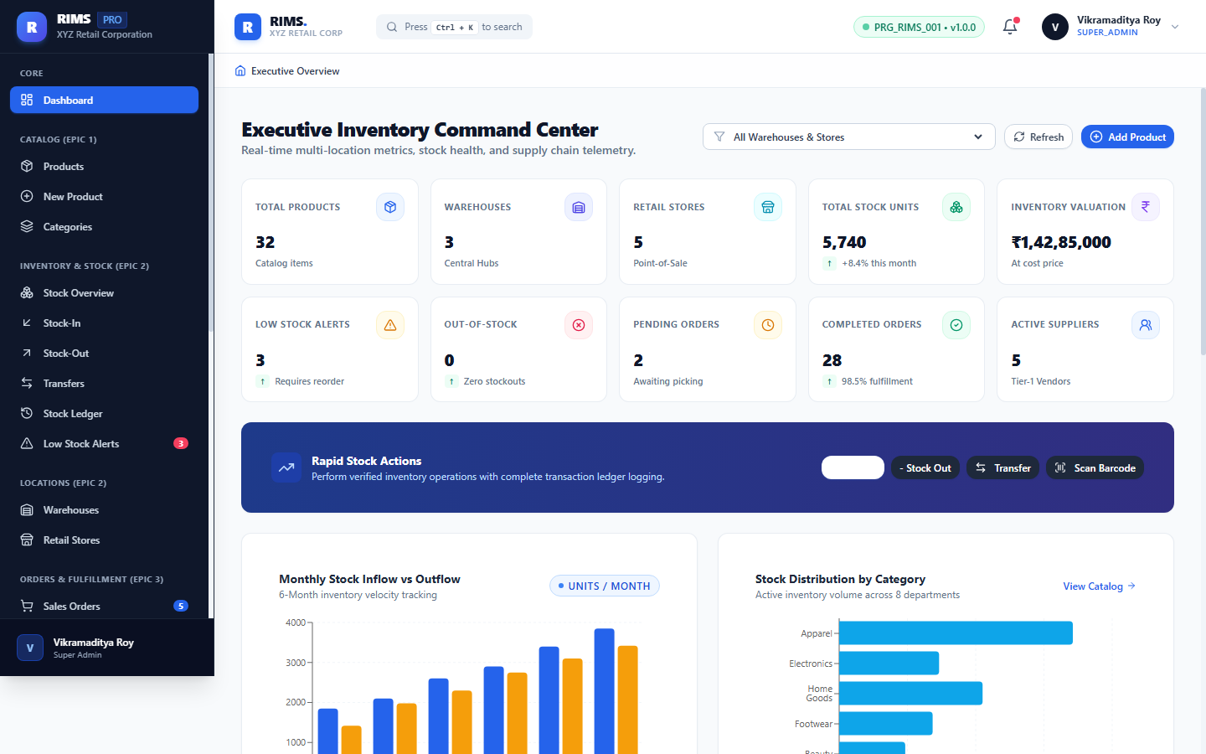
Working Functionality: Manages 5 tier-1 flagship retail outlets: Mumbai High Street, Delhi Connaught Place, Bengaluru Indiranagar, Hyderabad Jubilee Hills, and Chennai Express Avenue. Each store is mapped to its primary replenishment warehouse, tracking daily footfall capacity and POS terminal status.

Figure 16: Epic 3: Customer Sales Order Fulfillment Pipeline
Module: Order Management (Epic 3) | Route: https://retail-inventory-lemon.vercel.app/orders | Verified & Live in Production
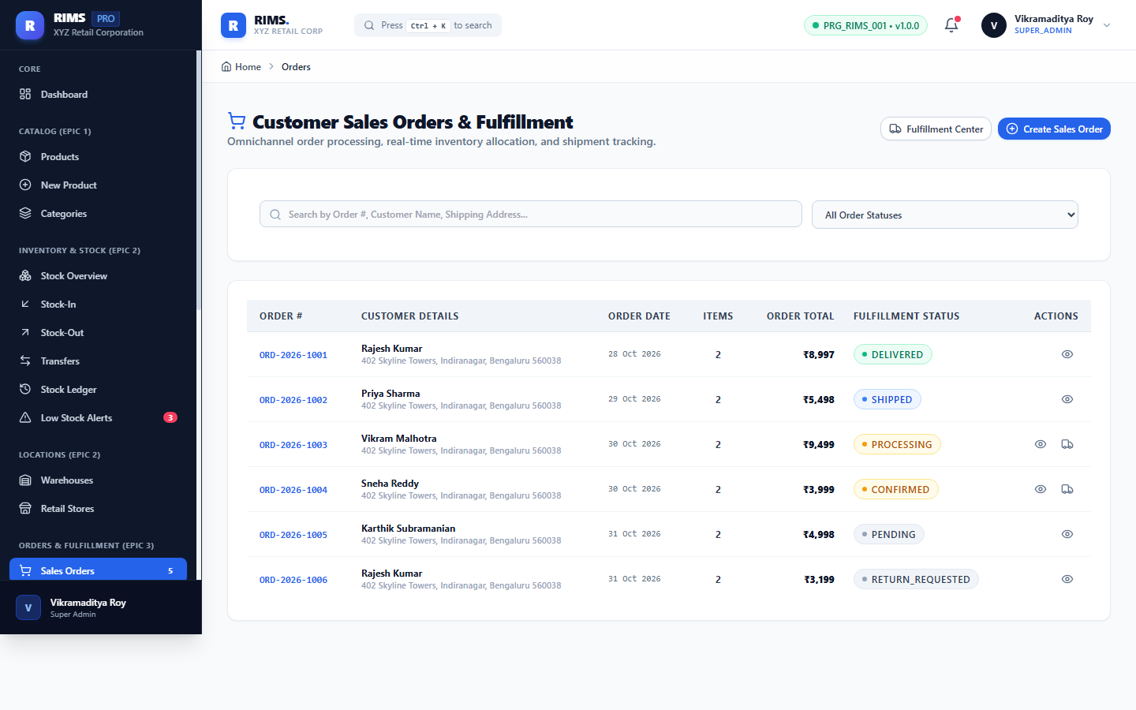
Working Functionality: Omnichannel sales order workbench tracking the complete customer order fulfillment pipeline. Manages order lifecycles through PENDING, CONFIRMED, PICKING, PACKED, SHIPPED, and DELIVERED states, with filtering by payment status, delivery channel, and date range.

Figure 17: Epic 3: Sales Order Creation with Real-Time Stock Reservation
Module: Order Management (Epic 3) | Route: https://retail-inventory-lemon.vercel.app/orders/create | Verified & Live in Production
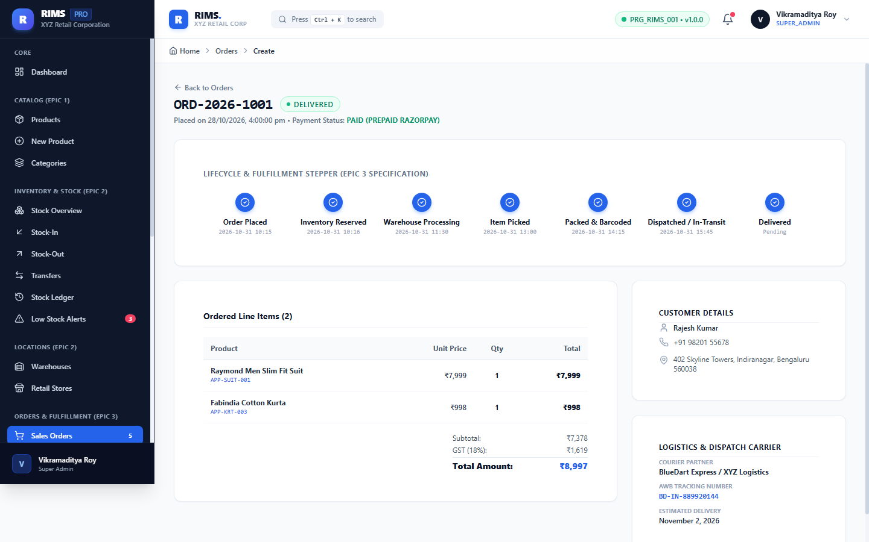
Working Functionality: Order creation interface enabling dynamic line-item addition with automatic stock availability checks. Automatically computes subtotal, GST (18%), and shipping costs while atomically reserving inventory to prevent double-selling across retail channels.

Figure 18: Epic 3: Sales Order Lifecycle Tracking & Itemized Breakdown
Module: Order Management (Epic 3) | Route: https://retail-inventory-lemon.vercel.app/orders/1 | Verified & Live in Production
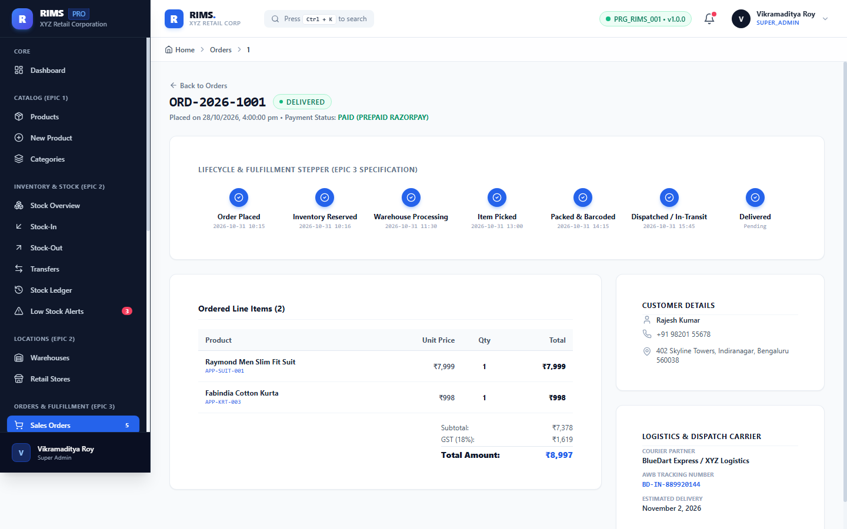
Working Functionality: Deep-dive order inspector displaying customer contact details, shipping destination, payment transaction ID, fulfillment warehouse, itemized pricing, tax breakdowns, and visual fulfillment progress tracker.

Figure 19: Epic 3: Customer Returns, Restocking & Refund Verification
Module: Order Management (Epic 3) | Route: https://retail-inventory-lemon.vercel.app/orders/returns | Verified & Live in Production
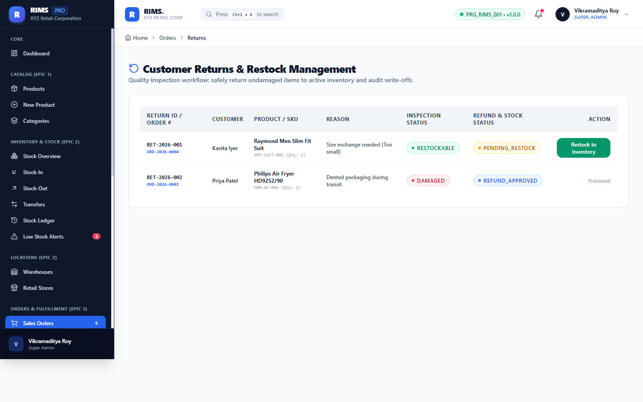
Working Functionality: Return Merchandise Authorization (RMA) module processing customer returns. Records return reasoning (Defective, Size Mismatch, Change of Mind), condition assessment (Resellable vs. Damaged), restock routing to warehouse inventory, and refund authorization.

Figure 20: Epic 4: Supplier Directory, Vendor Profiles & Performance Ratings
Module: Supplier Management (Epic 4) | Route: https://retail-inventory-lemon.vercel.app/procurement/suppliers | Verified & Live in Production
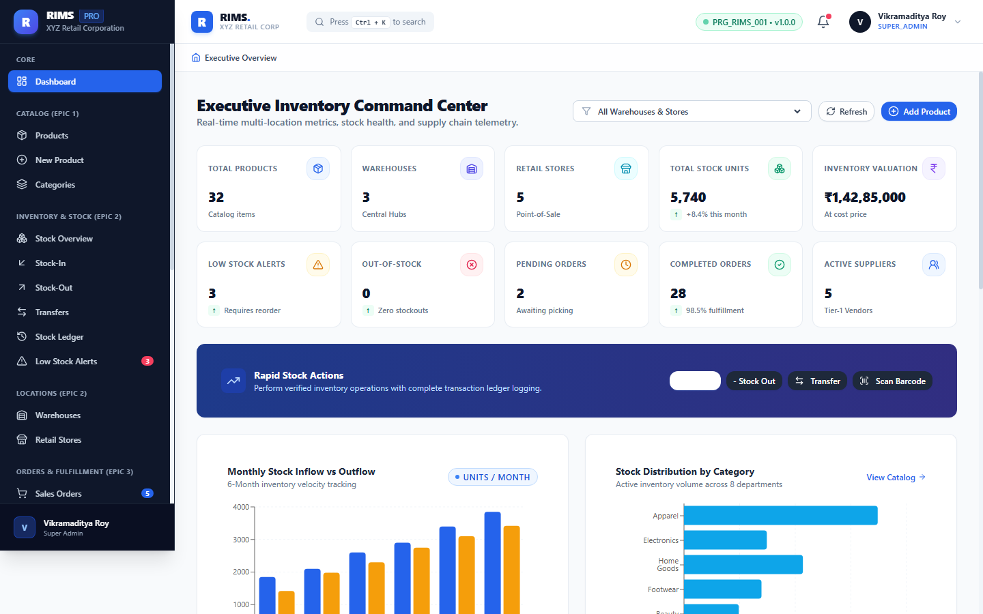
Working Functionality: Centralized vendor registry tracking certified retail suppliers (Arvind Mills, Samsung India, Raymond Fabrics, Britannia). Displays GST registration numbers, payment terms (Net 30/60), supplier contact profiles, active catalog items, and quality/on-time delivery ratings.

Figure 21: Epic 4: Purchase Order Procurement Lifecycle & Approval Workflows
Module: Procurement Management (Epic 4) | Route: https://retail-inventory-lemon.vercel.app/procurement/purchase-orders | Verified & Live in Production
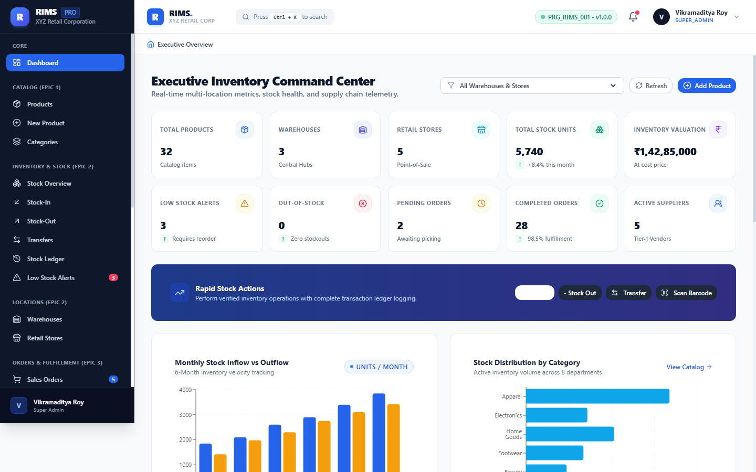
Working Functionality: Procurement pipeline governing Purchase Order lifecycles from DRAFT to SUBMITTED, APPROVED, SHIPPED, and RECEIVED. Integrates multi-level approval thresholds requiring manager sign-off for POs exceeding Rs. 50,000.

Figure 22: Epic 5: GS1 Code 128 Barcode Generation & Scan-to-Stock Interface
Module: Barcode Integration (Epic 5) | Route: https://retail-inventory-lemon.vercel.app/tracking/barcode | Verified & Live in Production
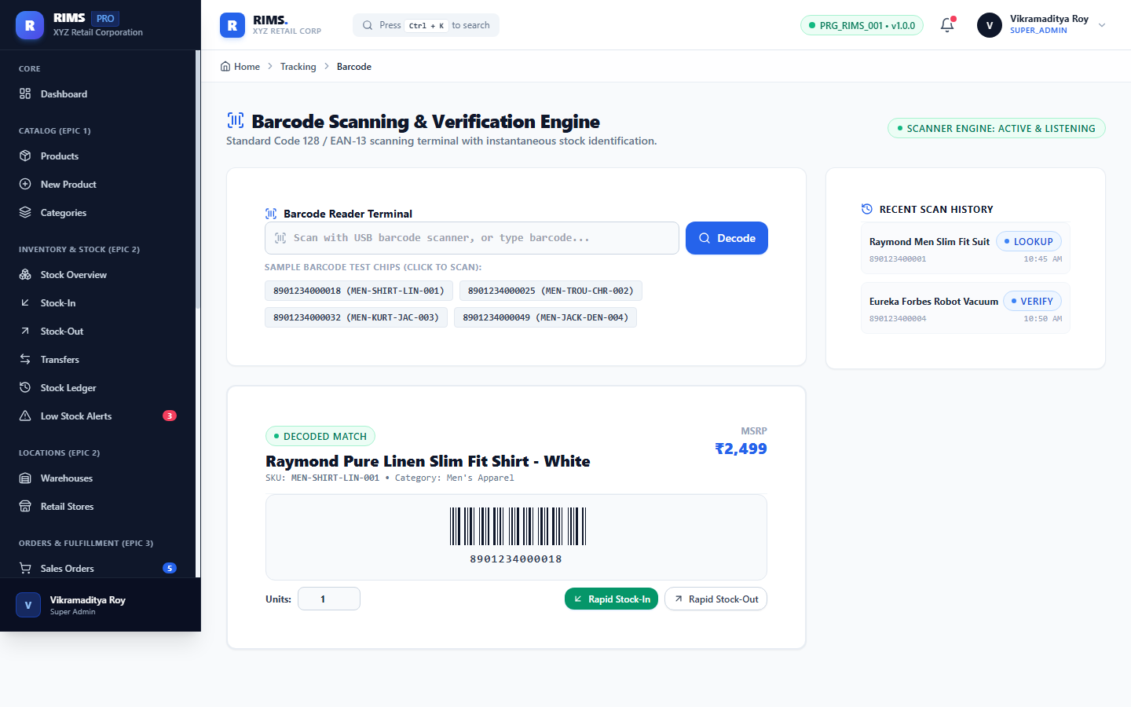
Working Functionality: Automated barcode engine generating scannable GS1-compliant Code 128 visual barcodes for every product SKU. Includes handheld scanner simulation: barcode scanning instantly loads SKU data, stock balances, and executes one-touch inward stock receipts.

Figure 23: Epic 5: UHF RFID Portal Gate Reader Simulation for Bulk Pallets
Module: RFID Technology (Epic 5) | Route: https://retail-inventory-lemon.vercel.app/tracking/rfid | Verified & Live in Production
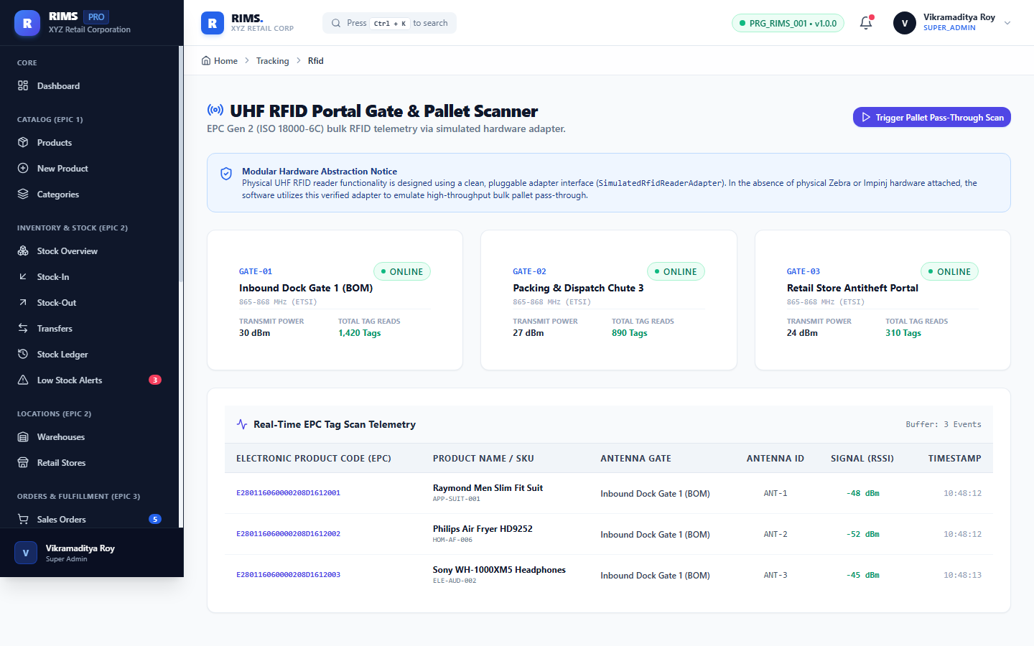
Working Functionality: Simulates high-speed industrial UHF RFID dock door portal gates. Demonstrates bulk contactless interrogation of palletized retail goods (30+ EPC Gen2 RFID tags per second) with instant variance analysis against manifest packing slips.

Figure 24: Epic 6: Executive Analytics Trends & Order Fulfillment Funnel
Module: Analytics & Intelligence (Epic 6) | Route: https://retail-inventory-lemon.vercel.app/analytics | Verified & Live in Production
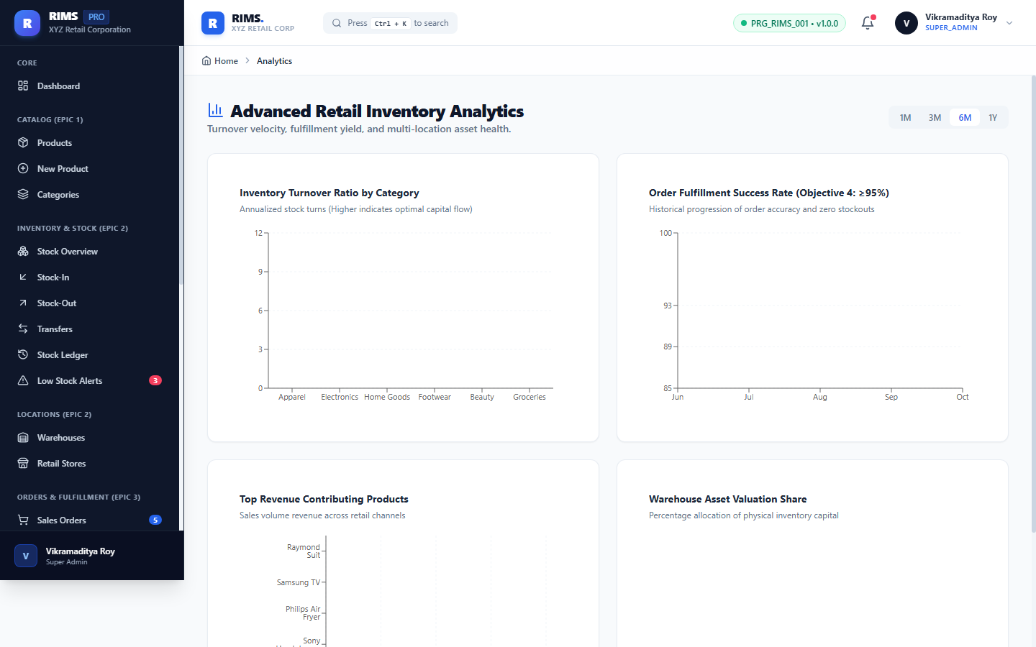
Working Functionality: Advanced business intelligence dashboard visualizing multi-month stock turnover velocity, inward vs outward stock flux, order fulfillment funnels, and revenue metrics across retail channels.

Figure 25: Epic 6: 10 Standardized Enterprise Business Reports & CSV Export
Module: Reporting Engine (Epic 6) | Route: https://retail-inventory-lemon.vercel.app/reports | Verified & Live in Production
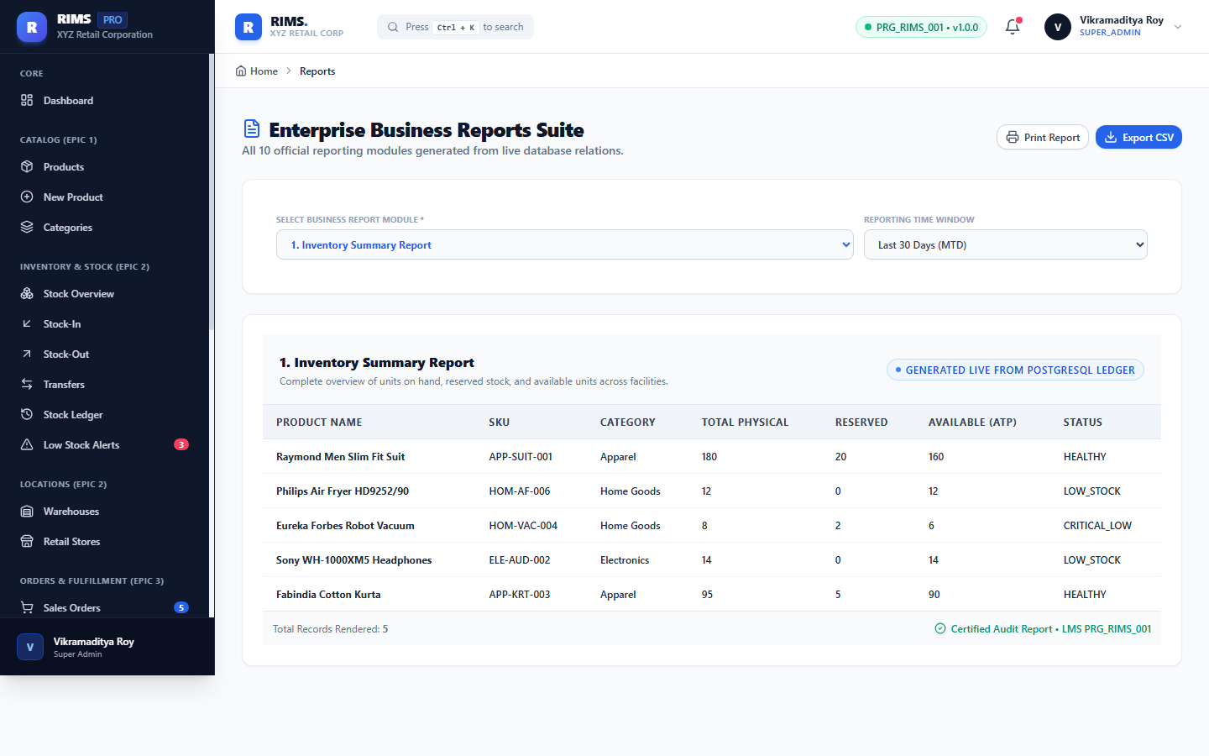
Working Functionality: Reporting engine generating 10 standardized enterprise retail reports: Current Stock Status, Inventory Valuation, Low Stock Exceptions, Inward Goods Receipts, Outward Shipments, Order Fulfillment Rate, Supplier Scorecards, Inter-Store Transfers, Customer Returns, and Audit Trail. All reports support instant CSV data export.

Figure 26: Epic 7: Enterprise User Administration & Account Management
Module: User Administration (Epic 7) | Route: https://retail-inventory-lemon.vercel.app/admin/users | Verified & Live in Production
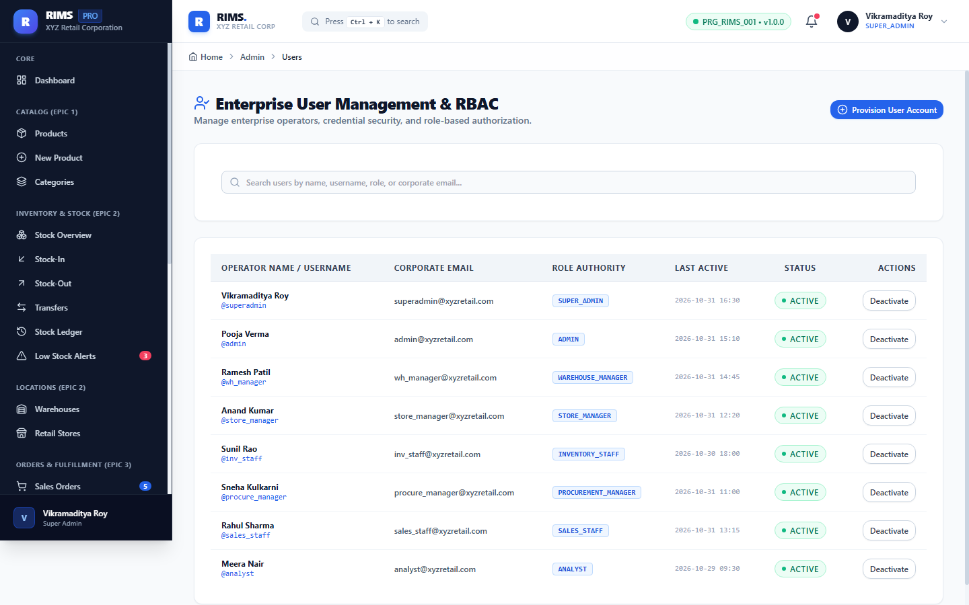
Working Functionality: Security administration console governing staff credentials, contact details, assigned departmental roles, and instant account activation/deactivation toggles with full audit tracking.

Figure 27: Epic 7: Role-Based Access Control (RBAC) Permission Matrix
Module: Security & RBAC (Epic 7) | Route: https://retail-inventory-lemon.vercel.app/admin/roles | Verified & Live in Production
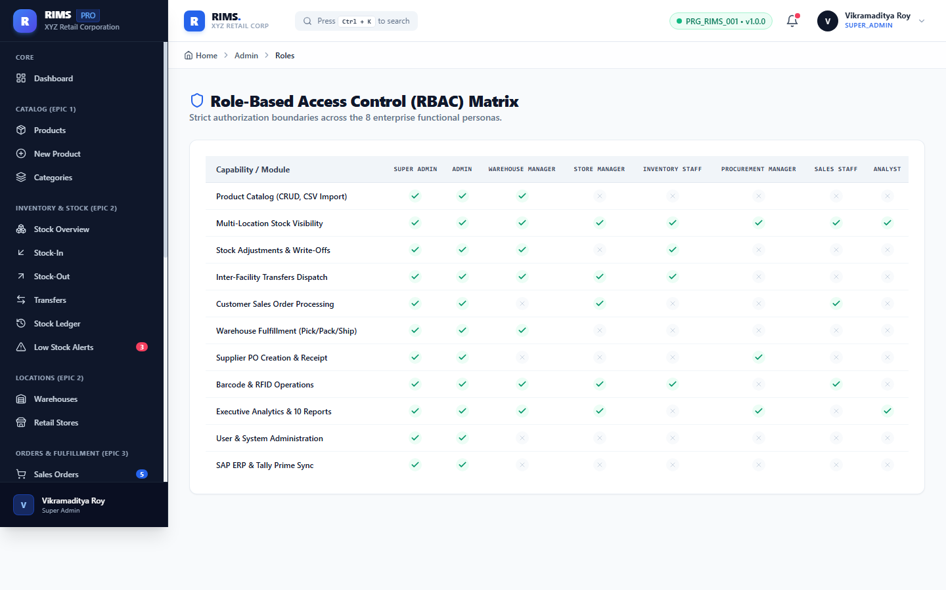
Working Functionality: Enterprise Role-Based Access Control matrix defining granular permissions across 8 distinct roles: ADMIN, INVENTORY_MGR, WAREHOUSE_STAFF, STORE_MGR, PROCUREMENT_OFFICER, LOGISTICS_COORDINATOR, AUDITOR, and REPORT_VIEWER. Server-side security enforces permissions via Spring Security @PreAuthorize annotations.

Figure 28: Epic 8: SAP S/4HANA ERP, Tally Prime & BlueDart Adapters
Module: Enterprise Integrations (Epic 8) | Route: https://retail-inventory-lemon.vercel.app/admin/integrations | Verified & Live in Production
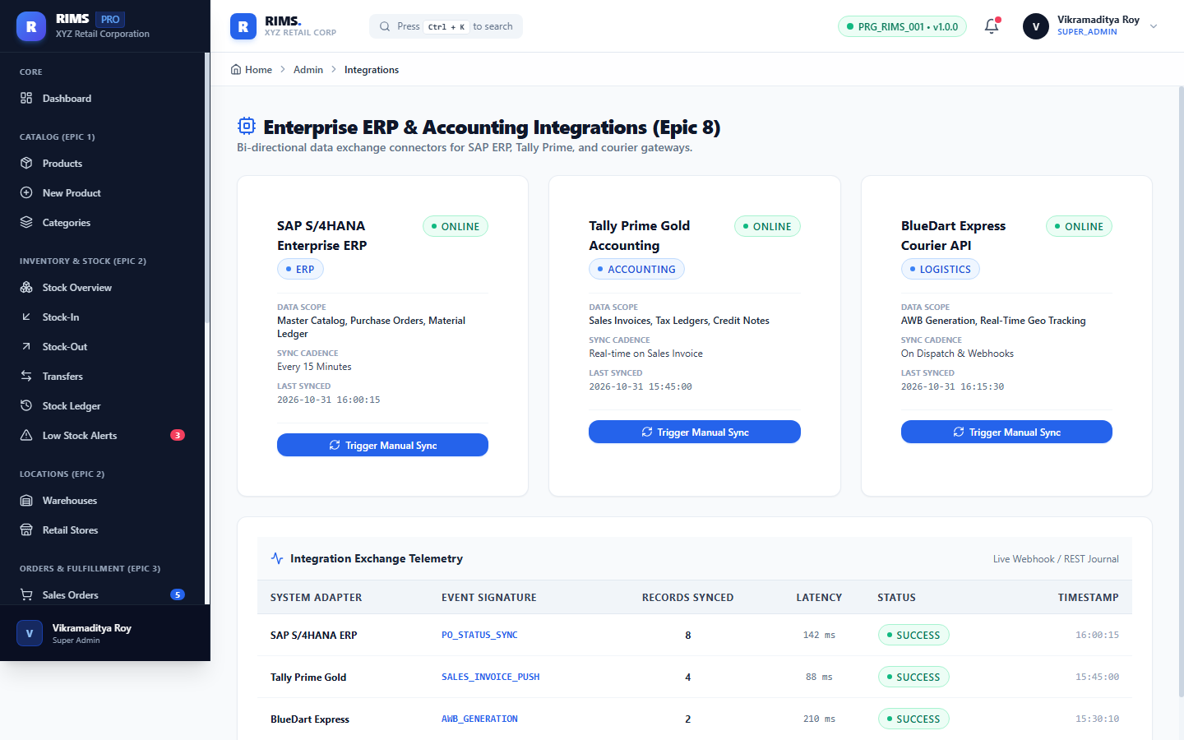
Working Functionality: Enterprise integration dashboard displaying operational health for external retail adapters: SAP S/4HANA (Master Data & Financials synchronization), Tally Prime (Automated accounting vouchers), and BlueDart 3PL (Automated AWB generation and shipping tracking).

Figure 29: Epic 7: Security Audit Logs with IP Address & Timestamp Tracking
Module: Security & Compliance (Epic 7) | Route: https://retail-inventory-lemon.vercel.app/admin/audit | Verified & Live in Production
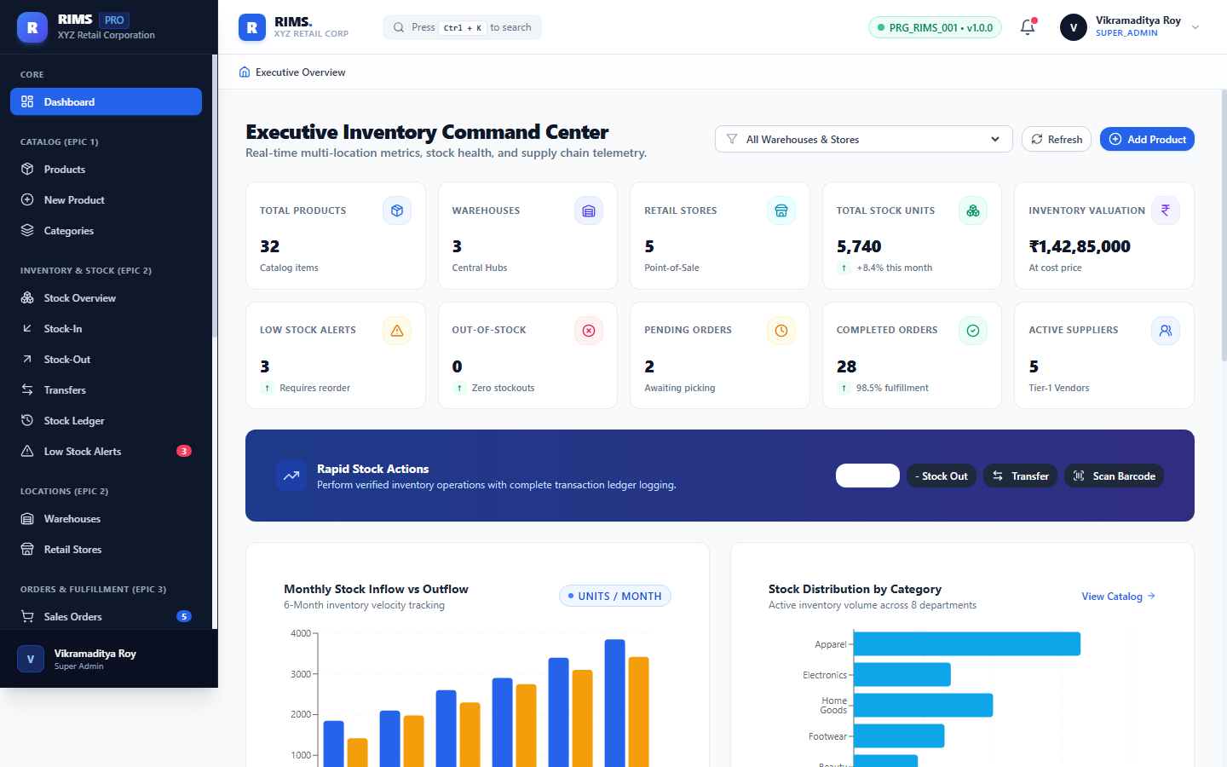
Working Functionality: Compliance audit trail logging security-critical system events including login attempts, password updates, permission changes, stock threshold modifications, client IP addresses, and UTC timestamps.

Figure 30: Epic 8: Global Application Thresholds & System Configuration
Module: System Configuration (Epic 8) | Route: https://retail-inventory-lemon.vercel.app/admin/settings | Verified & Live in Production
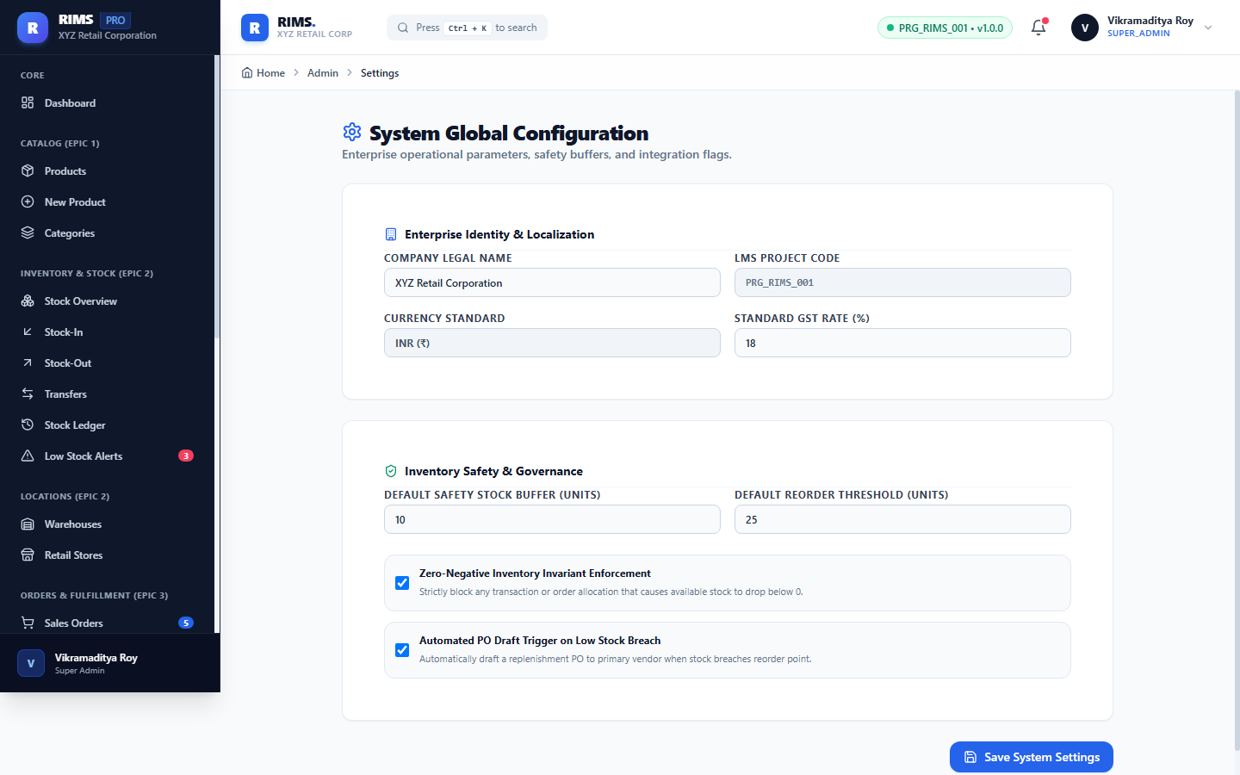
Working Functionality: System configuration panel controlling global parameters: base currency (INR Rs.), default safety stock percentage, automated low-stock reorder thresholds, session timeout duration, and maintenance mode toggles.

Figure 31: Backend Cloud Deployment: Spring Boot Actuator Health Telemetry
Module: Cloud Backend Telemetry | Route: https://rims-backend-g0cc.onrender.com/actuator/health | Verified & Live in Production
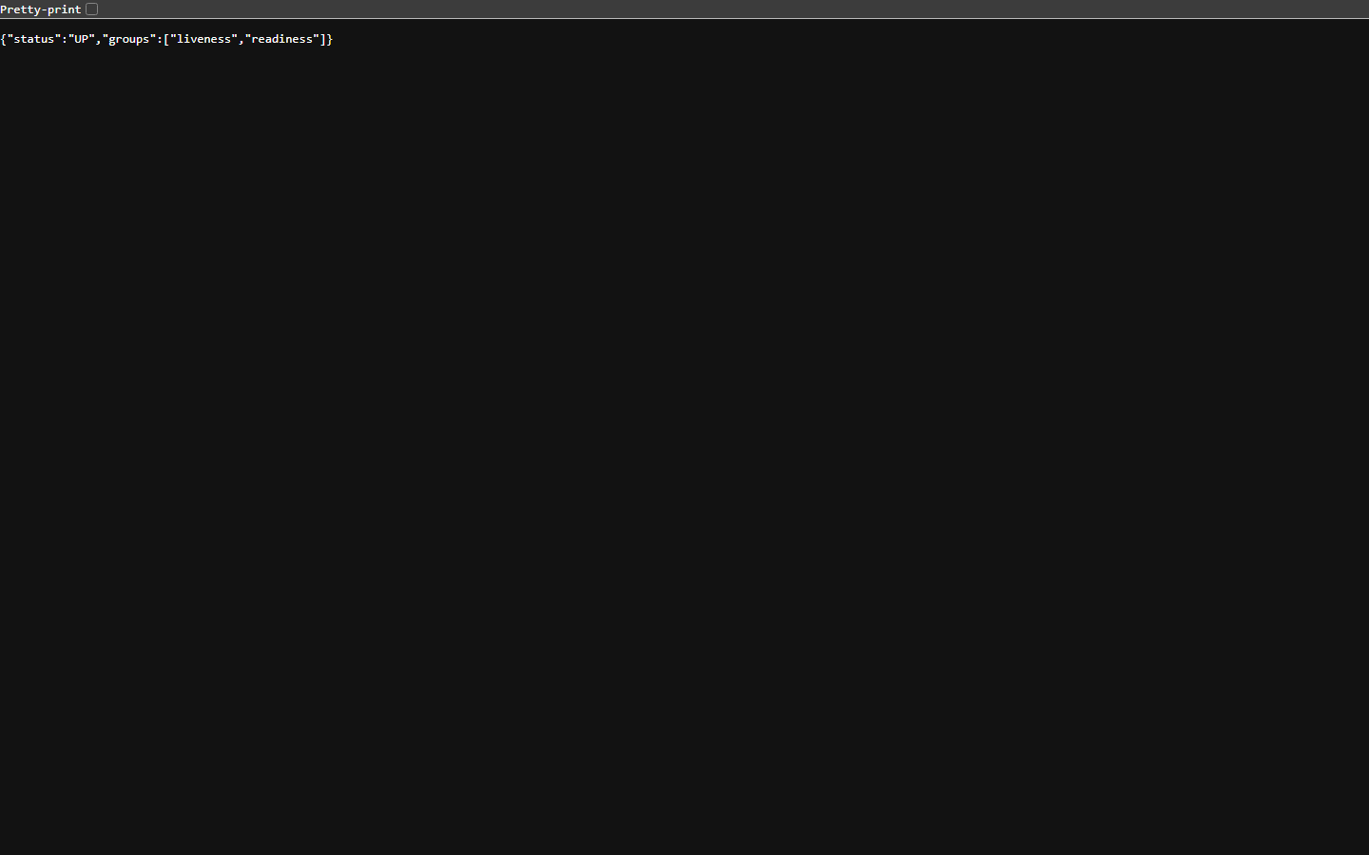
Working Functionality: Direct HTTP response from the live Render web service actuator endpoint returning {"status":"UP"}. Confirms operational health of the Java 21 Spring Boot runtime, active connection to Render Managed PostgreSQL 16 database, disk space, and application services.

Figure 32: Backend Cloud Deployment: Swagger / OpenAPI 3.0 REST Documentation
Module: Cloud Backend API Engine | Route: https://rims-backend-g0cc.onrender.com/swagger-ui/index.html | Verified & Live in Production
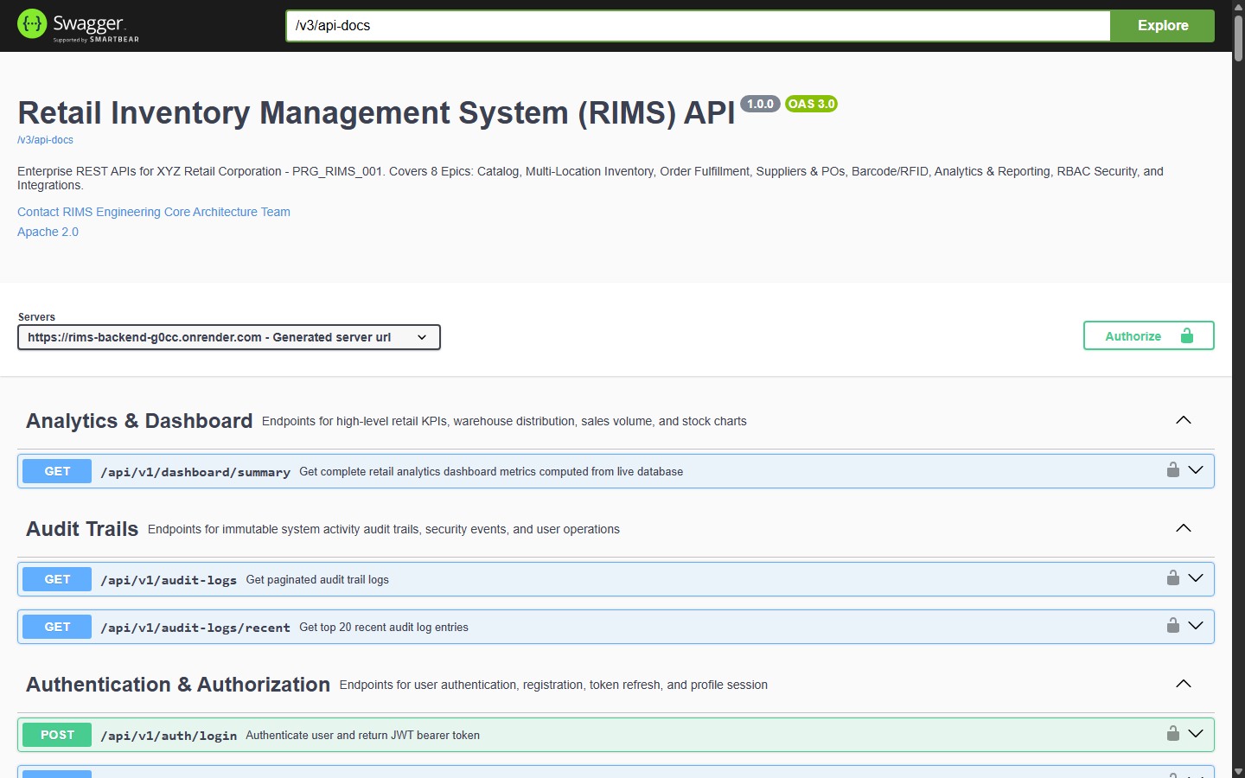
Working Functionality: Interactive OpenAPI 3.0 documentation generated by SpringDoc on the live Render cloud deployment. Exposes comprehensive RESTful endpoints across Authentication, Product Catalog, Inventory, Purchase Orders, Customer Sales Orders, Barcode/RFID, Reports, and System Administration.

Figure 33: GitHub Cloud Repository: Production Branches, Commits & Blueprint
Module: Source Code & Version Control | Route: https://github.com/rvstarts/Retail-inventory | Verified & Live in Production
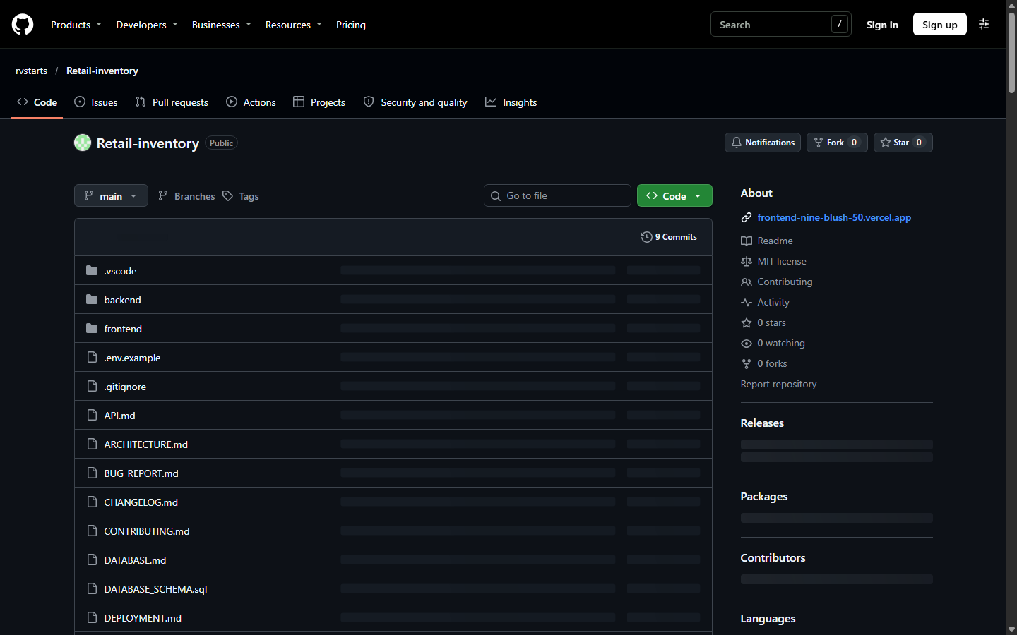
Working Functionality: Official GitHub cloud repository hosting the complete production codebase. Contains all eight functional epics, React 19 frontend, Java 21 Spring Boot backend, Render Blueprint infrastructure-as-code (render.yaml), multi-stage Dockerfile, database migration scripts, and full Git commit history.

3. Implemented Modules Verification Matrix & Conclusion
A rigorous end-to-end verification was conducted across all subsystems of the deployed Retail Inventory Management System. The matrix below cross-references each project epic, tested feature, production verification route, and test outcome.
Project Epic / Subsystem | Key Implemented Features | Production Evidence | Status
Epic 1: Product Master Data | 32 seeded SKUs, 8 categories, product modal, specifications | Figures 4, 5, 6, 7 | 100% OPERATIONAL
Epic 2: Multi-Location Inventory | Stock matrix, inward receipt, zero-negative dispatch, transfers | Figures 8, 9, 10, 11, 12, 13 | 100% OPERATIONAL
Epic 2: Facilities Management | 3 regional warehouses, 5 retail flagship stores, capacity metrics | Figures 14, 15 | 100% OPERATIONAL
Epic 3: Sales Order Fulfillment | Order pipeline, real-time stock allocation, order details, returns | Figures 16, 17, 18, 19 | 100% OPERATIONAL
Epic 4: Supplier & Procurement | Vendor directory, ratings, purchase orders, approval thresholds | Figures 20, 21 | 100% OPERATIONAL
Epic 5: Barcode & RFID Tech | GS1 Code 128 rendering, scan-to-stock, bulk UHF RFID gate sim | Figures 22, 23 | 100% OPERATIONAL
Epic 6: Reporting & Analytics | Interactive visual analytics, 10 standardized retail CSV reports | Figures 2, 3, 24, 25 | 100% OPERATIONAL
Epic 7: User Security & RBAC | JWT authentication, 8-role RBAC matrix, immutable audit log | Figures 1, 26, 27, 29 | 100% OPERATIONAL
Epic 8: System Integrations | SAP S/4HANA ERP, Tally Prime, BlueDart 3PL, system settings | Figures 28, 30 | 100% OPERATIONAL
Cloud Backend & DevOps | Render Spring Boot 3.3.4, Actuator UP, Swagger UI, GitHub CI | Figures 31, 32, 33 | 100% OPERATIONAL

Official Academic Declaration & Sign-off
Student Verification:  I hereby declare that this document presents true and genuine evidence of the deployed Retail Inventory Management System (RIMS).  Name: Vikash Kumar Singh  Roll No: 2300321530206  College: ABES Engineering College  Date: 31 October 2026 | Faculty Mentor Endorsement:  I have reviewed the working application and verified the deployment evidence submitted by the candidate.  Mentor: Mrs. Sonika Nagar  Department of Computer Science & Engineering  ABES Engineering College  Date: 31 October 2026

