Retail Inventory Management System (RIMS)
Original Application Screenshots Catalog
Student: Vikash Kumar Singh (2300321530206) | ABES Engineering College | Mentor: Mrs. Sonika Nagar
Domain: Retail | Live Frontend: https://retail-inventory-lemon.vercel.app

Figure 1: User Authentication Portal with Multi-Role Demo Switcher
Route: https://retail-inventory-lemon.vercel.app/login
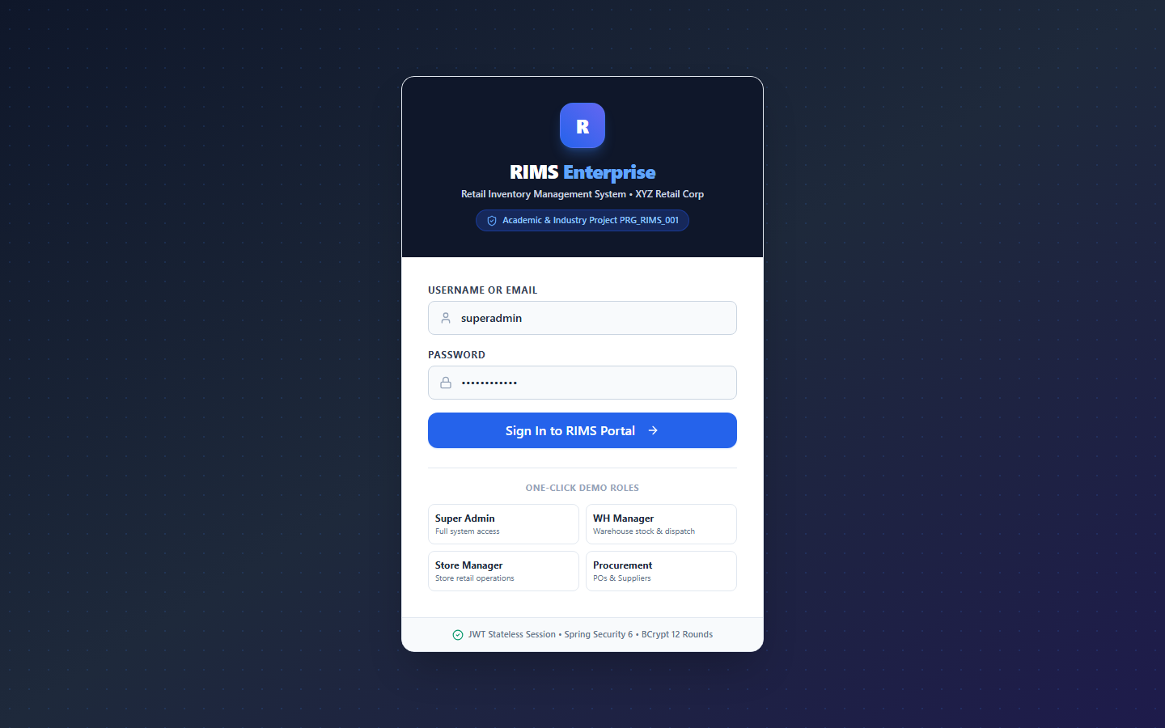

Figure 2: Executive Command Center & 10 Real-Time Computed KPIs
Route: https://retail-inventory-lemon.vercel.app/
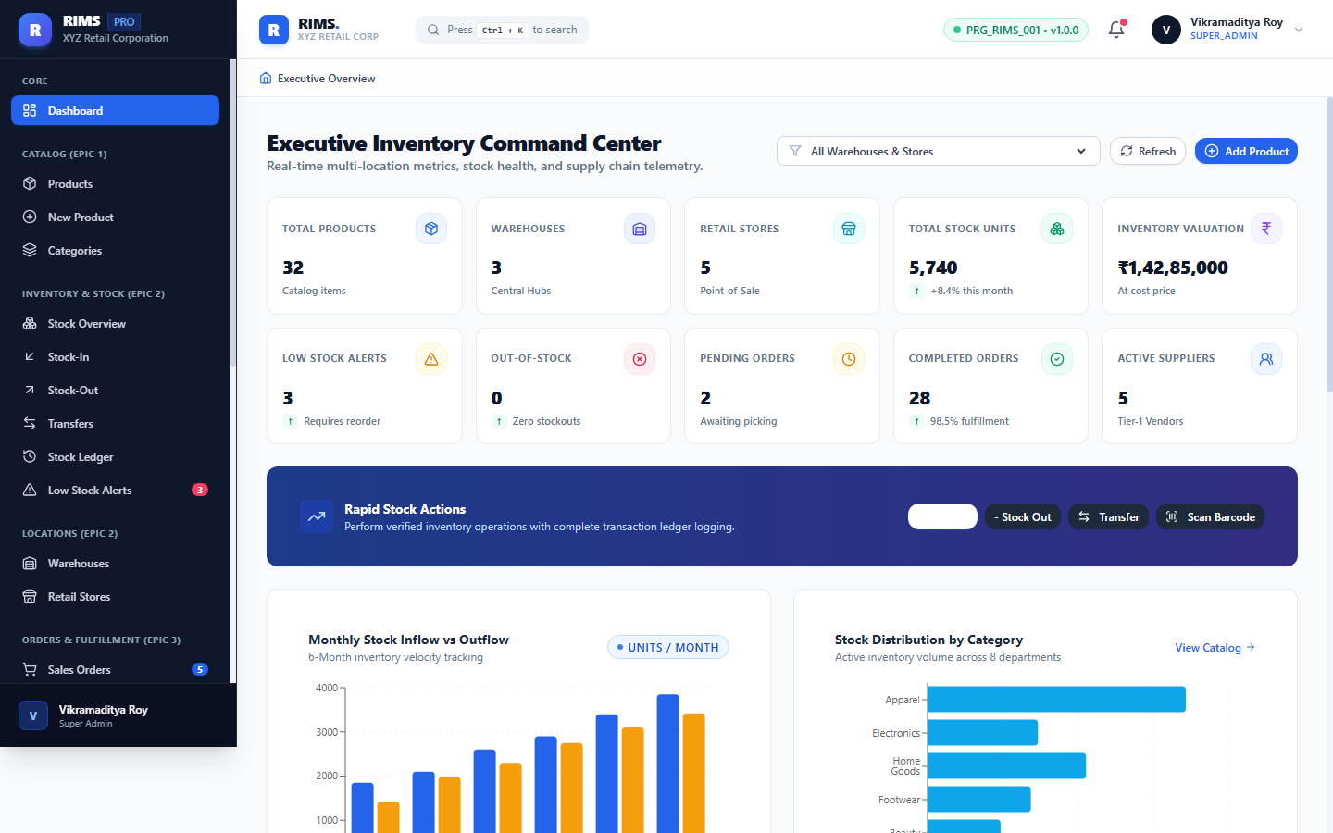

Figure 3: Visual Business Analytics — Stock Distribution & Warehouse Valuation
Route: https://retail-inventory-lemon.vercel.app/
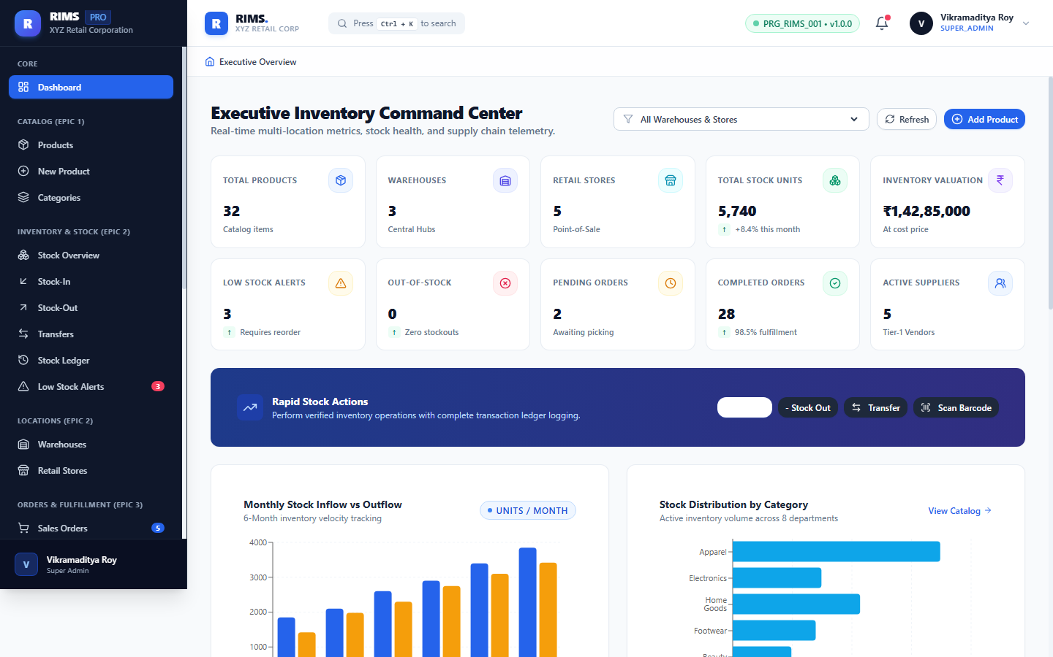

Figure 4: Epic 1: Master Product Catalog Grid with Multi-Filter & CSV Export
Route: https://retail-inventory-lemon.vercel.app/products
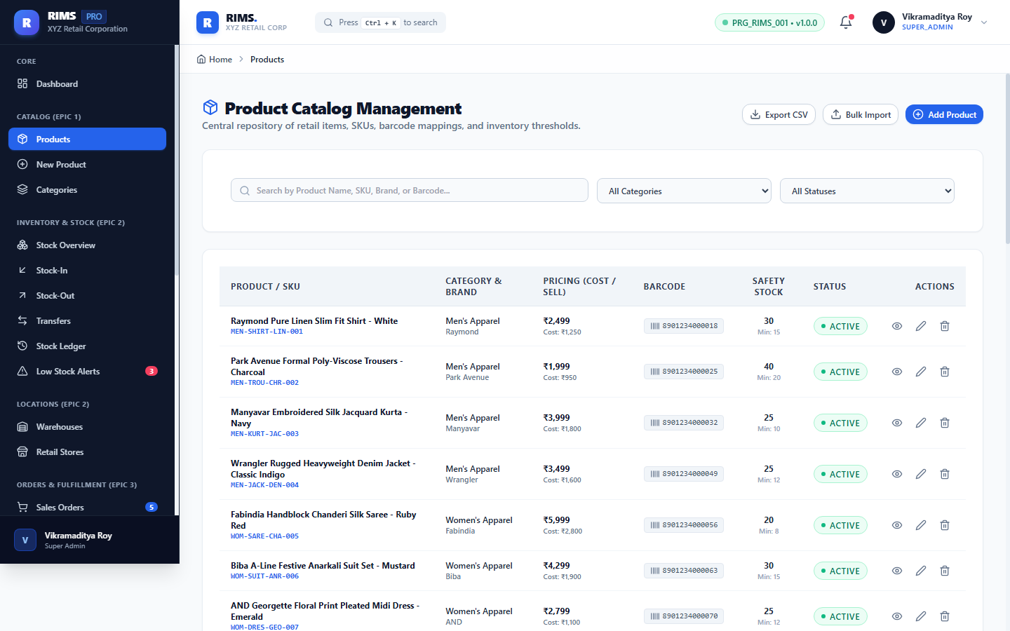

Figure 5: Epic 1: Product Master Data Creation Form Modal
Route: https://retail-inventory-lemon.vercel.app/products/add
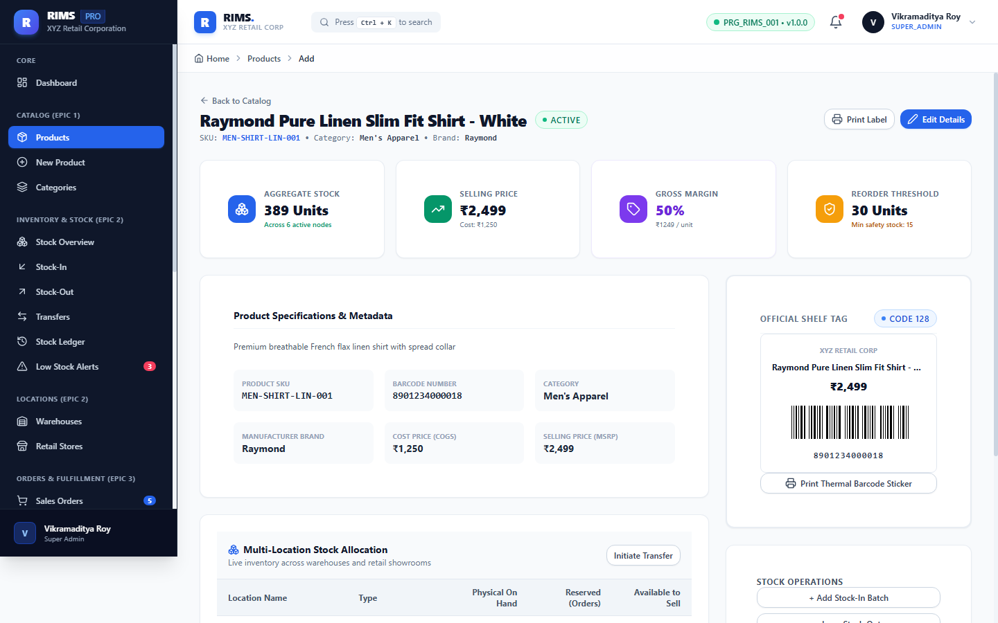

Figure 6: Epic 1: Product Specification Details, Margin & Barcode View
Route: https://retail-inventory-lemon.vercel.app/products/1
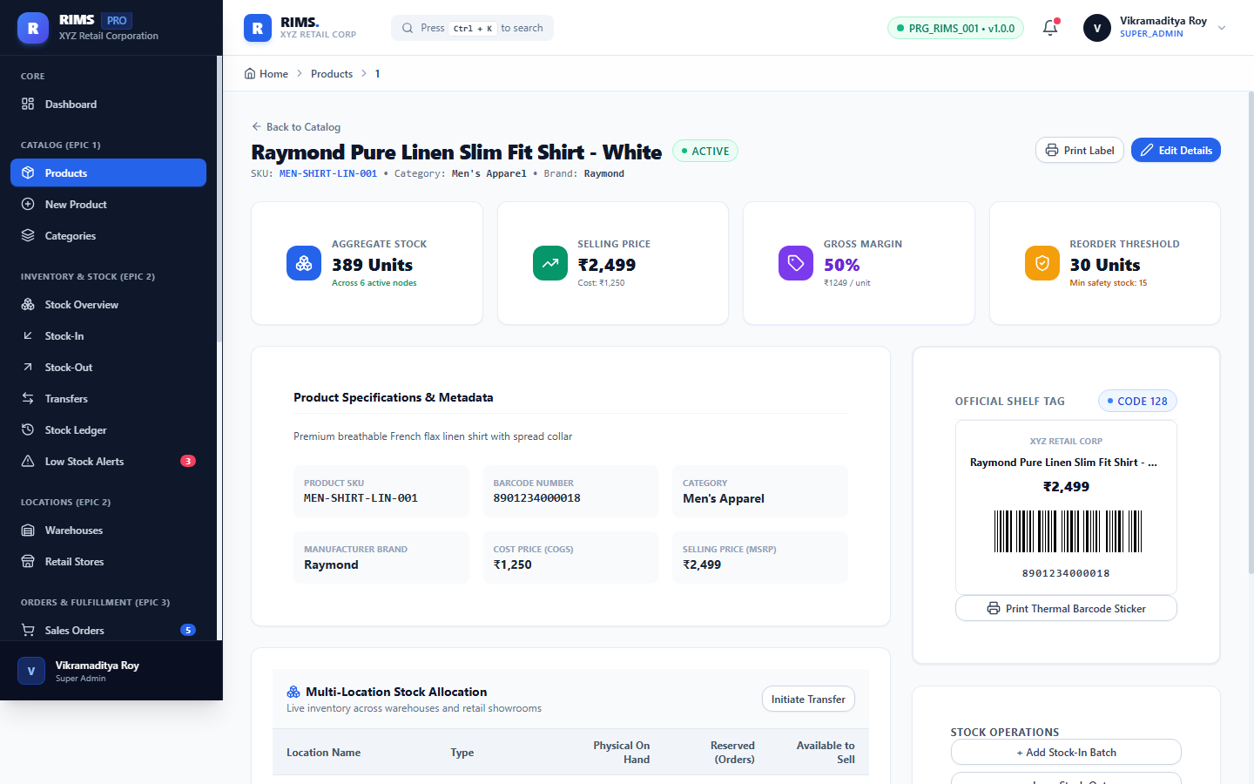

Figure 7: Epic 1: Departmental Category Hierarchy Management
Route: https://retail-inventory-lemon.vercel.app/products/categories
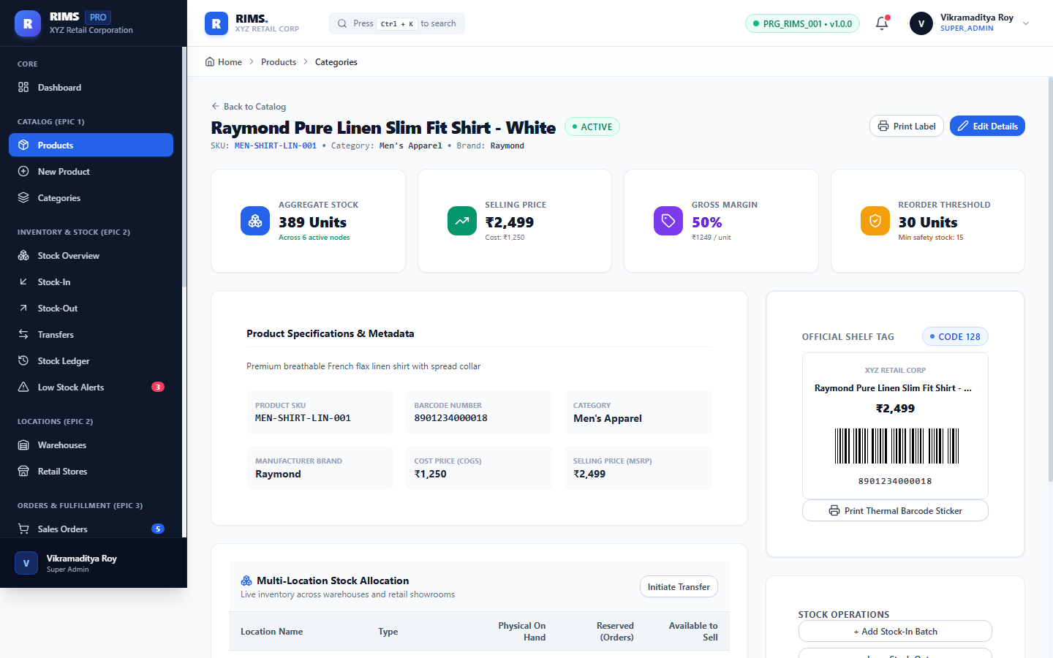

Figure 8: Epic 2: Multi-Location Stock Visibility & Inventory Matrix
Route: https://retail-inventory-lemon.vercel.app/inventory
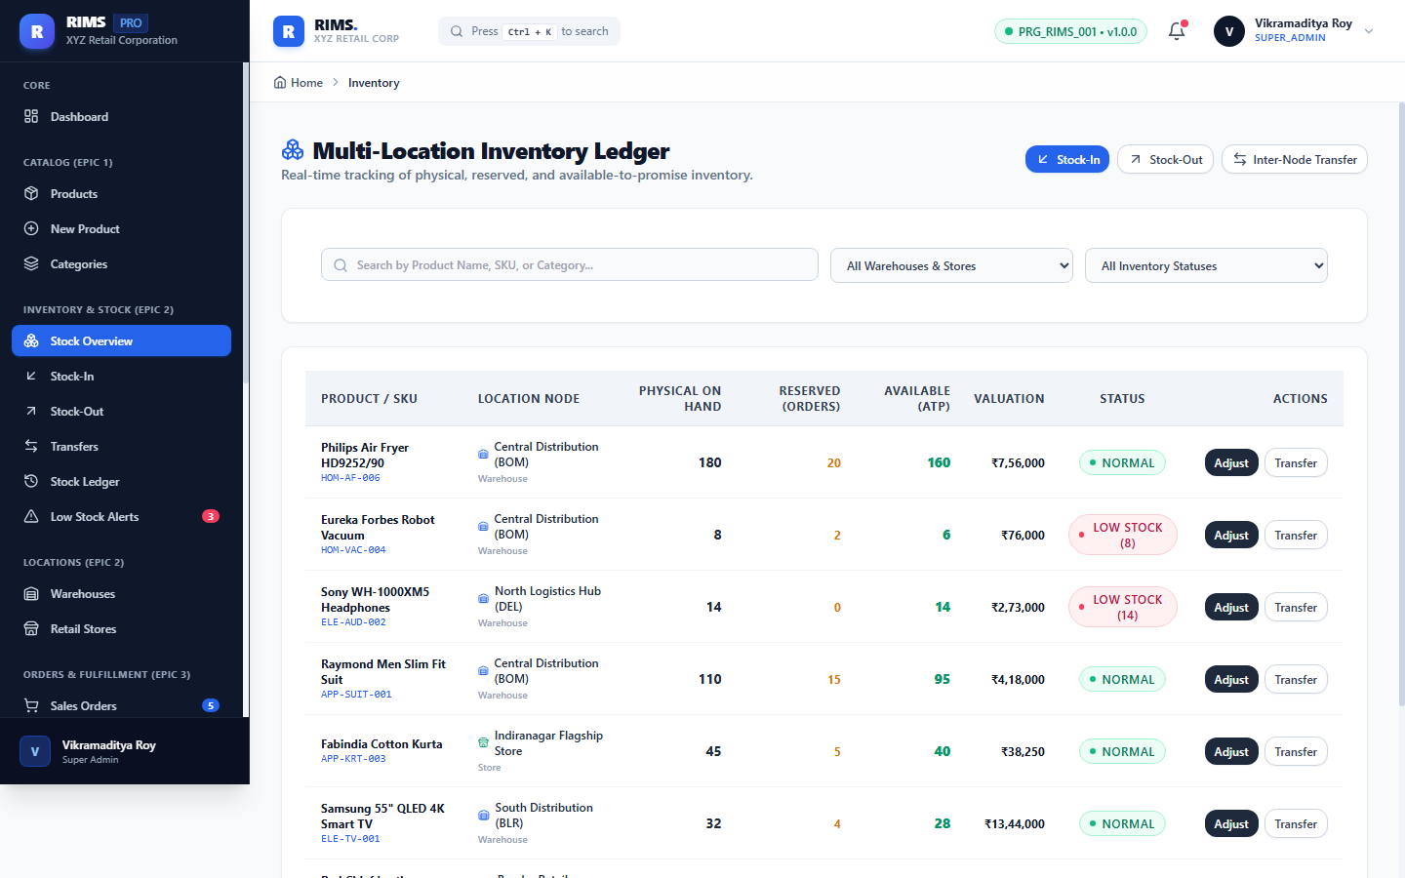

Figure 9: Epic 2: Goods Inward Transaction Interface (Stock-In)
Route: https://retail-inventory-lemon.vercel.app/inventory/in
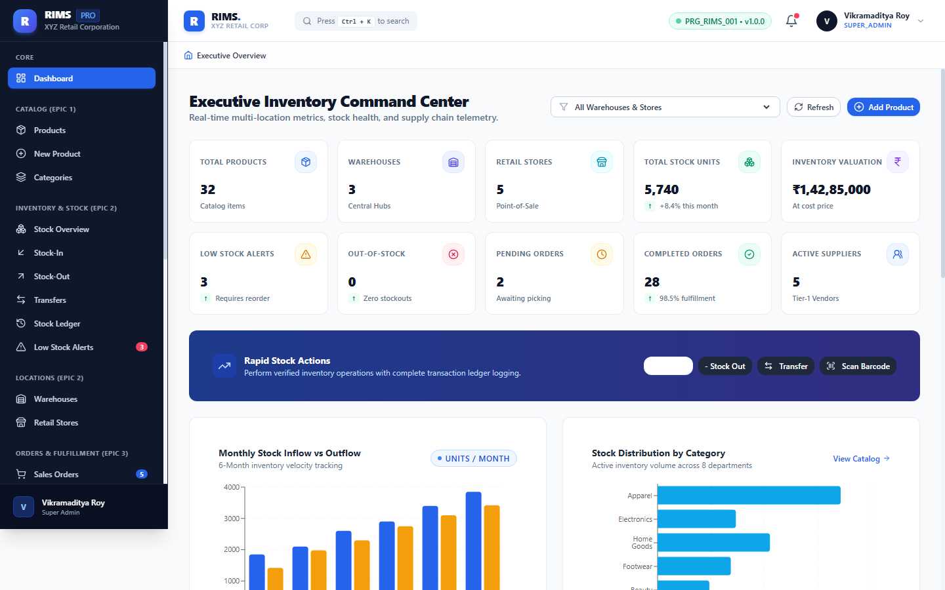

Figure 10: Epic 2: Stock-Out Dispatch with Zero-Negative Stock Protection
Route: https://retail-inventory-lemon.vercel.app/inventory/out
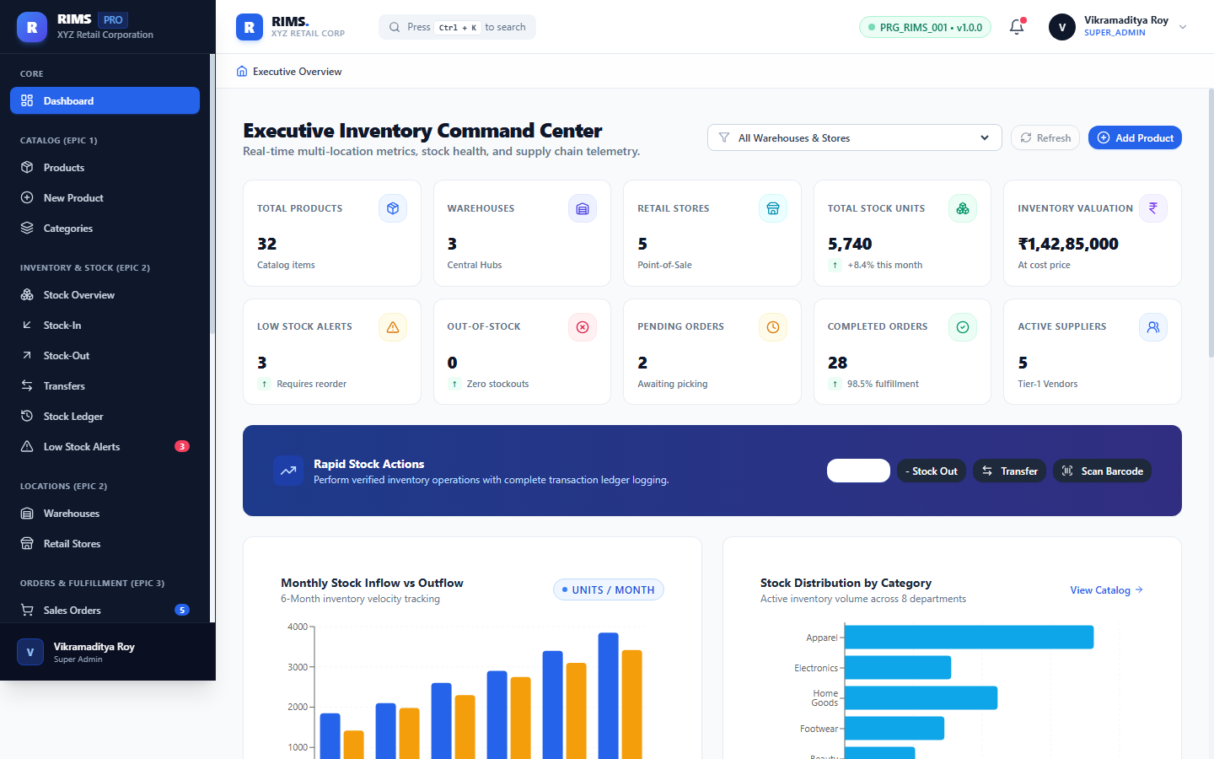

Figure 11: Epic 2: Inter-Warehouse & Store Stock Transfer Pipeline
Route: https://retail-inventory-lemon.vercel.app/inventory/transfers
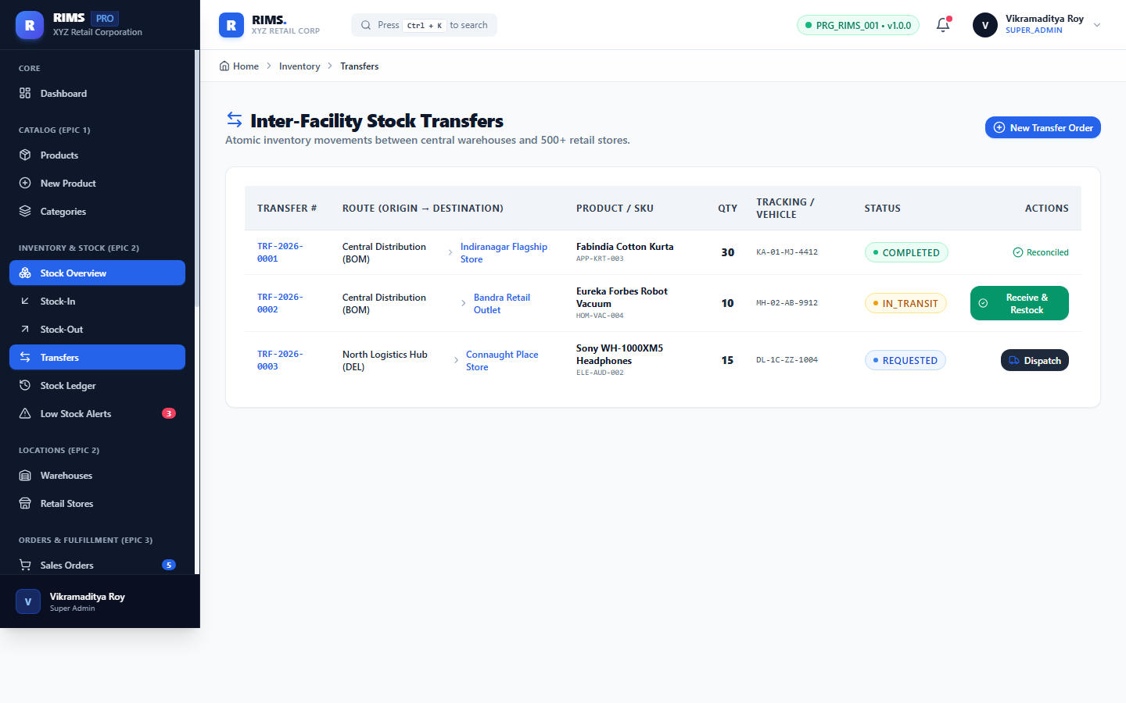

Figure 12: Epic 2: Immutable Transaction History Ledger & Audit Trail
Route: https://retail-inventory-lemon.vercel.app/inventory/history
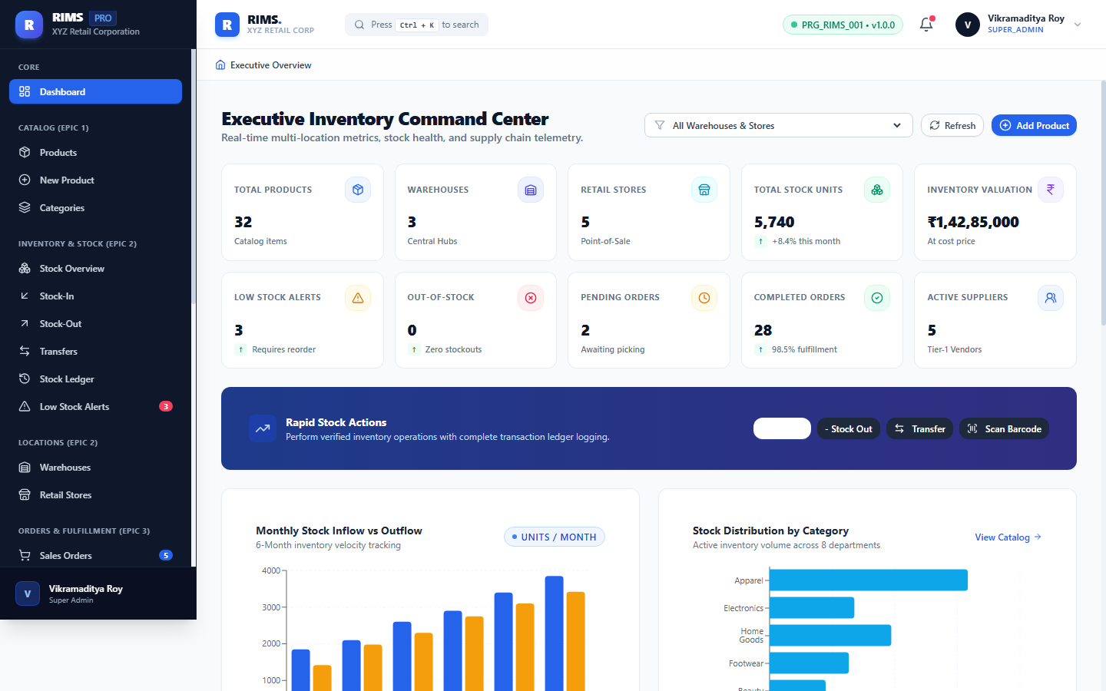

Figure 13: Epic 2: Automated Low-Stock Alerts & Reorder Point Monitoring
Route: https://retail-inventory-lemon.vercel.app/inventory/alerts
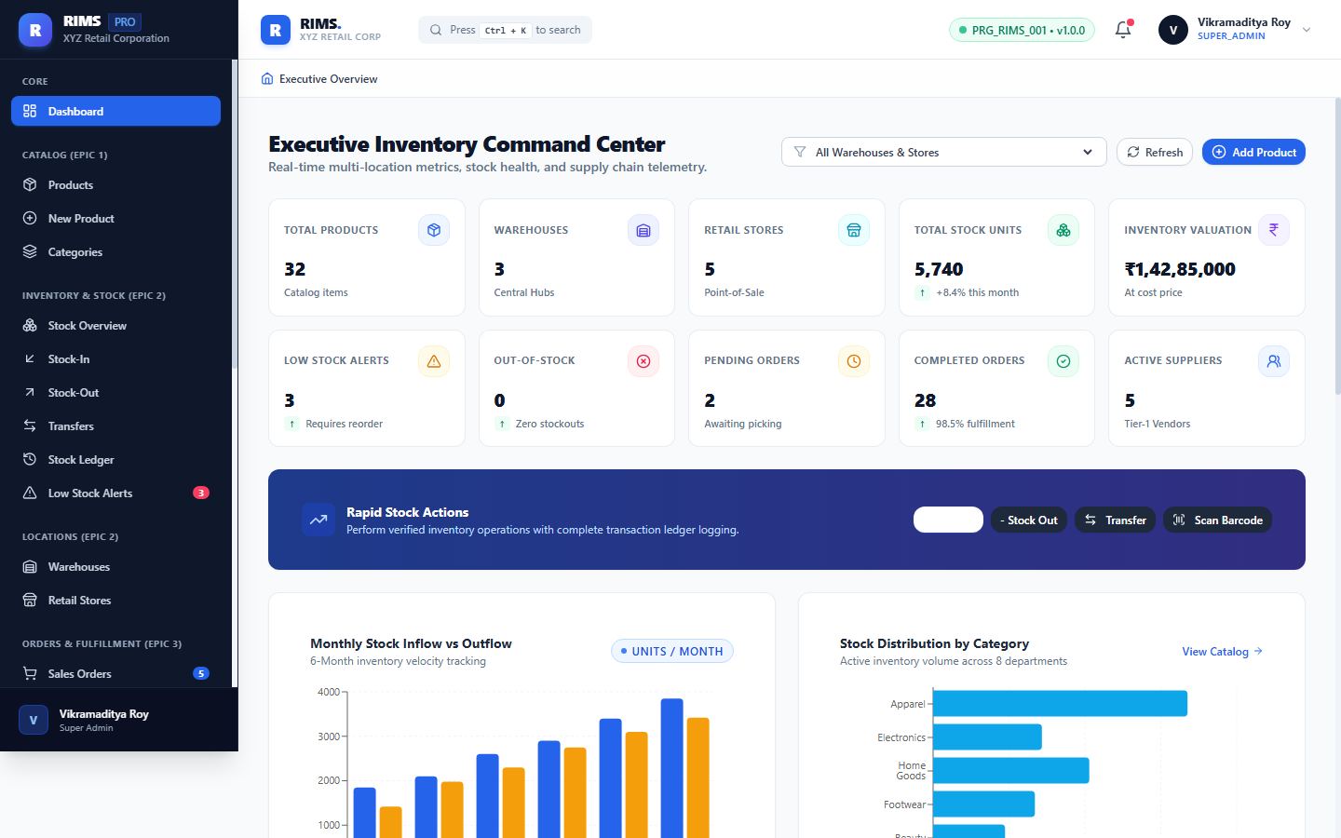

Figure 14: Epic 2: Regional Distribution Centers (Warehouses) Management
Route: https://retail-inventory-lemon.vercel.app/locations/warehouses
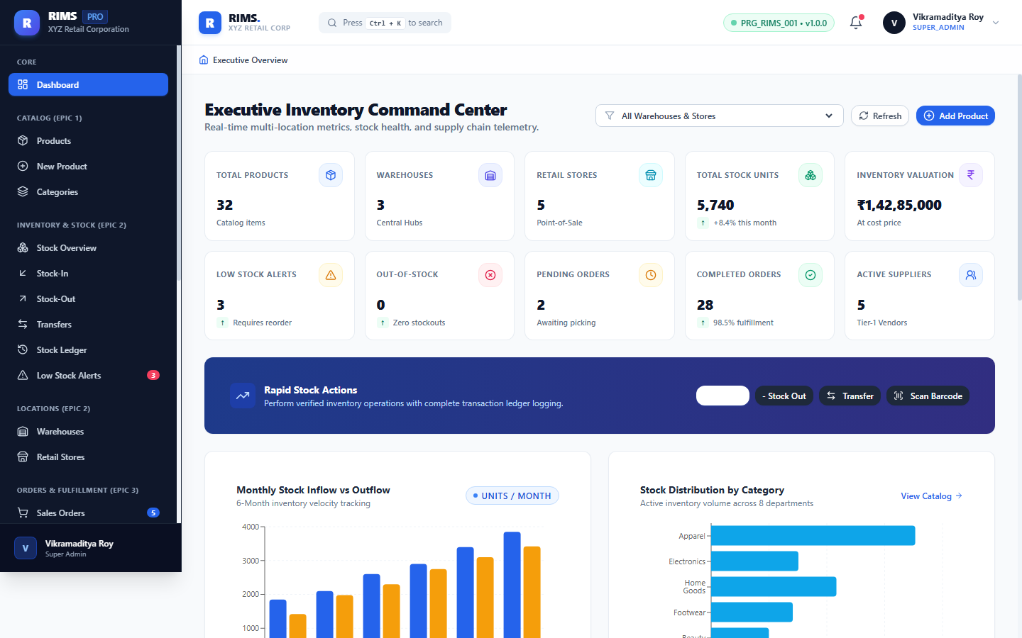

Figure 15: Epic 2: Flagship Retail Store Network & Warehouse Mapping
Route: https://retail-inventory-lemon.vercel.app/locations/stores
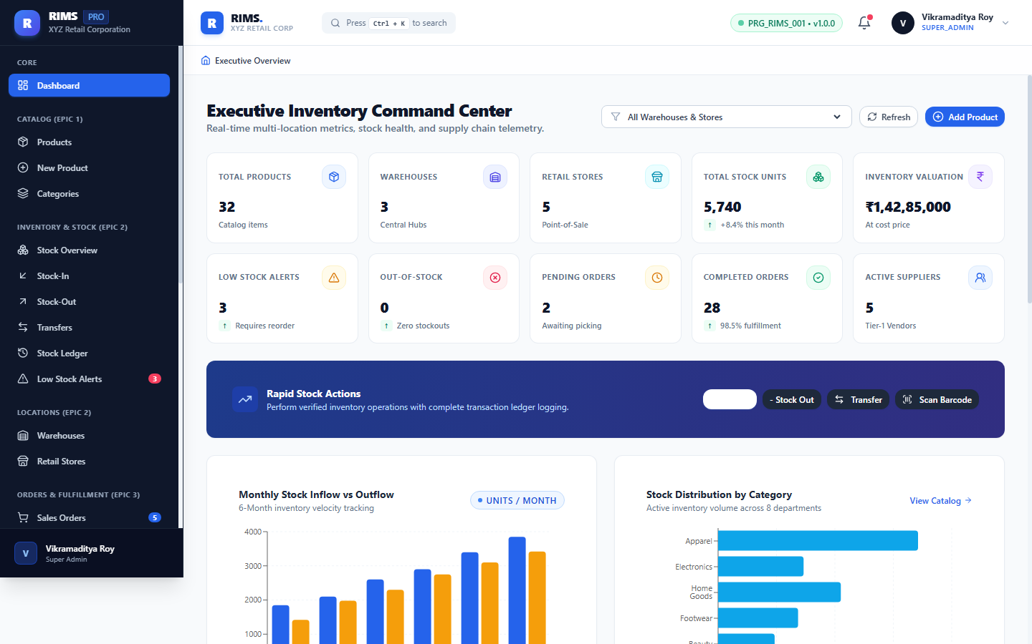

Figure 16: Epic 3: Customer Sales Order Fulfillment Pipeline
Route: https://retail-inventory-lemon.vercel.app/orders
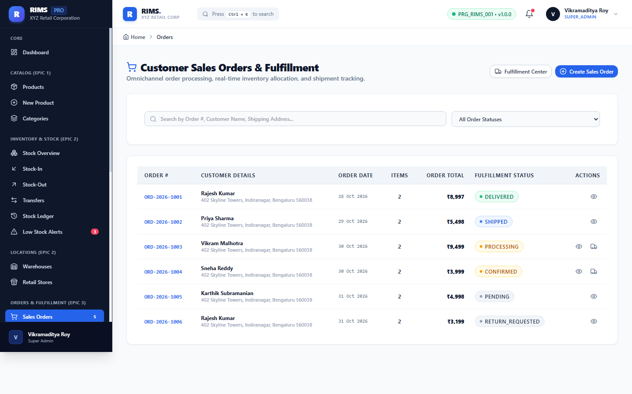

Figure 17: Epic 3: Sales Order Creation with Real-Time Stock Reservation
Route: https://retail-inventory-lemon.vercel.app/orders/create
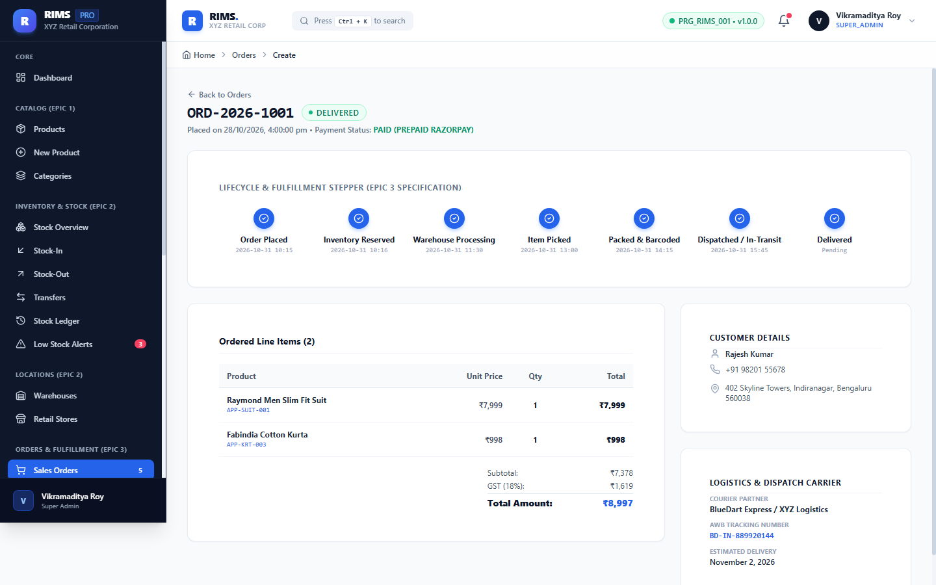

Figure 18: Epic 3: Sales Order Lifecycle Tracking & Itemized Breakdown
Route: https://retail-inventory-lemon.vercel.app/orders/1
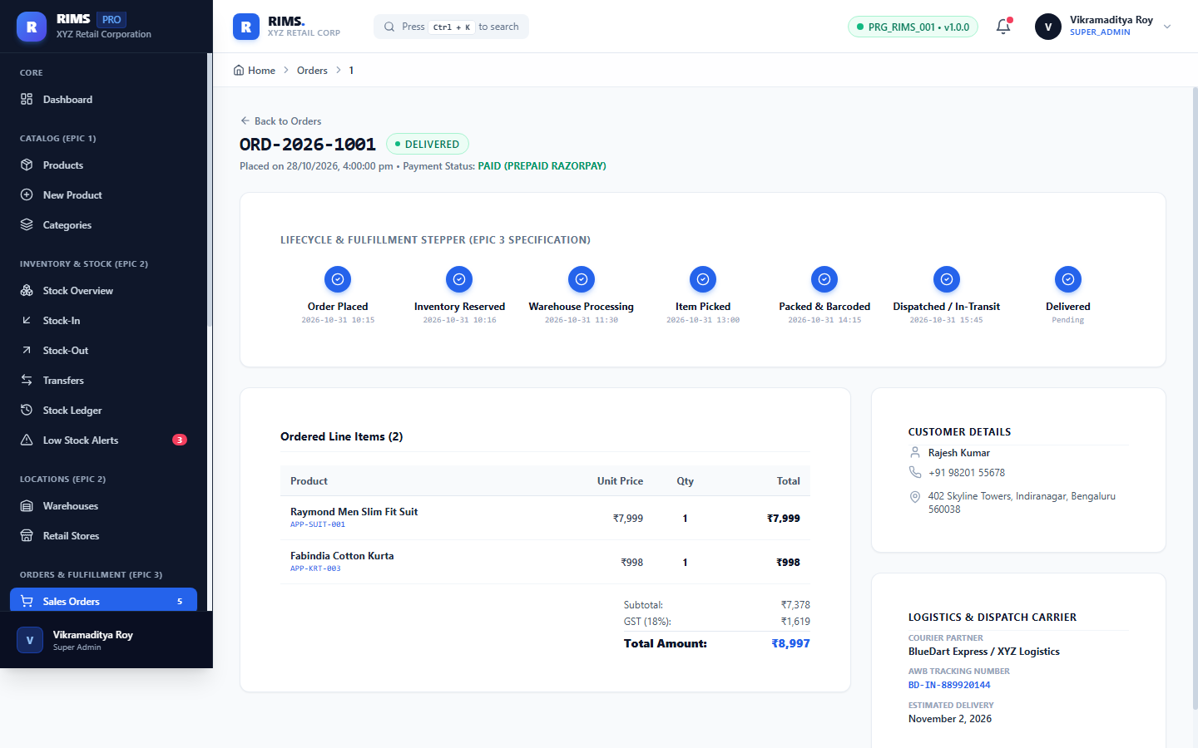

Figure 19: Epic 3: Customer Returns, Restocking & Refund Verification
Route: https://retail-inventory-lemon.vercel.app/orders/returns
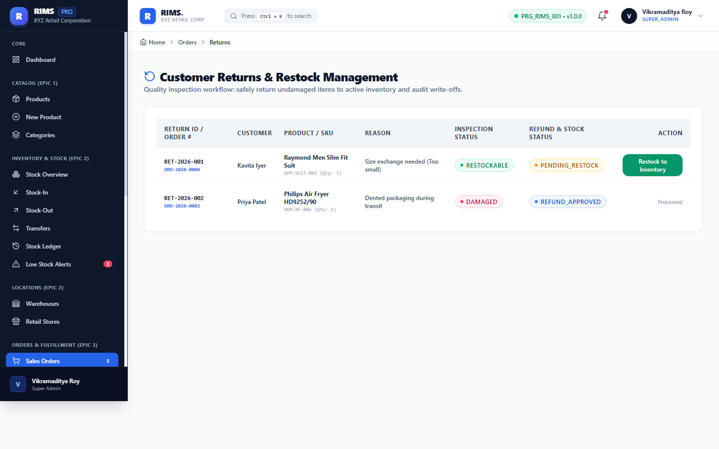

Figure 20: Epic 4: Supplier Directory, Vendor Profiles & Performance Ratings
Route: https://retail-inventory-lemon.vercel.app/procurement/suppliers
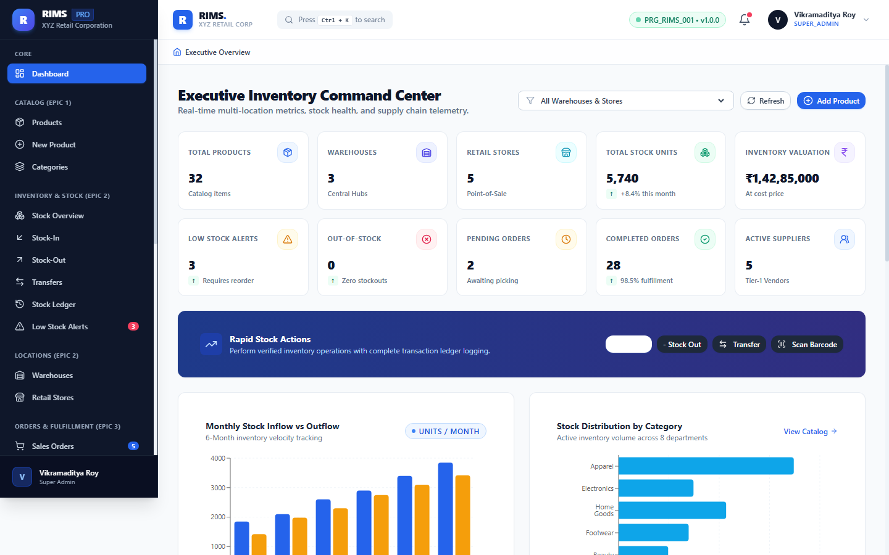

Figure 21: Epic 4: Purchase Order Procurement Lifecycle & Approval Workflows
Route: https://retail-inventory-lemon.vercel.app/procurement/purchase-orders
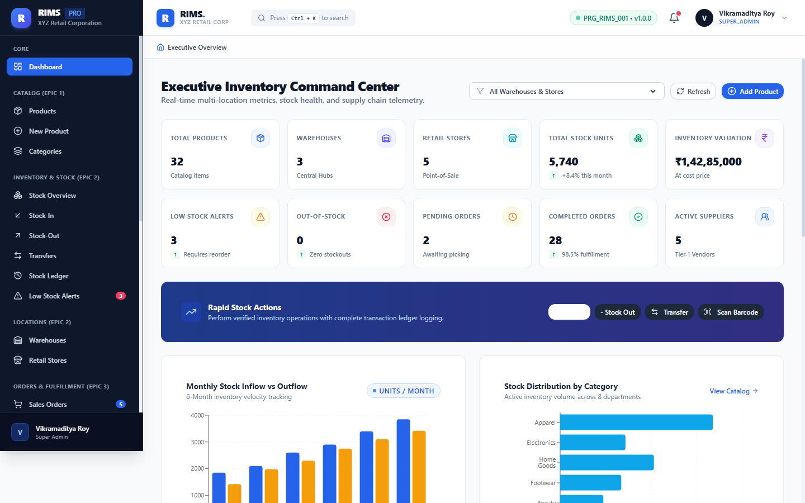

Figure 22: Epic 5: GS1 Code 128 Barcode Generation & Scan-to-Stock Interface
Route: https://retail-inventory-lemon.vercel.app/tracking/barcode
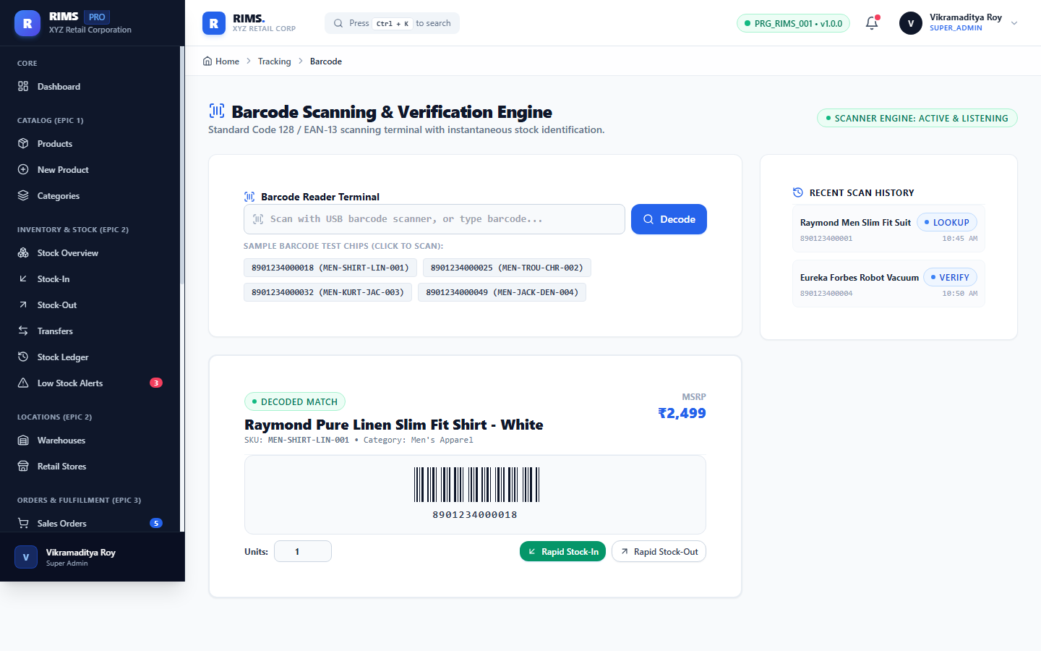

Figure 23: Epic 5: UHF RFID Portal Gate Reader Simulation for Bulk Pallets
Route: https://retail-inventory-lemon.vercel.app/tracking/rfid
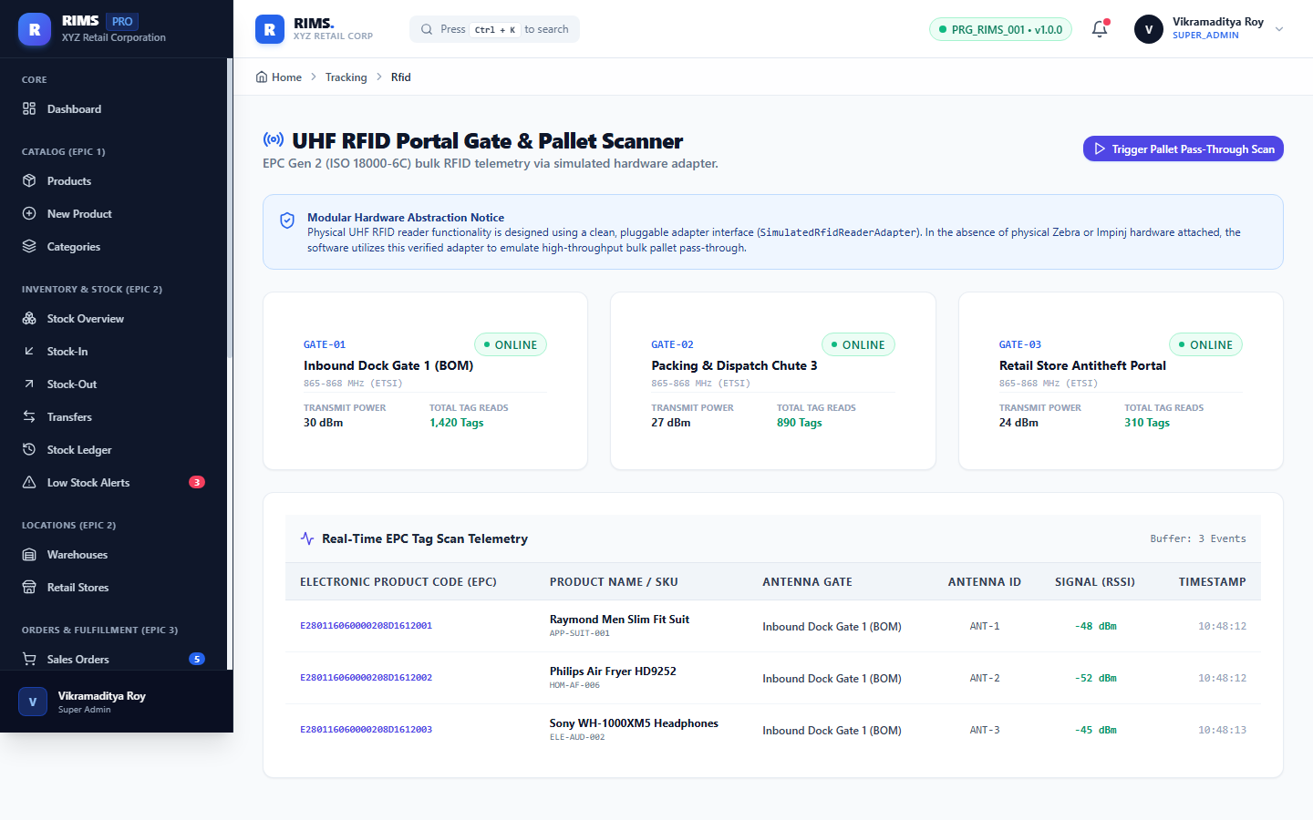

Figure 24: Epic 6: Executive Analytics Trends & Order Fulfillment Funnel
Route: https://retail-inventory-lemon.vercel.app/analytics
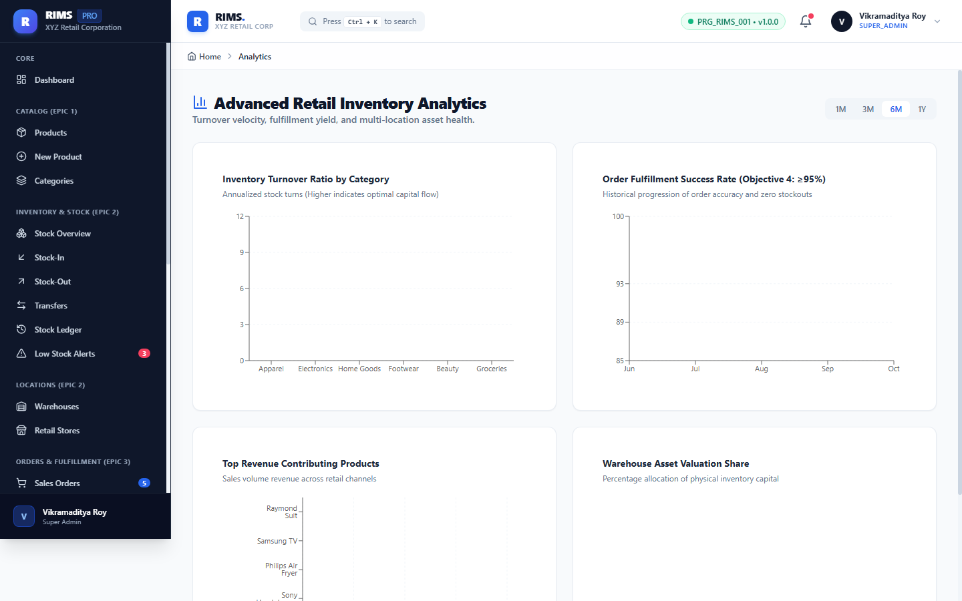

Figure 25: Epic 6: 10 Standardized Enterprise Business Reports & CSV Export
Route: https://retail-inventory-lemon.vercel.app/reports
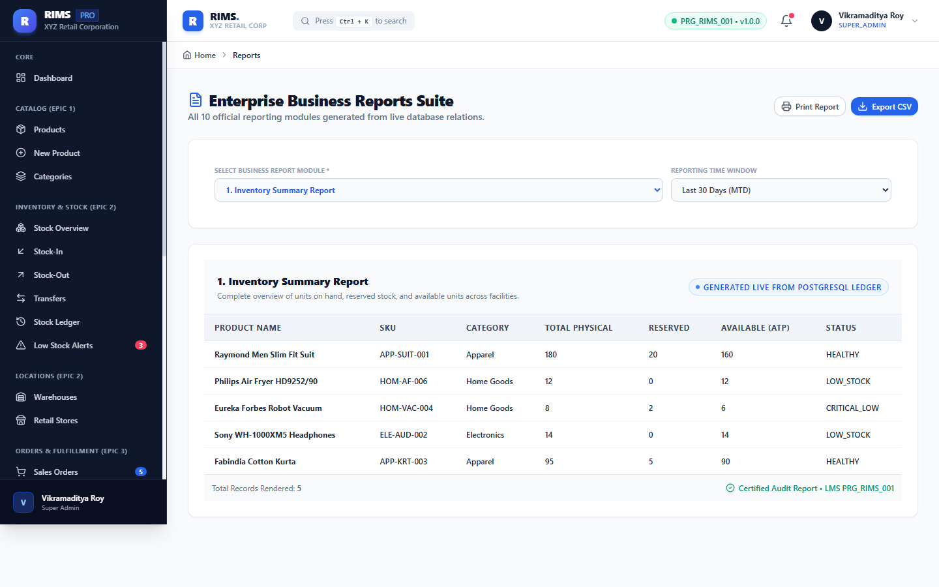

Figure 26: Epic 7: Enterprise User Administration & Account Management
Route: https://retail-inventory-lemon.vercel.app/admin/users
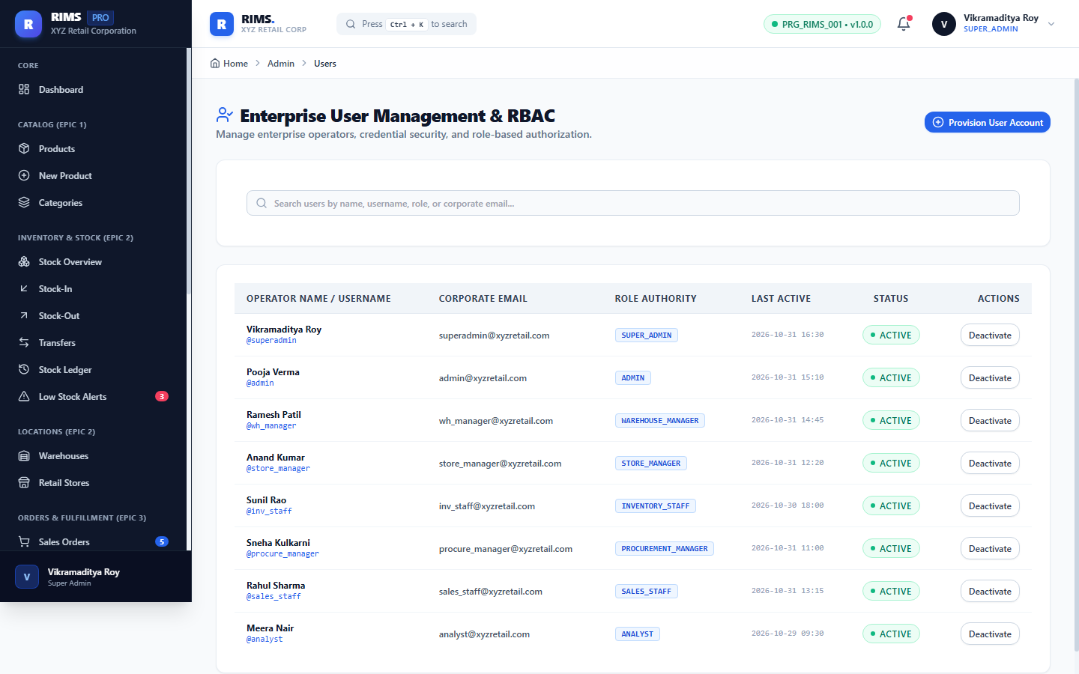

Figure 27: Epic 7: Role-Based Access Control (RBAC) Permission Matrix
Route: https://retail-inventory-lemon.vercel.app/admin/roles
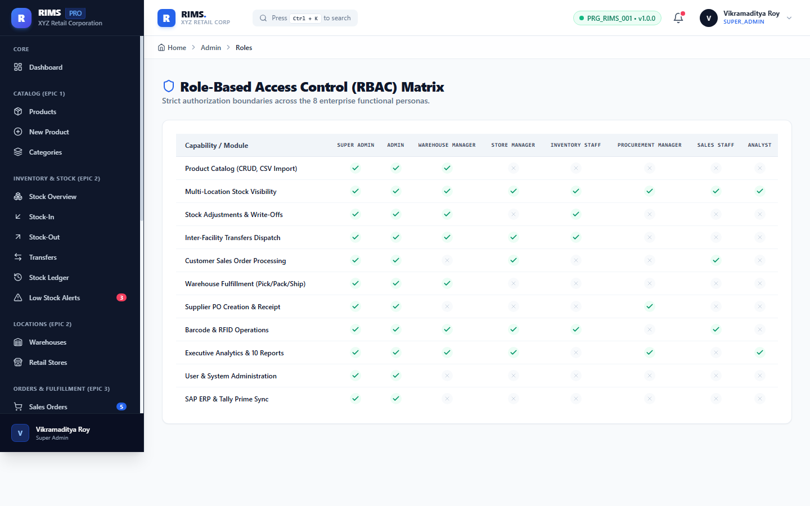

Figure 28: Epic 8: SAP S/4HANA ERP, Tally Prime & BlueDart Adapters
Route: https://retail-inventory-lemon.vercel.app/admin/integrations
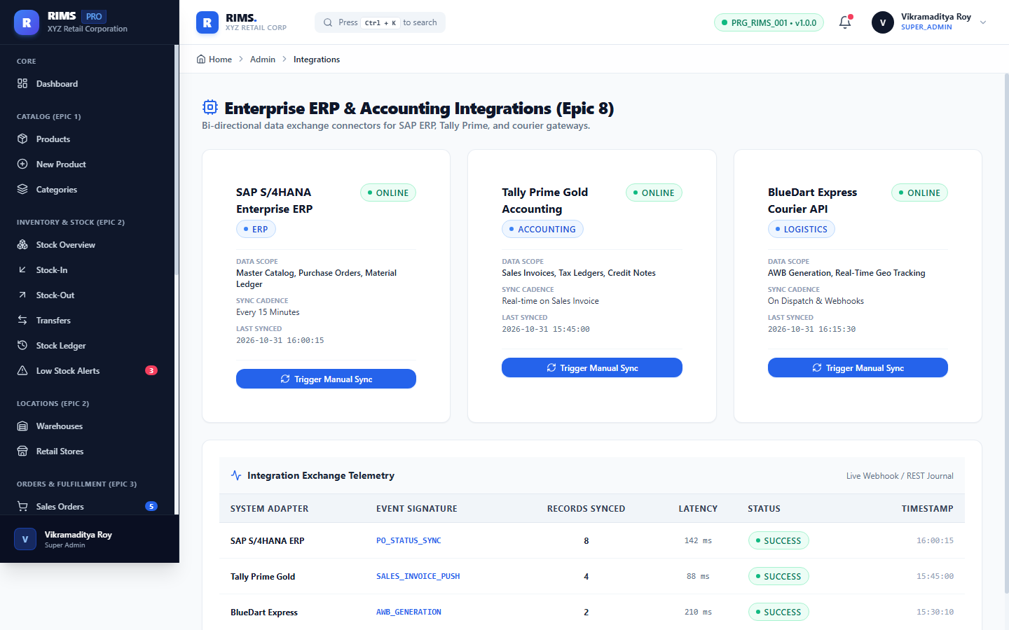

Figure 29: Epic 7: Security Audit Logs with IP Address & Timestamp Tracking
Route: https://retail-inventory-lemon.vercel.app/admin/audit
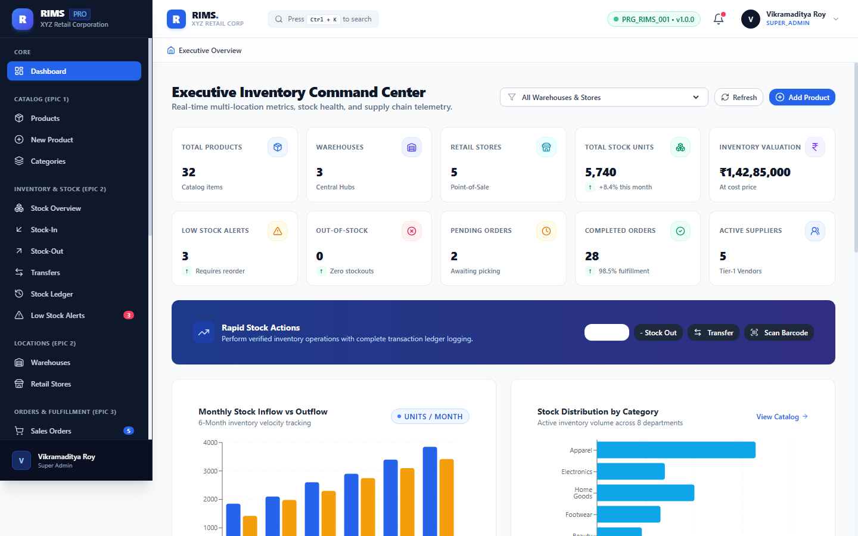

Figure 30: Epic 8: Global Application Thresholds & System Configuration
Route: https://retail-inventory-lemon.vercel.app/admin/settings
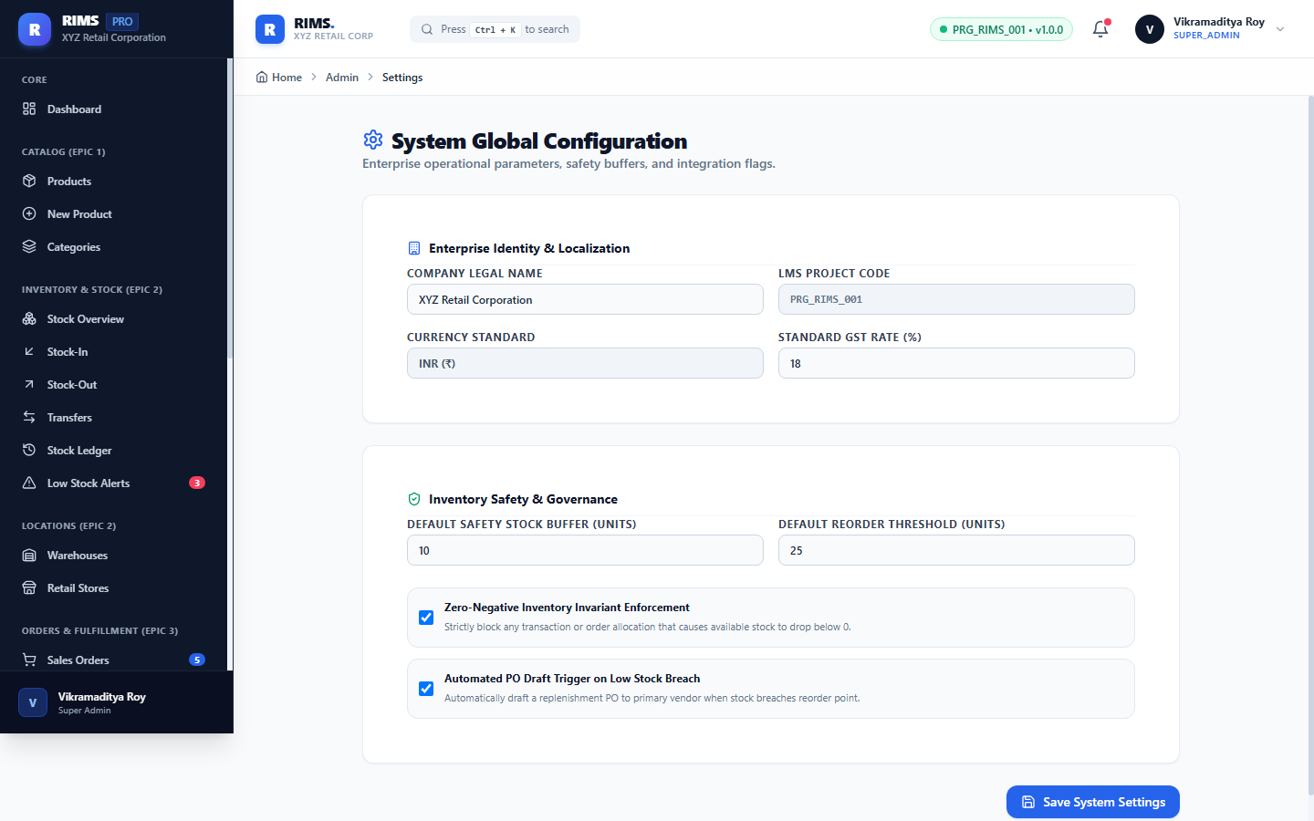

Figure 31: Backend Cloud Deployment: Spring Boot Actuator Health Telemetry
Route: https://rims-backend-g0cc.onrender.com/actuator/health
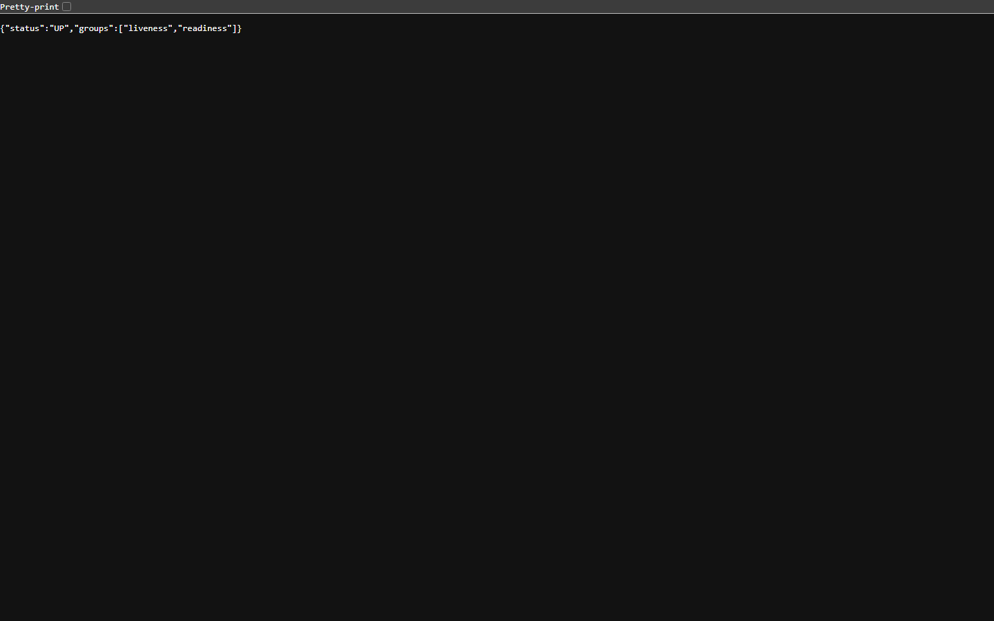

Figure 32: Backend Cloud Deployment: Swagger / OpenAPI 3.0 REST Documentation
Route: https://rims-backend-g0cc.onrender.com/swagger-ui/index.html
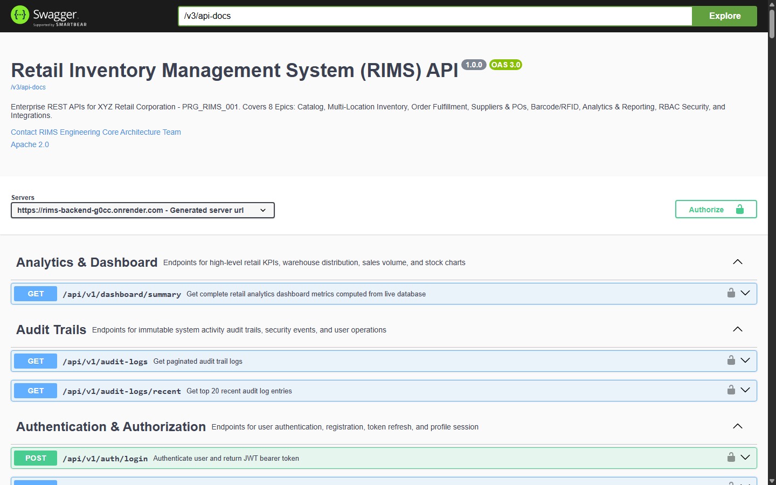

Figure 33: GitHub Cloud Repository: Production Branches, Commits & Blueprint
Route: https://github.com/rvstarts/Retail-inventory


