

Abstract

Overview of DWSP changes to be incorporated for introducing widget load on Dealer websites for both New as well as pre-Owned vehicles. Suggested implementation on Dealer Website Vehicle Listing and Vehicle Details Pages.

T3 new Widget Implementation Specifications

DWSP Reference Document

Contents

1 INTRODUCTION 2

2 Tag for New Vehicles 2

3 Tag for Pre-Owned(Used)Vehicles 2

4 Script inclusion for UAT application/DWSP Stage environment: 2

# INTRODUCTION

This document is intended to describe the process to embed a script in the third-party application/website in Production for a seamless of in-widget experience of E-Shop platform for both New as well as Pre-Owned (Used) vehicles. Upon embedding the code, the user will be able to access the E-Shop application in a popup/widget by clicking on the relevant CTA.

# Tag for NEW Vehicles

If vehicle type is New, this tag is to be inserted as part of the CTA specified for EShop T3 New Widget – ones with “Payment Options”. Upon embedding the script and clicking on the EShop CTA on the application/web page, the ORE component would open as a popup.

It is advised that DWSP includes the script within a Div of that section where they want the CTA to be shown.

There is no change needed for the existing implementation in place with the already enrolled dealers. For blended VLPs, where both New and Pre-owned vehicles are listed in the same page, Inclusion of the new vehicle script (app-root) is sufficient and works for both new and used vehicles.

Parameters to pass:

* vin*
* dealercode* - the dealer code to whom the VIN belongs
* vehicle_type *
* zipcode*

* **Indicates mandatory parameter**

Example Usage:

<app-root vin="1C4PJXEN6RW118542" dealercode="27044" zipcode="74055" vehicle_type="new"></app-root>

# Tag for Pre-Owned (Used) Vehicles

Parameters to pass:

* vin*
* dealercode* - the dealer code to whom the VIN belongs
* vehicle_type *
* zipcode*

* **Indicates mandatory parameter**

Example Usage :

<app-certified vin="1C6SRFLT4MN773108" dealercode="25001" zipcode="83402" vehicle_type="used"></app-certified>

></app-certified>

E-Shop T3 New UI Parameters:

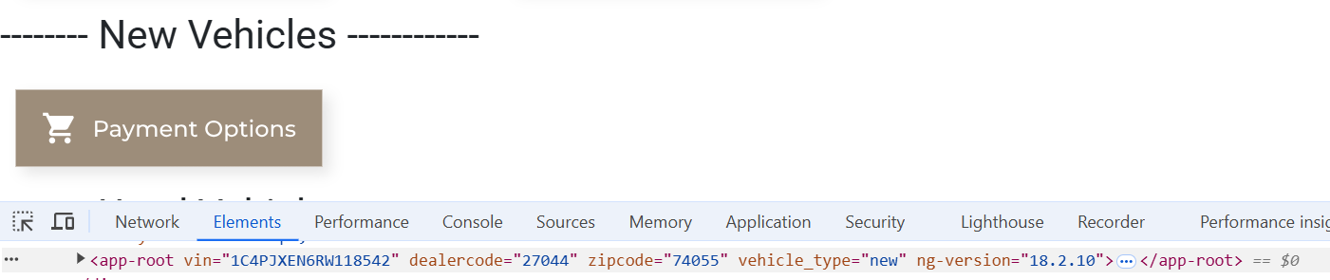

# Script inclusion for UAT application/DWSP Stage environment:

The following script must be embedded on the UAT environment:

**For non-DDC websites:**

<script type=”module” src=” https://stage-dealeradmin.eshopdemo.net/js/app-element-redesign-stage.js” ></script>

**For DDC websites:**

Yet to release Initiator file

E-Shop T3 New UI launches:

