VA Medication Refill Identifier
User Guide

Disclaimer
Please Read Before Using This App
This app is an independent personal tool created to help organize VA medication refill information. It is not created, operated, endorsed by, or affiliated with the U.S. Department of Veterans Affairs (VA), My HealtheVet, or any government agency.

This app is provided “as is,” with no warranty of any kind, and may contain errors. It is a convenience tool only — it does not replace, and should never be used as a substitute for, your official VA medication records or your VA provider's or pharmacist's guidance.

Always confirm your medications, refill status, and prescription details directly through VA.gov, My HealtheVet, or by contacting your VA pharmacy or provider before making any medical decisions or requesting a refill or renewal.

By using this app, you understand and agree that the creator of this app is not responsible for any missed refills, medication errors, delays, or other issues that may result from its use, and that you use it entirely at your own risk.

This app runs only on your own computer. It does not send your medication information anywhere — it simply reads the file you already downloaded and saves the results locally on your device.

One-Time Setup: Installing the App
Before you use the app for the first time, you'll need to install it. This takes a few seconds and you only have to do it once.
What You Should Have
A folder or a downloaded .zip file containing three items: Install_MedsToOrder.bat, MedsToOrder.exe, and this guide.
If you have a .zip file, right-click it and choose “Extract All…” first, then open the extracted folder.

- Open the folder containing the three items listed above
- Double-click Install_MedsToOrder.bat
- If a blue “Windows protected your PC” box appears, click “More info,” then click “Run anyway” — this is a normal first-time warning, not a problem
- A black window will briefly appear and then show a message confirming MedsToOrder is ready to use
- Press any key (or close the window) to finish
That's it — the installer automatically creates a folder named VAMEDS in your user folder, copies the app into it, and adds a “MedsToOrder” shortcut to your Desktop. You're ready to go.

What This App Does
This app reads your VA medication list (downloaded from My HealtheVet) and finds the medications you need to reorder. It looks for medications that are:
- Active — a current prescription
- Out of refills — 0 refills left
- Not already being processed — excludes refills already in progress
- A VA prescription — excludes vitamins, supplements, and other non-VA items
It shows the results in the app window, saves them to a file named MedsToOrder.txt, and keeps a record of your last 3 times using it.
Once it's installed, there's nothing else to set up — you just open the app and click one button.

Where to Find the App
The app lives in a folder on your computer called VAMEDS:
App Location
This PC → Documents (or your user folder) → VAMEDS

Tip: Right-click MedsToOrder.exe inside that folder and choose “Pin to taskbar” or “Show more options” → “Send to” → “Desktop (create shortcut)” so you can open it in one click next time.

Step-by-Step Instructions

Step 1: Download Your Medication List
- Go to VA.gov and sign in
- Go to My HealtheVet → Medications
- Download your full medication list
- Save it to your Downloads folder (this is where it saves by default)
The downloaded file will have a name like: VA-medications-list-YourName-8-29-2026_34157pm.txt

Step 2: Open the App
- Go to the VAMEDS folder
- Double-click MedsToOrder.exe (or use your taskbar/Desktop shortcut)
The app window opens with a blue button. That's it — nothing else to set up.
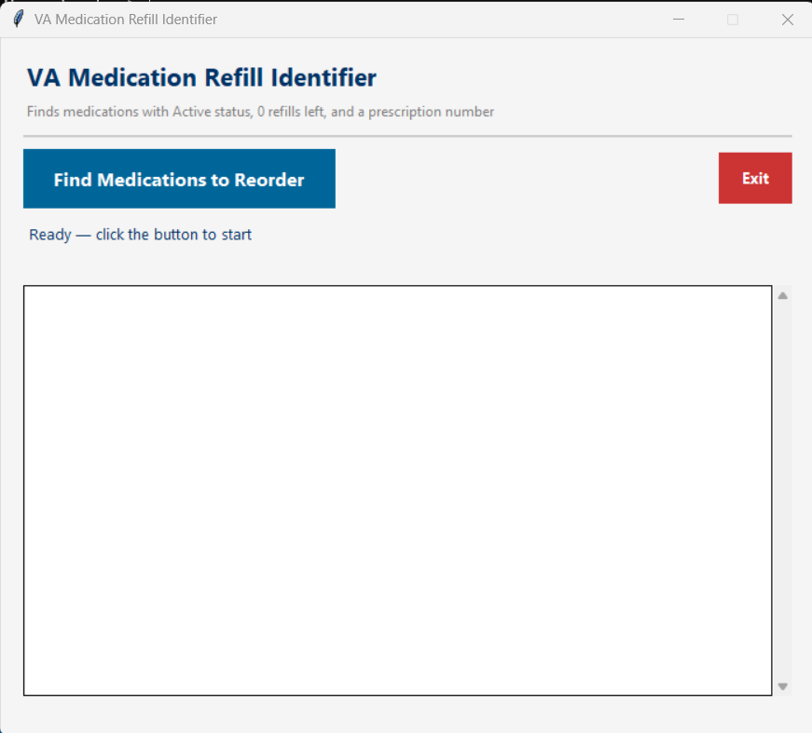
The MedsToOrder app window

Step 3: Click the Button
- Click “Find Medications to Reorder”
- The app reads your medication file
- Your results appear right in the window
You'll see a message like: “Found 7 medication(s) needing refills. Saved to MedsToOrder.txt”
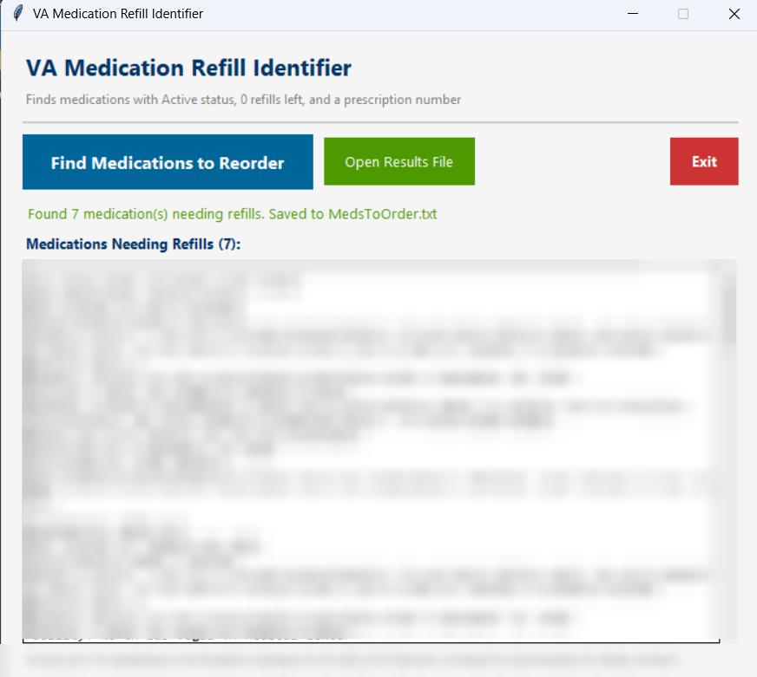
Example results (medication details and file name blurred for privacy)

Step 4: Review Your Results
Each medication listed shows:
- Medication name and dosage
- Last filled date
- Prescription number
- Status and refills left (0)
- Request refills by date
Not Every Medication Listed Is a Maintenance Medication
This list includes every active prescription with 0 refills left — not just the ones you take regularly (your maintenance medications). It can also include short-term prescriptions, such as an antibiotic or a one-time course of medication, simply because they also happen to be out of refills.

Go through the list and decide, for each one, whether it's something you actually need to keep taking. If it's a maintenance medication, request a renewal. If it was a short-term or as-needed prescription you're finished with, you can simply ignore it.

Click the green “Open Results File” button to open the list in Notepad, where you can print it or copy it.

Step 5: Request Your Refills
Since these medications have 0 refills left, you're requesting a new prescription (a renewal), not a simple refill — and not every method on VA.gov handles that the same way.
Best Option: Send a Secure Message
Sending a secure message to your VA provider is the fastest and most reliable way to get a renewal. This is exactly the problem this app was built to solve: the “Request Refill” button on VA.gov is built for refills, and often does not work once a prescription has 0 refills left and actually needs to be renewed.

Go to: VA.gov → My HealtheVet → Messages → Compose. Name the medication and ask your provider to renew it.

Other ways to reach your pharmacy or provider:
- Online “Request Refill” button: works for a true refill, but frequently fails once refills are at 0 and a renewal is needed. If it doesn't go through, use a secure message instead.
- Phone: Call your VA pharmacy directly
- In person: Visit your VA Medical Center pharmacy

Step 6: Close the App
Click the red “Exit” button when you're done.

The App Window
The app window has three buttons and a results area:
- Blue button — “Find Medications to Reorder”: runs the search
- Green button — “Open Results File”: opens your results (appears after you find results)
- Red button — “Exit”: closes the app
Below the buttons, a status message tells you what happened, and your medication list appears in a box underneath it.

What's in the VAMEDS Folder
- MedsToOrder.exe — the app itself. Double-click to open it.
- MedsToOrder.txt — your filtered medication list. This updates every time you run the app.
- MedsToOrder_Log.txt — a short record of your last 3 times running the app.
Your processed medication file is also automatically moved to a folder called Downloads\VA_Meds_Archive, so you never accidentally process the same file twice.

Helpful Tips
- Run it monthly — download a fresh medication list once a month.
- Run it before appointments — so you can talk about renewals with your provider.
- Set a reminder — add a note on your calendar for the 1st of each month: “Download VA meds list and run the app.”

If Something Goes Wrong
“No medication files found in Downloads folder”
This means you haven't downloaded your medication list yet.
Fix: Go to VA.gov, sign in, and download your medication list to your Downloads folder, then try again.

“No medications need refills right now”
This is good news — it means all your active medications still have refills remaining.
Fix: No action needed. You're all caught up.

The app shows fewer medications than you expected
The app is designed to leave out medications that still have refills, are already being processed, or aren't VA prescriptions.
Fix: This is expected behavior. Check your original medication list if you think something was missed.

A blue “Windows protected your PC” message appears
This is a standard first-time warning from Windows, not a sign of a problem.
Fix: Click “More info,” then click “Run anyway.” This only happens the first time.

The app won't open, or it closes right away
Fix: Restart your computer and try again. If it still won't open, delete the VAMEDS folder and reinstall the app using the installer file you were given, then try once more.
If the problem continues, reach out to whoever set up this app for you.

Quick-Reference Checklist
☐ Download your VA medication list from VA.gov — saves to Downloads
☐ Open the VAMEDS folder and double-click MedsToOrder.exe
☐ Click “Find Medications to Reorder”
☐ Review your medications in the app window
☐ Click “Open Results File” if you want to print or copy the list
☐ Request refills or renewals from your VA provider
☐ Click “Exit” to close the app
☐ Done!

