The GRUB Switch
Configuration scripts
Ruediger Willenberg
Version 1.2
June 19, 2021
Table of Contents
1 Prerequisite information 2
1.1 GRUB Switch only works with GRUB2 2
1.2 Conditions for script execution 2
1.3 Don’t execute with sudo 2
2 CONFIGURE_GRUBswitch.sh 3
3 Support scripts for specific actions 5
3.1 _1_extract_menuentries.sh 5
3.2 _2_configure_and_generate_bootfiles.sh 5
3.3 _3_remove_generated_files.sh 7
3.4 _4_write_entries_to_usb_device.sh 7
3.5 _5_install_uptodate_hashes.sh 8
3.6 _6_remove_all_hashes.sh 8
3.7 _7_install_grubswitch.sh 9
3.8 _8_remove_grubswitch.sh 9
4 Support scripts 10
4.1 _shared_objects.h 10
4.2 update-grub.sh update-grub2.sh 10

Prerequisite information

GRUB Switch only works with GRUB2
All of GRUB Switch’s functionality is built on the entirely redesigned GRUB 2.x versions. It will not work with GRUB 0.9x also known as “GRUB Legacy”.

Conditions for script execution
To provide stable, reproducible behaviour, the GRUB Switch configuration scripts described in this document need to be run under the following conditions. Scripts will check these right away and quit with an error message if not fulfilled.
- Scripts need to be executed from the grub-switch/1_config_scripts/ working directory as to properly read and write the the correct local and neighbouring paths and files. Make sure you’re in the right place, for example with
cd grub-switch/1_config_scripts/
- Scripts need to be called as an executable, i.e.
./SCRIPTNAME.sh [parameters]
Sourcing them with
. SCRIPTNAME.sh or source SCRIPTNAME.sh
would pollute the shell environment with variables and functions, and is therefore blocked.
If your repository clone has somehow not maintained executable flags, you can restore them in the 1_config_scripts/ directory with
chmod +x *.sh

Don’t execute with sudo
Unless you are doing all GRUB switch configuration as root anyway, start the scripts as a local user. While a few script actions like access to the /boot directory require super user access, they will explicitly ask for it at that point. Starting prematurely with sudo will just make all generated files root-owned and harder to access.

CONFIGURE_GRUBswitch.sh
CONFIGURE_GRUBswitch.sh is the main configuration script and in most cases the only script that needs to be started explicitly by the user. It checks presence of the required directory paths and files and acts as the main text UI status display and menu for all GRUB Switch functionality.
The complete call syntax for the script is
./CONFIGURE_GRUBswitch.sh -g GRUB_CFG_DIR -s CFG_SCRIPTS_DIR
In most cases, the extra arguments are not required because of automatic detection:

The -g switch specifies the boot directory in which grub.cfg (and other GRUB files and directories required during boot). If this argument is not specified, the script will check for presence of
/boot/grub/ as well as /boot/grub2/
as these are the default paths in all major Linux distributions.
The script will then check for the presence of grub.cfg in either the specified or the automatically detected path. If no path or no grub.cfg can be found, the scripts quits with an error.

The -s switch specifies the path of the scripts that update-grub/grub-mkconfig call to produce a new grub.cfg from their standard output. We need this to place our own extension 99_grub_switch there. In Ubuntu installations, this is usually /etc/grub.d/. However, as this location is included in the comments of grub.cfg, the script will by default just extract this location from there automatically. If the specified or extracted directory doesn’t exist, the scripts quits with an error.

With all collected data, the script will display its main screen, which holds information about the current sudo status, the existence and date of important files, and the actions that can be taken from here:
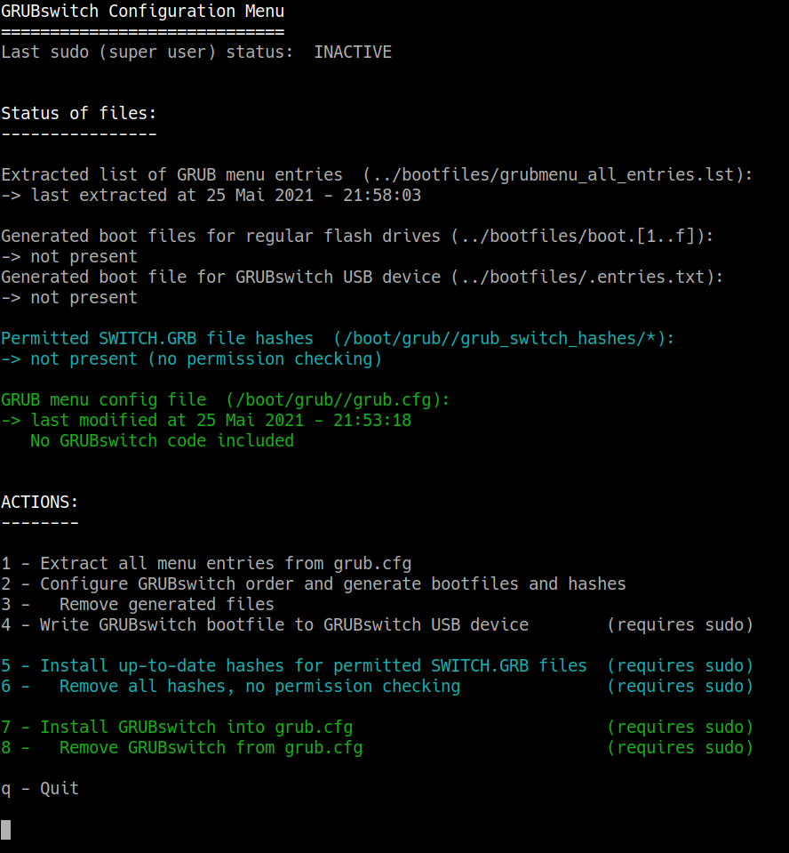
All actions to be taken can be chosen by number and will call the corresponding function script (see next section). If super user privileges are required for that function, sudo status will be requested before calling the scripts.
Configuration can be concluded by pressing q.

Support scripts for specific actions
All scripts listed here should in general be called through CONFIGURE_GRUBswitch. You can call them directly, but there will be no autodetection of required directory path, they will have to be explicitly specified through arguments or the script will exit with an error.

_1_extract_menuentries.sh
This script will extra the complete list of GRUB menu entries from grub.cfg and write them into grub-switch/bootfiles/grubmenu_all_entries.lst. It uses regular expressions and the sed command-line tool to extract the entries’ displayed names from the menuentry and submenu structures. Entries in submenus will be stored in the format
SUBMENU_DISPLAY_NAME>MENUENTRY_DISPLAY_NAME
which is the string format required later to specify this choice in the GRUB shell’s $default variable for booting.
The required syntax for directly executing the script is
./_1_extract_menuentries.sh -g GRUB_CFG_DIR
where GRUB_CFG_DIR is the directory in which grub.cfg is located.
This script might ask for sudo status if grub.cfg is only readable by root.

_2_configure_and_generate_bootfiles.sh
This action script has the most extensive functionality:
- It reads in all GRUB menu entries from bootfiles/grubmenu_all_entries.lst
- On its first screen, it enables the user to assign hexadecimal digits from 1..f (decimal 0..15) to entries, thereby both picking
  - the entries available for direct boot by GRUB Switch
  - the order of these entries
- On the second screen, the chosen entries are shown in the configured; the user can confirm the order or return to the previous screen to reconfigure.
- The third screen asks the user to specify for how many seconds the detected boot choice’s name is displayed. While this timeout allows a later GRUB Switch user to press ESC and return to the full boot menu, it can also be set to 000 seconds for instant boot.
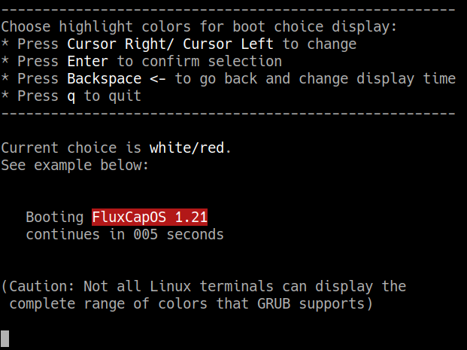
- The fourth screen lets the user specify a foreground/background to highlight the boot choice during the specified timeout (see below)
- When all setting are confirmed, the script will generated
  - bootfiles/.entries.txt for the configuration of the custom USB device.
  - the bootfiles/boot.*/ directories for the specified entry numbers, which each hold the corresponding SWITCH.GRB to copy on a flash drive that represents that choice.
  - corresponding SHA512-hashes for all generated SWITCH.GRB files in bootfiles/grub-switch-hashes/. This directory can later be copied to the directory that holds grub.cfg and thereby enable that every SWITCH.GRB will be checked for a matching hash before execution.
- At any stage, the script can be exit without generating new files by pressing q
The required syntax for directly executing the script is
./_2_configure_and_generate_bootfiles.sh
This script does not require sudo status.

_3_remove_generated_files.sh
This scripts removes the generated files/directories
bootfiles/.entries.txt
bootfiles/boot.*/SWITCH.GRB
bootfiles/grub-switch-hashes/
that the previous script generated. It does not remove the list of extracted GRUB menu entries bootfiles/grubmenu_all_entries.lst
The required syntax for directly executing the script is
./_3_remove_generated_files.sh
This script does not require sudo status.

_4_write_entries_to_usb_device.sh
This script’s purpose is to automate the installation of a generated GRUB Switch configuration to a custom USB device through these four steps:
- The script tries to find our custom USB device through its FAT12 drive’s 4-byte UUID, which is fixed in the FAT boot sector to the hexadecimal numbers 1985-1955.
- It will try to create a temporary mount path bootfiles/grub-switch-mount/ and mount the USB drive there.
- The configuration file bootfiles/.entries.txt will be copied to the mounted drive.
- The drive will be unmounted and the temporary folder will be removed.
(unmounting/removing can fail if a previous step was unsuccessful)
All the steps can be also be manually accomplished by the user.
The required syntax for directly executing the script is
./_4_write_entries_to_usb_device.sh
The boot directory will not be detected automatically when calling the script directly, it has to be specified.

_5_install_uptodate_hashes.sh
This script will copy the directory bootfiles/grub-switch-hashes/ with SHA512 hashes of SWITCH.GRB files to the same location as grub.cfg., thereby enabling hash checking for all offered SWITCH.GRB files on boot. On most systems, the destination folder will be /boot/grub/ or /boot/grub2/.

The required syntax for directly executing the script is

./_5_install_uptodate_hashes.sh -g $GRUB_CFG_DIR
The boot directory will not be detected automatically when calling the script directly, it has to be specified.
This script will ask for sudo status because it is required for writing to the boot directory.

_6_remove_all_hashes.sh
This script will remove the directory of SHA512 hashes from the GRUB boot directory. This action can both be used to remove outdated hashes as well as to disable all hash checking.
Note: Some improper updates of GRUB itself on systems with Secure Boot can result in the GRUB hash checking module to be rejected. In that case, GRUB Switch will yield to the GRUB menu as if the hash check itself has failed.
One fix for this issue is to remove the hashes again with this actions. With careful consideration, other fixes like de-activating Secure Boot itself can be used.

The required syntax for directly executing the script is

./_6_remove_all_hashes.sh -g $GRUB_CFG_DIR
The boot directory will not be detected automatically when calling the script directly, it has to be specified.
This script will ask for sudo status because it is required for removing the directory.

_7_install_grubswitch.sh
Calling this script will install the GRUB Switch functionality itself through these two steps:
- The script 99_grub_switch will be copied into the directory that holds all scripts called for the regeneration of grub.cfg. On Ubuntu systems, this is /etc/grub.d.
- The scripts update-grub/grub-mkconfig will be executed to regenerate grub.cfg. As our own generator script is now included with the others, the code to detect, hash-check and source SWITCH.GRB from an attached drive will be appended to grub.cfg and executed on each boot after menu construction but before menu display.
The required syntax for directly executing the script is

./_7_install_grubswitch.sh -g $GRUB_CFG_DIR -s $CFG_SCRIPTS_DIR
The boot and generator script directories will not be detected automatically when calling the script directly, they have to be specified.
This script will ask for sudo status because it is required for both actions.

_8_remove_grubswitch.sh
Calling this script will fully remove the GRUB Switch functionality through these two steps:
- The script 99_grub_switch will be removed from the directory that holds all scripts called for the regeneration of grub.cfg. On Ubuntu systems, this is /etc/grub.d.
- The scripts update-grub/grub-mkconfig will be executed to regenerate grub.cfg. As our own generator script is now removed, no GRUB Switch functionality will be executed.
The required syntax for directly executing the script is

./_8_remove_grubswitch.sh -g $GRUB_CFG_DIR -s $CFG_SCRIPTS_DIR
The boot and generator script directories will not be detected automatically when calling the script directly, they have to be specified.
This script will ask for sudo status because it is required for both actions.

Support scripts

_shared_objects.h
This script defines variables and helper functions used by the other scripts. It is sourced to include them into the executed scripts’ environment.

update-grub.sh
update-grub2.sh
These two scripts are defined for compatibility reasons in case a Linux installation only has the grub-mkconfig script and not its update-grub wrapper.

