The GRUB Switch - Quickstart Guide
Ruediger Willenberg
Version 1.3
May 26, 2021
This guide expects that you know how to use the Linux command-line in a console window and are familiar with commands to change directories, list files and start bash scripts. You will also need super user access for some steps, so make sure you have sudo rights.
Refer to the detailed documentation if these quick steps do not work on your platform.
Table of Contents
1 Downloading and installing GRUB Switch files 2
2 Configuring your boot choices 3
2.1 Extracting a list of GRUB menu entries 4
2.2 Selecting and ordering your boot choices 4
2.3 Storing hash values for boot choice authentication 7
3 Adding GRUB Switch to your GRUB installation 8
4 Method A to use GRUB Switch: Using regular USB flash drives for boot choice 9
5 Method B to use GRUB Switch: Using hardware switches and a programmable USB board for boot choice 10
5.1 Supported boards 10
5.2 Programming the boards with GRUB Switch firmware 10
5.3 Writing the GRUB Switch boot configuration onto your storage device 12
5.4 Electrical connections to the GRUB Switch boards 13

Downloading and installing GRUB Switch repository
The GRUB Switch scripts and files are designed to be installed and used under Linux. There are two ways to obtain the files:
- Via git clone:
  - Go to your preferred working directory
  - Clone the repository with
git clone https://github.com/rw-hsma-fpga/grub-switch.git
  - All GRUB Switch files are now available in the path
./grub-switch
- Via download:
  - Download to your preferred directory:
https://github.com/rw-hsma-fpga/grub-switch/archive/refs/heads/master.zip
  - Unzip with GUI-tool or on the command line with
unzip grub-switch-master.zip
  - All GRUB Switch files are now available in the path
./grub-switch-master
All further examples will assume you are starting in the parent directory above grub-switch

Configuring your boot choices
To configure your GRUB Switch boot choices, enter the bash script directory with
cd grub-switch/1_shell_scripts/
(exact path depends on your installation location and current working directory)
Start the configuration tool with
./CONFIGURE_GRUBswitch.sh
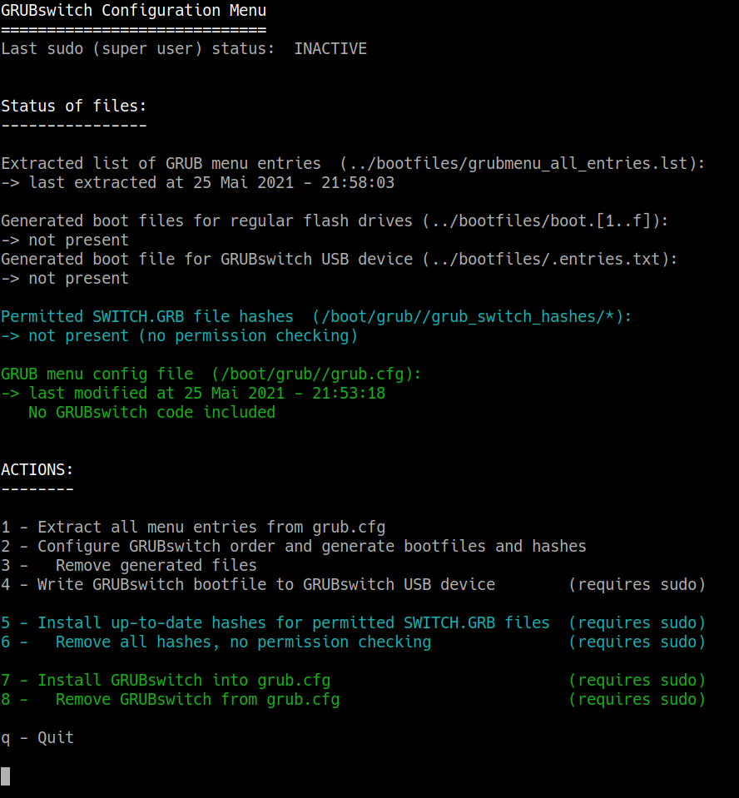
(we don’t recommend starting the script with sudo, because all generated files would then be owned by root)

The main screen should look as above (depending on your console theme).
The tool lists on top if sudo rights (which are needed for some actions) have been established previously.
Below that, the script lists the status of important files either required or generated by this tool.
In the lower half, the tool offers a menu of actions to take by pressing a corresponding number key.

Extracting a list of GRUB menu entries
By choosing option 1, the tool will parse GRUB’s menu configuration file and generate a local text file grub-switch/bootfiles/grubmenu_all_entries.txt that lists all menu entries, including ones in submenus, and is the basis for picking your custom boot choices.
After returning to the main screen, the status of grubmenu_all_entries.txt should reflect the recent extraction date.

Selecting and ordering your boot choices
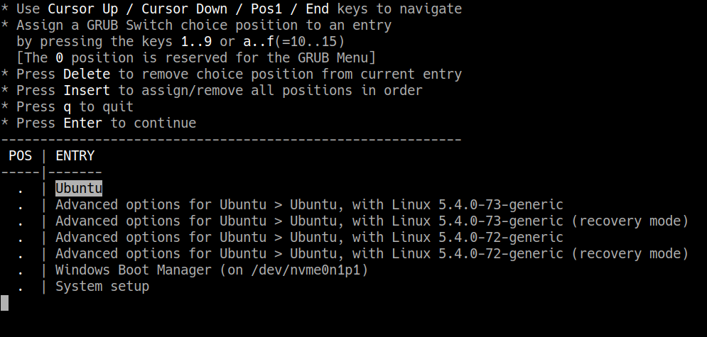
Choose menu option 2 to start the actual GRUB Switch configuration.
The tool will show a complete list of boot choices in the order extracted from the GRUB configuration. Moving up and down with the cursor keys, you can use number keys (and the hexadecimal letters a to f representing 10..15) to assign choices a position in the GRUB Switch selection order.
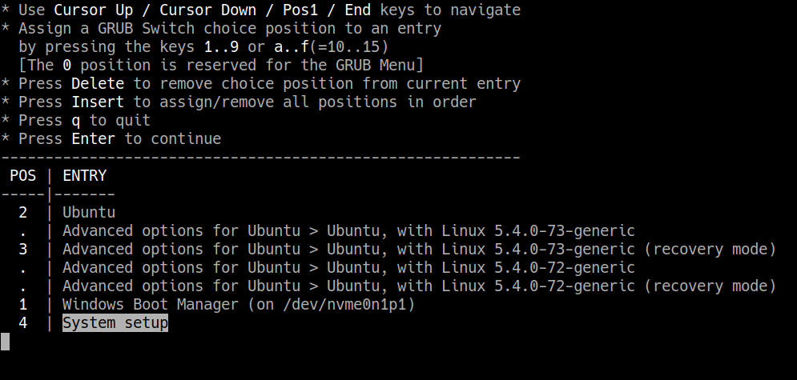
Not all entries have to be chosen and assigned a numerical position. The Enter key continues to the next screen.
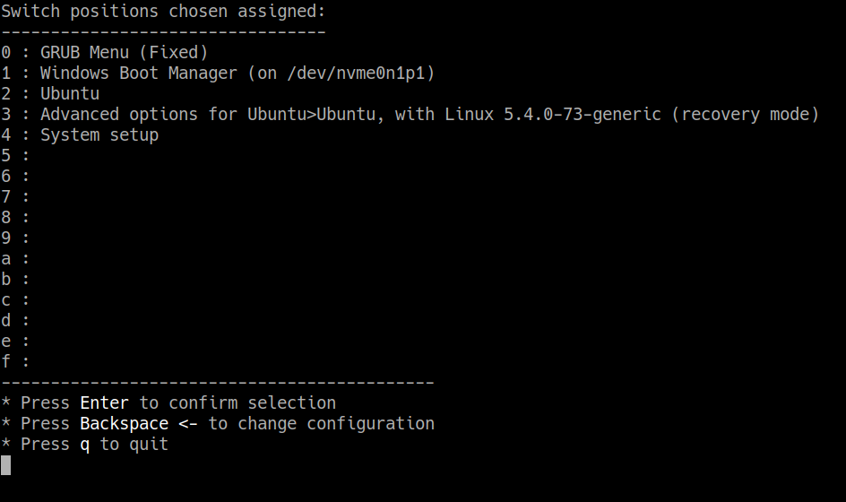
The next screen shows the selected choices and position assignments. They can be confirmed with the Enter key; the Backspace key returns to the previous screen for further changes.
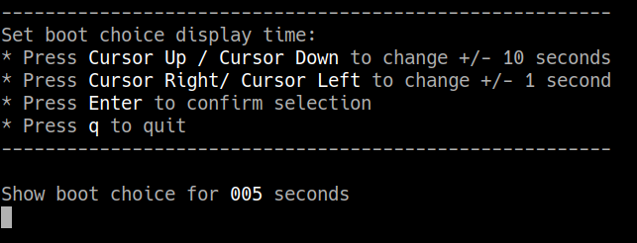

It is possible to display the chosen boot option for a number of seconds, which can be adjusted in the next tool screen. If you keep or set the value to 0 seconds, there will be no choice display. The operating system selected by GRUB Switch will be booted instantly.
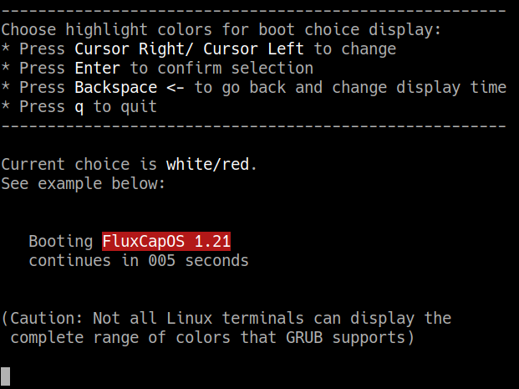

The last configuration screen allows choosing a highlight color (foreground/background) for the choice display. Enter finishes the boot configuration. A final screen shows the output written into the configuration file grub-switch/bootfiles/.entries.txt, which is used to configure the switchable USB storage device.
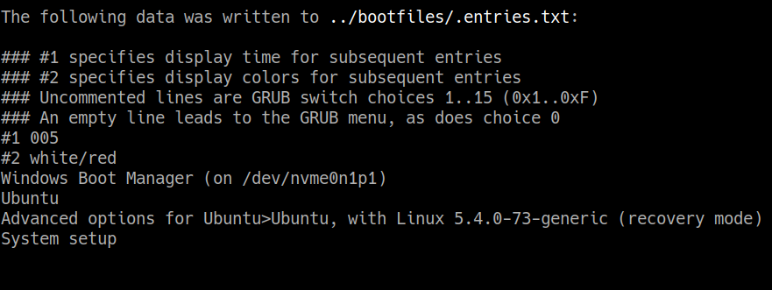

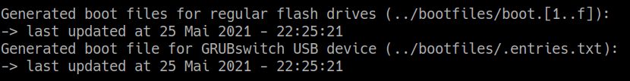
After pressing a key, the tool returns to the main screen. The status of generated bootfiles shows that they have just been generated.
To clean up, the generated files can be deleted with menu option 3.

Storing hash values for boot choice authentication
For every generated boot file, a unique SHA512 hash sum been generated. By selecting action 5, these hashes can be stored into the system’s boot directory. As this option writes into the boot path, both sudo rights authorization and an extra confirmation are required:
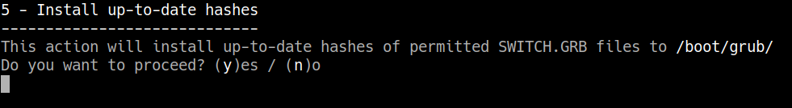
When such hashes have been installed, GRUB Switch will only execute boot options for which it finds corresponding hash sums. This mechanism protects the system against flash drives with unauthorized GRUB scripts.
The hashes can be removed again from the boot directory with option 6.
IMPORTANT NOTE: Some Linux distributions install updated versions of GRUB where not all submodules have an UEFI Secure Boot signature (I’m looking at you, Kubuntu 18.04). If you have an UEFI BIOS with Secure Boot enabled, GRUB Switch will give you an error on trying to use the hash module and will boot through the regular GRUB menu. If this happens, you have three possible fixes:
- Remove the hash sums again with option 6 (most simple).
- Disable Secure Boot in BIOS (consider first if Secure Boot is really optional for you).
- Roll back any updates to GRUB to the signed version (most complicated).

Adding GRUB Switch to your GRUB installation
Before your generated boot choice files can have any impact, you need to install the actual GRUB Switch modification to GRUB. This is accomplished with action 7 in the tool:
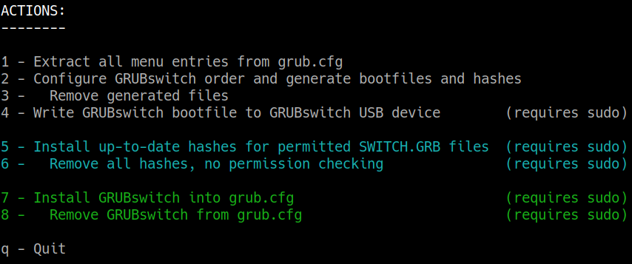
This action also requires sudo write rights and an additional confirmation:
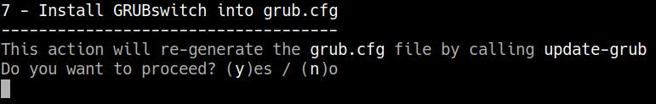

File status will show the installed GRUB Switch modification:
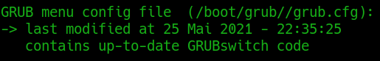

IMPORTANT: GRUB Switch needs to be installed ONLY ONCE, not every time you change the boot choices and generate new files. If you have downloaded a newer version of GRUB Switch where the GRUB modifications have changed, the file status will indicate this and you can reinstall.
GRUB Switch can be removed again with menu option 8.

Method A to use GRUB Switch:
Using regular USB flash drives for boot choice
Picking and configuring boot entries with option 2 in the CONFIGURE_GRUBswitch.sh tool has generated directories and files like these in your directory grub-switch/bootfiles :
bootfiles/boot.1/SWITCH.GRB
bootfiles/boot.2/SWITCH.GRB
bootfiles/boot.2/SWITCH.GRB
You will find boot.* dirs according to the positions you assigned during configuration. There won’t be a boot.0 dir because that choice is reserved for the GRUB menu. Each directory holds a SWITCH.GRB file that sets the variable for the corresponding boot choice when called by GRUB. You can open it with a text editor, though I don’t recommend editing it by hand.
You will now need as many USB flash drives as you have picked boot choices (excluding the GRUB menu).
- Make sure each flash drive is formatted with a FAT file system (FAT12/16/32, exFAT, VFAT), not with NTFS or any other file system.
You do not need to re-format an existing drive, or even delete its files (although you might want to for reasons of cleanliness, data protection, privacy, etc.).
- Copy each SWITCH.GRB file to a separate flash drive and mark the drive with the corresponding number, OS name or whatever helps you tell them apart.
- Before powering on your computer or rebooting, plug in the flash drive representing your boot choice.
- If you want the GRUB menu to appear, make sure none of the drives are plugged in.
- If multiple of your drives are plugged in by accident, boot choice will depend on the ordering of USB connections in your BIOS, which you might not be able to tell easily.
All further chapters are not relevant if you stick with this method to make your boot choice.

Method B to use GRUB Switch:
Using hardware switches and a programmable
USB board for boot choice
If you want to make your boot choice through an electromechanical switch, you need to use a programmable USB board, flash it with our firmware and connect a suitable switch to it.
Our firmware is designed for boards with the Microchip/Atmel ATmega32u4 chip, which can act as a USB device. All related files can be found in grub-switch/2_usb_device

Supported boards
Currently the project includes pre-built firmware images for the following products:
- PJRC Teensy 2.0
- Arduino Micro
- SparkFun Pro Micro (3V and 5V versions) and various clones
- Adafruit ItsyBitsy 32u4 (3V and 5V versions)
- DFRobot Beetle
- Our self-designed, non-commercial Custom Hardware PCB (see 5.2.3)
It is fairly simple to adapt the firmware to another board with the ATmega32u4 and build a firmware image. See the detailed documentation for instructions.

Programming the boards with GRUB Switch firmware
On the Linux command-line, go to the grub-switch/2_usb_device/prebuilt_images directory, where you can find the suitable image and programming scripts.

Teensy 2.0
Teensy 2.0 has a proprietary bootloader which works with its own GUI programming tool, Teensy Loader. You can find precise installation and download instructions here:
https://www.pjrc.com/teensy/loader_linux.html
The corresponding image is prebuilt_images/GRUB_SWITCH_TEENSY20.hex

Arduino-compatible boards
Arduino Micro, ItsyBitsy, Pro Micro and Beetle all use a bootloader that is compatible with Arduino IDE, however the IDE does not have an option for downloading any random *.hex file. We therefore require a command-line tool called avrdude, which is available in many Linux repositories.
- Under Ubuntu, for example, you can install avrdude with
sudo apt-get install avrdude
- To simplify the use of avrdude, we have provided a script in prebuilt_images. After plugging in your board, it can be started with:
sudo ./program_grubswitch_avrdude.sh CORRECT_FIRMWARE.hex
(The use of sudo might not be required on your installation)
- The script will ask you to put the connected board into bootloader mode:
  - For the Arduino Micro and ItsyBitsy bootloader mode can be entered by pushing the board’s reset button twice.
  - The Pro Micro does not have a reset button; you have to short the GND and RST pads twice in short order with a wire.
  - The Beetle has a group of 6 tiny pads on the bottom side below its USB socket:
1 3 5
# O O Pad number 1 is square, not round.
O O O Short the round pads number 5 and 6 twice in
2 4 6 short order to put Beetle into bootloader mode
- After putting your board into bootloader mode, you have between 5 and 10 seconds to press a keyboard key for the programming script to continue; any longer, and the board leaves bootloader mode again.
After successful firmware programming, the board identifies as a FAT12 storage device. Depending on your Linux GUI, you might get a device notification.
NOTE: There are separate firmware images for the 3V and 5V versions of both ItsyBitsy and Pro Micro, as they need different oscillator configurations. Downloading the wrong firmware will not cause harm, the firmware will just not function. The board can be brought into bootloader mode again, and reprogrammed with the correct firmware.

THE GRUB SWITCH custom USB hardware Rev.B
Our custom USB device design relies on the DFU bootloader which is factory-built into each ATmega32u4 chip. There is an open source command-line tool called dfu-programmer which needs to be installed for firmware flashing.
- Under Ubuntu Linux, it can be installed with:
sudo apt-get install dfu-programmer
- To simplify the use of dfu-programmer, we have provided a script in prebuilt_images. After plugging in your board, it can be started with:
sudo ./program_grubswitch_dfu.sh GRUB_SWITCH_CUSTOMHW_REVB.hex
(The use of sudo might not be required on your installation)
- Before or after starting the script, the chip needs to be brought into bootloader mode by pushing or shorting the PROG button. Unlike the Arduino boards, there is no bootloader timeout. Pressing a key on the keyboard will start programming.
After successful firmware programming, the board identifies as a FAT storage device with the drive name BOOTTHIS. Depending on your Linux GUI, you might get a notification.

Writing the GRUB Switch boot configuration onto your storage device
Together with the boot.* directories, option 2 of the CONFIGURE_GRUBswitch.sh script has also written a single text file holding the complete list and order of boot choices:
bootfiles/.entries.txt
You can open with a text editor to see the ordered list of boot choices, however it is not recommended to edit the file by hand. Because the filename starts with a period, it is only visible if you use the -a option with ls:
ls -la bootfiles/
If you mount your USB storage device automatically through the GUI, you can just copy the file onto the device and unmount again.
Alternatively, you can use option 4 - Write GRUBswitch bootfile to GRUBswitch USB device in the CONFIGURE_GRUBswitch.sh tool. This requires giving the sudo password because the mounting and unmounting of the device is being forced.
NOTE: Your USB device is not a regular flash drive. .entries.txt is the only file that will be accepted for writing, and only if the Write-Protect jumper is not set on the board (see wiring section). The only other (read-only) files on the device are:
SWITCH.GRB – The actual boot setting script read by GRUB. If there are no switch connections on the board yet, this will be empty because that is the default leading to the GRUB menu.
.bootpins.txt – This file (also hidden without ls -a) shows the choice pins currently connected to GND as ones. It is only included for testing purposes.

Electrical connections to the GRUB Switch boards
There are multiple ways to connect switches to each board to control the boot choice.

Arduino Micro
1-OF-N MODE with ON/OFF/ON toggle switch:
-------------------------------------------

To choose this mode, pin PF1 needs to stay UNCONNECTED.

The Write Protect against modifying boot entry configurations is activated
by tieing/jumpering pin PF6 to GND or PF7 (adjacent pad, driving a low level).

Using a three-position on/off/on switch permits choosing between two
OS options, while the neutral middle position leads to the GRUB menu

##### [1]
.-----------o=# # ////
| # #|| ////
| .---o=# #||//// [0] Menu
| | # #||
| .---|---o=# #
| | | ##### [2]
| | |
| | |
.--------------------------------------+---+---+-----------------------.
| O O O O O O O O O O O O O O O O O |
| 12 11 10 9 8 7 6 5 4 3 2 GND RST RX TX SS MOSI |
| PD6 PB7 PB6 PB5 PB4 PE6 PD7 PC6 PD4 PD0 PD1 PD2 PD1 PB0 PB2 |
| |
| |
|=========# |
| USB # |
| # ARDUINO MICRO |
| MICRO-B # |
|=========# |
| |
| |
| PC7 PF7 PF6 PF5 PF4 PF1 PF0 PB3 PB1 |
| 13 3V3 AREF A0 A1 A2 A3 A4 A5 5V0 RST GND VIN MISO SCK |
| O O O O O O O O O O O O O O O O O |
'--------------+---+---------------------------------------------------'
| |
| |
?
/WR_PROT

1-OF-N MODE with rotary switch: (Motto: "This one goes to 11!")
---------------------------------------------------------------

To choose this mode, pin PF1 needs to stay UNCONNECTED.

The Write Protect against modifying boot entry configurations is activated
by tieing/jumpering pin PF6 to GND or PF7 (adjacent pad, driving a low level).

Common rotary switches have up to 12 positions (some can be limited to fewer
positions with a mechanical keyring). Keeping the first position [0] unconnected
permits choosing the GRUB menu and leaves 11 boot choices, which is the maximum
number of pins sampled. Connecting one of the pins PD1..PD6 to GND
therefore reflects boot choices 1..11 (hexadecimal 0x1..0xB). Accidentally
connecting multiple pins results in the lowest-order entry being chosen.

.-----------------------------------------o [11/0xB]
| .-----------------------------------o [10/0xA]
| | .------------------------------o [9]
| | | .-------------------------o [8]
| | | | .--------------------o [7]
| | | | | .----------------o [6] x-----o
| | | | | | .------------o [5] / |
| | | | | | | .---------o [4] / |
| | | | | | | | .------o [3] / |
| | | | | | | | | .---o [2] / |
| | | | | | | | | | .-o [1] |
| | | | | | | | | | | o [0] Menu |
| | | | | | | | | | | |
| | | | | | | | | | | .-------------'
| | | | | | | | | | | |
.--+---+---+---+---+---+---+---+---+---+---+---+-----------------------.
| O O O O O O O O O O O O O O O O O |
| 12 11 10 9 8 7 6 5 4 3 2 GND RST RX TX SS MOSI |
| PD6 PB7 PB6 PB5 PB4 PE6 PD7 PC6 PD4 PD0 PD1 PD2 PD1 PB0 PB2 |
| |
| |
|=========# |
| USB # |
| # ARDUINO MICRO |
| MICRO-B # |
|=========# |
| |
| |
| PC7 PF7 PF6 PF5 PF4 PF1 PF0 PB3 PB1 |
| 13 3V3 AREF A0 A1 A2 A3 A4 A5 5V0 RST GND VIN MISO SCK |
| O O O O O O O O O O O O O O O O O |
'--------------+---+---------------------------------------------------'
| |
| |
?
/WR_PROT

BINARY MODE:
------------

To choose this mode, pin PF1 needs to be tied to GND or adjacent pad PF0.

The Write Protect against modifying boot entry configurations is activated
by tieing/jumpering pin PF6 to GND or PF7 (adjacent pad, driving a low level).

Common binary-encoding rotary switches have 10 to 16 positions and connect
the corresponding bit values 1,2,4,8 [LSB..MSB] to the 'C'-contacts; using the
device's binary mode means tieing the four pins PD1..PC6 [LSB..MSB] to GND/0V
as to encode the corresponding boot choices 0(GRUB Menu) up to 15(0xF).
Obviously a proper nerd can also use four separate switches to encode the
choice in binary herself!
(Reminder: The device interprets a pin tied to GND as a '1', so all four
connections mean choice 15/0xF, while no connection means 0.

.---------------.
| |
.--+ 2 --- 4 +--.
| | / \ | |
| | C | --> | C +--|-----------.
| | \ / | | |
.--|--+ 8 --- 1 +--|-------. |
| | | | | | |
| | '---------------' | | |
| '---------------------|---. | |
| | | | |
'--------------------. | | | |
| | | | |
.------------------------------+---+---+---+---+-----------------------.
| O O O O O O O O O O O O O O O O O |
| 12 11 10 9 8 7 6 5 4 3 2 GND RST RX TX SS MOSI |
| PD6 PB7 PB6 PB5 PB4 PE6 PD7 PC6 PD4 PD0 PD1 PD2 PD1 PB0 PB2 |
| |
| |
|=========# |
| USB # |
| # ARDUINO MICRO |
| MICRO-B # |
|=========# |
| |
| |
| PC7 PF7 PF6 PF5 PF4 PF1 PF0 PB3 PB1 |
| 13 3V3 AREF A0 A1 A2 A3 A4 A5 5V0 RST GND VIN MISO SCK |
| O O O O O O O O O O O O O O O O O |
'--------------+---+-----------+---+-----------------------------------'
| | | |
| | '---'
? /BM
/WR_PROT

Adafruit ItsyBitsy 3V/5V

1-OF-N MODE with ON/OFF/ON toggle switch:
-------------------------------------------

To choose this mode, pin PF1 needs to stay UNCONNECTED.

The Write Protect against modifying boot entry configurations is activated
by tieing/jumpering pin PF6 to GND or PF7 (adjacent pad, driving a low level).

Using a three-position on/off/on switch permits choosing between two
OS options, while the neutral middle position leads to the GRUB menu

.---------------------------------------------------------.
| O O O O O O O O O O O O O O |
| BAT GND USB 13 12 11 10 9 7 5* SCL SDA TX RX |
| PC7 PD6 PB7 PB6 PB5 PE6 PD0 PD1 PD3 PD2 |
| | ##### [1]
| PD4 4 O | .-----o=# # ////
| | | # #|| ////
|=========# PD7 6 O +--' .--o=# #||//// [0] Menu
| USB # | | # #||
| # ItsyBitsy 3V/5V PB4 8 O +-----|--o=# #
| MICRO-B # | | ##### [2]
|=========# GND O +-----'
| |
| EN O |
| |
| PF7 PF6 PF5 PF4 PF1 PF0 PB1 PB2 PB3 |
| RST * ARf * A0 A1 A2 A3 A4 A5 SCK MOSIMISO * |
| O O O O O O O O O O O O O O |
'------------------+---+----------------------------------'
| |
| |
?
/WR_PROT

1-OF-N MODE with rotary switch: (Motto: "This one goes to 11!")
---------------------------------------------------------------

To choose this mode, pin PF1 needs to stay UNCONNECTED.

The Write Protect against modifying boot entry configurations is activated
by tieing/jumpering pin PF6 to GND or PF7 (adjacent pad, driving a low level).

Common rotary switches have up to 12 positions (some can be limited to fewer
positions with a mechanical keyring). Keeping the first position [0] unconnected
permits choosing the GRUB menu and leaves 11 boot choices, which is the maximum
number of pins sampled. Connecting one of the pins PB4..PB7 to GND
therefore reflects boot choices 1..11 (hexadecimal 0x1..0xB). Accidentally
connecting multiple pins results in the lowest-order entry being chosen.

.---------------------------------------------o [11/0xB]
| .---------------------------------------o [10/0xA]
| | .----------------------------------o [9]
| | | .-----------------------------o [8]
| | | | .--------------------o [7]
| | | | | .----------------o [6] x-----o
| | | | | | .------------o [5] / |
| | | | | | | .---------o [4] / |
| | | | | | | | .----o [3] / |
.----------------------+---+---+---+-------+---+---+---+--. | .-o [2] / |
| O O O O O O O O O O O O O O | | | o [1] |
| BAT GND USB 13 12 11 10 9 7 5* SCL SDA TX RX | | | | o [0] Menu |
| PC7 PD6 PB7 PB6 PB5 PE6 PD0 PD1 PD3 PD2 | | | | |
| | | | | |
| PD4 4 O +--' | | |
| | | | |
|=========# PD7 6 O +------' | |
| USB # | | |
| # ItsyBitsy 3V/5V PB4 8 O +----------' |
| MICRO-B # | |
|=========# GND O +--------------------------'
| |
| EN O |
| |
| PF7 PF6 PF5 PF4 PF1 PF0 PB1 PB2 PB3 |
| RST * ARf * A0 A1 A2 A3 A4 A5 SCK MOSIMISO * |
| O O O O O O O O O O O O O O |
'------------------+---+----------------------------------'
| |
| |
?
/WR_PROT

BINARY MODE:
------------

To choose this mode, pin PF1 needs to be tied to GND or adjacent pad PF0.

The Write Protect against modifying boot entry configurations is activated
by tieing/jumpering pin PF6 to GND or PF7 (adjacent pad, driving a low level).

Common binary-encoding rotary switches have 10 to 16 positions and connect
the corresponding bit values 1,2,4,8 [LSB..MSB] to the 'C'-contacts; using the
device's binary mode means tieing the four pins PB4..PD2 [LSB..MSB] to GND/0V
as to encode the corresponding boot choices 0(GRUB Menu) up to 15(0xF).
Obviously a proper nerd can also use four separate switches to encode the
choice in binary herself!
(Reminder: The device interprets a pin tied to GND as a '1', so all four
connections mean choice 15/0xF, while no connection means 0.

.---------------.
| |
.--+ 2 --- 4 +--.
| | / \ | |
| | C | --> | C +--|-----------.
| | \ / | | |
.--|--+ 8 --- 1 +--|-------. |
| | | | | | |
| | '---------------' | | |
| '---------------------|---. | |
| | | | |
'------------------. | | | |
| | | | |
.------------------------------------------------------+--. | | | |
| O O O O O O O O O O O O O O | | | | |
| BAT GND USB 13 12 11 10 9 7 5* SCL SDA TX RX | | | | |
| PC7 PD6 PB7 PB6 PB5 PE6 PD0 PD1 PD3 PD2 | | | | |
| | | | | |
| PD4 4 O +--' | | |
| | | | |
|=========# PD7 6 O +------' | |
| USB # | | |
| # ItsyBitsy 3V/5V PB4 8 O +----------' |
| MICRO-B # | |
|=========# GND O +--------------'
| |
| EN O |
| |
| PF7 PF6 PF5 PF4 PF1 PF0 PB1 PB2 PB3 |
| RST * ARf * A0 A1 A2 A3 A4 A5 SCK MOSIMISO * |
| O O O O O O O O O O O O O O |
'------------------+---+-----------+---+------------------'
| | | |
| | '---'
? /BM
/WR_PROT

Sparkfun Pro Micro 3V/5V (and clones)

1-OF-N MODE with ON/OFF/ON toggle switch:
-------------------------------------------

To choose this mode, pin PD2 needs to stay UNCONNECTED.

The Write Protect against modifying boot entry configurations is activated
by tieing/jumpering pin PF4 to GND or PF5 (adjacent pad, driving a low level).

Using a three-position on/off/on switch permits choosing between two
OS options, while the neutral middle position leads to the GRUB menu

/WR_PROT
?
| |
| |
.------------------+---+--------------------------.
| O O O O O O O O O O O O |
| RAW GND RST VCC A3 A2 A1 A0 15 14 16 10 |
| PF4 PF5 PF6 PF7 PB1 PB3 PB2 PB6 |
| |
|=========# |
| USB # |
| # Pro Micro 3.3V/5V |
| MICRO-B # |
|=========# |
| |
| PD3 PD2 PD1 PD0 PD4 PC6 PD7 PE6 PB4 PB5 |
| TXO RXI GND GND 2 3 4 5 6 7 8 9 |
| O O O O O O O O O O O O |
'--------------+---+---+--------------------------'
| | |
| | | ##### [1]
| | '-----------o=# # ////
| | # #|| ////
'---|---------------o=# #||//// [0] Menu
| # #||
'---------------o=# #
##### [2]

1-OF-N MODE with rotary switch: (Motto: "This one goes to 11!")
---------------------------------------------------------------

To choose this mode, pin PD2 needs to stay UNCONNECTED.

The Write Protect against modifying boot entry configurations is activated
by tieing/jumpering pin PF4 to GND or PF5 (adjacent pad, driving a low level).

Common rotary switches have up to 12 positions (some can be limited to fewer
positions with a mechanical keyring). Keeping the first position [0] unconnected
permits choosing the GRUB menu and leaves 11 boot choices, which is the maximum
number of pins sampled. Connecting one of the pins PD1..PB3 to GND
therefore reflects boot choices 1..11 (hexadecimal 0x1..0xB). Accidentally
connecting multiple pins results in the lowest-order entry being chosen.

/WR_PROT .--------------------.
? | .-------------. |
| | | | .------. | |
| | | | | | | |
.------------------+---+---------------+---+---+--. | | |
| O O O O O O O O O O O O | | | |
| RAW GND RST VCC A3 A2 A1 A0 15 14 16 10 | | | |
| PF4 PF5 PF6 PF7 PB1 PB3 PB2 PB6 | | | |
| | | | |
|=========# | | | |
| USB # | | | |
| # Pro Micro 3.3V/5V | | | |
| MICRO-B # | | | |
|=========# | | | |
| | | | |
| PD3 PD2 PD1 PD0 PD4 PC6 PD7 PE6 PB4 PB5 | | | |
| TXO RXI GND GND 2 3 4 5 6 7 8 9 | | | |
| O O O O O O O O O O O O | | | o [11/0xB]
'--------------+---+---+---+---+---+---+---+---+--' | 'o [10/0xA]
| | | | | | | | | '--o [9]
| | | | | | | | '--------o [8]
| | | | | | | '-----------o [7]
| | | | | | '---------------o [6] x-----o
| | | | | '-------------------o [5] / |
| | | | '------------------------o [4] / |
| | | '-----------------------------o [3] / |
| | '----------------------------------o [2] / |
| '----------------------------------------o [1] |
| o [0] Menu |
| |
'------------------------------------------------------------'

BINARY MODE:
------------

To choose this mode, pin PD2 needs to be tied to the adjacent GND pin.

The Write Protect against modifying boot entry configurations is activated
by tieing/jumpering pin PF4 to GND or PF5 (adjacent pad, driving a low level).

Common binary-encoding rotary switches have 10 to 16 positions and connect
the corresponding bit values 1,2,4,8 [LSB..MSB] to the 'C'-contacts; using the
device's binary mode means tieing the four pins PD1..PC6 [LSB..MSB] to GND/0V
as to encode the corresponding boot choices 0(GRUB Menu) up to 15(0xF).
Obviously a proper nerd can also use four separate switches to encode the
choice in binary herself!
(Reminder: The device interprets a pin tied to GND as a '1', so all four
connections mean choice 15/0xF, while no connection means 0.

/WR_PROT
?
| |
| |
.------------------+---+--------------------------.
| O O O O O O O O O O O O |
| RAW GND RST VCC A3 A2 A1 A0 15 14 16 10 |
| PF4 PF5 PF6 PF7 PB1 PB3 PB2 PB6 |
| |
|=========# |
| USB # |
| # Pro Micro 3.3V/5V |
| MICRO-B # |
|=========# |
| |
| PD3 PD2 PD1 PD0 PD4 PC6 PD7 PE6 PB4 PB5 |
| TXO RXI GND GND 2 3 4 5 6 7 8 9 |
| O O O O O O O O O O O O |
'------+---+---+---+---+---+---+------------------'
| | | | | | |
'---' | | | | '-----------------------.
/BM | | | | |
| | '---|-----------------------. |
| | | | |
| | | .---------------. | |
| | | | | | |
| '-------|---+ 1 --- 8 +---|---'
| | | / \ | |
'-----------|---+ C | <-- | C | |
| | \ / | |
'---+ 4 --- 2 +---'
| |
'---------------'

DFRobot Beetle

1-OF-N MODE with ON/OFF/ON toggle switch:
-------------------------------------------

To choose this mode, pin PB6 needs to stay UNCONNECTED.

The Write Protect against modifying boot entry configurations is activated
by tieing/jumpering pin PB7 to GND.

Using a three-position on/off/on switch permits choosing between two
OS options, while the neutral middle position leads to the GRUB menu

.-------------------.
| |
___________ _____ _____ | ____ |
| | | \___/ \___/ \_|_/ | |
| -+5V- | O O O _|_ | ##### [1]
| | | A2 A1 A0 / \ '---o=# # ////
|-------/ PF5 PF6 PF7 / | \ # #|| ////
| | GND |------------o=# #||//// [0] Menu
|=========# \ | /| # #||
| USB # \___/ | .---o=# #
| # DFRobot Beetle ___ | | ##### [2]
| MICRO-B # / \ | |
|=========# / | \| |
| | -+5V- | |
|-------\ PB7 PB6 PB5 \ | / |
| | | D11 D10 D9 \___/ |
| GND | _O_ _O_ _O_ | |
|___|___|___/ | \_____/ \_____/ | \____| |
| | | |
| | | |
| /WR_PROT| '-------------------'
?

1-OF-N MODE with rotary switch: (Motto: "This one goes to 11!")
---------------------------------------------------------------

To choose this mode, pin PB6 needs to stay UNCONNECTED.

The Write Protect against modifying boot entry configurations is activated
by tieing/jumpering pin PB7 to GND.

Common rotary switches have up to 12 positions (some can be limited to fewer
positions with a mechanical keyring). Keeping the first position [0] unconnected
permits choosing the GRUB menu and in principle leaves 11 boot choices, however
Beetle only has 8 accessible connection points left, side pads PB5..BF5 for
positions [1]..[4] and the PCB bottom pads PD0..PD3 for positions [5]..[8]
Connecting one of those pads to GND through the switch reflects the boot
choices 1..8. Accidentally connecting multiple pins results in the lowest-order
entry being chosen.

o [11/0xB]
o [10/0xA]
o [9]
PD3/TX O--------o [8]
PD2/RX O-------o [7]
PD1/SDA O-------o [6] x-----o
PD0/SCL O-------o [5] / |
.--------------------------------o [4] / |
| .-----------------------o [3] / |
| | .--------------o [2] / |
___________ | _____ | _____ | ____ .-o [1] |
| | | \_|_/ \_|_/ \_|_/ | | o [0] Menu |
| -+5V- | O O O _|_ | |
| | | A2 A1 A0 / \ | |
|-------/ PF5 PF6 PF7 / | \ | |
| | GND |---|-----------------'
|=========# \ | /| |
| USB # \___/ | |
| # DFRobot Beetle ___ | |
| MICRO-B # / \ | |
|=========# / | \| |
| | -+5V- | |
|-------\ PB7 PB6 PB5 \ | / |
| | | D11 D10 D9 \___/ |
| GND | _O_ _O_ _O_ | |
|___|___|___/ | \_____/ \_____/ | \____| |
| | | |
| | | |
| /WR_PROT| '--------------'
?

BINARY MODE:
------------

To choose this mode, pin PB6 needs to be tied to GND.

The Write Protect against modifying boot entry configurations is activated
by tieing/jumpering pin PB7 to GND.

Common binary-encoding rotary switches have 10 to 16 positions and connect
the corresponding bit values 1,2,4,8 [LSB..MSB] to the 'C'-contacts; using the
device's binary mode means tieing the four pins PB5..PF5 [LSB..MSB] to GND/0V
as to encode the corresponding boot choices 0(GRUB Menu) up to 15(0xF).
Obviously a proper nerd can also use four separate switches to encode the
choice in binary herself!
(Reminder: The device interprets a pin tied to GND as a '1', so all four
connections mean choice 15/0xF, while no connection means 0.

.---------------.
| |
.--+ 2 --- 4 +--.
| | / \ | |
| | C | --> | C +--|------------------------.
| | \ / | | |
.--|--+ 8 --- 1 +--|------------------------|---.
| | | | | | |
| | '---------------' | | |
| '---------------------|---------. | |
| | | | |
'--------------. | | | |
| | | | |
| | | | |
___________ | _____ | _____ | ____ | |
| | | \_|_/ \_|_/ \_|_/ | | |
| -+5V- | O O O _|_ | |
| | | A2 A1 A0 / \ | |
|-------/ PF5 PF6 PF7 / | \ | |
| | GND |---' |
|=========# \ | /| |
| USB # \___/ | |
| # DFRobot Beetle ___ | |
| MICRO-B # / \ | |
|=========# / | \| |
| | -+5V- | |
|-------\ PB7 PB6 PB5 \ | / |
| | | D11 D10 D9 \___/ |
| GND | _O_ _O_ _O_ | |
|___|___|___/ | \_____/ | \_____/ | \____| |
| | | | |
| | | | |
| /WR_PROT| | '------------------'
| ? |
| |
| |
'-------------------'
/BM

PJRC Teensy 2.0

1-OF-N MODE with ON/OFF/ON toggle switch:
-------------------------------------------

To choose this mode, pin PB6 needs to stay UNCONNECTED.

The Write Protect against modifying boot entry configurations is activated
by tieing/jumpering pin PF4 to GND or PF1 (adjacent pad, driving a low level).

Using a three-position on/off/on switch permits choosing between two
OS options, while the neutral middle position leads to the GRUB menu

/WR_PROT
?
| |
| |
.----------+---+---------------------------------.
| O O O O O O O O O O O O |
| VCC F0 F1 F4 F5 F6 F7 B6 B5 B4 D7 D6 |
| |
| D4 O |
| |
|========# RST O |
| USB # |
| # Teensy 2.0 GND O |
| MINI-B # |
|========# VCC O |
| |
| D5 O |
| |
| GND B0 B1 B2 B3 B7 D0 D1 D2 D3 C6 C7 |
| O O O O O O O O O O O O |
'--+---+---+-------------------------------------'
| | |
| | |
| | |
| | | ##### [1]
| | '----------------------------o=# # ////
| | # #|| ////
'---|--------------------------------o=# #||//// [0] Menu
| # #||
'--------------------------------o=# #
##### [2]

1-OF-N MODE with rotary switch: (Motto: "This one goes to 11!")
---------------------------------------------------------------

To choose this mode, pin PB6 needs to stay UNCONNECTED.

The Write Protect against modifying boot entry configurations is activated
by tieing/jumpering pin PF4 to GND or PF1 (adjacent pad, driving a low level).

Common rotary switches have up to 12 positions (some can be limited to fewer
positions with a mechanical keyring). Keeping the first position [0] unconnected
permits choosing the GRUB menu and leaves 11 boot choices, which is the maximum
number of pins sampled. Connecting one of the pins PB0..PC7 to GND
therefore reflects boot choices 1..11 (hexadecimal 0x1..0xB). Accidentally
connecting multiple pins results in the lowest-order entry being chosen.

/WR_PROT
?
| |
| |
.----------+---+---------------------------------.
| O O O O O O O O O O O O |
| VCC F0 F1 F4 F5 F6 F7 B6 B5 B4 D7 D6 |
| |
| D4 O |
| |
|========# RST O |
| USB # |
| # Teensy 2.0 GND O |
| MINI-B # |
|========# VCC O |
| |
| D5 O |
| |
| GND B0 B1 B2 B3 B7 D0 D1 D2 D3 C6 C7 |
| O O O O O O O O O O O O |
'--+---+---+---+---+---+---+---+---+---+---+---+-'
| | | | | | | | | | | |
| | | | | | | | | | | '------o [11/0xB]
| | | | | | | | | | '--------o [10/0xA]
| | | | | | | | | '-----------o [9]
| | | | | | | | '--------------o [8]
| | | | | | | '-----------------o [7]
| | | | | | '---------------------o [6] x-----o
| | | | | '-------------------------o [5] / |
| | | | '------------------------------o [4] / |
| | | '-----------------------------------o [3] / |
| | '----------------------------------------o [2] / |
| '----------------------------------------------o [1] |
| o [0] Menu |
'------------------------------------------------------------------'

BINARY MODE:
------------

To choose this mode, pin PB6 needs to be tied to GND or adjacent pad PB5.

The Write Protect against modifying boot entry configurations is activated
by tieing/jumpering pin PF4 to GND or PF1 (adjacent pad, driving a low level).

Common binary-encoding rotary switches have 10 to 16 positions and connect
the corresponding bit values 1,2,4,8 [LSB..MSB] to the 'C'-contacts; using the
device's binary mode means tieing the four pins PB0..PB3 [LSB..MSB] to GND/0V
as to encode the corresponding boot choices 0(GRUB Menu) up to 15(0xF).
Obviously a proper nerd can also use four separate switches to encode the
choice in binary herself!
(Reminder: The device interprets a pin tied to GND as a '1', so all four
connections mean choice 15/0xF, while no connection means 0.

/WR_PROT
? /BM
| | .---.
| | | |
.----------+---+---------------+---+-------------.
| O O O O O O O O O O O O |
| VCC F0 F1 F4 F5 F6 F7 B6 B5 B4 D7 D6 |
| |
| D4 O |
| |
|========# RST O |
| USB # |
| # Teensy 2.0 GND O |
| MINI-B # |
|========# VCC O |
| |
| D5 O |
| |
| GND B0 B1 B2 B3 B7 D0 D1 D2 D3 C6 C7 |
| O O O O O O O O O O O O |
'--+---+---+---+---+-----------------------------'
| | | | |
| | | | '-----------------------.
| | | | |
| | '---|-----------------------. |
| | | | |
| | | .---------------. | |
| | | | | | |
| '-------|---+ 1 --- 8 +---|---'
| | | / \ | |
'-----------|---+ C | <-- | C | |
| | \ / | |
'---+ 4 --- 2 +---'
| |
'---------------'

The GRUB SWITCH Custom Hardware Revision B
Our custom PCB has been designed with an eye to directly mounting and soldering two common types of switches for 1-of-n mode (shorting one single choice pin to ground at a time).
The silhouettes for both a 1-of-12 rotary switch and a on/off/on toggle switch are visible on the PCB side titled with “THE GRUB SWITCH” (the bottom layer in the PCB files). The switches are supposed to be through-hole-mounted on this side (which means they will be soldered on the side labeled with “1/n-mode”). Therefore, this is also the side facing the front panel of a case.
Because both types of switches are available with a screw thread for front-panel mounting, the PCB and switch can be affixed mechanically to a case.
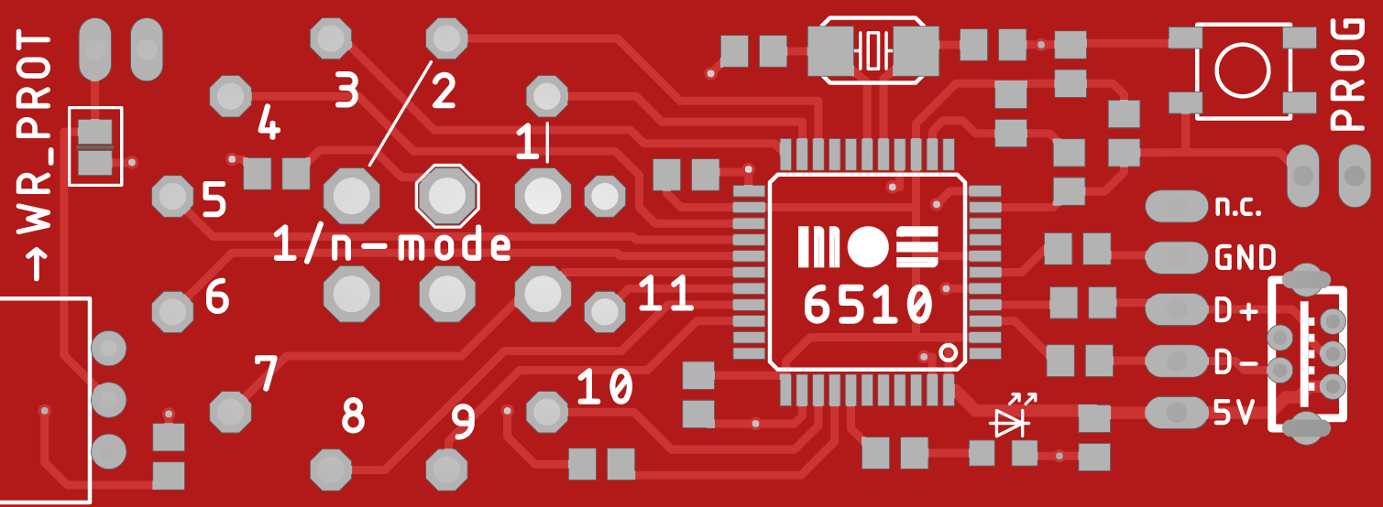
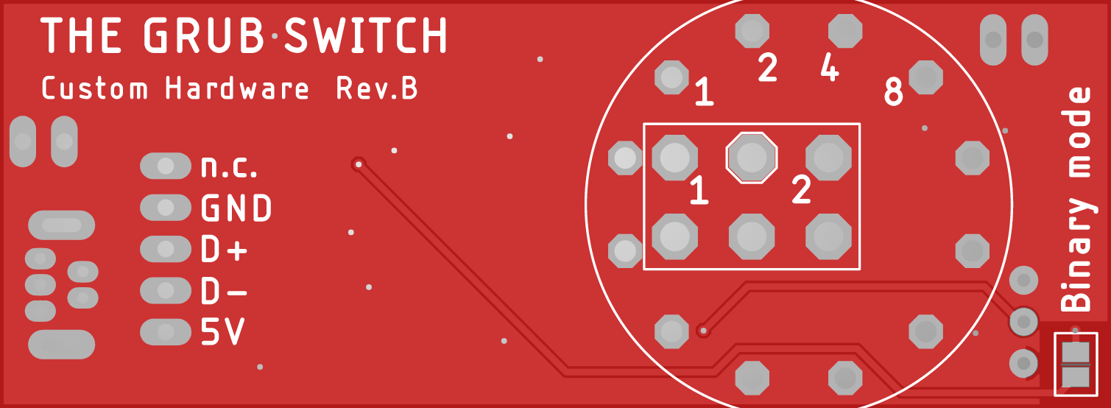

1-of-n mode with ON/OFF/ON switch
The rectangular white silhouette shows the mounting position for a two-channel on/off/on toggle switch (DPDT - ”double-pole/double-throw”). Only the upper channel is actually used; the two channel model was chosen to decrease mechanical stress on solder pads and increase stability.
The pad numbers 1 and 2 indicate the boot choices made through electrical connection to the center pad. Note that the toggle switch lever moves across a fixed pivot, so moving the lever to the left (as seen from the front) actually connects choice 2, while moving the lever to the right chooses boot option 1. The neutral center position leads to the GRUB menu.
The following toggle switch series include DPDT on/off/on models with the required 4.7-4.75mm distance between PCB pins:
APEM Series 5000 E-Switch Series 100
NKK Series M TE-Connectivity Gemini A
(these suggestions should not be considered a commercial endorsement)

1-of-n mode with 1-of-12 rotary switch
The round silhouette indicates the mounting position of a 1-of-12 rotary switch. On the PCB side labeled with “1/n-mode” the 11 switch positions for boot choices of increasing order are indicated; position 0 leads to the menu. Because the switch is mounted on the other PCB side, choices increase by turning the switch clockwise.
The switch’s main connection pin, which is tied to GND, shares a pad with the toggle switch and is indicated by an octagonal silhouette. It is not in the center of the rotary switch, therefore the switch can only be mounted in exactly one position.
Compatible rotary switches with various actuator shapes and lengths, as well as metric and imperial mounting holes and threads, are available from multiple vendors:
C&K A112.**.*.NC.** E-Switch KC52.*.***.**.NP.*
LORLIN CK1049/CK1059 (metric), CK1044/CK1054 (imperial)
(these suggestions should not be considered a commercial endorsement)
Make sure to order the 1x12 variation, as there are also 2x6, 3x4 and 4x3 models. Most switches come with a metal keyring that can be inserted before tightening the screw and that will limit the range of movement to less than 12 steps; so if you only need, say, 4 boot choices including the GRUB menu option, the range of movement can be fixed to 4 steps.

Binary mode
The Custom PCB isn’t designed to hold a binary-encoding switch, but binary mode can be selected anyway by connecting the solder bridge marked with “Binary mode”. The numbers
1, 2, 4, 8 inside the round silhouette indicate the pads to connect to GND to choose the corresponding power of 2. GND level is available at the pad marked with an octagonal silhoutte.

Write-protect
A fully-equipped board should include a slide switch to enable and disable write-protect for the boot configuration file. Two alternatives are:
- Write-protect can be enabled permanently by connecting the solder bridge marked with a rectangle next to the WR_PROT label.
- Next ot the solder bridge are pads for a 1x2 pin header, which can be jumpered to enable write-protect non-permanently.

Further details about the custom PCB can be found in the full documentation.

