The GRUB Switch
General information
Ruediger Willenberg
Version 1.1
June 18, 2021
Note: The GRUB Switch only works with GRUB versions 2.x, not with the older versions also known as “GRUB Legacy”. This shouldn’t be a problem as all major Linux/Unix distributions have upgraded to GRUB 2 a decade ago.
Table of Contents
1 How GRUB2 works 2
1.1 The GRUB2 boot process 2
1.2 How grub.cfg is generated 4
2 How The GRUB Switch works 7
2.1 Basic idea 7
2.2 GRUB Switch directory and file structure 8
3 Downloading and installing GRUB Switch repository 11
4 Steps to install and configure GRUB Switch 12
5 Example files 14

How GRUB2 works
Disclaimer: This information is likely oversimplified and possibly inaccurate, but it should explain how what we do works.

The GRUB2 boot process
The following image gives a rough overview how GRUB2 boots one of multiple installed operating systems.
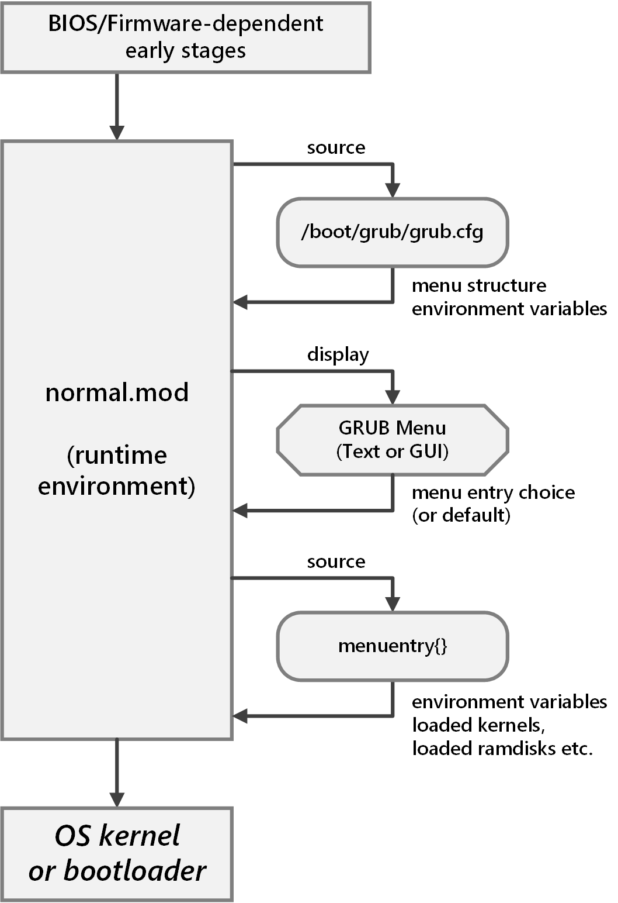
How and from where the boot process starts is dependent on the type of BIOS or (U)EFI firmware that is running on the hardware but they will all lead to executing a central GRUB binary module called normal.mod, which can be considered a runtime environment for a POSIX-like shell with syntax, variable handling, control structures etc. very similar to what a common Unix shell like bash offers. One major difference is that there is no support to write files, so GRUB cannot change persistent storage. Another difference is a large set of commands and environment variables related to how GRUB supports booting various operating systems. See the GRUB2 documentation for detailed information on all features:
https://www.gnu.org/software/grub/manual/grub/grub.html
The environment will by default source a script named grub.cfg located in the GRUB installation directory. This is usually located in /boot/grub or /boot/grub2 on the root drive of the Linux installation that installed GRUB.
When sourced, grub.cfg will usually set a few environment variables, for example settings related to the GRUB menu like a timeout, a default boot entry and graphics settings if a GUI menu instead of a text menu is desired.
grub.cfg‘s other purpose is to build the structure of the menu, which involves adding the menu entries in text form as well as the actions to be taken when a specific menu entry is chosen. The central shell command to do this is called menuentry. Here is a (simplified) version of what a menuentry call could look like:
menuentry 'Windows 10' --class windows --class os {
insmod part_gpt
insmod fat
search --no-floppy --fs-uuid --set=root 2E9D-AF3F
chainloader /EFI/Microsoft/Boot/bootmgfw.efi
}
This would generate a menu entry named “Windows 10” which, when chosen, loads two additional GRUB code modules for reading GPT partition tables and FAT file systems, identifies a partition by its UUID and sets it as the Windows root partition and then starts Windows’ own proprietary bootloader.
It is important to understand that this code is not executed when the grub.cfg reaches the menuentry statement. Rather, with its curly braces, it can be understood like a C function definition, and that function is called later when the menu entry has been chosen by the user or by default.
Another important command is the submenu command which can enclose a group of menuentry blocks inside curly braces and results in a submenu grouping multiple choices in the GRUB menu. For example, Ubuntu uses this to group older kernel versions and safe mode boot options in a submenu.
When the execution of grub.cfg has finished, normal.mod will display the GRUB menu, based on the environment parameters for graphics, timeout and default choice that have been set in grub.cfg. Menu entries and submenus will be displayed in the order in which they have been registered in grub.cfg.
If the user chooses an entry by pressing enter or if the default is chosen by timeout, the runtime environment will execute the commands listed in the corresponding menuentry definition and will start executing the chosen OS’s kernel or proprietary bootloader.

How grub.cfg is generated
grub.cfg is not designed to be edited by hand to change GRUB menu and boot behaviour, but rather to be auto-generated based on a series of Linux shell scripts. In fact, distributions like Ubuntu re-generate grub.cfg every time they update the kernel version, so any changes made directly to it by hand would be overwritten again. To understand how to influence GRUB behaviour, we need to take a look at that generation process. It is illustrated in the image on the next page.
To update grub.cfg, one has to call the grub-mkconfig script. However, most distributions wrap this call into another script called update-grub so that extra call parameters can be included whenever the user calls the script. To trigger the update explicitly, call
sudo update-grub
This should usually not lead to any changes in grub.cfg if your OS installation configuration has not changed, as the script has been called with the identical data before. When grub-mkconfig executes, it first sources the file /etc/default/grub, which only holds variable definitions like these, for example:
GRUB_DEFAULT=0
GRUB_TIMEOUT=10
# Uncomment to disable graphical terminal (grub-pc only)
#GRUB_TERMINAL=console
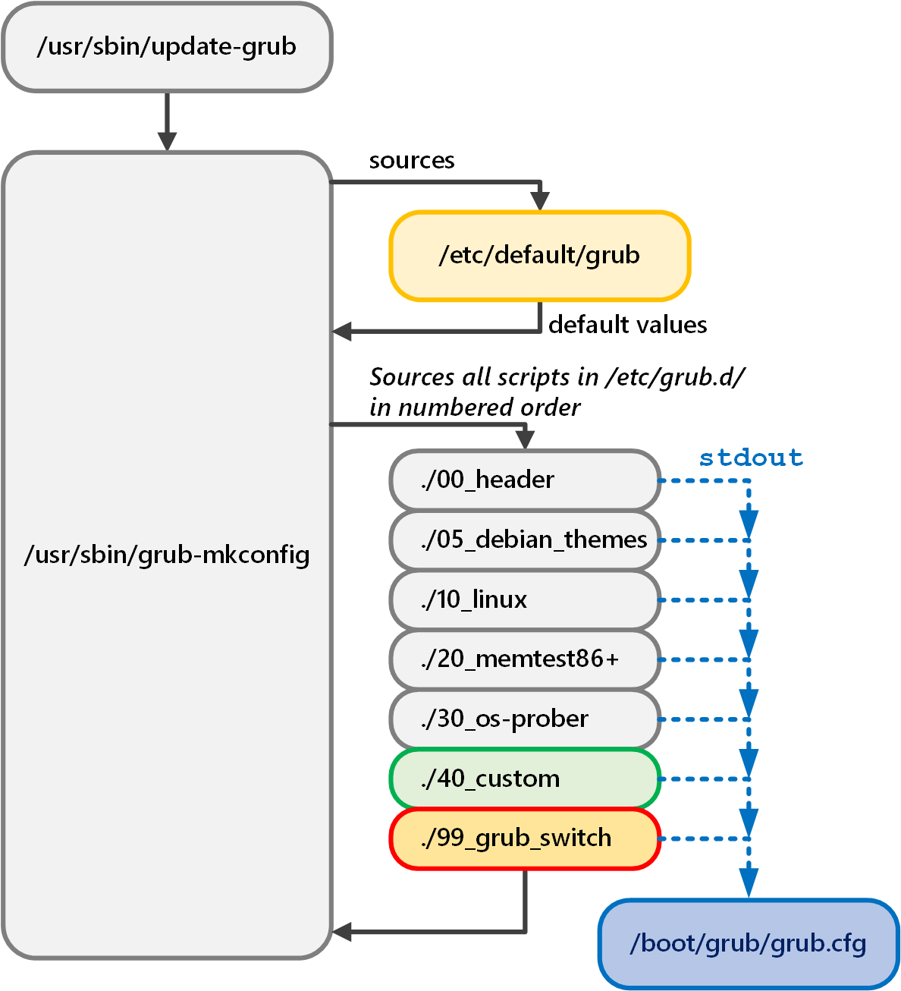
/etc/default/grub is in fact the file you are supposed to change by hand, because it will never be overwritten by others. However, the variables set here will be used to generate grub.cfg, which will then set the GRUB environment variables. Based on the example, the menu timeout is set to 10 seconds, and the first menu entry (the count starts at 0) is made the default, while a GUI menu will not be suppressed in favor of a text menu.

After sourcing /etc/default/grub, the grub-mkconfig searches the directory /etc/grub.d for shell script files starting with a number and executes all of them in numerical order (which will later influence the menu entry order). These scripts are not supposed to write directly to grub.cfg, however. Instead, their stdout output will be redirected to be written into it, therefore assuring that all outputs are concatenated in sequence, resulting in the corresponding menuentry order.
Our image shows a simplified example list of scripts that can be found in /etc/grub.d:
- 00_header produces a few initial settings for grub.cfg that relate to menu appearance, like GUI or text display, timeout and default entry. For that purpose it reads the values defined in /etc/default/grub but also checks the for validity before setting corresponding environment variables in grub.cfg.
- 05_debian_themes probably sets a few style (font, font size, background image, etc.) for GUI menu mode.
- 10_linux probes for Linux installations, older kernel versions and safe mode boot options and generates the corresponding menuentry blocks for grub.cfg.
- 20_memtest86+ generates a menu entry for the memtest86+ tool that can be executed right from GRUB.
- 30_os-prober probes for other non-Linux operating systems, most prominently Windows, and produces corresponding menuentry blocks
- 40_custom is a mostly empty script in which the user can enter desired grub.cfg code. It will be automatically redirected to stdout to be concatenated.
- 99_grub_switch is shown here somewhat prematurely for illustration purposes, as it is the script with which we add our GRUB Switch modifications. The 99_ prefix assures that this is the very last code executed in grub.cfg. We are providing configuration scripts that will automatically copy our script to the /etc/grub.d directory and call update-grub respectively grub-mkconfig so that the new code is installed in GRUB. We also provide a script to remove it again cleanly.

How The GRUB Switch works

Basic idea
The basic operating principle of GRUB Switch is very simple:
- A block of extra commands is added at the end of grub.cfg through the update-grub/grub-mkconfig mechanism. This means that our commands are executed after the menu structure has been constructed, but before the menu is being displayed.
- The extra commands are searching all readable partitions for a FAT partition that holds a file called SWITCH.GRB. If that file is found, it is sourced as an extra script from grub.cfg (the execution of any random, unsafe script with that name can be avoided through checking the file’s hash signature).
- The main purpose of a SWITCH.GRB script is to
  - set the GRUB environment variable $default to a specific menu entry. Because $default is not set to a number but to the entry’s displayed name, the menu entry order in grub.cfg can change and the correct OS is still being chosen.
  - The environment variable $timeout is set to 0 and therefore the menu will not even be displayed; when execution of grub.cfg is finished, the new default choice is booted right away.
- As a result, offering a different SWITCH.GRB file can lead to a different boot choice. There are two ways to accomplish that, both of which GRUB Switch facilitates:
  - By using multiple, plain USB flash drives that hold different SWITCH.GRB files, the boot choice can be made by plugging in the corresponding drive. A SWITCH.GRB file only has a size of a few hundred bytes, so any old flash drive will do.
  - A custom USB hardware that can change the file content, based on an electrical switch. We provide a USB firmware for corresponding devices.
- Two final comments on the SWITCH.GRB files:
  - The scripts do NOT execute the complicated sequences of commands that are necessary to boot the various OS options. By setting $default, it only points to the grub.cfg menuentry block in which these actions have been defined.
  - The scripts also include a mechanism to display the chosen boot option for a defined number of seconds; during that time, pressing ESC cancels the choice and leads back to the GRUB menu with its original timeout.

GRUB Switch directory and file structure
This shows a partial file structure of the GRUB Switch repository to illustrate how GRUB Switch is used and configured:
grub-switch/
|
+---1_config_scripts/
| +---CONFIGURE_GRUBswitch.sh
| +---[ various support scripts ]
| +---modifier_script/
| +---99_grub_switch
|
+---2_usb_device/
| +---[ various source and build directories and makefiles ]
|
+---3_custom_hardware/
| +---[ project files for PCB design/manufacturing/assembly ]
|
+---bootfiles/
| +---template
| +---grubmenu_all_entries.lst
| +---.entries.txt
| +---boot.1/
| | +---SWITCH.GRB
| +---boot.2/
| | +---SWITCH.GRB
| +---boot.3/
| | +---SWITCH.GRB
| +---[ can continue up to boot.15/ ]
| +---grub_switch_hashes
| +---1.sha512
| +---2.sha512
| +---3.sha512
| +---[ can continue up to 15.sha512 ]
|
+---documentation/
| +---[ various documentation and documentation sources ]
|
+---README
+---LICENSE
+---quickstart.pdf

The 1_config_scripts/ directory holds all bash scripts that are necessary to deploy and configure GRUB Switch. The only script that needs to be called directly is CONFIGURE_GRUBswitch.sh, but there are multiple support scripts that will be called by it to execute various operations. In principle, these scripts can be called separately, although there is really no need for that. They and their command-line arguments are documented in more detail in grub-switch/documentation/1_config_scripts.pdf.
The subdirectory modifier_script/ holds 99_grub_switch, which will be copied to /etc/grub.d/ before updating grub.cfg, thereby activating GRUB Switch.
The 2_usb_device/ directory holds all files to build and program firmware images for custom USB devices that can offer a SWITCH.GRB based on hardware input. Detailed documentation can be found in grub-switch/documentation/2_usb_device.pdf

The 3_custom_hardware/ directory holds all project files to modify, manufacture or assemble our own PCB design for a USB device. Detailed documentation can be found in
grub-switch/documentation/3_custom_hardware.pdf

The bootfiles/ directory is central to generating the files for a specific GRUB Switch configuration:
The text file template holds almost the entire script that is placed into the SWITCH.GRB files; it is only prepended by the specific variable assignments for the GRUB default and the choice display.
grubmenu_all_entries.lst is a list of all GRUB menu entries by name. It is extracted from grub.cfg by an action available in our configuration script. In another action, our configuration can be used to pick and order the entries you need for your particular GRUB Switch setup. This action will subsequently generate a number of subdirectories and files.
.entries.txt is the first file generated by our configuration script. It is intended to be written onto the custom USB storage device if that method is used, and holds all menu entries available for boot choice in the requested order, as well as display settings for the boot choice.
The boot.*/ subdirectories (at maximum, boot.1/ to boot.15/) each hold the specific SWITCH.GRB corresponding to that numbered choice. They should be copied onto separate, regular flash drives. If that method is used, only the flash drive corresponding to your next boot choice should be plugged in.
The grub_switch_hashes/ directory holds a numbered file with a SHA512 hash for each SWITCH.GRB file that has been placed in a boot.*/ directory with the corresponding choice number. If grub_switch_hashes/ is copied to /boot/grub (this can be accomplished with our configuration script) and GRUB Switch is installed, every SWITCH.GRB file found is checked against the hashes and any file that does not match will not be executed, thereby ignoring manipulated SWITCH.GRB files.

Downloading and installing GRUB Switch repository
The GRUB Switch scripts and files are designed to be installed and used under Linux. There are two ways to obtain the files:
- Via git clone:
  - Go to your preferred working directory
  - Clone the repository with
git clone https://github.com/rw-hsma-fpga/grub-switch.git
  - All GRUB Switch files are now available in the path
./grub-switch
- Via download:
  - Download to your preferred directory:
https://github.com/rw-hsma-fpga/grub-switch/archive/refs/heads/master.zip
  - Unzip with GUI-tool or on the command line with
unzip grub-switch-master.zip
  - All GRUB Switch files are now available in the path
./grub-switch-master
All further examples will assume you are starting in the parent directory above grub-switch

Steps to install and configure GRUB Switch
Almost all actions to configure your system with GRUB Switch can be accomplished through the CONFIGURE_GRUBswitch.sh script. For a How-To guide with screenshots, see grub-switch/quickstart.pdf.
- Go to the configuration script directory with
cd grub_switch/1_config_scripts/
and execute the script with
./CONFIGURE_GRUBswitch.sh
- Install GRUB Switch into grub.cfg with action 7 (this only needs to be done once).
You will need super user rights, so the script will ask you for your sudo password.
You can use action 8 to cleanly remove GRUB Switch again from the boot process.
- Extract the current menu entries from grub.cfg with action 1. If you want to change your GRUB Switch boot choices (or if GRUB Menu entries have been renamed), you will have to repeat steps from here.
- By picking action 2, you will be able to pick the GRUB menu entries you want to be able to boot through GRUB Switch. This includes assigning them an order with numbers; this ordering is mostly relevant for the custom USB device option with .entries.txt (choice by hardware switch), but the numbers also correspond to the naming of the bootfiles/boot.* directories and hashes.
You will next be asked for how long the GRUB Switch choice should be displayed. A three-digit number of seconds can be adjusted. If you set 0 seconds, booting will continue instantly. However, this precludes the chance to go back to the GRUB menu by pressing the ESC key.
You can further pick a background/foreground colour combination that highlights the name of your chosen menu entry during the display time.
After all settings have been chosen, all the files in bootfiles/ will be generated. They can be removed again with action 3.
- If you want any SWITCH.GRB file to be checked for authenticity, you have to install the hashes into /boot/grub/ with action 5.
Note: Some improper updates of GRUB itself on systems with Secure Boot can result in the GRUB hash checking module to be rejected. In that case, GRUB Switch will yield to the GRUB menu as if the hash check itself has failed.
One fix for this issue is to remove the hashes again, which can be done under any circumstances with action 6. With careful consideration, other fixes like de-activating Secure Boot itself can be used.
- If you are using the custom USB device solution, menu action 4 can automatically mount the device, copy the generated bootfiles/.entries.txt onto it and unmount the drive again. This will again require sudo access.
Of course the file can also be copied on the mounted device manually.
- If you are using the solution with multiple regular USB drives, you have to copy the various generated bootfiles/boot.*/SWITCH.GRB files to the corresponding drives manually.
- On the next boot, GRUB will look for a SWITCH.GRB file on all drives and, if it finds it, react with the corresponding boot action.

Example files

grubmenu_all_entries.lst (extracted from grub.cfg)

### All entries, extracted from current GRUB menu
Ubuntu
Advanced options for Ubuntu>Ubuntu, with Linux 5.4.0-74-generic
Advanced options for Ubuntu>Ubuntu, with Linux 5.4.0-74-generic (recovery mode)
Advanced options for Ubuntu>Ubuntu, with Linux 5.4.0-73-generic
Advanced options for Ubuntu>Ubuntu, with Linux 5.4.0-73-generic (recovery mode)
Windows Boot Manager (on /dev/nvme0n1p1)
System setup

.entries.txt (generated by configuration script)

#1 005
#2 white/blue
Windows Boot Manager (on /dev/nvme0n1p1)
Ubuntu
System setup
### These comments may be cut off (without harm) if the file gets too large
### (ATmega32u4 has 960 bytes of available space, ATmega16u4 has only 448 bytes)
###
### #1 specifies display time for subsequent entries
### #2 specifies display colors for subsequent entries
###
### Uncommented lines above are GRUB switch choices 1..15 (0x1..0xF)
### An empty line leads to the GRUB menu, as does choice 0

SWITCH.GRB (generated by configuration script or USB device)
Red part is generated specifically for a boot choice, blue part is from the fixed template file
grubswitch_sleep_secs='005'
grubswitch_choice_color='white/blue'
grubswitch_choice='Ubuntu'
### ONLY CHANGE BELOW IF YOU KNOW WHAT YOU'RE DOING ###
# make boot default
set default="$grubswitch_choice"
# suppress menu display
set timeout_style=menu
set timeout=0
# print boot choice
clear
echo 'Press ESC for boot menu'
echo
echo -n 'Booting '
old_color="$color_normal" # save normal color
if [ -n "${grubswitch_choice_color}" ]; then
set color_normal="$grubswitch_choice_color" # highlight if defined
fi
echo $grubswitch_choice
set color_normal="$old_color" # restore normal color
echo -n 'continues in '
# wait for specified num of seconds
if sleep --interruptible --verbose $grubswitch_sleep_secs
then
clear
else
unset timeout
fi
# return to grub.cfg and boot

