Name: Rayan Wali

Date: February 14, 2019

Period 3, Ms. Lorena

**Biometric Facial Analysis Project Update**

The goal of my project is to create an ASP.NET Web Application that detects faces from an image, with face attributes like gender, age, or pose extracted using Microsoft Cognitive Services on the Azure platform. The key goals of my project are to:

* Create Face API in Microsoft Azure. File:Check mark 23x20 04.svg
* Detect faces from an image and mark them using rectangular framing. File:Check mark 23x20 04.svg
* Code all attributes (eye color, hair color, gender, and age) that I will be testing. File:Check mark 23x20 04.svg
* Create the ASP.NET Web Application. File:Check mark 23x20 04.svg
* Load an image through the Web Application. File:Check mark 23x20 04.svg
* Analyze the head pose, gender, and age of the face and display facial features. File:Check mark 23x20 04.svg
* Get the program to detect multiple faces in a picture.
* Code a program that matches an image to an image within a set of images.
* Train FaceAPI attributes with series of images.

Below are screenshots of what I have accomplished since my last presentation:

**Created ASP.NET Web Application:**

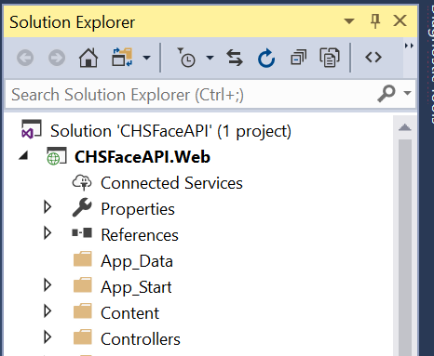

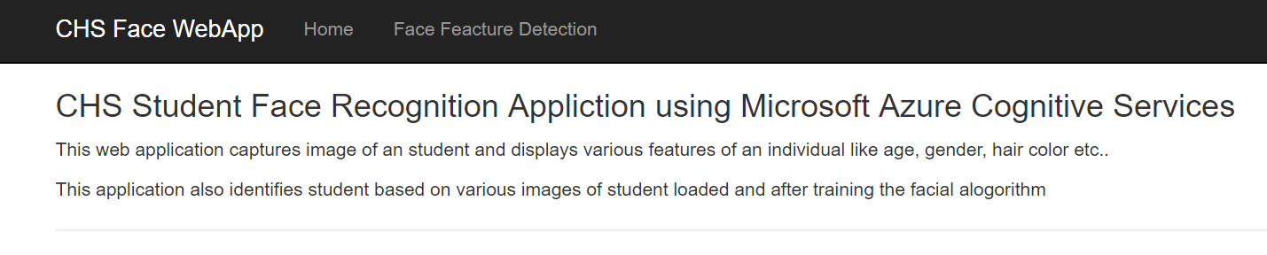



**I created the FaceModel class to capture the facial attributes I am testing by calling Azure Face API, and display it to the screen:**

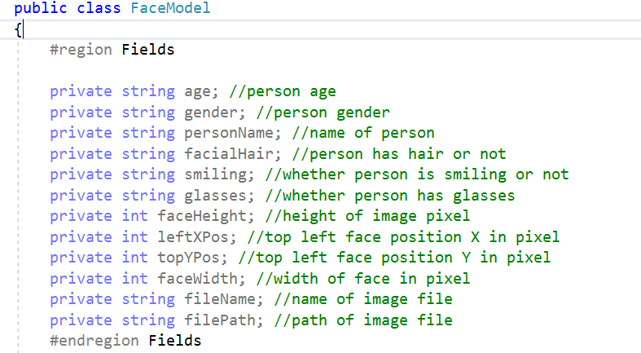

**I created the View page that loads the image and displays the facial attributes:**

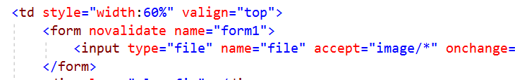

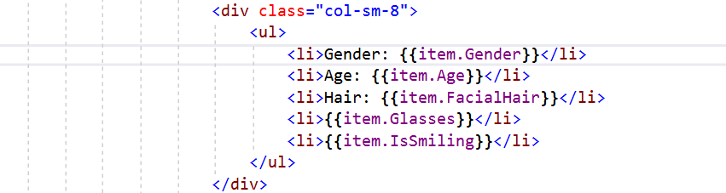

**I created the Model class that has the method that calls the Azure Face API and passes a loaded file stream:**

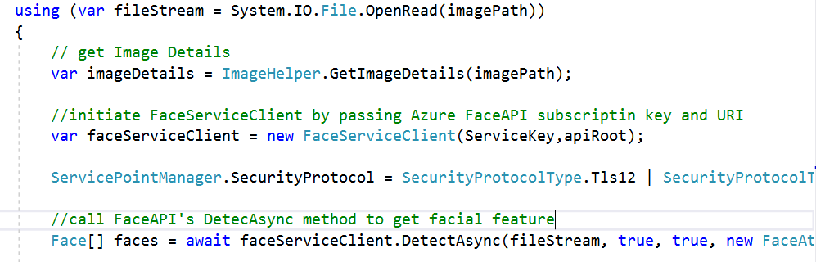

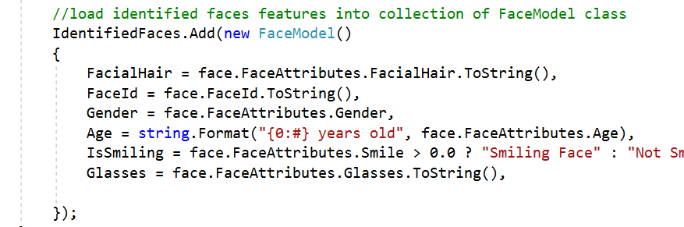

Overall Progress and Next Steps

**Work Accomplished:**

* Coded the eye color, hair color, and gender, and age attributes in Visual Studio using the Facial API package of Microsoft Azure.
* Set up a Web App and placed a file reader (input) on it for a user of the website to upload an image.
* Display facial features (eye color, hair color, gender, and age attributes) on the web app page.

**Work in Progress:**

* Detect multiple faces in a picture.

**Next Focus Areas:**

* Code a program that matches an image to an image within a set of images.
* Load a series of images and tag the images with student name.
* Train FaceAPI attributes with series of images.
* Identify students in the image.