Downloading and launching KitapHana from Github

1. Download the archive from the main page of the project: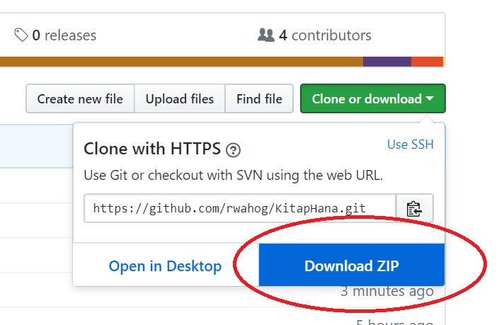

2. Unpack it where you wish: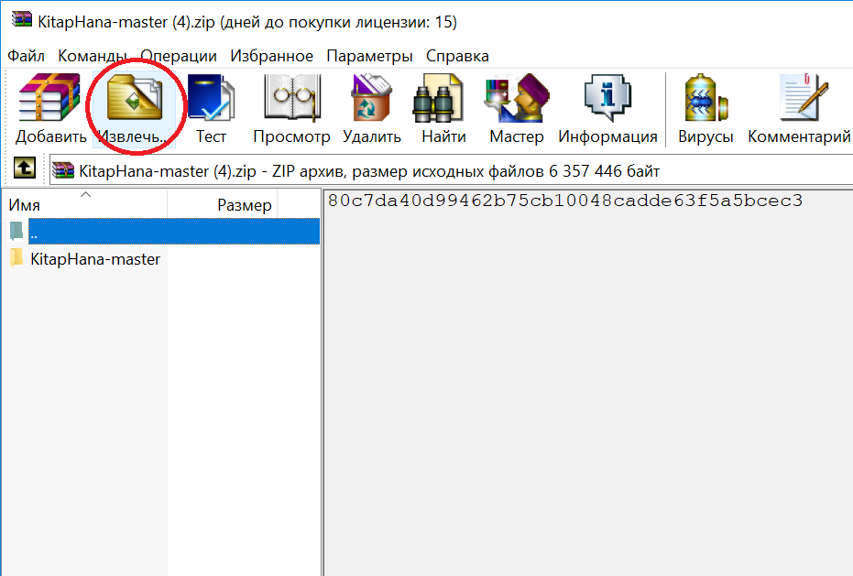

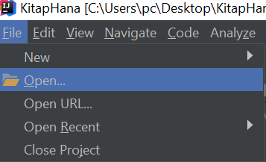3. Open project from Intellij IDEA:

Open the progect where you left it: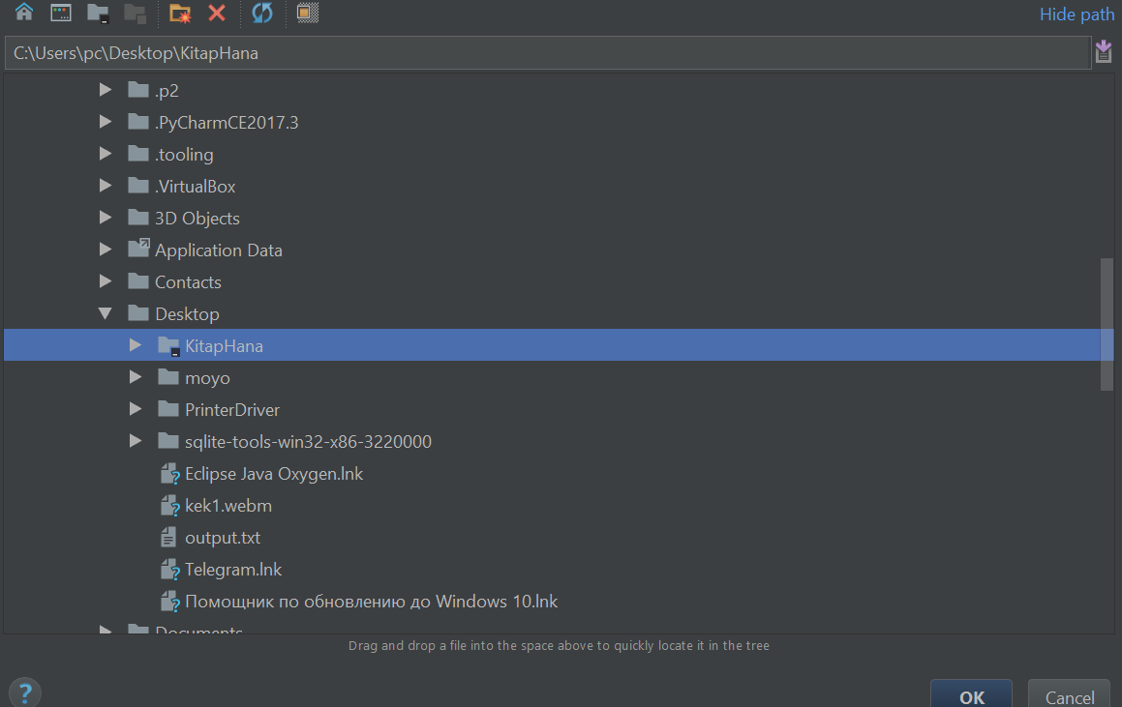

IMPORTANT! IF INTELLIJ IDEA SUGGEST TO DOWNLOAD SOME MAVEN FILES OR DATABASES, DO IT!

4. Connect to the database:

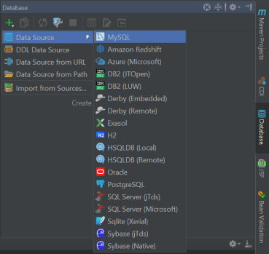a) click on Database at the right corner and shoose mysql as follows:

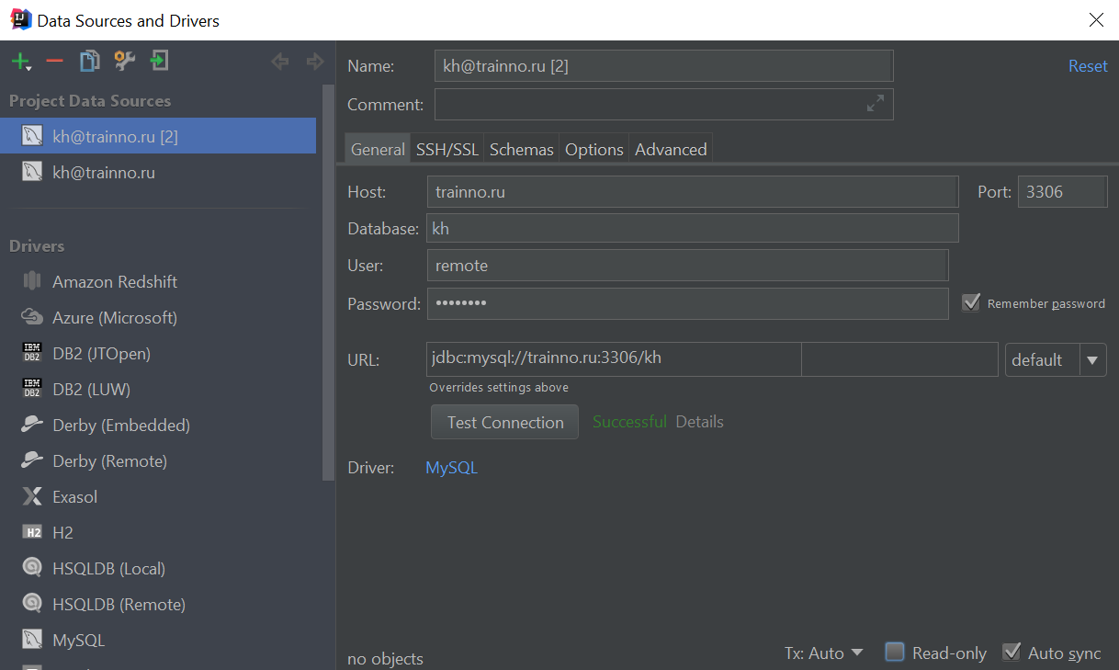 b)Fill in the gaps:

1. Host: trainno.ru

2.Database: kh

3.User: remote

4.Password: password

Then click on “Test Connection” and download the Driver if necessary (it would be red, follow IDEA suggestions)

Apply it and click “OK”

5. Launching:

a) go to Maven, check the tick: 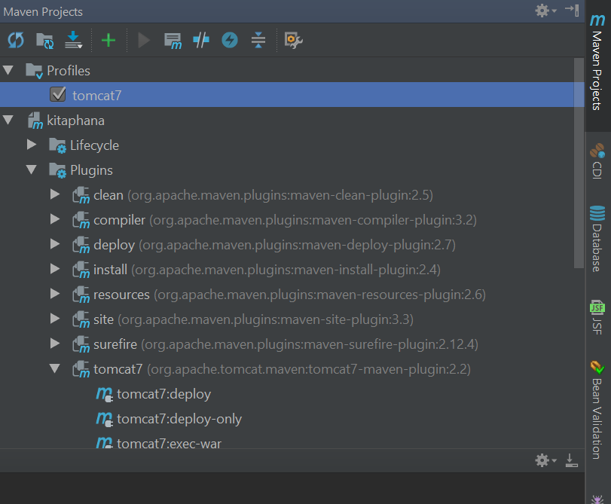

b)execute tomcat7:run-war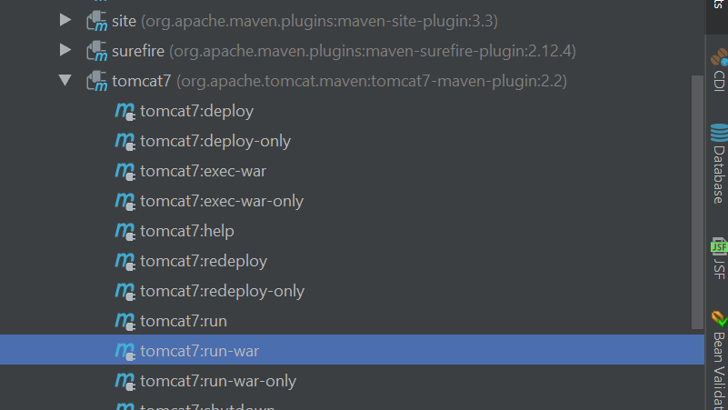

c)FINALLY:

tap in any your browser <http://localhost:8080/>

Congratulations! You are done!!