NE 723 Final Program

Ryan Walden

December 13, 2017

Contents

Methods 2

Test A 2

Test B 4

Appendix A: Algorithm 10

Appendix B: Code 10

# Methods

A code was designed for solving a k-eigenvalue problem for the multigroup transport equation in two-dimensional geometry. The method of long characteristics was used for discretization of the group transport equation and the method of power iterations and source iterations were used for solving the system of multigroup transport equations. Two different geometries were used to test the code, one UO2 pincell and a 3x3 grid of pincells made from different fuels. The results are shown in the sections below. The exact algorithm is shown in Appendix A.

# Test A

Test A is made up of a single UO2 fuel pin surrounded by moderator. The test was solved in 24 iterations and the eigenvalue was found to be $k=1.6788467$. The following graphs and figures show the results of the test.

The figure above shows the convergence history versus the number of iterations. The blue line shows the infinity norm of the scalar flux between iterations, ${\left\|ϕ^{s}-ϕ^{s-1}\right\|}_{∞}$, and the orange line shows the difference in eigenvalues between iterations, $|k^{s}-k^{s-1}|$.

The figure above shows the change in $ρ_{PI}$ and $ρ_{k}$ versus iterations.

**Average Group Scalar Flux**

|  |  |  |
| --- | --- | --- |
|  | Mod | Fuel |
| Group 1 | 0.076392 | 0.113776 |
| Group 2 | 0.081656 | 0.117311 |
| Group 3 | 0.004856 | 0.004170 |
| Group 4 | 0.000431 | 0.000348 |
| Group 5 | 0.000266 | 0.000267 |
| Group 6 | 0.059815 | 0.048212 |
| Group 7 | 0.459132 | 0.349600 |

The table above shows the average group scalar fluxes in the moderator and fuel pin for Test A.

The graphs of the group scalar flux over the pincell is presented in the next pages.

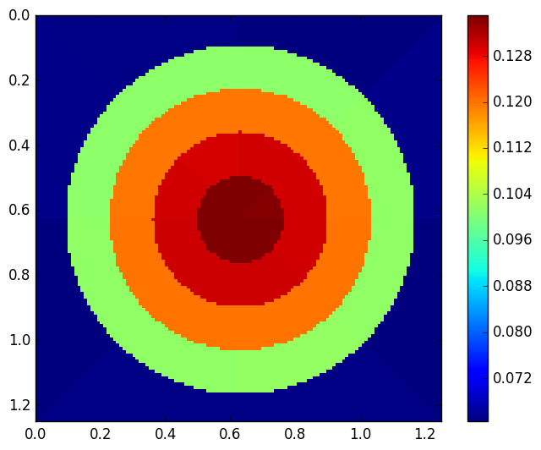

Group 2

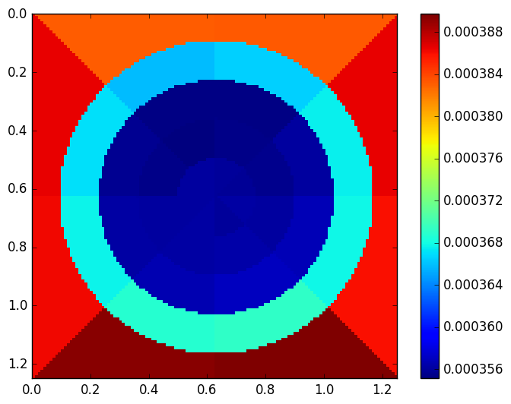

Group 4

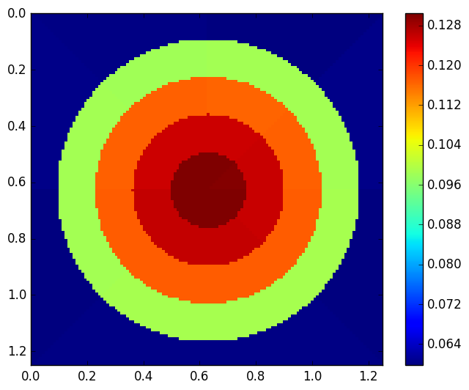

Group 1

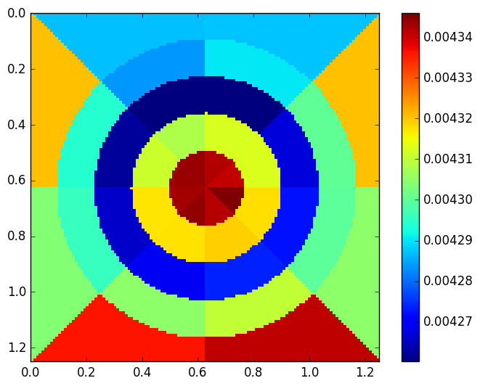

Group 3

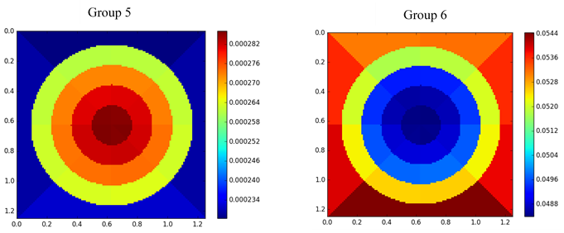

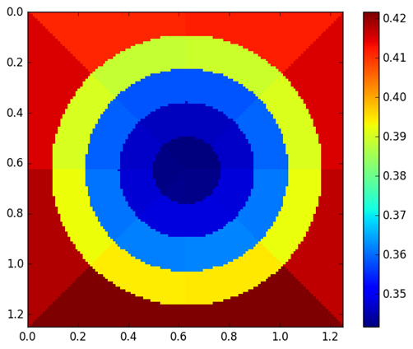

# Test B

This is a 3 by 3 pin-cell configuration consisting of UO2, MOX 4.3, MOX 7.0, MOX 8.7, and guide tube materials. The test was solved in 30 iterations and the k-eigenvalue was found to be $k=1.5837776$. The following graphs and figures show the results of the test.

The graph above shows the convergence history of the scalar flux and eigenvalue.

The graph above shows the change in $ρ_{PI}$ and $ρ_{k}$ versus iterations. There is a large fluctuation in $ρ_{k}$ at the end of the iterations because the difference of eigenvalues between iterations is very small.

The flowing figures shows the distribution of group scalar flux across the pincells. Note that pincells 1, 2, and 3 are on the top row of the figures and pincells 7, 8, and 9 are on the bottom.

**Group 1**

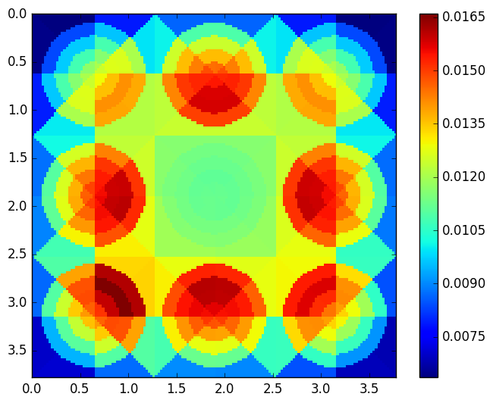

**Group 2**

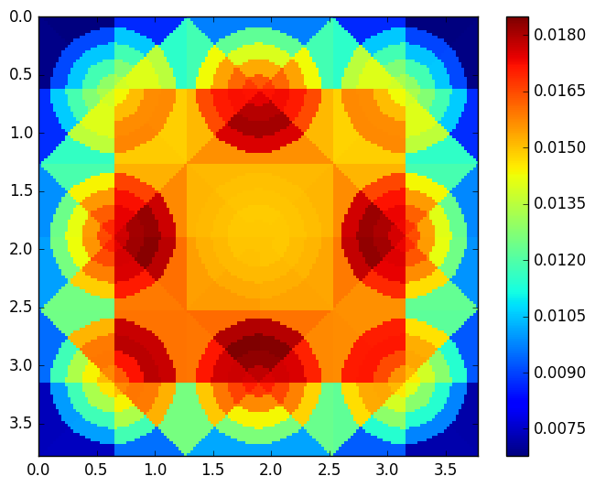

**Group 3**

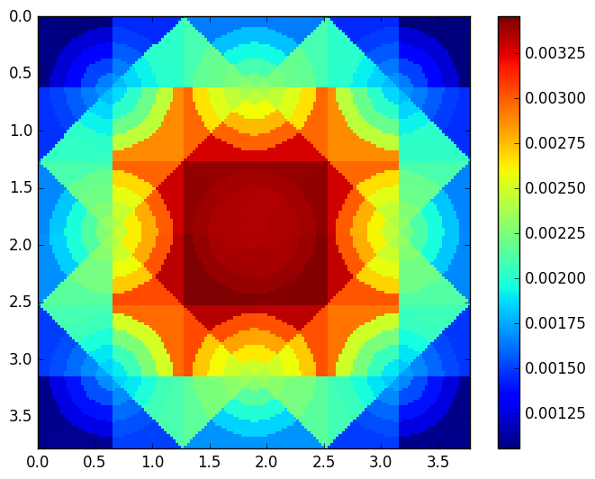

**Group 4**

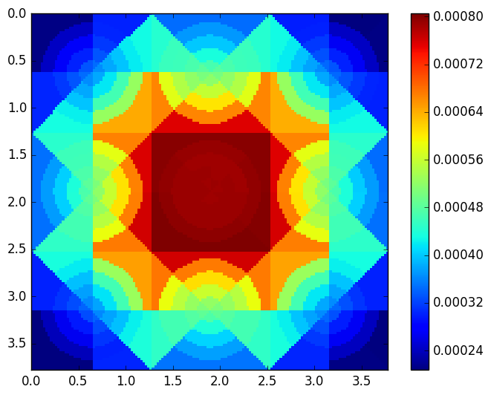

**Group 5**

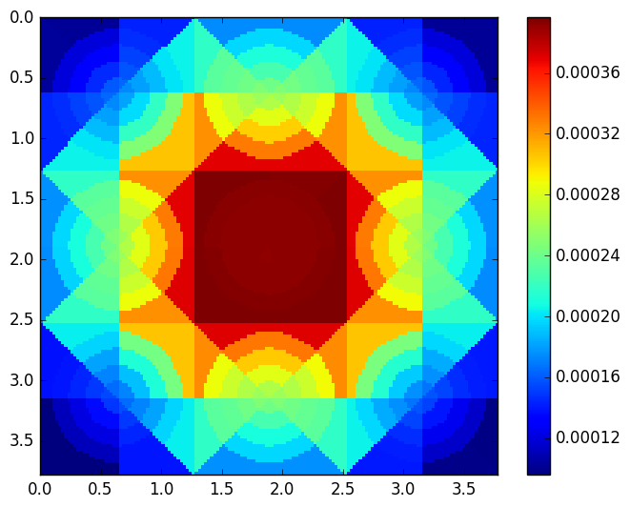

**Group 6**

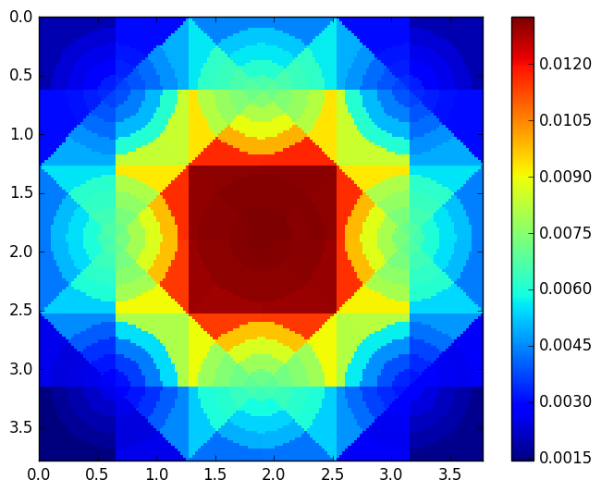

**Group 7**

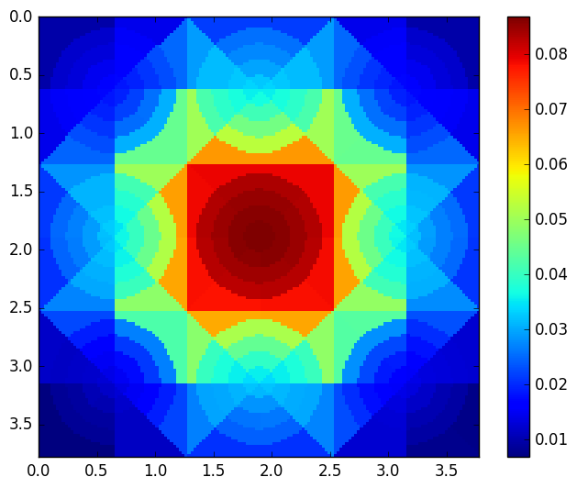

**Average Group Scalar Flux Across Pincells**





# Appendix A: Algorithm

1. Define geometry and characteristic tube with ray tracing method.

2.Guess initial values for scalar flux and angular flux B.C.

3.Calculate source from upscatter and fission with .

4. Loop through groups, calculating downscattering source with $ϕ^{s}$, and solving the transport equation iteratively with characteristic line.

5. Calculate k.

6. Normalize scalar flux.

7. Check convergence criteria, if not fulfilled repeat steps 2-6.

# Appendix B: Code

*(sent via email)*

NE723-FinalProgram.f95: Main driver for program.

TransportSolver.f95: Subroutine for solving transport equation across characteristic line.

RayTrace.f95: Module containing subroutines for drawing characteristic lines.

XSBuilder.f95: Builds geometry and cross section meshes across different sub-cells.

FluxMap.f95: Subroutine for generating output used for creating flux map pictures.

DataVis.py: Python script used to generate flux map pictures