 Hursley

Maker Space

**Arduino Nano Lesson 1 – Blink Example**



1. Open the Arduino IDE, this is where we upload the code that our board will use.
2. Make sure the system is able to read from the board, go to tools and set the board as “Arduino Nano”.
3. Set the Processor as “ATmega328P (Old Bootloader), and the port to whichever the board is plugged into e.g. “COM4”. Note: A way to check the port is to plug in your Arduino and see which one appears.

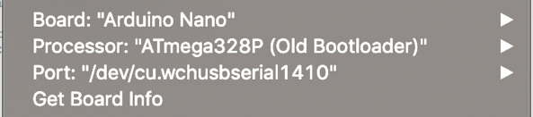

1. Go to File -> Examples -> Basics and load Blink

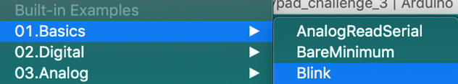

1. Have a read of this example code. Once you understand the purpose of the setup and loop functions, click the Upload Icon.

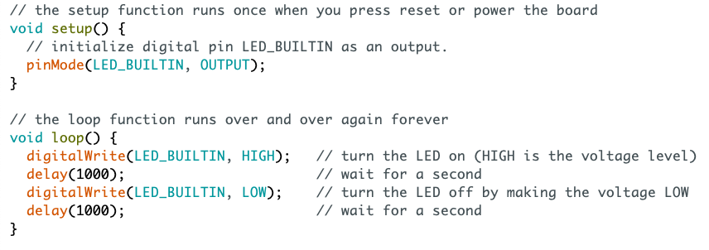

1. If successful, the ‘L’ LED on the board will flash & you will receive a ‘Done Uploading’ message on your IDE.

**Challenge – Modify the Code**

1. Have a play with the code-sample, re-upload and view changes!

 Hursley

Maker Space

**Arduino Nano Lesson 2 – Using the Keypad**

1. If you haven’t been through Lesson 1, make sure the Arduino settings under Tools are correct and test by running ‘blink’.
2. 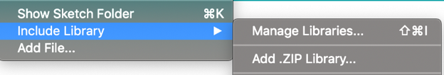Now, lets write our own program to read keypad input. Go to File -> Open and import the lesson_2_starter file. This code was generated by adding the keypad library through downloading a .zip file from the Arduino website. You can do this through sketch -> manage libraries.
3. Go through the keypad setup code. More information on this can be found on this at http://www.circuitbasics.com/how-to-set-up-a-keypad-on-an-arduino.
4. Now, add code to process a key-press and set it to a variable.

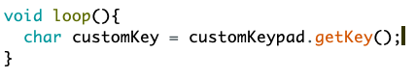

1. Leave the setup as it is, and print to Serial whenever a key press is recognised.

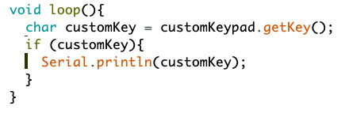

1. Upload this script, then once it’s running go to Tools -> Serial Monitor to watch the logs of your button presses live! Or to Tools -> Serial Plotter to plot all pressed values.

**Challenge 1 – investigate the keypad library**

1. Explore the examples under Files -> Examples using the keypad library.

**Challenge 2 – explore other available libraries**

2. There are loads of fantastic libraries like this one available both already installed to the IDE and online, go have a look!

 Hursley

Maker Space

**Arduino Nano Lesson 3 – Use the Keypad to control the LED**

1. Begin with your completed code from lesson 2, or open lesson_3_starter from the Arduino folder on the machine.
2. First, initialise the in-built LED with the following line in setup().

­­

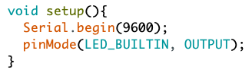

­­­

1. Run an LED flash by adding the following as a function below the loop() method. Test this works by adding a flash() at customKey, import this and the LED should flash at each press on the keypad.

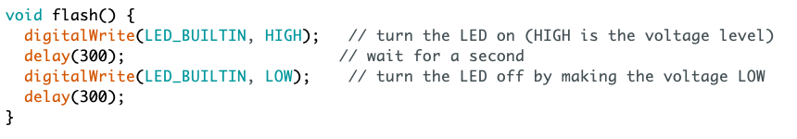

1. Now, let’s make the value that is pressed mean something. Save the number pressed as an int. This can be done using the line shown. The (– ‘0’) relates to the conversion from char to int in C/C++ , details about this are available online.­­­



1. Finally, wrap the flash() call in a for-loop with an upper limit equal to the number entered.

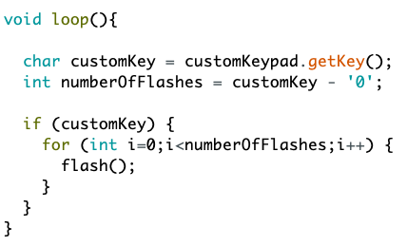

1. Import your code, key in a value and use the keypad to control the LED!

**Challenge – modify the Code**

1. Can you build the code to also process the lettered keys? How about 2 digit numbers?