 Hursley

Maker Space

**Raspberry Pi & Sense Hat Lesson 1 – Scrolling Text**

1. Import the Sense Hat *Output*node from the Node Red side-bar.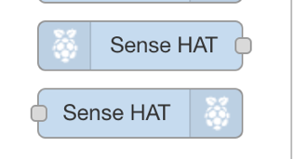
2. 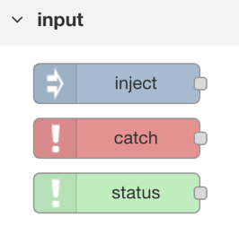Import an *inject input* node too
3. 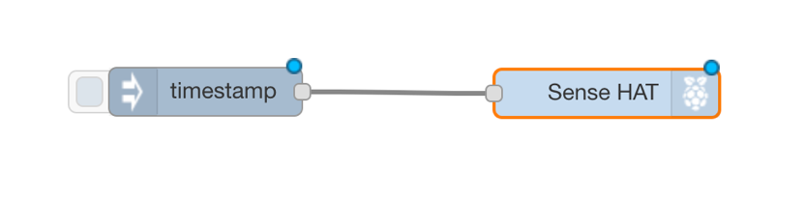Connect them together on the flow editor
4. Double click on the input node and add a custom string to the ‘payload’ input.





1. Deploy your flow to the Pi.
2. Click the ‘inject’ button to inject your text to the Pi. It should follow your flow and scroll the text

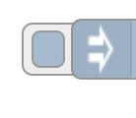

**Challenge 1 – use a native Python script instead**

1. Open a new terminal (click on the icon on the left of the task bar at the bottom)
2. Do ‘cd Documents/Maker-Space-Opening’
3. Run our pre-made python script using ‘python pi-scroll_text.py’

**Challenge 2 – make the text-scroll repeat**

1. (Use Node-RED or edit the script)

 Hursley

Maker Space

**Raspberry Pi & Sense Hat Lesson 2 – Import a function**

1. 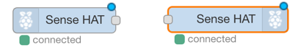Open a new Flow tab, and add 2 Sense Hat nodes: 1 Input and 1 output
2. Find a cool function to import. For example, copy the contents of Documents/Maker-Space-Opening/maze_game.json to clipboard
3. 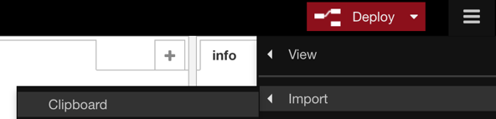Click on the hamburger menu in the top right, click Import > Clipboard

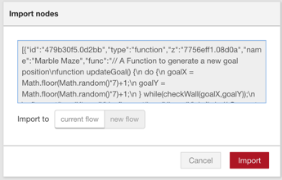

1. Paste in your JSON
2. 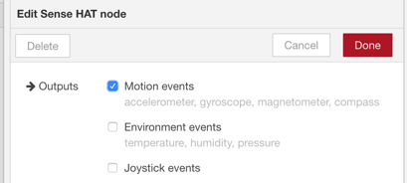(optional) Double click on the Sense Hat Input node and make sure only ‘Motion events’ is checked. This speeds up the flow by limiting inputs from the Sense Hat to those that matter

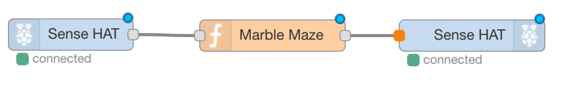

1. Deploy your flow, and play the game!

**Challenge 1 – make a cool change to the game**

1. Double click on the function node (Marble Maze) and use your imagination (e.g. edit the number of walls, or the sensitivity).
2. When your updated function is ready, deploy your flow then restart the Node-RED server (in the terminal, use ‘node-red-stop’ then ‘node-red-start’). Your game should have updated!

**Challenge 2 – import functions from the web**

1. We got the JSON you used from <https://developer.ibm.com/recipes/tutorials/connecting-a-sense-hat-to-watson-iot-using-node-red/>. Head over there
2. Look for “**2.** Open the **Import Nodes** dialog and paste in the JSON from [here](https://gist.githubusercontent.com/knolleary/da4fc4348e44dcf81744eb4e042e8635/raw/b5e811fb83c931262d23fcd099e2db570f281bf3/Step%25203%2520-%2520Marble%2520Maze%2520Function%2520Node%2520v1.json)." And follow that hyperlink
3. Copy the JSON and import into your function as before.
4. Find other functions on the web and import them in.

 Hursley

Maker Space

**Raspberry Pi & Sense Hat Lesson 3 – Sense temperature**

1. 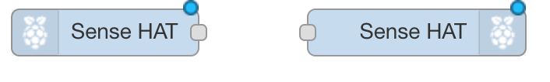Begin with Sense HAT input and output nodes.
2. 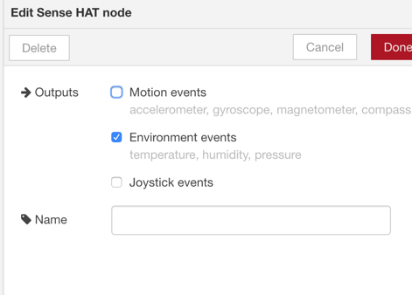Modify the output node to emit only Environment events.
3. Add a function node between the two nodes, and double click on it to edit its code

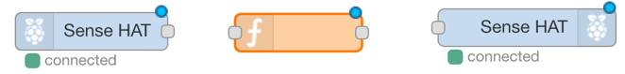

1. We want the Sense Hat to display only the temperature, so set the payload to include only that field, then hit deploy.

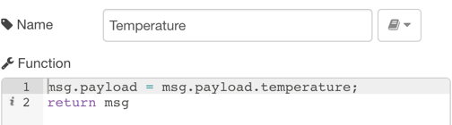

1. 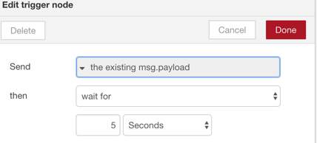The Sense Hat will now display the temperature as scrolling text. However, the Sense Hat reprints the temperature every second, before the text has finished scrolling. So use a ‘trigger’ node to trigger the flow only every 5 seconds. Now when you hit deploy, the temperature should finish scrolling, then repeat every 5 seconds.



**Challenge 1 – use a native Python script instead**

1. Open a new terminal (click on the icon on the left of the task bar at the bottom)
2. Do ‘cd Documents/Maker-Space-Opening’
3. Run our pre-made python script using ‘python pi-scroll_temperature.py’

**Challenge 2 – make the text colour respond to temperature**

­

1. E.g. show red text if it’s above 40°; show blue if below 40°. (Use Node-RED or edit the script).